APPLICATION FOR A NON-MATERIAL AMENDMENT
CASE OFFICER REPORT

APPLICATION REFERENCE: | PL/2026/00806
APPLICATION TYPE: | NON-MATERIAL AMENDMENT
SITE ADDRESS: | Land at Elm Grove, Trowbridge
DEVELOPMENT DESCRIPTION: | Non-material Amendment to the approved reserved matters consent for Land at Elm Grove, Trowbridge. Substitution of a series of approved plans in order to reflect essential, but minor, technical adjustments identified following detailed engineering review.
RECOMMENDATION: | That the non-material amendment be GRANTED

PROPOSAL
Following detailed design work and land title investigations, it was identified that the originally approved locations of both the pumping station and sub-station partially overlapped an area of unregistered land adjacent to Drynham Lane. As both pieces of infrastructure must ultimately be transferred to their respective statutory undertakers, this overlap would prevent adoption. To address this, the following amendments are proposed:
- Minor re-siting and slight elongation of the pumping station, resulting in a very minor
encroachment into the attenuation basin. The accompanying JRC technical note
confirms that this does not materially affect basin performance or storage capacity.
- Re-siting of the sub-station, requiring a reduction in its footprint and a change in
external material.
- Additional planting and hedgerow screening is provided, enhancing boundary
landscaping to Drynham Lane.
- Minor amendments to the private driveways serving Plots 38, 39 and 51, moving
them wholly within registered land to avoid conveyancing issues.

PLANNING HISTORY

19/11459/OUT – Outline Planning Consent for up to 261 dwellings following the demolition of Elm Grove Farmhouse; erection of multi-use community facility (Class F2); strategic landscaping; access and drainage works; and demolition of redundant former agricultural outbuildings - Approved 31/10/2022

PL/2022/09425 – Reserved Matters Application - Demolition of existing buildings and structures and construction of 248 residential homes, playing pitches, allotments, areas of open space, upgrading of existing play area, sustainable drainage infrastructure, internal roads, paths and parking areas, landscaping and associated works, plant and infrastructure (Reserved Matters Application pursuant to 19/11459/OUT - relating to appearance, landscape, layout and scale) (Amended Details) – Approved 05/12/2024

PL/2022/08859 – Discharge of condition 4 on 19/11459/OUT – Approved 11/01/2023

PL/2024/03327 – To display two advertisement signs to advertise the land for residential development – Approved 18/06/2024

PL/2024/05853 – Discharge of conditions 36, 38 and partial discharge of 34 on 19/11459/OUT – Approved 10/07/2024

PL/2024/09649 – Discharge of conditions 7 (construction waste), 8 (finished floor levels), 9 (surface water) and 37 (nesting and roosting) of planning application 19/11459/OUT – Approved 29/01/2025

PL/2024/11151 – Discharge of condition 32 (hard and soft landscaping) for Phase 1 and partial discharge of condition 16 (road condition survey) of 19/11459/OUT – Approved 18/02/2025

PL/2024/11610 – Discharge of conditions 10 (Drainage related CMP) 15 (CTMP), 41 (CEMP) and partial discharge of condition 40 (Traffic Management Plan) relating to application 19/11459/OUT – Approved 20/03/2025

PL/2025/01120 – Discharge of Conditions 6 (materials), 7 (materials), 8 (materials) & 9 (materials) of planning application PL/2022/09425 – Approved 02/04/2025

PL/2025/06617 - Discharge of condition 11 (Flood Risk Emergency) and partial discharge of condition 35 (Lighting) relating to application 19/11459/OUT – Approved 23/09/2025

PL/2025/07848 – Discharge of condition 10 (overhearing assessment) & condition 13 (Bat Roost Details) relating to planning application PL/2022/09425 – Awaiting a decision

RELEVANT LEGISLATION AND GUIDANCE

Town and Country Planning Act 1990 (as amended):
Section 96A: This section provides the legal basis for non-material amendments to an existing planning permission. It allows Local Planning Authorities (LPAs) to make changes to a planning permission without the need for a new application, provided that the changes are considered to be "non-material."
The Act does not define "non-material," and it is at the discretion of the LPA to determine whether a proposed amendment qualifies as such, considering the specific context of the development and its impacts.
CONSULTATION
As an application for a non-material amendment is not a full planning application, the provisions under the Town and Country Planning (Development Management Procedure) (England) Order 2015 relating to statutory consultation and publicity do not apply. Consequently, local planning authorities have discretion regarding whether and how to inform interested parties or seek their views.
Given that the changes proposed are by definition non-material, consultation or publicity are typically not required. Additionally, as the proposed amendments are minor in nature, there are generally no significant effects that would necessitate consideration under the Environmental Impact Assessment Regulations 2011. In this instance it has been considered appropriate to consult the Councils Drainage Team for comment.
ASSESSMENT
Non-material amendments are changes that do not significantly alter the scheme's overall impact. They can involve minor adjustments to the design or other aspects of the development but should not fundamentally change its character, scale, or overall effect on the surrounding area.
Driveways:
The proposal shows a slight amendment to the layout of the access road and driveways serving plots 37, 38, 39. This includes a straighter road that is further back from the tree line making the driveways to units 38 and 39 slightly shorter. There is no overall impact on parking to these units and this would not require re-consultation with the highways department. The changes are also considered not to alter the proposed character and appearance of this area of the scheme. As such this element of the NMA is acceptable for approval
As Proposed As Approved
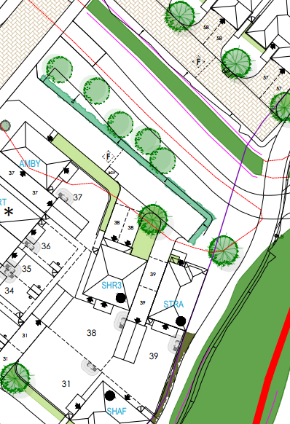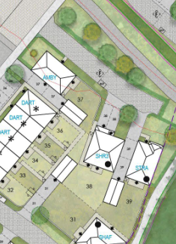

Pumping Station and Substation
As Proposed As Approved
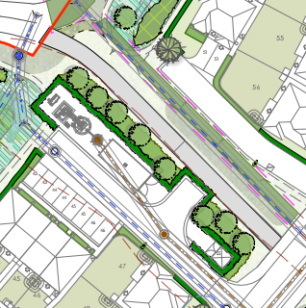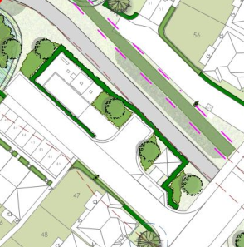
The substation is being made smaller and is being accessed slightly differently. Additional planning has also been proposed to obscure it further when using Drynham Lane. The substation was previously proposed to be built with brickwork but it is now proposed to be built with Green GRP as there is insufficient space to house the brick work.

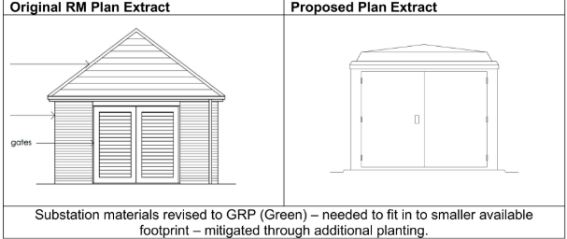
It is considered that these changes would be considered acceptable as it is a small element of the scheme, the substation is being reduced in size and the green colour will be similar to the additional planting it would sit adjacent to. The changes are also considered not to significantly alter the proposed character and appearance of this area of the scheme. As such this element of the NMA is considered to be acceptable.
The proposed pumping station is being elongated and will be brought slightly closer to the existing neighbouring properties. It also slightly encroaches into the attenuation basin.
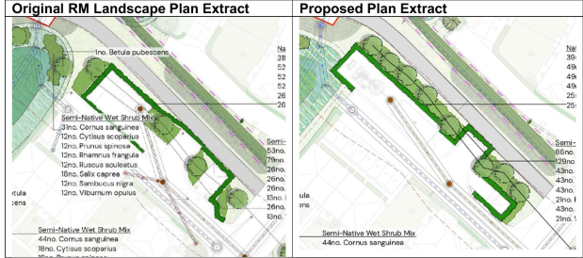
The Councils Drainage Officers have assessed the submitted information and have confirmed that the relocation would not adversely impact the swale.
There were concerns raised by nearby residents during the life of the planning applications regarding the pumping station, predominantly in relation to noise. However, the majority of the pumping station still remains underground (as previously proposed) and it is still approximately 30 metres from the nearest neighbour and as such it is considered that there would be no adverse impact on neighbours in terms of noise.
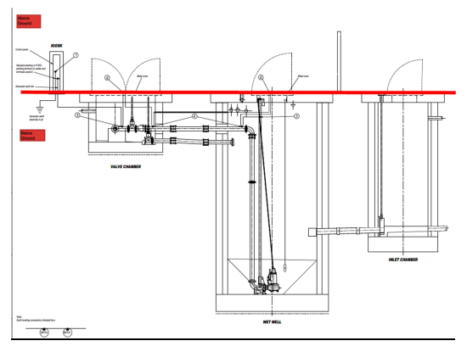

CONCLUSION
In conclusion, based on the assessment, it is recommended that the non-material amendment application be granted.
SUMMARY OF REASONS FOR RECOMMENDATION:
The proposed changes are considered to be minor and non-material in nature for the following reasons:
It is considered that the proposed changes would not impact the developments overall appearance and character and would not materially affect the operation and outcome of the attenuation basin, pumping station and substation and parking to future occupiers.
The changes are considered to be relatively small and proportionate when compared against the original permission and would not require substantial reworking. They would comply with relevant policies. The proposed changes are also considered to maintain the integrity of the original approved development with regards to the original design principles and would ensure that the broad objectives of the planning permission remain intact. As such it is considered that the NMA should be approved.

