APPLICATION FOR HOUSEHOLDER PLANNING PERMISSION
DELEGATED REPORT

APPLICATION REFERENCE: | PL/2025/09904
APPLICATION TYPE: | Householder planning permission
SITE ADDRESS: | 22 Bridge Avenue, Trowbridge, BA14 9SF
DEVELOPMENT DESCRIPTION: | Rear single storey extension.
RECOMMENDATION: | That Planning Permission be GRANTED

PROPOSAL
The proposal seeks planning permission for the construction of a single storey extension on the rear south elevation of the host property.

SITE DESCRIPTION/CONTEXT
The site is a detached residential, two storey brick constructed dwelling, located within an established residential housing estate, within the Principal Town of Trowbridge.

PLANNING HISTORY
2025/09141 Certificate of lawful development for proposed single storey rear extension. Refused.

RELEVANT POLICIES AND GUIDANCE
Wiltshire Core Strategy:

- Core Policy 57 Ensuring High Quality Design and Place Shaping
- Core Policy 50: Biodiversity and Geodiversity
- Core Policy 51: Landscape
- Core Policy 58: Ensuring the Conservation of the Historic Environment
- Core Policy 61: Transport and New Development
- Core Policy 64: Demand Management
- Core Policy 67: Flood Risk

Trowbridge emerging Neighbourhood Plan (Status: Designation of Trowbridge Neighbourhood Area).

Wiltshire Design Guide: Appendix D – Design Guidance for Householder extensions

The National Planning Policy Framework (NPPF)

The Planning Practice Guidance

National Design Guide

Emerging Wiltshire Local Plan:
The emerging Wiltshire Local Plan has reached Regulation 24 stage. The examination is programmed to have more hearing sessions through 2026 and as such, the weight to be attributed to the emerging local plan is very limited at this stage.

CONSULTATION RESPONSES
Trowbridge Town Council: No objection.

Drainage: No objections.

REPRESENTATIONS
No comments received.

ASSESSMENT
Section 38(6) of the Planning and Compulsory Purchase Act 2004 states:

"If regard is to be had to the development plan for the purposes of any determination to be made under the planning Acts, the determination must be made in accordance with the plan unless material considerations indicate otherwise."

In accordance with this statutory requirement, this application has been assessed against the relevant policies of the Development Plan, including the adopted Wiltshire Core Strategy (2015).

Design and Impact upon the upon the character and context of the area

Core Policy 57 - Ensuring High Quality Design and Place Shaping of the Wiltshire Core Strategy seeks to ensure that all new development is of high design quality, reflecting local context, character, and distinctiveness.

The proposals can be viewed within the following plan snippets taken from the submitted plans:

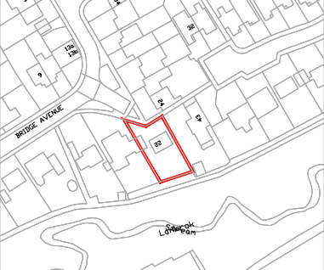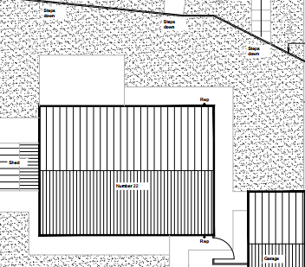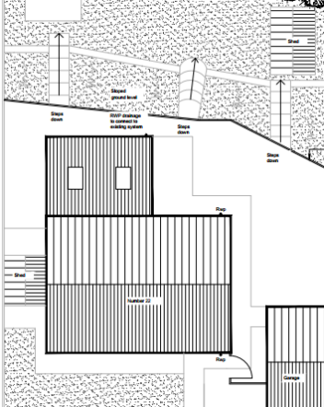
Location Plan Existing Site Plan Proposed Site Plan

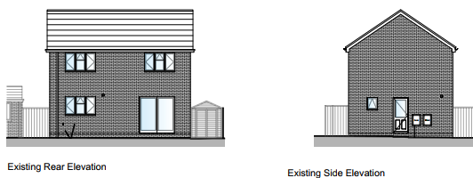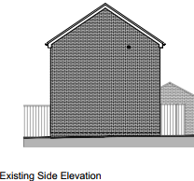
Existing rear & side elevations.

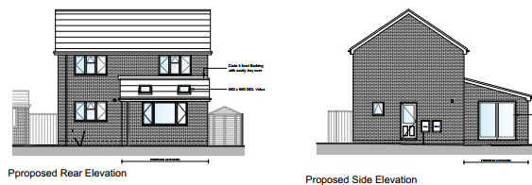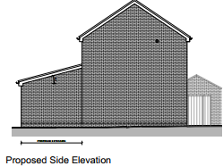
Proposed rear & side elevations.

The proposal would see the construction of a rear ‘lean-to’, single storey extension on the south elevation. The extension would use matching materials and would be utilised as an extended living room, it would have a set of sliding glass doors leading out onto the site’s garden area. The roof height of the proposal would be significantly lower than that of the main house roof and so would be a subservient addition to the principal dwelling.

Therefore, in summary, having regard to the above, the proposal complies with the design principles set out in Core Policy 57 of the Wiltshire Core Strategy and Appendix D of the Wiltshire Design Guide.

Amenity. Point vii. of Core Policy 57 - Ensuring High Quality Design and Place Shaping of the Wiltshire Core Strategy seeks to ensure that developments do not adversely affect neighbouring properties. The National Planning Policy Framework (NPPF), particularly Paragraph 135(f), stresses that planning decisions should ensure developments provide a high standard of amenity for existing and future users.
The existing dwelling shares a boundary with two neighbouring properties, 20 Bridge Avenue to the west and 43 Crawley Avenue to the east. 24 Bridge Avenue lies to the north and is separated by a pedestrian footway and would be unaffected by development to the rear (south) of the host dwelling. The proposed extension would be single storey and would look out onto and face its private rear garden area. Proposed fenestration would consist of side located sliding glass doors and a single rear window on the south elevation, therefore there would not be any overlooking of the neighbouring properties to either side. Likewise, due to the location, orientation and modest size of the proposal, there would not be any significant overshadowing or loss of light to the most immediate neighbour at No.20 Bridge Avenue, or to the rear of No. 43 Crawley Avenue. There have been no third party objections raising issues to the contrary.

The proposal therefore accords with Core Policy 57 point vii. in respect of safeguarding residential amenity and Appendix D of the Wiltshire Design Guide.

Drainage. The site sits 5 metres higher than the nearby land within Flood Zones 2 and 3, meaning the site is not at risk from either fluvial or surface-water flooding. The council’s drainage team have been consulted who raise no objections and comment:

The proposed works are minor in nature and will not result in a significant increase in impermeable area or corresponding flood risk when compared to the existing baseline scenario. As such, we have no objections to this application.

The consultation response has asked that a number of informatives are attached to the decision notice, which are considered wholly reasonable.

Ecology Impact CP50 requires no net loss of biodiversity on site. The site is located within the grey hatched zone of the Trowbridge Westbury Bat Mitigation Strategy Area. The proposed development because of its minor nature and high-density urban location is considered unlikely to result in harm to bats or their habitat. There is no mechanism for significant effects from recreational pressure since it does not result in the creation of a new dwelling. Accordingly, the proposal is acceptable in this regard. As such, the development complies with Core Policy 50 of the Wiltshire Core Strategy and the relevant provisions of the NPPF.

Biodiversity Net Gain. This application is exempt from the requirement to deliver Biodiversity Net Gain under Schedule 7A, Section 4(2)(a) of the Town and Country Planning Act 1990, as inserted by the Environment Act 2021, because the proposal is a householder extension.

CONCLUSION
The proposed development is acceptable in terms of its design, scale, and relationship with the surrounding area. It would not result in any unacceptable harm to the character of the locality, the amenities of neighbouring occupiers, or the interests of highway safety, heritage, or ecology.

The proposal is therefore considered to comply with the relevant policies of the Wiltshire Core Strategy, the Wiltshire Local Plan, and the National Planning Policy Framework. As such, the application is recommended for approval, subject to the conditions set out below.

RECOMMENDATION: Planning Permission be GRANTED subject to conditions.

