APPLICATION FOR HOUSEHOLDER PLANNING PERMISSION
DELEGATED REPORT

APPLICATION REFERENCE: | PL/2026/00191
APPLICATION TYPE: | Householder Planning Permission
SITE ADDRESS: | 1 Tory, Bradford On Avon, BA15 1NN
DEVELOPMENT DESCRIPTION: | Widening of garden steps and extension of seating area
RECOMMENDATION: | That Planning Permission be GRANTED

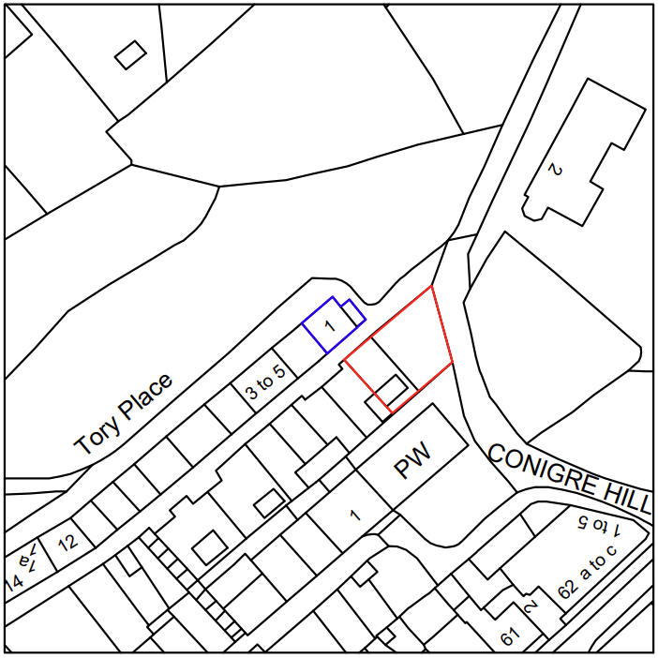

PROPOSAL

The application seeks permission for alterations within a residential garden, including the expansion of an existing stepped seating area. The proposal involves lowering ground levels at the northern end of the site to create a larger, flatter space for seating, finished in pea shingle to match the existing area, with a new dry‑stone retaining wall and a central circular limestone feature. The existing garden steps would be widened using reclaimed pennant slabs and enclosed by a new retaining wall constructed from stone salvaged on site.

SITE DESCRIPTION / CONTEXT

The site comprises a residential garden located within the Bradford on Avon settlement boundary and inside the Bradford on Avon Conservation Area. It sits opposite the applicant’s associated Grade II listed two‑storey end‑of‑terrace dwelling, from which it is separated by Public Right of Way BRAD84. The garden occupies land that falls downhill from north to south, with the higher northern boundary running adjacent and parallel to the public footpath and the listed dwelling. The site is surrounded by a number of designated heritage assets, including the Grade II listed terraces at 1–25 Tory and 1–18 Middle Rank, as well as the Grade II listed Zion Baptist Church. It also lies within several ecological constraint zones, including the GHS 4km SAC Parcel and Core Roost Buffers and the LHS 2km Core Roost Buffer.

The application site is subject to the following planning policy constraints:

- Bradford on Avon Conservation Area (CA/W/31)
- 1-25 Tory – Grade II Listed buildings (1036138)
- 1-18 Middle Rank – Grade II Listed buildings (1364525)
- Zion Babtist Church – Grade II Listed building (1184076)
- GHS 4km SAC Parcel Buffer
- GHS 4km Core Roost Buffer
- LHS 2km Core Roost Buffer
- Site is accessed off a Grade F footway / Public Right of Way (BRAD84)
- Within Bradford on Avon settlement boundary (Market Town)

PLANNING HISTORY

Reference No. | Proposal / Summary | Decision
W/04/00806/LBC | Replacement and installation of additional railings on boundary wall | Approved
W/05/02388/FUL | Take down corner of wall at junction of Conigre Hill and Tory, stabilise and rebuild | Approved
W/04/01507/LBC | Replacement of 5 casement window frames | Approved

RELEVANT LEGILSATION, POLICIES AND GUIDANCE

Wiltshire Core Strategy:

Core Policy 1 Settlement Strategy;
Core Policy 2 Delivery Strategy;
Core Policy 7 Spatial Strategy: Bradford on Avon Community Area;
Core Policy 50 Biodiversity and Geodiversity;
Core Policy 51 Landscape;
Core Policy 57 Ensuring High-Quality Design and Place Shaping;
Core Policy 58 Ensuring Conservation of the Historic Environment;
Core Policy 60 Sustainable Transport;
Core Policy 61 Transport and Development;
Core Policy 64 Demand Management;
Core Policy 67 Flood Risk;

Bradford on Avon Neighbourhood Plan 2013-2026

The National Planning Policy Framework (NPPF)

The Planning Practice Guidance (PPG)

Wiltshire Design Guide - Appendix D – Design Guidance for Householder extensions

Emerging Policy – Wiltshire Local Plan Review

The Council’s emerging Local Plan has reached Regulation 24 stage, and is progressing through examination but the emerging plan carries limited weight at this stage with the hearing sessions currently being paused.

- Policy 1 Settlement Strategy
- Policy 85 Sustainable construction and low carbon energy
- Policy 88 Biodiversity and Geodiversity
- Policy 89 Biodiversity Net Gain
- Policy 95 Flood Risk
- Policy 98 High Quality Design and Place Shaping

CONSULTATION RESPONSES

Bradford on Avon Town Council – No Comment

REPRESENTATIONS

No comments received.

ASSESSMENT

Section 38(6) of the Planning and Compulsory Purchase Act 2004 states:

"If regard is to be had to the development plan for the purposes of any determination to be made under the planning Acts, the determination must be made in accordance with the plan unless material considerations indicate otherwise."

In accordance with this statutory requirement, this application has been assessed against the relevant policies of the Development Plan, including the adopted Wiltshire Core Strategy (2015) and, where applicable, any made Neighbourhood Plans.

Design and Impact upon the upon character, conservation, and heritage
Core Policy 57 of the Wiltshire Core Strategy, supported by emerging Policy 98, requires development to be of high design quality, respecting local character, landscape setting, and the established pattern of materials and built form. Core Policy 58 and emerging Policy 99 set out the requirement for development to conserve the significance and setting of designated heritage assets, including conservation areas and listed buildings. The proposal involves modest landscaping alterations within an existing residential garden, with works limited to changes in surfacing, retaining structures, and the widening of steps. All proposed materials are consistent with those already present on site, including reclaimed pennant stone and drystone walling, ensuring the design responds positively to the existing palette and character of the garden and the wider area.

Although situated within the Bradford on Avon Conservation Area and in close proximity to several Grade II listed buildings, the garden is visually well contained due to its steep, north–south incline and its enclosed boundaries. During the site visit, it was noted that views into the garden are largely screened from the public realm, with only brief passing visibility available at the gated northern boundary. The limited scale of the works, together with their sympathetic material treatment, ensures that the proposal does not alter the character or setting of the conservation area or neighbouring listed buildings. The development is therefore considered to accord with the design and heritage requirements of Core Policies 57 and 58, emerging Policies 98 and 99, and the guidance set out within the Wiltshire Design Guide.

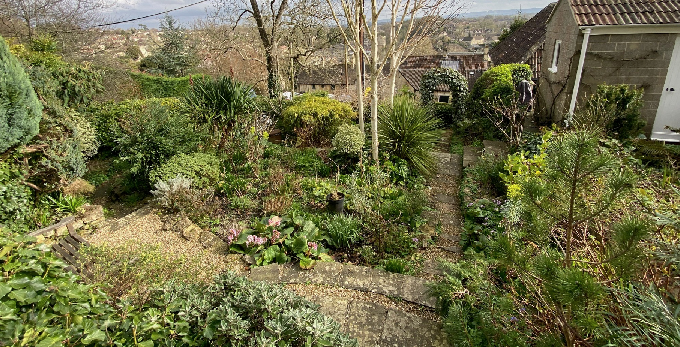
Site Visit Image

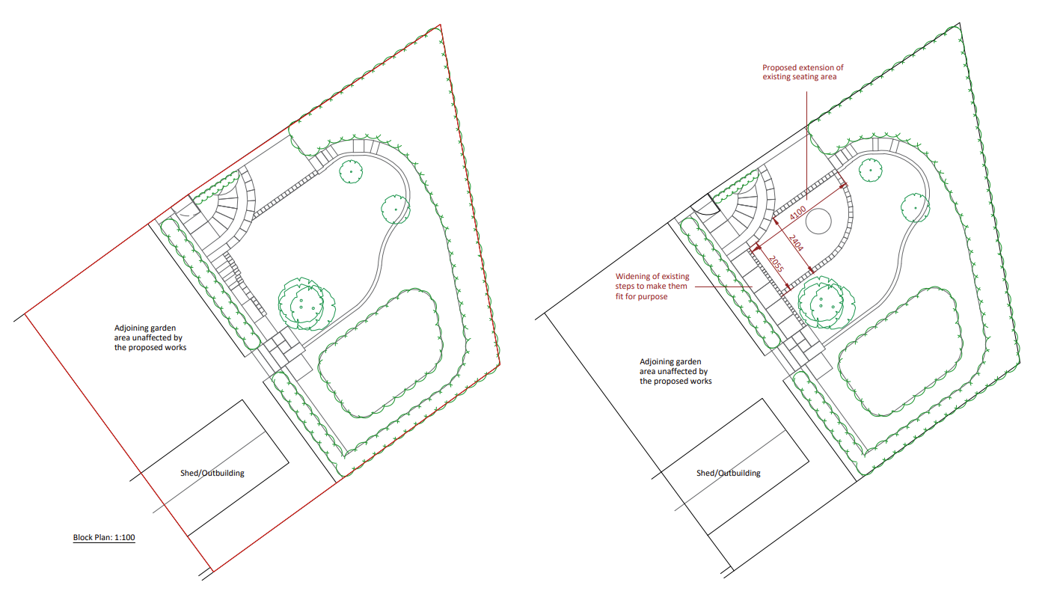
Existing and Proposed Site Plan

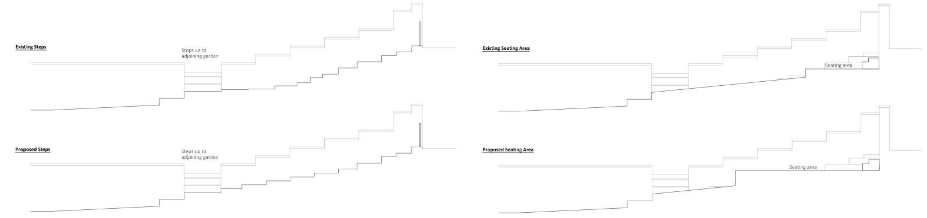
Existing and Proposed Site Sections

Amenity
Point vii of Core Policy 57 Ensuring High Quality Design and Place Shaping of the Wiltshire Core Strategy seeks to ensure that developments do not adversely affect neighbouring properties.

The National Planning Policy Framework (NPPF), particularly Paragraph 135, stresses that planning decisions should ensure developments provide a high standard of amenity for existing and future users.

Given the limited scope of the works, which relate solely to landscaping and alterations to an existing garden area, the proposal is not considered to give rise to any material impacts on residential amenity. The development would not introduce additional built form, levels of activity, or overlooking, and therefore would not adversely affect neighbouring occupants in terms of privacy, outlook, noise, or disturbance. As such, the proposal is regarded as compliant with the amenity requirements of Policy 57 of the Wiltshire Core Strategy.

Other Issues
The proposal concerns landscaping and design alterations within an established residential garden, with the new areas of hardstanding largely comprising permeable materials. Core Policy 67 of the Wiltshire Core Strategy and Policy 95 of the emerging Wiltshire Local Plan require new development to manage surface water appropriately and, where relevant, to incorporate sustainable drainage measures. Paragraph 172 of the NPPF sets out a sequential, risk-based approach to development and flood risk; however, the site lies within Flood Zone 1 and is not identified as being at risk from surface water or groundwater flooding within the Council’s Strategic Flood Risk Assessment. Given the limited scale and nature of the works, and the use of permeable surfacing, the proposal is not considered likely to increase flood risk or conflict with relevant policy requirements.

The application only concerns alterations to the garden and does not include any alteration to the existing parking and access arrangements for the property. It is therefore considered that there is no highway or transportation concerns present with the proposal, and it is otherwise considered acceptable.

Core Policy 50 of the Wiltshire Core Strategy requires development to avoid and reduce disturbance to sensitive species and habitats, while Biodiversity Net Gain (BNG) is a statutory consideration under Schedule 7A of the Town and Country Planning Act 1990 as amended, although householder applications are exempt from the requirement to deliver BNG. Emerging Policy 88 similarly requires proposals to apply the mitigation hierarchy and protect features of ecological value. The current proposal involves limited landscaping works within an established domestic garden and would not affect buildings, trees, roost features, or habitats typically associated with protected species. Although the site lies within strategic ecological buffer zones relating to designated bat sites, the nature and scale of the works are not considered likely to cause ecological disturbance, and no external lighting or activities that could disrupt foraging or commuting routes are proposed. The development is therefore regarded as compliant with Core Policy 50 and emerging Policy 88, with no further ecological mitigation or assessment required.

CONCLUSION

The proposal is considered to be acceptable and in accordance with the relevant policies and guidance outlined above.

RECOMMENDATION: That Planning Permission be GRANTED subject to the following conditions:

1.
The development hereby permitted shall be begun before the expiration of three years from the date of this permission.

REASON: To comply with the provisions of Section 91 of the Town and Country Planning Act 1990 as amended by the Planning and Compulsory Purchase Act 2004.

2.
The development hereby permitted shall be carried out in accordance with the following approved plans and documents:

Proposed Block Plan 2501202 (12 January 2026)
Location and Existing Block Plan (12 January 2026)
Proposed Layout Plan 2501204 (12 January 2026)
Existing and Proposed Section 2501205 (12 January 2026)

REASON: For the avoidance of doubt and in the interests of proper planning.

