APPLICATION FOR FULL-PLANNING PERMISSION
CASE OFFICER REPORT

APPLICATION REFERENCE: | PL/2025/08799
APPLICATION TYPE: | Full planning permission
SITE ADDRESS: | Paddock behind Hookside (Graystone Paddock), BA13 4NZ
DEVELOPMENT DESCRIPTION: | Proposed Access Track (Retrospective)
RECOMMENDATION: | Approve with Conditions

SITE DESCRIPTION/CONTEXT

The application site comprises a paddock located to the north of Colston, positioned within open countryside. The land sits to the rear of the property known as Hookside and is accessed via a pedestrian gate from the lane that runs along the site’s eastern boundary. From this point, the access route follows the southern hedge line and leads to a small paddock area at the western end of the site. The land accommodates a mobile field shelter and is currently used for grazing ponies. The surrounding area is characterised by open countryside and agricultural fields, interspersed with occasional farmsteads and residential properties. Other than its designation as Grade 4 agricultural land and lying within the Salisbury Plain SPA (6.4km buffer zone) the site does not contain any notable constraints.

PROPOSAL

The application is being made under Section 73A of the Town and Country Planning Act 1990, for retrospective planning permission for the laying of a stone track through the site.

The application specifically only requests approval for the laying of the stone on top of a track that had already been formed. The stone track takes access from the lane, as noted above, it follows the hedge line to the far end of the field where the track then extends around the perimeter of the small paddock. The track is formed of loose stone along the access path and then compacted stone around the paddock. No other works are being applied for retrospectively in this instance.

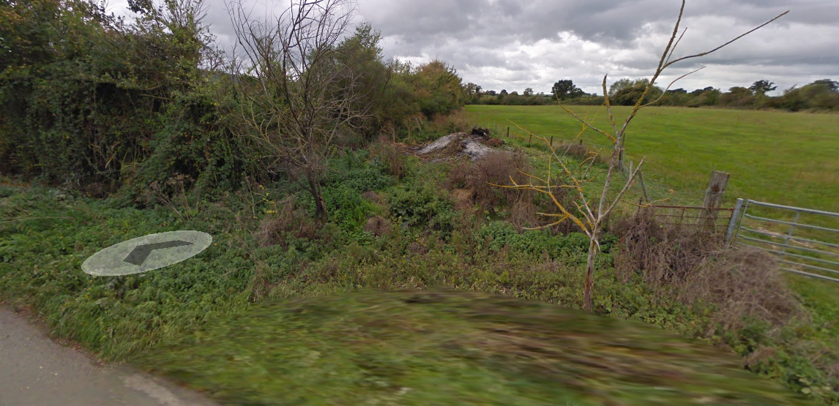
Google Street View Image Oct 2011
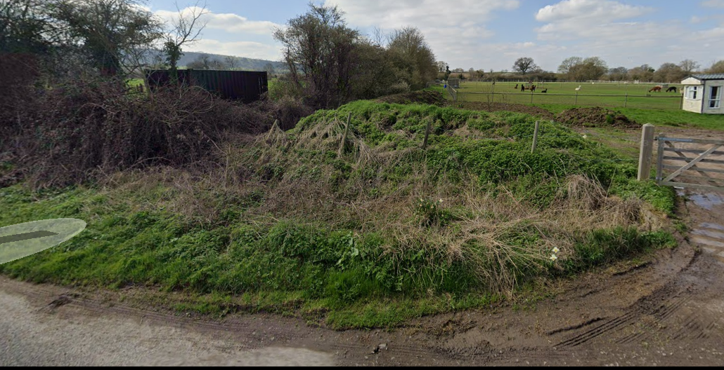
Google Street View Image April 2023

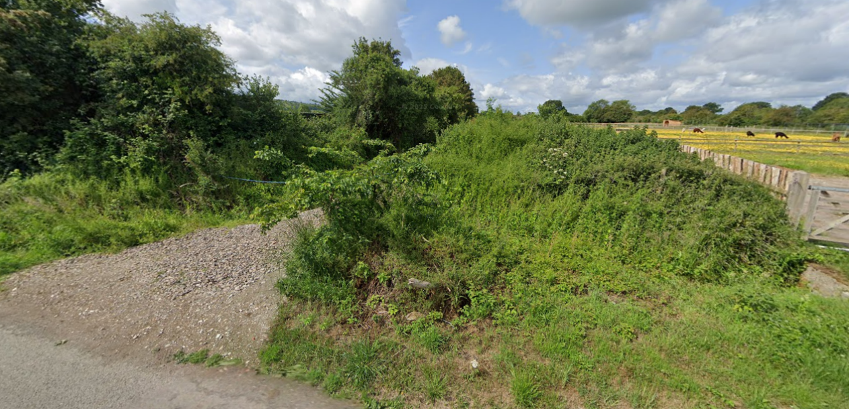
Google Street View June 2025
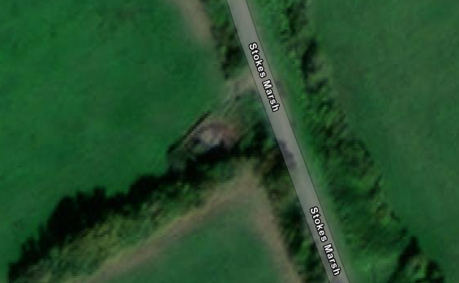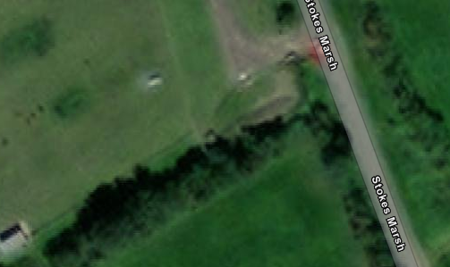

Areial Image 2020 Areial Image 2021

PLANNING HISTORY

Proposal / Summary
20/02756/FUL - Full planning permission Decision - Allowed Date: 7/8/2023 – Retrospective application for the siting of a temporary rural workers dwelling and associated works including erection of kennels and haystore and formation of hardsurface for access and parking.
PL/2022/01917 - Non-Material Amendment Decision - Approve Date: 11/4/2022 – Non-Material Amendment to application 20/02756/FUL (allowed on appeal under APP/Y3940/W/21/3270044) pursuant to replacing the single-unit caravan (allowed on appeal) with a twin unit caravan with dog kennel
PL/2022/01921 - Approval of details reserved by a condition Decision - Refuse Date: 11/4/2022 – Discharge of conditions imposed by allowed appeal ref APP/Y3940/W/21/3270044 relating to the hay store/ workshop and generator (conditions 2 and 3 as cited on the appeal decision)
PL/2023/02459 - Prior notification: Building Decision - Withdrawn by Applicant Date: 6/4/2023 – Proposed agricultural building to store fleece from livestock
PL/2023/02460 - Full planning permission Decision - Approve with Conditions Date: 21/12/2023 – Breeding Kennel, Isolation Kennel & Agricultural Building.
PL/2025/06703 - Full planning permission – Retention of a temporary rural workers dwelling for a further temporary period.

RELEVANT LEGISLATION, POLICIES AND GUIDANCE

Statutory Legislation:

Town and Country Planning Act 1990

National Planning Policy:
- National Planning Policy Framework (NPPF)
- Planning Practice Guidance (PPG)
- National Design Guide
Development Plan:
The development plan for Wiltshire comprises the Wiltshire Core Strategy (WCS) (adopted January 2015) and any made neighbourhood plans, which remains the principal statutory planning document guiding development across the county. In line with Section 38(6) of the Planning and Compulsory Purchase Act 2004, planning decisions must be made in accordance with the development plan unless material considerations indicate otherwise.

Though the development plan is considered as a whole, those parts deemed to be particularly relevant to this application are listed below:

The adopted Wiltshire Core Strategy (WCS), with particular regard to:

- Core Policy 1 Settlement Strategy;
- Core Policy 2 Delivery Strategy;
- Core Policy 12 Spatial Strategy for the Devizes Community Area
- Core Policy 50 Biodiversity and Geodiversity;
- Core Policy 51 Landscape
- Core Policy 57 Ensuring High Quality Design and Place Shaping;
- Core Policy 60 Sustainable Transport;
- Core Policy 64 Demand Management

Draft Wiltshire Local Plan Policies

- Policy 1: Settlement Strategy
- Policy 2: Delivery Strategy
- Policies 64 – 75: Economic, tourism, retail and transport
- Policies 76 – 84: Social, housing, community, public open space and wellbeing
- Policies 85 – 101: Sustainability, ecology, water and landscape, heritage, air quality

Supplementary Planning Documents and other Guidance:
- Wiltshire Design Guide (adopted April 2024)
- Wiltshire Local Transport Plan 2011-2026, adopted 2015 - including the Car Parking Strategy and Cycling Strategy, adopted 2015

ISSUES

The main issues that need to be addressed in this case include:

- Whether the development is acceptable in principle (CP 1 and 2)
- Whether the scheme constitutes high quality design (CP 57)
- Whether the scheme would have an acceptable impact upon the reasonable living conditions of the adjoining occupants (CP 57)
- Whether the scheme would have an acceptable landscape impact (CP 51)
- Whether the proposal would have a negative effect upon highway safety, including if there is sufficient parking for the proposed development (CP 61 and 64)
- Whether there would be any harmful impacts upon protected species or priority habitats (CP 50)

CONSULTATION RESPONSES

WC Highways: Initial response – No objections subject to conditions. However, the response assessed the access as vehicular which is not the case and so further informal discussions were had to establish whether any parking provision would be required at the site. Subsequently the highway officer updated their comments, the result remained as no objections subject to a condition securing the control of private water onto the highway. The comments will be summarised in the relevant section of the assessment below.

WC Ecology: No objection subject to conditions. Comments summarised within assessment section of this report.

Coulston Parish Council: No comments received.

REPRESENTATIONS
In accordance with the requirements of the Town and Country Planning (Development Management Procedure) (England) Order 2015 (as amended), the application was publicised by way of:

- Neighbour notification letters sent to adjoining and nearby properties;
- A site notice displayed near the site.

These methods were used to inform interested parties and provide a period of 21 days for comments to be submitted.

Below is a summary of the representations received during the consultation period. Only material planning considerations have been taken into account in the assessment of this application. Non-material issues, such as property values or private legal disputes, cannot be considered in the determination process.
A total of 5 public representations were received, comprising both objections and expressions of support. The material planning considerations raised are summarised below:
Objections

1. Damage to highway verge and requests for reinstatement
Representations state that prolonged vehicle use and parking associated with the formation and use of the access(es) has resulted in notable damage to the grass verge opposite the site. Photographs were submitted to evidence this, and a request is made for a condition requiring full reinstatement of the verge should planning permission be granted.

2. Creation and alteration of access points / impact on roadside environment
Objectors report that what was originally a single access has been subdivided into two, allegedly involving removal of hedging and installation of drainage pipework, with the formation of a bank between the two entrances. Concerns relate to highway impact, the alteration of established boundaries, and the effect on the rural roadside character.

Support

1. Improved functional access to the land
Supporters state that the stone track has significantly improved access to the paddock, particularly during winter when the land had previously become extremely muddy and hazardous. While animal welfare itself is not a determinative planning consideration, improved functional access to land in equine/agricultural use is capable of being afforded limited weight.

2. Benefits to land management and site condition
Representations in support indicate that the defined access route helps maintain a tidier and more stable surface, potentially reducing informal verge parking and improving day-to-day land management.

ASSESSMENT
Section 38(6) of the Planning and Compulsory Purchase Act 2004 states:

"If regard is to be had to the development plan for the purposes of any determination to be made under the planning Acts, the determination must be made in accordance with the plan unless material considerations indicate otherwise."

In accordance with this statutory requirement, this application has been assessed against the relevant policies of the Development Plan, including the Wiltshire Core Strategy (2015) and, where applicable, any made Neighbourhood Plans. Consideration has also been given to the policies of the National Planning Policy Framework (NPPF) as a material consideration in the assessment.

Principle of Development
Policy Context
Core Policy 1: Settlement Strategy of the WCS establishes a hierarchy of settlements to guide where development should be focused. The policy prioritises growth in:
- Principal Settlements (e.g., Salisbury, Chippenham, Trowbridge) – main focus for strategic growth.
- Market Towns – support local services and employment; suitable for sustainable development.
- Local Service Centres – smaller towns and villages with a range of services; limited development supported.
- Large and Small Villages – development should be limited and respond to local needs.
- Outside the defined settlements – development is strictly controlled and generally not supported unless exceptional circumstances apply.
.
Core Policy 2: Delivery Strategy of the WCS sets out how development will be distributed and delivered across Wiltshire. The policy emphasises:
- Sustainable patterns of growth, reducing the need to travel and supporting local services.
- Development should be plan-led, aligning with the settlement strategy and supported by infrastructure.
- Windfall development (not allocated in plans) must still comply with the principles of sustainable development.
- Development outside settlement boundaries is generally not permitted, unless it meets specific policy exceptions (as set out in paragraph 4.25 of the WCS).

Together, CP1 and CP2 ensure that new development is strategically located, sustainable, and supports the character and function of Wiltshire’s communities.

Assessment

The laying of a loose‑stone track across agricultural land might, in some circumstances, have been considered under agricultural permitted development rights via the prior approval process. However, as the works have already been carried out, permitted development cannot apply retrospectively, and the proposal must therefore be assessed as a full planning application.

In terms of the principle of development, the proposal does not involve any change of use, and the land retains its established agricultural function as a paddock within the open countryside. The formation of an access track to support the efficient use and management of agricultural land is broadly compatible with the rural character of the area and, in this instance, raises no in‑principle concerns under Core Policies 1 and 2 of the Wiltshire Core Strategy, provided the development accords with other relevant plan policies.

The remainder of this report therefore considers the key material matters arising, including landscape and visual impact, highways considerations, ecological implications, and any other relevant issues.

Conclusion

In summary, the proposal is acceptable in principle, subject to compliance with all other applicable development plan policies.

Design and Impact on the Landscape Character and Appearance of the Area
Policy Context
Core Policy 57 of the WCS requires high-quality design that:
- Enhances local character.
- Responds to the natural, historic, and built environment.
- Retains important features (e.g., trees, hedges).
- Supports sustainable construction and compatibility with surrounding uses.
- Creates safe, legible, and accessible spaces.

Core Policy 51 of the Wiltshire Core Strategy requires development to:
- Protect, conserve, and enhance landscape character and quality.
- Respect local distinctiveness, key views, and visual receptors.
- Give particular weight to impacts on National Landscapes (formerly AONBs) and locally valued landscapes.

Section 12 of the NPPF emphasises design that is:
- Visually attractive.
- Functionally effective.
- Contributes to the quality of the built environment.

The Wiltshire Design Guide encourages sensitivity to local character, materials, and architectural styles and supports modern living standards while maintaining aesthetic and functional quality.

Assessment

The loose‑stone track itself raises no significant concerns in design terms. Representations have referred to the manner in which the “track” was formed, and accompanying photographs show evidence of operational development, including mechanical excavation, earth movement, the creation of a bund, and the laying of a pipe within the existing roadside ditch beneath the access point. However, a review of historic satellite and Google Street View imagery confirms that the bund was formed some years ago, between 2020 and 2021, and lies outside the application site.

On this basis, the Local Planning Authority considers that the current application does not seek permission for the formation of the access or the bund, but solely for the laying of loose stone over the gap between the existing bund and hedgerow in order to formalise a pedestrian route leading to the applicant’s paddock. While land ownership itself is not a material planning consideration, it is noted that the access and track lie outside the applicant’s ownership; nevertheless, the applicant benefits from a right of access and has notified the relevant landowner, with the correct ownership certificates submitted. This confirms the scope of the proposal and establishes that any historic formation of the access or bund falls outside this application. Matters relating to those works are therefore for the planning enforcement team to pursue separately with the landowner should this be necessary.

Notwithstanding these background issues, the case officer is satisfied that no hedgerow has been removed as part of the recent works (although it is accepted that some cutting back and general husbandry was carried out at that time for which planning permission is not required). Instead, a narrow strip of scrub and bramble appears to have been cleared to re‑establish a previously formed pedestrian access. From a design perspective, this represents a minimal intervention and does not materially alter the rural character of the lane. The laying of loose stone along the access/track and around the paddock is typical of the informal agricultural and equestrian entrances commonly found in this countryside setting and integrates appropriately with the pattern of development in the locality.

Given the limited scale and low‑level nature of the works, their impact on the landscape character of the area and on wider views is considered negligible.

Conclusion

In conclusion, the development is judged to accord with Core Policies 51 and 57 of the Wiltshire Core Strategy.

Amenity
Policy Context
Core Policy 57 (Point vii) of the Wiltshire Core Strategy requires development to respect the amenity of existing occupants and ensure appropriate amenity levels for future residents.

The National Planning Policy Framework (NPPF), particularly Paragraph 135, reinforces the need for development to provide a high standard of amenity for both existing and future users.

The nature and scale of the works are modest, comprising only the resurfacing of an existing access with loose stone, and do not introduce any built form, activity, or illumination that would materially affect the living conditions of neighbouring occupiers. The track serves an established paddock in the open countryside, and its use is consistent with the longstanding agricultural character of the area. As such, the proposal is not considered to give rise to any adverse impacts in terms of noise, disturbance, privacy, or overbearing effects, and would therefore not result in harm to neighbour amenity.

Highways Impacts and Parking
Policy Context
Transport implications are a key factor in assessing planning applications, especially for larger developments. Proposals must demonstrate:
- Safe and suitable access for all users, including pedestrians, cyclists, and those with mobility impairments.
- No severe residual impacts on the surrounding highway network.
- Promotion of sustainable travel, reducing reliance on private vehicles.
- Adequate parking and cycle provision, in line with adopted standards.
- Protection and enhancement of public rights of way and active travel routes.

Relevant policies include Core Policies 60–64 of the Wiltshire Core Strategy, supported by the Wiltshire Local Transport Plan, Car Parking Strategy, and Cycling Strategy. The Local Cycling and Walking Infrastructure Plan (LCWIP) and LTN 1/20 (DfT) provide further design guidance for active travel infrastructure.

Proposals must also ensure safe access for refuse collection vehicles and comply with the Wiltshire Council Waste Storage and Collection SPD (2017).

Where necessary, Transport Assessments or Statements should be submitted to evaluate impacts and identify mitigation. Planning conditions or legal agreements may be used to secure off-site improvements, travel plans, or contributions to sustainable transport infrastructure.

Assessment

The Highway Authority initially raised concern regarding the clarity of the submitted plans, noting the absence of details relating to any potential vehicular access onto Stokes Marsh Lane. However, it was confirmed that the proposal relates solely to a pedestrian access and track, with no vehicular access or on‑site parking provision. While the Authority acknowledges ongoing verge damage in the vicinity, this is considered a separate issue outside the scope of the current application and will be referred to the Area Highways Office for monitoring. As the development does not introduce a new vehicular access, the usual requirements for consolidated surfacing and visibility splays etc do not apply. Subject to a condition requiring measures to prevent private water from discharging onto the public highway, the Highway Authority raises no objection to the proposal. With regard to the proposed condition, the Case Officer is of the view that due to the loose and permeable nature of the works, there would be no increase to surface water run off in this instance and as such this condition would not be reasonable or necessary to the application.

Although the applicant resides a short distance from the paddock and generally visits the site on foot, it is recognised that occasional vehicular visits will still be required, for example for veterinary call‑outs, farrier visits, feed deliveries or other essential access needs. In these circumstances, verge side parking is not an appropriate or sustainable arrangement, however it is also acknowledged that the verge damage in this location cannot solely be attributed to activity associated with the paddock as the lane is regularly used by larger agricultural and commercial vehicles, which further contributes to erosion of the roadside edges, particularly in the winter months. While roadside parking cannot be restricted in this location, the matter has been highlighted to the Area Highways Office, who will continue to monitor conditions.

Given the above, it is considered that occasional visitors would be entitled to park on the roadside, or, where necessary, pull slightly onto the pedestrian access at its junction with the highway, as this area is sufficiently wide to accommodate a vehicle without causing obstruction or inconvenience to other users of the lane.

Conclusion

Overall, the proposal is not considered to give rise to any highway safety concerns, and the Highway Authority raises no objection to the development.

Ecology and Biodiversity
Policy Context
The ecological impact of development is a key planning consideration, especially for larger schemes. Proposals must assess and address potential effects on:

- Protected species
- Priority habitats
- Ecological networks
- Green and blue infrastructure

Core Policy 50 of the Wiltshire Core Strategy requires development to:

- Avoid harm to ecological assets.
- Deliver measurable Biodiversity Net Gain (BNG), in line with the Environment Act 2021.
- Support habitat restoration and connectivity.
- Integrate biodiversity into site design.

The Green & Blue Infrastructure Strategy (2022–2030) promotes nature recovery, ecosystem services, and habitat connectivity through development.

Unless exempt, National policy requires a minimum of 10% Biodiversity Net Gain (BNG) for major developments, demonstrated via:

- Biodiversity Metric calculations
- Ecological assessments (e.g. PEAs, Phase 1 surveys, protected species surveys)

Assessment

The Council’s Ecologist has reviewed the proposal and raises no objection, subject to conditions. It is confirmed that mandatory Biodiversity Net Gain does not apply in this case, as the application is retrospective and therefore does not trigger the statutory pre‑commencement BNG requirement.

No ecological constraints were identified that would prevent the development from proceeding; however, a condition is recommended to ensure that any external lighting within the site is subject to prior approval, demonstrating compliance with ILP guidance and avoiding illumination of wildlife habitat. With these safeguards in place, all ecological matters are considered satisfactorily addressed.

Conclusion

Accordingly, the proposal is considered to comply with Core Policy 50 of the Wiltshire Core Strategy, as no unacceptable ecological impacts have been identified and appropriate safeguards can be secured by condition.

PLANNING BALANCE AND CONCLUSION
At the heart of the NPPF there is a presumption in favour of sustainable development requiring local planning authorities to approve development proposals that accord with an up-to-date development plan without delay; and where there are no relevant development plan policies, or the policies which are most important for determining the application are out-of-date, permission should be granted unless (taken from paragraph 11d of the NPPF):

- The application of policies in the NPPF that protect areas or assets of particular importance provides a clear reason for refusing development proposed; or
- any adverse impacts of doing so would significantly and demonstrably outweigh the benefits, when assessed against the policies in the NPPF taken as a whole.

The principle of development is considered acceptable when assessed against the settlement strategy of the Wiltshire Core Strategy and the emerging Local Plan.

The proposal is broadly compliant with relevant local and national planning policies in respect of design, scale, residential amenity, landscape, highway safety and ecology and biodiversity, subject to the recommended conditions.

Accordingly, the proposal is considered acceptable in planning terms and in accordance with the Wiltshire Core Strategy, the National Planning Policy Framework, and all other relevant material considerations.

RECOMMENDATION:
That Planning Permission be GRANTED, subject to conditions.

