APPLICATION FOR HOUSEHOLDER PLANNING PERMISSION
DELEGATED REPORT

APPLICATION REFERENCE: | PL/2025/09770
APPLICATION TYPE: | Householder planning permission
SITE ADDRESS: | The Beech House, Townsend, Pitton, Salisbury , SP5 1DH
DEVELOPMENT DESCRIPTION: | Installation of solar panels to the dwelling and garage roof. Hybrid Inverter and battery storage to be installed in garage
RECOMMENDATION: | That Planning Permission be GRANTED

PROPOSAL

The proposal seeks planning permission for the installation of solar panels on the south, east and west roof slopes of the existing dwelling. It is proposed that the invertor and battery storage are located within the existing garage.

Revised drawings were received 24.02.2026 removing solar panels from the roof of the garage.

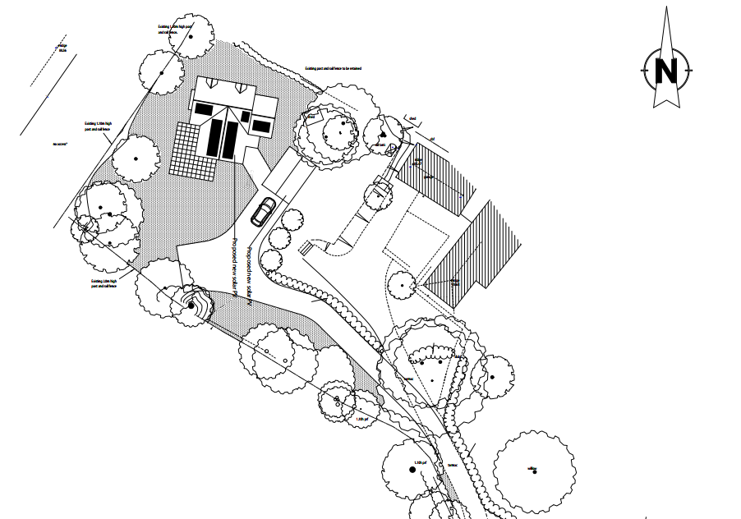

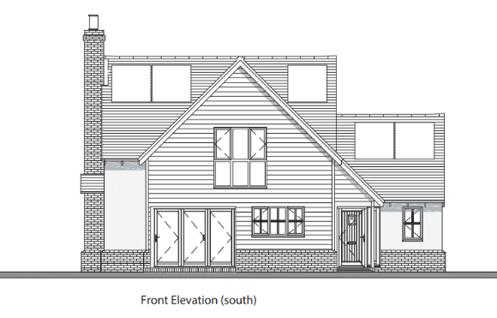
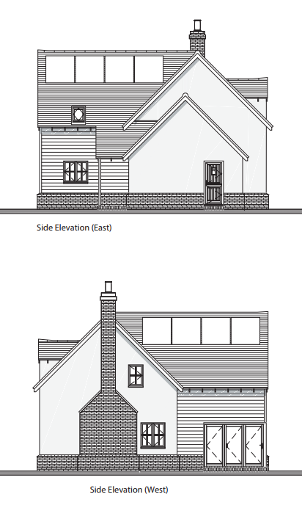

SITE DESCRIPTION/CONTEXT

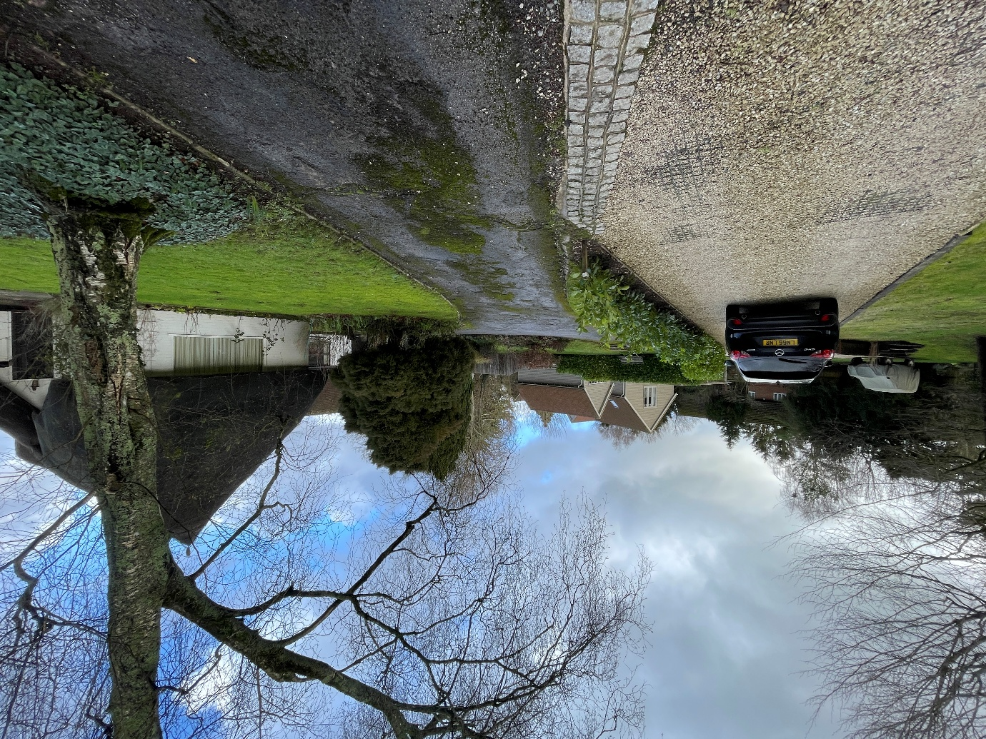
The application relates to The Beech House, a modern detached house with detached garage permitted as PL/07103/FUL, located on land to the rear of Willow Cottage, within the large village of Pitton, as defined by Wiltshire Core Strategy (WCS) core policies 1 (Settlement Strategy), 2 (Delivery Strategy) and 23 (Spatial Strategy for the Southern Wiltshire Community Area).

The site is within the Pitton Conservation Area and on land that historically formed the garden of Grade II Listed ‘Willow Cottage’. Grade II* listed ‘Church of St Peter’ lies to the south of the site.

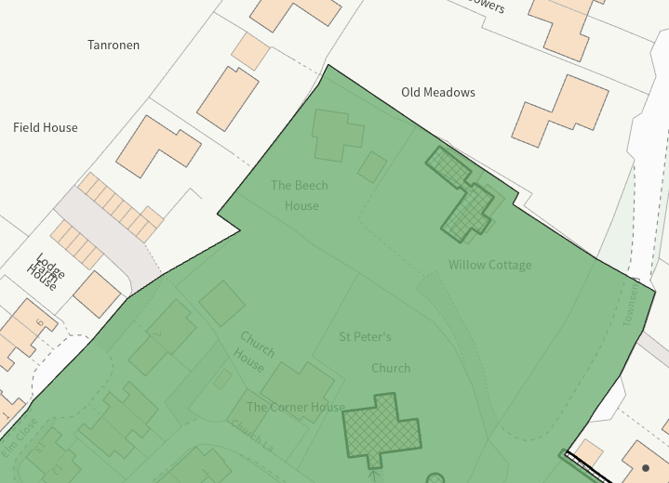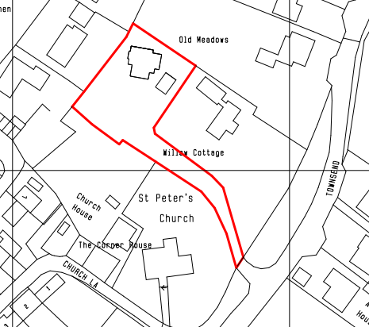

PLANNING HISTORY

Proposal / Summary
PL/2022/02780 - Householder planning permission Decision - Approve with Conditions Date: – Mounting solar Panels to the roof of the house and Garage.
19/07103/FUL - Full planning permission Decision - Approve with Conditions Date: 24/10/2019 – Construction of a new 3 bedroom detached dwelling with detached garage.
20/00052/DOC - Approval of details reserved by a condition Decision - Approved Date: 21/2/2020 – Discharge of condition 7 of planning application 19/07103/FUL (Construction of a new 3 bedroom detached dwelling with detached garage)
20/02188/DOC - Approval of details reserved by a condition Decision - Approved Date: 9/4/2020 – Discharge of condition 3, application reference 19/07103/FUL.

RELEVANT POLICIES AND GUIDANCE

Wiltshire Core Strategy:
- Core Policy 41: Sustainable Construction and low carbon energy
- Core Policy 57 Ensuring High Quality Design and Place Shaping
- Core Policy 58: Ensuring the Conservation of the Historic Environment

Wiltshire Design Guide: Appendix D – Design Guidance for Householder extensions

Section 72 of the Planning (Listed Buildings and Conservation Areas) Act 1990
The National Planning Policy Framework (NPPF)

The Planning Practice Guidance

National Design Guide

CONSULTATION RESPONSES

Pitton and Farley Parish Council: No objection

REPRESENTATIONS

No comments were received.

ASSESSMENT

Section 38(6) of the Planning and Compulsory Purchase Act 2004 states:

"If regard is to be had to the development plan for the purposes of any determination to be made under the planning Acts, the determination must be made in accordance with the plan unless material considerations indicate otherwise."

In accordance with this statutory requirement, this application has been assessed against the relevant policies of the Development Plan, including the adopted Wiltshire Core Strategy (2015) and, where applicable, any made Neighbourhood Plans.

Design and Impact upon the character and context of the Conservation Area
Core Policy 57 - Ensuring High Quality Design and Place Shaping of the Wiltshire Core Strategy seeks to ensure that all new development is of high design quality, reflecting local context, character, and distinctiveness.

From the point of view of the historic environment the main statutory tests are set out within the Planning (Listed Building and Conservation Areas) Act 1990.

Section 72(1) of the Act requires the Council to pay special attention to the desirability of preserving or enhancing the character or appearance of designated Conservation Areas.

The Council’s Core Strategy Policy CP58 ‘Ensuring the conservation of the historic environment’ requires that designated and non-designated heritage assets and their settings will be conserved, and where appropriate enhanced, in a manner appropriate to their significance and encourages proposals which improve the condition of heritage assets at risk.

The NPPF outlines government policy for planning. Chapter 16 of the NPPF 'Conserving and enhancing the historic environment' sets out the Government's high-level policies concerning heritage and sustainable development.

Core Policy 41: sustainable construction and low-carbon energy encourages retrofitting measures to improve the energy performance of existing buildings. In relation to buildings within conservation areas proposals “should ensure that appropriate sensitive approaches and materials are used.”

The Beech House in within the Pitton Conservation Area and on land that historically formed the garden of Grade II Listed ‘Willow Cottage’. Grade II* listed ‘Church of St Peter’ lies to the south of the site.

The application is seeking planning permission for the installation of 5 banks of solar PV panels on the roof of the existing dwelling. The panels would be located on the south, east and west facing roof slopes of the two storey and single storey roofs.

It is noted that planning consent for solar PV panels was granted under PL/2022/02780, this permission included three banks of solar PV and has now lapsed.

Approved site plan from PL/2022/02780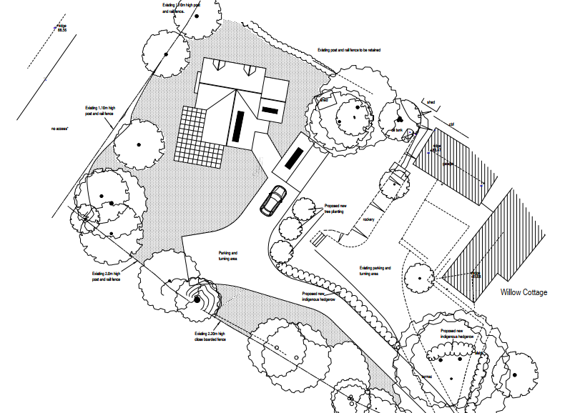

The Beech House is in a relatively secluded location, on land to the rear of Willow Cottage, via a shared driveway, set back from the road. There are a number of mature trees and hedges along the northwest and southwest boundaries that limit views of the site (particularly from the Church of St Peter).

During the determination period, PV panels proposed on the south east facing roof of the detached garage were omitted as this roof slope is highly visible from listed ‘Willow Cottage’, the public realm and conservation area.

The proposed panels on the main dwelling would be modest in scale and will be mostly screened by the position and orientation of the dwelling within the site and trees/planting. It is not unusual to see PV panels on this type of modern residential development and the proposed panels on the west and south west roof slopes would be compliant with GDPO Part 14, Class A – Installation or alteration etc of solar equipment on domestic properties which would be considered as a fallback position.

The setting or significance of the adjacent listed church and adjacent listed dwelling would remain unaffected, as there is limited intervisibility between the proposal site, the listed house, and the listed church.

The submitted information confirms that the panels would be matt black with anti-reflective coating: ‘INFINITY RT N-type mono facial module with double glass’, this is considered appropriate within the setting of the conservation area. The siting of the PV panels on the roof complies with the conditions of the GDPO Part 14, Class A.2.

It is therefore considered that the proposed development would have a neutral impact upon the character and appearance of this part of the conservation area.

The development is therefore considered to comply with Core Policy 57 and 58 of the Wiltshire Core Strategy and Sections 72 of the Planning (Listed Buildings and Conservation Areas) Act 1990, as well as the relevant provisions of the NPPF.

Amenity

Point vii of Core Policy 57 - Ensuring High Quality Design and Place Shaping of the Wiltshire Core Strategy seeks to ensure that developments do not adversely affect neighbouring properties.

The National Planning Policy Framework (NPPF), particularly Paragraph 135(f), stresses that planning decisions should ensure developments provide a high standard of amenity for existing and future users.

The proposed development has been assessed in terms of its potential impact on the residential amenity of neighbouring properties, with particular regard to loss of light, overshadowing, loss of privacy, and overbearing effects.

By virtue of the proposal’s nature as a PV array and battery, there are no concerns raised regarding loss of amenity to neighbouring properties.
The proposal therefore accords with Core Policy 57 point vii in respect of safeguarding residential amenity and Appendix D of the Wiltshire Design Guide.

Biodiversity Net Gain

Householder planning applications are exempt from the requirement to deliver Biodiversity Net Gain under Schedule 7A, Section 4(2)(a) of the Town and Country Planning Act 1990, as inserted by the Environment Act 2021.

CONCLUSION

The proposed development is considered to be acceptable in terms of its design, scale, and relationship with the surrounding area. It would not result in any unacceptable harm to the character of the locality, the amenities of neighbouring occupiers, or the interests of highway safety, heritage, or ecology.

The proposal is therefore considered to comply with the relevant policies of the Wiltshire Core Strategy, the Wiltshire Local Plan, and the National Planning Policy Framework. As such, the application is recommended for approval, subject to the conditions set out below.

RECOMMENDATION: That Planning Permission be GRANTED subject to conditions.

- The development hereby permitted shall be begun before the expiration of three
years from the date of this permission.
REASON: To comply with the provisions of Section 91 of the Town and Country
Planning Act 1990 as amended by the Planning and Compulsory Purchase Act
2004.

- The development hereby permitted shall be carried out in accordance with the
following approved plans and documents:

Location Plan 19-060/LP1, received 19.12.2025
Propose site plan 19-060/SP1 Revision 1, received 24.02.2026
Front & Rear Elevations 19-060 E1 Revision E, received 18.12.2025
Side Elevations 19-060 E2 Rev E, received 18.12.2025

REASON: For the avoidance of doubt and in the interests of proper planning.

- The solar panels hereby approved shall be removed within 2 months of them no longer being needed for microgeneration purposes and within 2 months of their removal, the roof slopes and the surface of the building shall be made good to its appearance at the time immediately before the panels' first installation.
REASON: In the interests of visual amenity.

- The details of the solar panels shall be as per the submitted details and specification Infinity RT N-Type Mono facial Module with Double Glass DMxxxG12RT-G48HBB 55-575W

REASON: In the interests of visual amenity and the character and appearance of the area.

