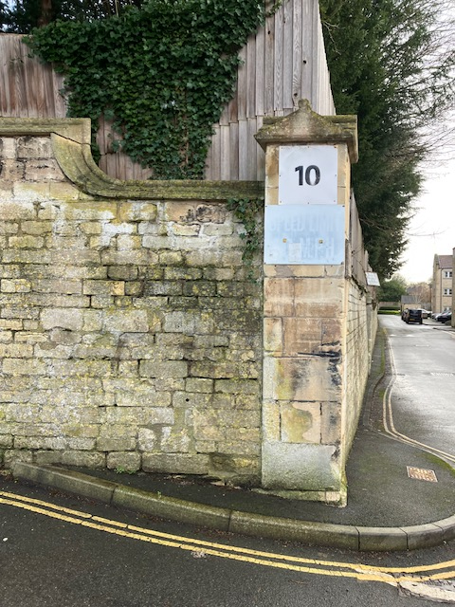
Proposed position of plaque
Kingston
Road

Mill Lane

