Application for Listed Building Consent

3 Five Alls Court, London Road, Marlborough, Wiltshire SN8 1BA

Location Plan

Original Building
The original property, formerly part of the Five Alls pub and now designated as grade II listed, comprises a living room/hallway, a staircase and landing, as well as two bedrooms located on the upper floor. The original building retains distinctive historic features and character.
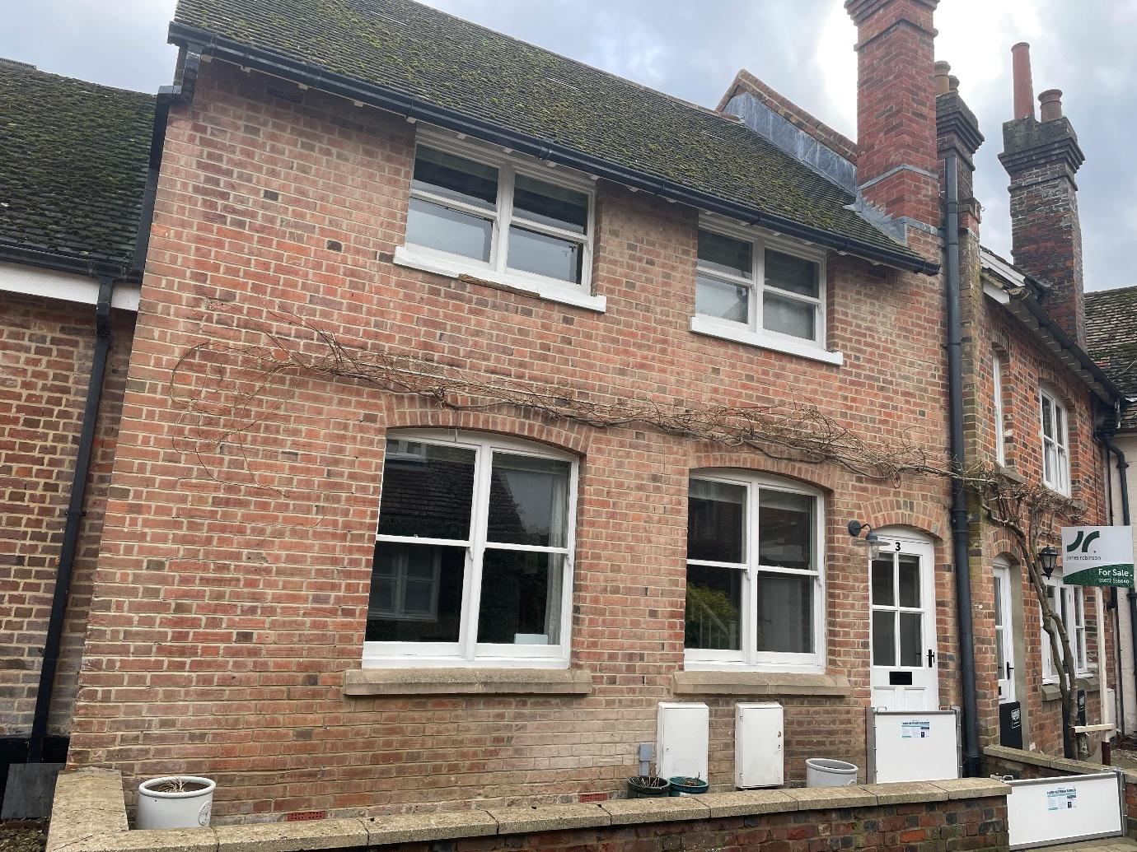
Original building

Kitchen and Bathroom Extension (2001)
In 2001, Beaverbrook Properties redeveloped the Five Alls site and added a kitchen and bathroom extension to the property.
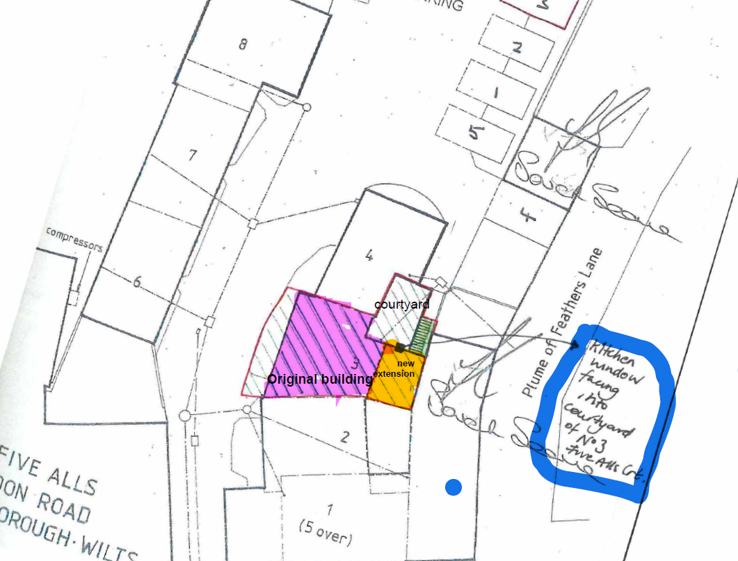
Location map showing original building, new extension and position of kitchen window denoted by black square.

