Application for Listed Building Consent PP-14725633

3 Five Alls Court, London Road, Marlborough, Wiltshire SN8 1BA

Heritage Statement
The replacement kitchen window is situated within a modern extension, constructed in 2001, attached to a Grade II listed building. While the extension itself does not comprise original historic fabric, it forms part of the wider setting and curtilage of the listed property, contributing to its overall character and significance. The principal heritage asset is the main listed building, whose architectural and historic interest is preserved through the careful management of alterations within its setting.
The impact of the proposed works is limited and localised, affecting only the modern extension and not the historic core or original elements of the listed structure. By replicating the design, materials, and finish of the existing heritage-sensitive bathroom window, the intervention maintains visual coherence and architectural integrity.
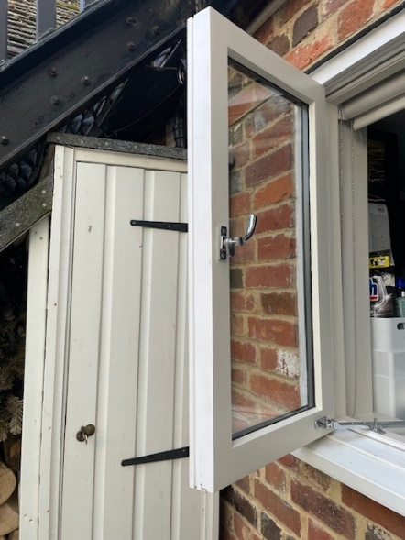
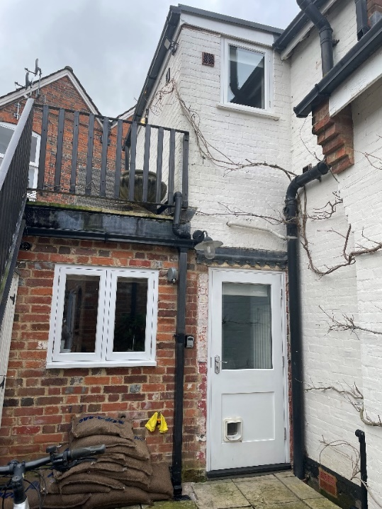
Replacement casement kitchen window replicates design, materials and finish of bathroom window shown on upper floor above rear door
Steps have been taken to minimise any adverse impact, including the use of high-quality painted Accoya timber and careful attention to detail, ensuring that the replacement window complements the established character and appearance of the building. As such, the significance of the heritage asset is sustained, with the scheme representing a sensitive and justified response to functional needs, such as improved ventilation and flood resilience, while respecting the special interest of the listed building.

