Application for Listed Building Consent PP14725633

3 Five Alls Court, London Road, Marlborough, Wiltshire SN8 1BA

Plans and drawings

Kitchen Window
During the 2001 development, a multi-pane kitchen window was installed by Beaverbrook Properties to the new extension. This window was designed to mimic a traditional sash window, consisting of two separate fixed frames, and the upper sash frame was modified from a larger sash window to fit the non-standard opening.
However, the multi-pane design was not consistent with the original windows of the Five Alls pub in appearance and did not preserve the building’s visual and architectural integrity. The window was fixed and non-ventilating, as the box frame required for the sash mechanism was omitted, causing problems with condensation and dampness in the extension.
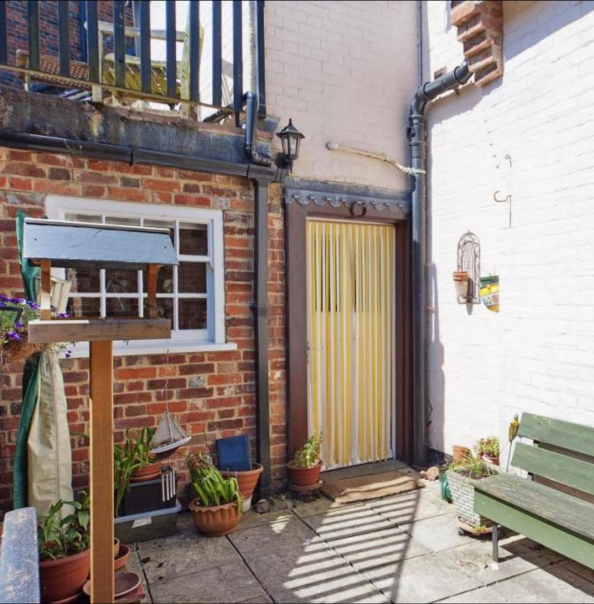
Multi-pane fixed frame kitchen window installed in modern extension (2001) by Beaverbrook Properties
In 2019, recognising the unsuitability of the fixed-frame kitchen window and its incompatibility with the architectural character of the building, I replaced it. The new window replicates the casement design of the upstairs bathroom window, which improves visual cohesion and supports the building’s historic integrity. This replacement has significantly enhanced airflow and ventilation in the extension, resolving previous damp issues and contributing to the ongoing protection and preservation of the building’s structure.
1:50 Scale Drawing
The materials and finish are heritage-sensitive and the design preserves the architectural character and appearance of the property matching the bathroom window. See below details and photos below..
Element | Description
Frame | Accoya timber, painted finish. Dimensions as per 1:50 scale drawing
Glazing | Double glazed unit
Moulding | 20mm chamfered profile matches existing bathroom window
WalAccoyl Interface | Timber liner, weatherproof seals for insulation, fixed to plaster walls

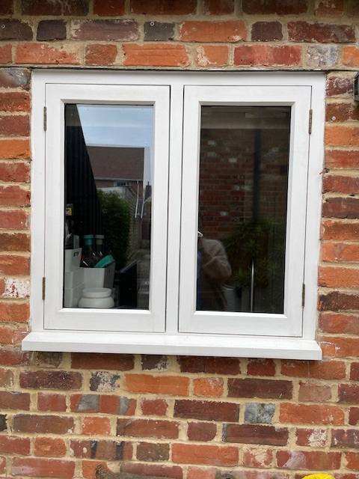
Replacement casement kitchen window fixed in opening
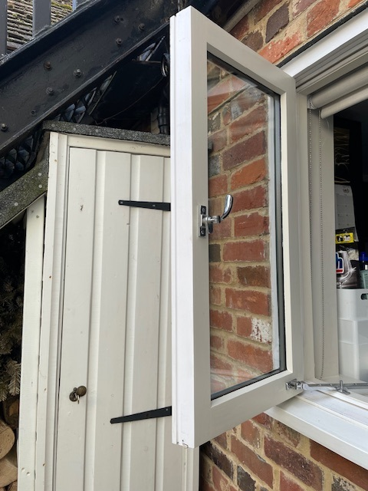
Cross sectional view of replacement casement kitchen window showing heritage-sensitive ironmongery and weatherproof seals

