APPLICATION FOR FULL-PLANNING PERMISSION
CASE OFFICER REPORT

APPLICATION REFERENCE: | PL/2025/09579
APPLICATION TYPE: | Full planning permission
SITE ADDRESS: | Sandhyrst Stables, Drove Lane, Market Lavington, Devizes, SN10 4NT
DEVELOPMENT DESCRIPTION: | Alteration of existing Redwood Creosote posted Paddock which measures 55m x 20m to a Sand School. Fix low level Creosote kick board to the existing paddock posts, add equestrian grade rubber chips to complement the existing surface. Increase existing mixed hedge by 20m. Change of use from agricultural to equestrian use.
RECOMMENDATION: | Approve with Conditions

SITE DESCRIPTION/CONTEXT

The application site refers to a parcel of land associated with Sandhyrst Stables situated on Drove Lane in Market Lavington. This area of land is immediately to the northwest of the existing stable building and separated from the surrounding agricultural land to the southwest and northwest (used for grazing) by post and wire fencing. To the northeast is a further paddock, separated from the application site by mature hedging. There is a Public Right of Way (PRoW) MLAV14 to the west of the site which cuts diagonally across the agricultural field. To the north of the site is a residential dwelling, with further residential properties situated to the southeast of the stables. The site lies within the Salisbury Plain Special Protected Area (64k buffer). There are no other known constraints within the site.

PROPOSAL

The application seeks full planning permission for the formation of a Sand School over the existing fenced area as shown in the submitted block plan (see image below). The works will involve fixing kickboards to the existing fence posts, adding equestrian grade rubber chips and sand to the existing ground surface, laying of hedge and change of use from agricultural to equestrian.

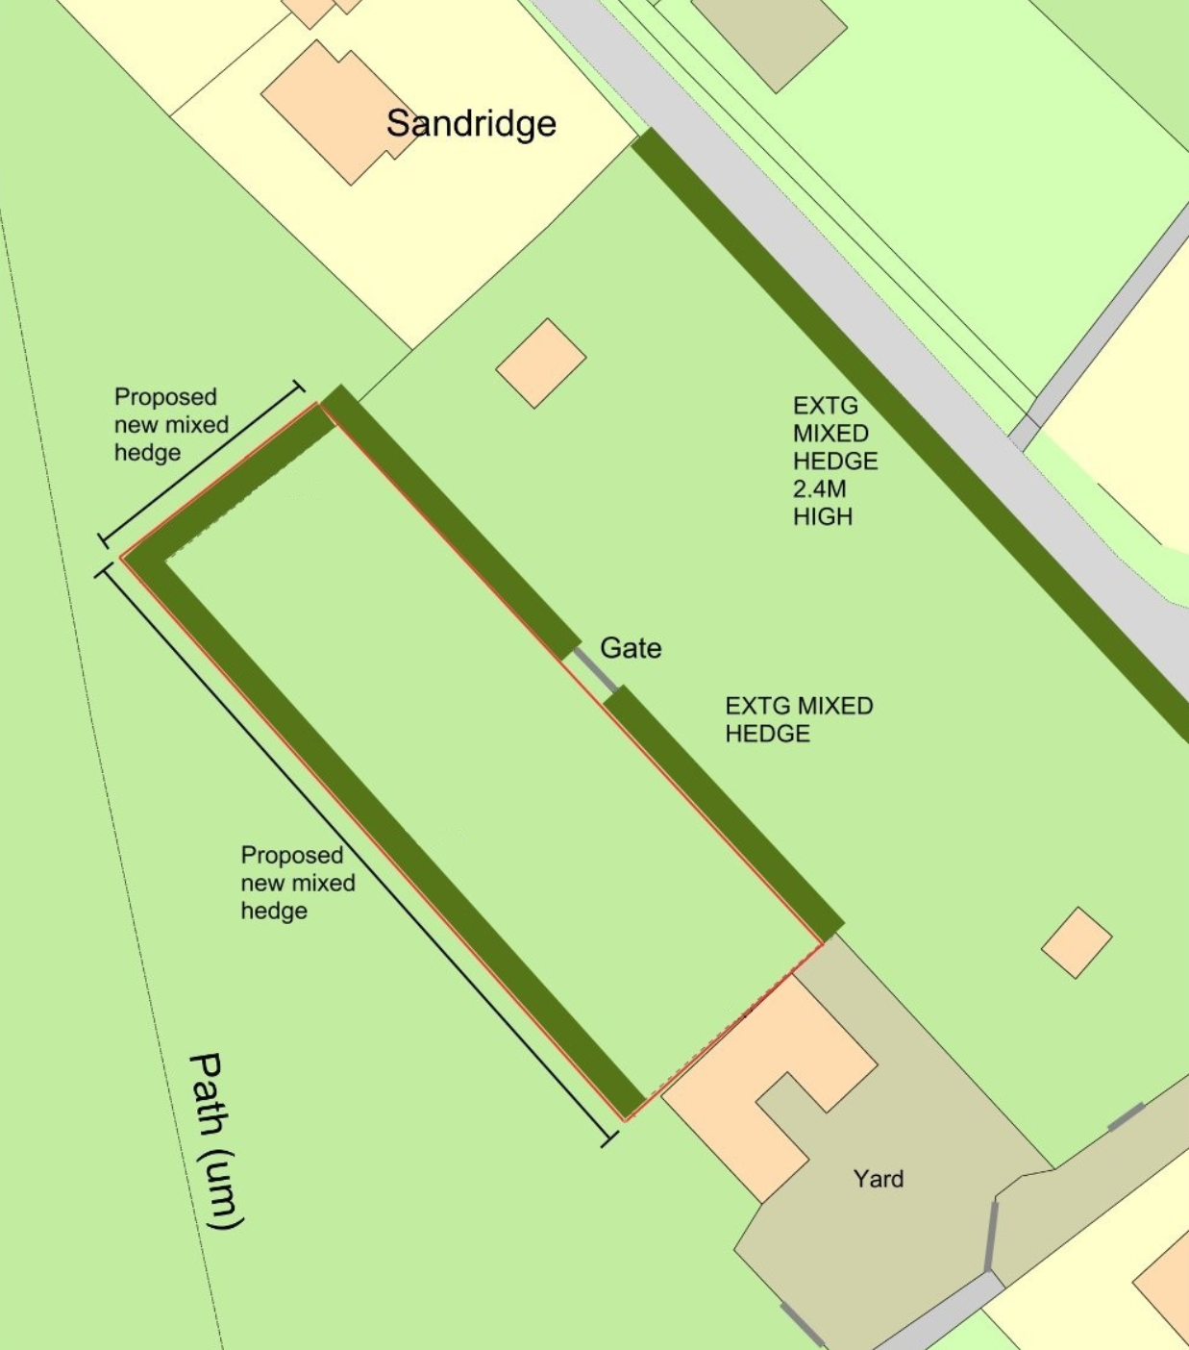
Proposed Block Plan ‘Sand Arena’.

PLANNING HISTORY

Proposal / Summary
E/09/0916/FUL - Full planning permission Decision - Approve with Conditions Date: 3/11/2009 – Change of use of 2 areas of agricultural land to equestrian.
E/09/1609/FUL - Full planning permission Decision - Refused Date: 1/2/2010 – Erection of barn for stabling and hay storage.
E/10/0551/FUL - Full planning permission Decision - Approve with Conditions Date: 24/6/2010 – Change of use from agricultural to equestrian; erection of stables with hay store and feed store; repair and resurface existing access drive

RELEVANT LEGISLATION, POLICIES AND GUIDANCE

Statutory Legislation:
Town and Country Planning Act 1990

National Planning Policy:
- National Planning Policy Framework (NPPF)
- Planning Practice Guidance (PPG)
- National Design Guide
Development Plan:
The development plan for Wiltshire comprises the Wiltshire Core Strategy (WCS) (adopted January 2015) and any made neighbourhood plans, which remains the principal statutory planning document guiding development across the county. In line with Section 38(6) of the Planning and Compulsory Purchase Act 2004, planning decisions must be made in accordance with the development plan unless material considerations indicate otherwise.

Though the development plan is considered as a whole, those parts deemed to be particularly relevant to this application are listed below:

The adopted Wiltshire Core Strategy (WCS), with particular regard to:

- Core Policy 1 Settlement Strategy;
- Core Policy 2 Delivery Strategy;
- Core Policy 12 Spatial Strategy: Devizes Community Area;
- Core Policy 50 Biodiversity and Geodiversity;
- Core Policy 51 Landscape
- Core Policy 57 Ensuring High Quality Design and Place Shaping;
- Core Policy 60 Sustainable Transport;
- Core Policy 61 Transport and New Development
- Core Policy 64 Demand Management

Draft Wiltshire Local Plan Policies

- Policy 1: Settlement Strategy
- Policy 2: Delivery Strategy
- Policies 64 – 75: Economic, tourism, retail and transport
- Policies 76 – 84: Social, housing, community, public open space and wellbeing
- Policies 85 – 101: Sustainability, ecology, water and landscape, heritage, air quality

Neighbourhood Plan:

Market Lavington Neighbourhood Development Plan 2018 – 2026 (Made May 2021)

Supplementary Planning Documents and other Guidance:
- Wiltshire Design Guide (adopted April 2024)
- Wiltshire Local Transport Plan 2011-2026, adopted 2015 - including the Car Parking Strategy and Cycling Strategy, adopted 2015

ISSUES

The main issues that need to be addressed in this case include:

- Whether the development is acceptable in principle (CP 1 and 2)
- Whether the scheme constitutes high quality design (CP 57)
- Whether the scheme would have an acceptable impact upon the reasonable living conditions of the adjoining occupants (CP 57)
- Whether the scheme would have an acceptable landscape impact (CP 51)
- Whether the proposal would have a negative effect upon highway safety, including if there is sufficient parking for the proposed development (CP 61 and 64)
- Whether there would be any harmful impacts upon protected species or priority habitats (CP 50)

CONSULTATION RESPONSES

WC Highways: No objection subject to use remaining private and not commercial.

WC Rights of Way: No objection, noted the nearby PRoW MLAV14 runs nearby but would not be adversely affected by the proposal.

Market Lavington Parish Council: No objection in principle. However, the flowing comments were received:

“Councillors considered the application. Whilst there was no objection in principle, concern was raised regarding the proposed use of “equestrian-grade rubber chips”, particularly the potential environmental impact if recycled tyre material were to be used.

It was resolved that the Parish Council supports the application in principle, subject to clarification from the planning authority/applicant on the specification and suitability of the proposed rubber surfacing material.”

In response to this consultation feedback, a comment was received from the applicant which explains that equestrian‑grade rubber chips made from recycled tyres are recognised by the Environment Agency as non‑waste materials, supported by an EA quality protocol confirming they meet end‑of‑waste criteria and are approved for use in equestrian surfaces. They state that using these chips has a positive environmental impact, promoting recycling and reducing waste, while also improving the safety and performance of the Sand School surface by enhancing shock absorption and reducing the risk of injury to horses. The applicant adds that the material retains strong second‑hand value, meaning it would not become waste even if the sand school were decommissioned.

REPRESENTATIONS
In accordance with the requirements of the Town and Country Planning (Development Management Procedure) (England) Order 2015 (as amended), the application was publicised by way of:

- Neighbour notification letters sent to adjoining and nearby properties;

This method was used to inform interested parties and provide a period of 21 days for comments to be submitted.

Below is a summary of the representations received during the consultation period. Only material planning considerations have been taken into account in the assessment of this application. Non-material issues, such as property values or private legal disputes, cannot be considered in the determination process.

One letter received in support of the scheme subject to consideration and restriction of external lighting.

ASSESSMENT
Section 38(6) of the Planning and Compulsory Purchase Act 2004 states:

"If regard is to be had to the development plan for the purposes of any determination to be made under the planning Acts, the determination must be made in accordance with the plan unless material considerations indicate otherwise."

In accordance with this statutory requirement, this application has been assessed against the relevant policies of the Development Plan, including the Wiltshire Core Strategy (2015) and, where applicable, any made Neighbourhood Plans. Consideration has also been given to the policies of the National Planning Policy Framework (NPPF) as a material consideration in the assessment.

Principle of Development
Policy Context
Core Policy 1: Settlement Strategy of the WCS establishes a hierarchy of settlements to guide where development should be focused. The policy prioritises growth in:
- Principal Settlements (e.g., Salisbury, Chippenham, Trowbridge) – main focus for strategic growth.
- Market Towns – support local services and employment; suitable for sustainable development.
- Local Service Centres – smaller towns and villages with a range of services; limited development supported.
- Large and Small Villages – development should be limited and respond to local needs.
- Outside the defined settlements – development is strictly controlled and generally not supported unless exceptional circumstances apply.
.
Core Policy 2: Delivery Strategy of the WCS sets out how development will be distributed and delivered across Wiltshire. The policy emphasises:
- Sustainable patterns of growth, reducing the need to travel and supporting local services.
- Development should be plan-led, aligning with the settlement strategy and supported by infrastructure.
- Windfall development (not allocated in plans) must still comply with the principles of sustainable development.
- Development outside settlement boundaries is generally not permitted, unless it meets specific policy exceptions (as set out in paragraph 4.25 of the WCS).

Together, CP1 and CP2 ensure that new development is strategically located, sustainable, and supports the character and function of Wiltshire’s communities.

Assessment

Whilst Core Policies CP1 and CP2 focus growth at sustainable settlements they do not preclude appropriate rural development. This would include equestrian proposals, where they are of an appropriate scale, compatible with their context and do not harm landscape character or residential amenity.

The proposal constitutes small scale, private equestrian use and formation of Sand School, incidental to the enjoyment of the existing, adjoining stables and does not introduce intensive activity, commercial traffic, or urbanising infrastructure.

The change of use of an existing field to private equestrian Sand School with associated landscaping is characteristic form of rural diversification. Subject to siting, design, traffic, ecology and landscape safeguards (addressed below), the principle of development at this location is acceptable.

Conclusion

Acceptable in principle, subject to compliance with other relevant policies of the development plan.

Design and Impact on the Character and Appearance of the Area
Policy Context
Core Policy 57 of the WCS requires high-quality design that:
- Enhances local character.
- Responds to the natural, historic, and built environment.
- Retains important features (e.g., trees, hedges).
- Supports sustainable construction and compatibility with surrounding uses.
- Creates safe, legible, and accessible spaces.

Section 12 of the NPPF emphasises design that is:
- Visually attractive.
- Functionally effective.
- Contributes to the quality of the built environment.

The Wiltshire Design Guide encourages sensitivity to local character, materials, and architectural styles and supports modern living standards while maintaining aesthetic and functional quality.

Assessment

The proposal raises no significant design concerns given the low‑level and unobtrusive nature of the works. The surfacing—comprising sand and equestrian‑grade rubber chips—is a typical and established material for sand schools and offers both performance and welfare benefits for horses. While the Parish Council queried the environmental implications of rubber chip use, it is noted that the product is derived from recycled material and its use is consistent with longstanding equestrian practice. The inclusion of perimeter kickboards will ensure the surface material is contained within the arena, preventing overspill into the surrounding agricultural land. A condition requiring removal of the surfacing and reinstatement of the land upon decommissioning of the sand school will provide additional reassurance and ensure no residual material remains on site.

In visual terms, the proposed surface treatment would not materially alter the character of the site, which is already in active equestrian use and has no established grass cover due to the presence of horses. The proposal is therefore unlikely to increase visual impact when compared with existing conditions. Existing fencing is already in place, and the proposed extension to the hedgerow will assist in both screening and softening and the appearance of the arena and enhancing the site’s integration into the wider rural landscape.

The change of use would not materially affect local character, as the wider holding already includes several parcels in equestrian use, with the remainder used for grazing. The sand school would sit immediately adjacent to the existing stables and paddock, ensuring it remains closely related to the established equestrian facilities and reads as part of the existing complex. Any associated equestrian paraphernalia, such as jumps, would be expected for this type of facility and would not appear out of keeping, particularly given the availability of existing stables and storage areas for equipment. Although the arena would be visible from the neighbouring public footpath, its presence would not be incongruous in this context, and screening from the lane and extended hedgerow would limit wider visual effects.

Conclusion

The proposal would not result in harm to the character, appearance, or visual amenity of the area. The design and layout are appropriate to the site and its surroundings and are considered to comply with Core Policy 57 of the Wiltshire Core Strategy, the Wiltshire Design Guide, and relevant sections of the National Planning Policy Framework.

Amenity
Policy Context
Core Policy 57 (Point vii) of the Wiltshire Core Strategy requires development to respect the amenity of existing occupants and ensure appropriate amenity levels for future residents.

The National Planning Policy Framework (NPPF), particularly Paragraph 135, reinforces the need for development to provide a high standard of amenity for both existing and future users.

These policies guide the assessment of amenity impacts, which will be considered in detail under the below headings.

Overlooking / loss of privacy

No overlooking or loss of privacy would amount from the works. The application site is already in use for the keeping of horses. The impacts caused to amenity would be largely inline with the existing arrangement. The proposed hedging would in fact improve any impact due to providing screening between the application site and the nearest neighbour to the north at ‘Sandridge’. Any other nearby residential properties are buffered by existing development.

Loss of light / overshadowing

Due to the low-level nature of the works, there would be no loss of light or overshadowing.

Overbearing Impact / Overall sense of enclosure

For the same reasons, no concerns are raised with regards to overbearing impacts.

Noise

The site will remain in a private use; there are not considered to be any increases in noise when compared to the existing arrangement.

In conclusion, the proposal is expected to have little impact in terms of amenity to adjoining or nearby properties.

Highways Impacts and Parking
Policy Context
Transport implications are a key factor in assessing planning applications, especially for larger developments. Proposals must demonstrate:
- Safe and suitable access for all users, including pedestrians, cyclists, and those with mobility impairments.
- No severe residual impacts on the surrounding highway network.
- Promotion of sustainable travel, reducing reliance on private vehicles.
- Adequate parking and cycle provision, in line with adopted standards.
- Protection and enhancement of public rights of way and active travel routes.

Relevant policies include Core Policies 60–64 of the Wiltshire Core Strategy, supported by the Wiltshire Local Transport Plan, Car Parking Strategy, and Cycling Strategy. The Local Cycling and Walking Infrastructure Plan (LCWIP) and LTN 1/20 (DfT) provide further design guidance for active travel infrastructure.

Proposals must also ensure safe access for refuse collection vehicles and comply with the Wiltshire Council Waste Storage and Collection SPD (2017).

Where necessary, Transport Assessments or Statements should be submitted to evaluate impacts and identify mitigation. Planning conditions or legal agreements may be used to secure off-site improvements, travel plans, or contributions to sustainable transport infrastructure.

Assessment

No alternations to parking or access are included nor are they required. The site is established, with existing parking provision and will remain in private use. As such there would be no intensification on the highway network. The highway officer raises no objection subject to the use remaining private which is confirmed by the applicant within the submission, in addition the private use will be conditioned on the decision notice.

Conclusion

The proposal is considered acceptable in highway terms and would have no impact on highway safety or parking. The proposal complies with the relevant policies of the WCS.

Ecology and Biodiversity
Policy Context
The ecological impact of development is a key planning consideration, especially for larger schemes. Proposals must assess and address potential effects on:

- Protected species
- Priority habitats
- Ecological networks
- Green and blue infrastructure

Core Policy 50 of the Wiltshire Core Strategy requires development to:

- Avoid harm to ecological assets.
- Deliver measurable Biodiversity Net Gain (BNG), in line with the Environment Act 2021.
- Support habitat restoration and connectivity.
- Integrate biodiversity into site design.

The Green & Blue Infrastructure Strategy (2022–2030) promotes nature recovery, ecosystem services, and habitat connectivity through development.

Unless exempt, National policy requires a minimum of 10% Biodiversity Net Gain (BNG) for major developments, demonstrated via:

- Biodiversity Metric calculations
- Ecological assessments (e.g. PEAs, Phase 1 surveys, protected species surveys)

Assessment

There are no significant concerns regarding ecological impacts. The site is already managed as horse‑grazing land, and the proposed works are low‑intensity, involving no new buildings or substantial ground disturbance. Although a small area of grassland will be replaced by the sand‑school surface, this is not considered ecologically harmful, particularly as a condition will ensure that all surfacing materials are removed and the land reinstated to its former state once the sand school is no longer required. No external lighting is proposed, and a condition will be attached requiring any future lighting to be agreed in writing with the Local Planning Authority to safeguard nocturnal wildlife.

Given the nature of the works and the existing condition of the paddock, no protected species are likely to be affected. In addition, the proposed hedgerow extension represents a modest ecological enhancement, improving connectivity and providing additional habitat within the site.

The proposal triggers the requirement to deliver a minimum 10% Biodiversity Net Gain (BNG) in accordance with the Environment Act 2021. A Biodiversity Metric calculation has been submitted and assessed, and it is confirmed that the 10% BNG requirement can be achieved on site through the provision of the proposed hedgerow extension.

The site lies within the 64 km buffer of the Salisbury Plain SPA; however, the development would not generate any increase in recreational pressure, and the proposal is therefore screened out of requiring Appropriate Assessment.

Conclusion

Overall, the scheme would avoid harm to biodiversity and would deliver the required 10% BNG enhancement through the proposed hedgerow planting. The proposal therefore accords with the requirements of Core Policy 50, which seeks to protect, conserve and enhance Wiltshire’s natural environment.

Landscape and Visual Impact
Policy Context
Core Policy 51 of the Wiltshire Core Strategy requires development to:
- Protect, conserve, and enhance landscape character and quality.
- Respect local distinctiveness, key views, and visual receptors.
- Give particular weight to impacts on National Landscapes (formerly AONBs) and locally valued landscapes.

The Wiltshire Design Guide SPD (2024) promotes a context-led approach, encouraging integration with natural features and settlement patterns while avoiding visual intrusion.

The Green & Blue Infrastructure Strategy (2022–2030) supports landscape protection through green infrastructure, habitat connectivity, and nature-based solutions.

The NPPF emphasises the need to protect and enhance valued landscapes, particularly those with scenic, historic, or ecological significance. Planning decisions should:

- Recognise the intrinsic character and beauty of the countryside.
- Safeguard key views, local distinctiveness, and landscape settings.
- Ensure development is well-integrated into its surroundings and avoids visual intrusion, especially in sensitive or designated areas.

Landscape impact must be considered alongside biodiversity, heritage, and green infrastructure objectives, with mitigation measures encouraged where harm cannot be avoided.

Assessment

The site does not fall within a designated National Landscape (formerly AONB), and there are no statutory landscape designations affecting the land. The proposed works are modest in scale and involve no new built structures of visual prominence. The sand‑school surface, kickboards and associated works sit entirely at ground level and are contained within an existing paddock that already forms part of a managed equestrian landscape. As such, the proposal will not introduce new vertical elements, massing, or lighting that could alter the wider landscape character or affect long‑distance views.

The surrounding area is characterised by a mix of grazing land, established hedgerows, field boundaries and small‑scale equestrian activity. The sand school would be read as part of this existing pattern of land use, with the surface treatment representing only a subtle change within an already well‑enclosed field. The proposed hedgerow extension will provide additional screening and help reinforce the site’s existing landscape structure, further integrating the development into its rural surroundings.

Given these characteristics, the proposal would not materially alter landscape form, pattern, or character, nor would it erode the rural qualities of the area. Visual effects would be limited to short‑range views from the adjacent public right of way, where the development would appear as a typical and expected feature of an equestrian holding. Views from the adjacent lane are already constrained by existing vegetation and built form, and the proposal would not increase the site’s visual prominence.

Conclusion

Overall, the works would conserve the existing landscape character, reinforce boundary vegetation, and maintain the rural appearance of the wider setting, as such the works would comply with CP51 of the WCS.

PLANNING BALANCE AND CONCLUSION
At the heart of the NPPF there is a presumption in favour of sustainable development requiring local planning authorities to approve development proposals that accord with an up-to-date development plan without delay; and where there are no relevant development plan policies, or the policies which are most important for determining the application are out-of-date, permission should be granted unless (taken from paragraph 11d of the NPPF):

- The application of policies in the NPPF that protect areas or assets of particular importance provides a clear reason for refusing development proposed; or
- any adverse impacts of doing so would significantly and demonstrably outweigh the benefits, when assessed against the policies in the NPPF taken as a whole;

The principle of development is considered acceptable when assessed against the settlement strategy of the Wiltshire Core Strategy.

The proposal is broadly compliant with relevant local and national planning policies in respect of design, scale, residential amenity, landscape, highway safety, ecology and biodiversity, and environmental impacts, subject to the recommended conditions.

Accordingly, the proposal is considered acceptable in planning terms and in accordance with the Wiltshire Core Strategy, the National Planning Policy Framework, and all other relevant material considerations.

RECOMMENDATION:
That Planning Permission be GRANTED, subject to conditions.

