Heritage Statement
Repointing Works to Littlefield
Bath Road
Marlborough
SN8 1PA
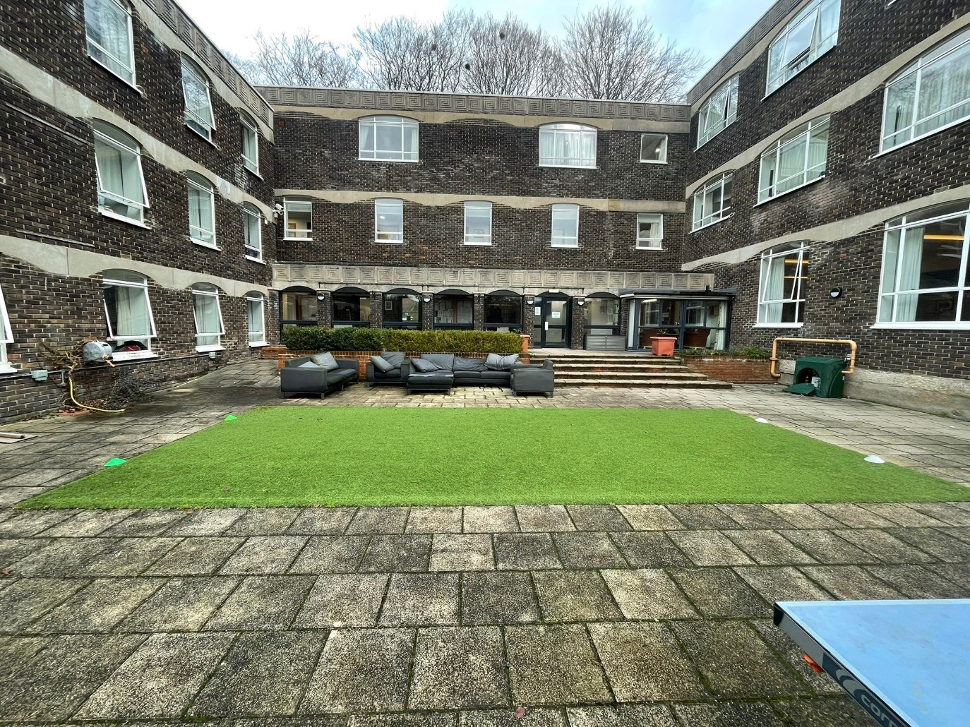
Image 1 shows Littlefield’s north elevation Courtyard.

1. Introduction
This Heritage Statement has been prepared in support of an application for Listed Building Consent for external repointing works to Littlefield, Bath Road (List Entry No. 1252912), a Grade II listed building. The statement has been produced in accordance with the National Planning Policy Framework (NPPF), Historic England guidance, and local planning and conservation policies. Its purpose is to describe the significance of the listed building, assess the need for the proposed works, and demonstrate that the proposals will preserve and enhance the building’s special architectural and historic interest.
The proposals relate solely to essential repair and maintenance works and represent the minimum level of intervention necessary to ensure the long-term conservation of the heritage asset.

2. Site and Building Description
Littlefield is a Grade II listed building located on the north side of Bath Road. The property was designed in 1870 by the architect G. E. Street and constructed between 1871 and 1872. The building represents a significant and early example of experimental Victorian concrete construction.
The structure was built using the patented method of Charles Drake, incorporating concrete with flint aggregate and lump chalk packing. This technique was innovative for the period and represents an important phase in the development of modern construction materials. The building was later referenced in professional engineering and construction literature, demonstrating its wider historical and technological importance.
The building is externally finished with cement render, with limited use of tile hanging beneath the eaves and brick string courses at plinth and first floor sill level. The roof is pitched and finished with clay tiles, and the property features tall brick chimneystacks with decorative cornicing.
The building comprises three storeys with a basement and is arranged on an irregular plan, with individual pitched roofs over each element, contributing to its steep vertical proportions. A former wing was destroyed by fire and rebuilt in the 1960s in a more restrained Brutalist architectural style.
Windows are mullioned and transomed casements set within flush frames and finished with moulded cornices. The property also retains original planked doors with contemporary iron hinges and mullioned fanlights.
The listed building makes a strong contribution to the character and historic significance of Bath Road and the surrounding built environment.

3. Historic and Architectural Significance
3.1 Architectural Interest
Littlefield is significant for the following reasons:
• It was designed by the prominent Victorian architect G. E. Street.
• It represents an early and innovative use of concrete as a primary construction material.
• The survival of original structural and external fabric, including rendered concrete walls and historic detailing.
• The steep proportions, roofscape, and high-quality architectural detailing.
• The relationship between materials, form, and design, which reflects Victorian experimentation and craftsmanship.
The external rendered concrete and pointing are integral to the architectural character of the building.

3.2 Historic Interest
The building has technological and historic value as an early example of patented concrete construction and reflects developments in 19th-century engineering and building techniques.

4. Condition and Need for Works
A visual inspection of the external north, east, south, and west elevations of the brutalised courtyard have identified areas where mortar joints have deteriorated. see plan *****
These defects include:
• Localised erosion and loss of mortar.
• Open and cracked joints.
• Previous repairs undertaken using inappropriate cement-rich mortars.
• Weathering and failure of external finishes, particularly in exposed elevations.
The deterioration is leading to moisture penetration and will accelerate the decay of the underlying historic fabric if left untreated. The proposed works are therefore essential to preserve the structural integrity and long-term performance of the building.

5. Proposed Works
The proposed works include:
• Careful hand removal of defective and inappropriate mortar.
• Removal of hard cementitious pointing that is incompatible with the historic structure.
• Repointing using a breathable lime-based mortar compatible with the historic concrete and render.
• Matching of colour, texture, aggregate, and joint profile to the existing historic finish.
• Phased implementation to ensure quality and minimal disruption.
The works will be carried out by experienced contractors specialising in historic buildings.

6. Impact Assessment
The proposed works will have a positive and beneficial impact on the significance of the listed building. In particular, the works will:
• Remove damaging modern repairs.
• Reinstate appropriate traditional materials.
• Improve breathability and moisture management.
• Prevent further deterioration of the historic structure.
• Safeguard the building’s architectural and technological significance.
The visual impact will be neutral to beneficial, as the repaired areas will closely match the existing historic appearance.
There will be no loss of significant historic fabric.

7. Justification and Policy Compliance
The proposals comply with the statutory duty under Sections 16 and 66 of the Planning (Listed Buildings and Conservation Areas) Act 1990, which requires special regard to be given to the desirability of preserving listed buildings.
The works are also consistent with the NPPF, which supports the conservation of heritage assets in a manner appropriate to their significance.
The repointing works represent essential maintenance and are necessary to sustain the long-term conservation of the asset.

8. Conservation Principles
The proposals follow established conservation best practice:
• Minimum intervention.
• Repair rather than replacement.
• Retention of historic fabric.
• Use of compatible traditional materials.
• Reversibility where possible.
• Skilled workmanship.

9. Conclusion
The proposed repointing works are necessary, proportionate, and appropriate. They will preserve and enhance the special architectural and historic interest of Littlefield and will secure its long-term conservation.
The proposals will result in a beneficial impact on the heritage asset and are fully compliant with national and local heritage policy.

