Design and Access Statement
Repointing Works to Littlefield
Bath Road
Marlborough
SN8 1PA
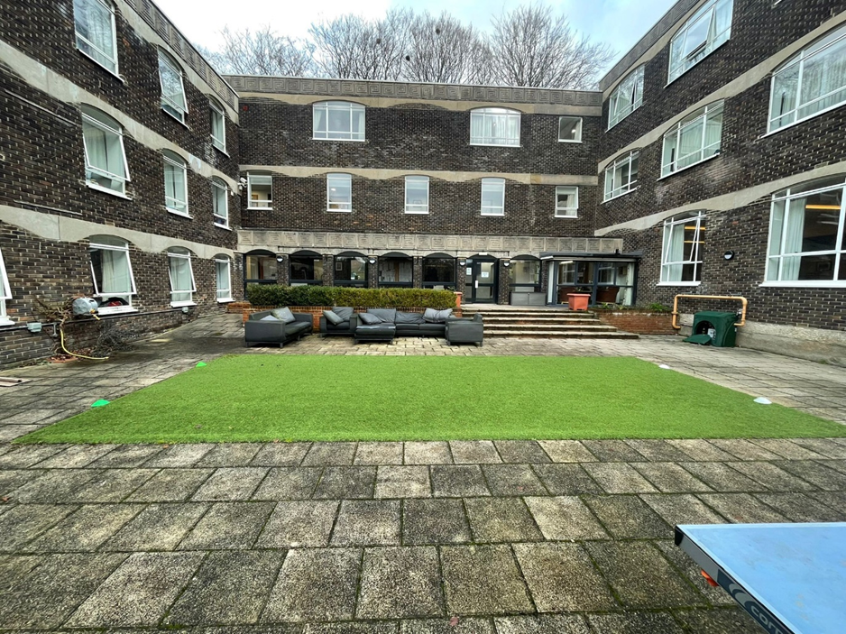
Image 1 shows Littlefield’s north elevation Courtyard.

1. Introduction
This Design and Access Statement has been prepared in support of an application for Listed Building Consent for external repointing works to Littlefield, Bath Road (List Entry No. 1252912). The building is Grade II listed and is of special architectural and historic interest, designed in 1870 by the noted Victorian architect G. E. Street and constructed between 1871 and 1872.
The purpose of this statement is to explain the design principles behind the proposed works and demonstrate how the proposals will preserve the character, appearance, and significance of the heritage asset, in accordance with national and local planning policy.
As the works relate to repair and maintenance only, the access considerations are limited and proportionate to the scale of the proposal.

2. Site Context
Littlefield is located on the north side of Bath Road and forms part of an established historic streetscape. The property makes a strong contribution to the character of the area due to its scale, architectural quality, and distinctive construction method.
The building is notable for its early use of experimental Victorian concrete construction using the patented system developed by Charles Drake, incorporating flint aggregate and chalk packing. The external walls are cement rendered, with brick string courses and limited tile hanging beneath the eaves. The steep proportions, varied roofscape, and decorative brick chimneystacks contribute to the building’s distinctive architectural identity.

3. Design Principles
The design approach for the proposed works has been guided by the following key conservation principles:
• Preservation of historic fabric.
• Minimum intervention.
• Repair rather than replacement.
• Use of compatible and breathable traditional materials.
• Reinstatement of appropriate historic detailing.
• Avoidance of unnecessary visual change.
The works are focused on essential maintenance and will ensure the long-term durability and performance of the building while maintaining its architectural character.

4. Amount and Nature of Development
The proposals relate solely to external repointing works to areas of deteriorated mortar and do not involve any extensions, structural alterations, or changes to the layout or appearance of the building.
The scope of the works is limited to the rear courtyard elevations only. While this area is confined to the rear of the property, it is relatively extensive, covering approximately 585m² across seven separate elevations. The proposed works are considered proportionate, appropriate, and necessary to preserve the condition and long-term performance of the historic fabric. They represent essential maintenance to ensure the continued conservation of the building in accordance with best practice.
Due to the scale and extent of the works, the repointing will be carried out in a series of carefully planned phases over a period of time. This approach will allow for close supervision, the review of sample areas, and the monitoring of mortar performance and curing, ensuring that the works are delivered to an appropriate conservation standard while minimising disruption to the building’s use.

5. Materials
The proposed repointing will use a carefully specified lime-based mortar compatible with the historic concrete and rendered surfaces. The design process has prioritised the selection of materials that:
• Match the original historic appearance.
• Are physically and chemically compatible.
• Allow the structure to breathe.
• Avoid trapping moisture within the fabric.
Trial panels will be prepared on site and agreed with the Local Planning Authority prior to the commencement of works.
The colour, texture, aggregate size, and joint profile will be matched to the existing historic finish to ensure visual continuity.

6. Appearance
The works will have a neutral to beneficial impact on the external appearance of the building. Removal of inappropriate cementitious repairs will improve the visual quality and authenticity of the elevations.
The repaired areas will integrate seamlessly with the existing fabric and will not alter the character, form, or architectural detailing of the building.

7. Heritage Considerations
The proposed works will preserve and enhance the special architectural and historic interest of the listed building by:
• Addressing deterioration and preventing further damage.
• Reinstating appropriate traditional materials.
• Improving long-term performance and sustainability.
• Protecting the technological significance of the early concrete structure.
The proposals represent best conservation practice and are consistent with the statutory duty to preserve listed buildings.

8. Sustainability
The proposed works support sustainable conservation by extending the lifespan of existing historic fabric and reducing the need for more extensive future intervention.
The use of lime mortar improves moisture management and thermal performance, contributing to the building’s long-term resilience.
Repair and maintenance of existing structures is recognised as a sustainable approach to development.

9. Access
9.1 Access to the Site
The works will be carried out from temporary scaffolding positioned around the building as required. Access will be arranged to minimise disruption to occupants and neighbours.
Construction access will be managed to ensure safe working practices.

9.2 Inclusive Access
The proposals do not alter the existing access arrangements to the building and will not affect inclusive or step-free access.
Given the nature of the works, no changes to entrances, circulation, or internal arrangements are required.

9.3 Health and Safety
The contractor will prepare appropriate risk assessments and method statements, including:
• Safe erection and use of scaffolding.
• Protection of the public and occupants.
• Dust and noise control.
• Careful handling of historic fabric.

10. Conclusion
The proposed repointing works are essential maintenance and repair to a Grade II listed building of significant architectural and technological interest. The works have been carefully designed to preserve the character and appearance of the building and will result in a beneficial impact on its long-term conservation.
The proposals are proportionate, appropriate, and compliant with national and local planning policy. Accordingly, Listed Building Consent is respectfully sought.

