Construction Phase Health & Safety and Environmental Plan
3556- Nadder Community Energy V2

Prepared by: | Jon Collins QSHE & Compliance Manager | Signature: |  | Date: | 16/02/2026
Reviewed by: | Reg Barrington | Signature: |  | Date:
Approved by: | Graham Watts General Manager | Signature: |  | Date:

Change Record:

Version | Revised by | Job Title | Reason for Change | Date
V2 | Jon Collins | QSHE & compliance Manager | Additions requested by client | 19/02/2026

Page 1 of 61

Contents (format tbd):

- Objectives 5
- Project Information 6
  - Project Details 6
  - Project Dates 6
  - Project Contractors 6
  - Project Contacts 8
  - Emergency Contacts 9
- Health and Safety Policy Statement… 10
  - Health and Safety General Policy Statement… 10
  - Professional Safety Advisor’s Statement… 11
- Site Details 12
  - Site Location Plan 12
  - Site Access 12
  - Existing Environment… 12
- Site Rules 13
- Management of Health and Safety… 14
  - Coordination and Cooperation 14
  - Communication 14
  - Site Induction & Training 14
  - Permits to Work 14
- Emergency Procedures 15
  - Fire Assembly Points and Extinguisher Locations 15
  - Fire and Emergency Procedures 15
  - Fire Prevention 15
- Site Establishment and Welfare Provisions 16
  - Site Layout and Setup 16
  - Welfare Arrangements 16
- First Aid Training and Incident Reporting 17
  - First Aid Arrangements 17
  - Injury Management… 17
  - Incident Reporting and Investigation 17
- Safe Systems of Work and Monitoring 18
  - Risk Assessments, Method Statements & Safe Systems of Work 18
  - Monitoring 18
- Health and Safety Arrangements for Site Specific Risks 19
  - Manual Handling 19
  - Lifting Equipment and Operations 19
  - Plant and Vehicle Safety… 19
  - Site Traffic Management… 20
  - Maintenance of Tools and Equipment… 20
  - Utilities and Services 20
  - Excavations 21
  - Control of Dust… 21
  - Contaminated Land 22
  - Site Security 22
  - Storage of Materials 23
  - Interaction with Members of the Public 23
  - Working with Electricity 23
- Site File and Documentation 24
  - Documents on Display… 24
  - Signs on Display… 24
  - Site File… 24
Appendices:
  - Appendix 1 – Waste Management Plan 27
    - Introduction 27
    - The Waste Hierarchy… 27
    - Types of Waste… 28
    - Waste Management Procedures 28
    - Monitoring and Reporting 30
    - Emergency Procedures 30
  - Appendix 2 – Emergency Procedure 31
  - Appendix 3 – Environmental Management Plan 32
    - Introduction 32
    - Environmental Aspects and Impacts 32
    - Environmental Management Procedures 33
    - Monitoring and Reporting 35
  - Appendix 4 – Traffic Management Plan 36
    - Site Location 36
    - Pre-Construction Works 37
    - Construction Schedule… 37
    - Traffic Management… 38
    - Emergency Access 39
    - Monitoring and Reporting 39
    - Post-Construction Works 40
  - Appendix 5 – Project Management Plan 41
    - Organisation 41
    - Responsibilities 42
    - Project Management Interface… 44
    - Project Phases 46
    - Communications 49
    - Timelines and Milestones 51
    - Risk Management… 52
    - Quality Management… 53

Objectives

- The overall objective of the Construction Phase, Health & Safety Plan and Environmental Plan is to ensure that all construction works on this project comply with the HASAWA 1974, along with CDM. Our aim is to keep everyone safe at work and promote a safety first culture.
- The requirements for Safety will be set out in advance and communicated to all site personnel to ensure safe working at all times. The Site Safety Policy is stated in this Plan and a copy is displayed on the notice board.
- Relevant systems and methods of work, choice of materials, plant, etc., will be established in advance, to ensure effective execution of key activities to the specified standard.

- The site organisation and lines of communication have been defined in the Project Management Plan, to be read in conjunction with the Construction Phase Health and Safety and Environmental Plan.
- Records will be maintained and stored to provide confirmation that the works have been completed to the specified standards and the Company requirement

Project Information

Project Details
Project Name: | Pythouse Farm Extension
Client: | Nadder Community Energy
Reference Number: | 3556
HSE Notification Required: | Yes
Site Address: | Pythouse Farm, Newton, Tisbury, Salisbury SP3 6PA
Outline of Works: | To design, supply and construct a new 262.08 KWp Ground mount Solar farm. We will be responsible for all activities during the length of the project, this will consist of supporting structures for the solar panels and inverters. Also all trenching and cabling works along with foundation slab for transformers and point of connection

Project Dates

Anticipated Start  Date: | TBC
Duration of Works: | 4 weeks
Working Hours: | Monday to Friday - 7am – 6pm

Project Contractors
Principal Designer | SSWUK Ltd. | Coombe Farm Crewkerne Somerset  TA18 8RR
Principal Contractor | SSWUK Ltd. | Coombe Farm Crewkerne Somerset TA18 8RR
Mechanical Designer | Solarport Systems Ltd | Unit 3 The Core  Gore Cross Business Park Bridport  DT6 3FH
Security Contractor | TBC
Civils Contractor | K J Hobbs Construction Ltd. | 7 Morston Court Aisecome Way Weston-Super-Mare  BS22 8NG
Mechanical Contractor  (Piling, Framework  & Panel installation) | Direct Fencing Ltd | Aysgarth London Road Fairford GL7 4AR
Electrical Contractor | SSWUK Ltd. | Coombe Farm Roundham Crewkerne  TA18 8RR
HV Contractor | High Voltage Utility Services Ltd. | 5 Moss Drive  Sutton Coldfield B72 1JQ

Project Contacts

Contact Name | Job Title | Contact Number
Matt Tuffton | Managing Director | 01460 279571
Graham Watts | Project Director | 07790480668
Joe Hartley | Operations Manager | 07808 644374
Graham Watts | Electrical Manager | 07790 480668
Reginald Barrington | Project Manager | 01460 279571
Fahad Mukhtar | Electrical Designer | 01460 279571
Paul Gosney | Senior Electrician | 01460 279571
Jon Collins | Health & Safety, Quality, Environment Manager | 07500233134

Site Representatives:
Graham Poole | Construction manager | 07970712173
Graham Poole | First Aider | 07970712173

Emergency Contacts
SSWUK Ltd. | 01460 77349
Emergency - Police/Fire/Ambulance | 999
HSE Incident Contact Centre | 0845 3009923
Environment Agency | 0800 807060
Gas - SGN | 0800 111999
Electricity - SSE | 105
Water – Wessex Water | 0345 6003600

Health and Safety Policy Statement

Health and Safety General Policy Statement
It is SSWUK’s firm intention to ensure that the highest practicable standards of Health, Safety and Welfare are achieved in respect of its operations. The Company accepts in full its obligations to work to the requirements of all relevant legislation and codes of practice relating to Health, Safety and Welfare.

SSWUK acknowledges that the key to successful health and safety management requires an effective policy, organisation and arrangements, which reflect the commitment of senior management. To maintain that commitment, we will continually measure, monitor, improve and revise where necessary, an annual plan to ensure that health and safety standards are adequately maintained.
The Directors will implement the company’s health and safety policy and recommend any changes to meet new circumstances. SSWUK recognises that successful health and safety management contributes to successful business performance and will allocate adequate finances and resources to meet these needs.
The effectiveness of the company’s Health and Safety Policy relies heavily on the co- operation of Company employees and sub-contractors engaged by the company. All employees have duties under the Health and Safety at Work Act 1974 and are informed of their personal responsibilities to take due care of the health and safety of themselves and to ensure that they do not endanger other persons by their acts or omissions.

A proactive approach to health and safety on site is crucial to the successful and safe delivery of a construction project. The company or individuals within the company may hold duties as a Contractor, Principal Designer or Principal Contractor under The Construction (Design and Management) Regulations 2015. The organisation understands its responsibilities under CDM 2015. As a Principal Contractor, the organisation will plan, manage and coordinate health and safety while construction work takes place.

The organisation will ensure a systematic approach to identifying hazards, assessing the risks, determining suitable and sufficient control measures and informing employees of the correct procedures needed to maintain a safe working environment. We will provide, so far as is reasonably practicable, safe places and systems of work, safe plant and machinery, safe handling of materials and

substances, the provision of adequate safety equipment and ensure that appropriate information, instruction, training and supervision is given.

We regard all health and safety legislation as the minimum standard and expect management to achieve their targets without compromising health and safety.

Signed: Graham Watts

Role: General Manager
Date:

Professional Safety Advisor’s Statement
Jon Collins (SW) Ltd.’s duties will, ‘so far as is reasonably practicable’, be:
To advise the organisation, when required, on health and safety matters in advance of construction operations.

To carry out regular site inspections.
To discuss and advise on matters affecting health, safety, and welfare.

To notify the organisation’s Construction manager of all defects, contraventions and non-compliances found and provide a written report.

To notify the company Director if serious defects are continually not remedied.
To immediately contact the Director if situations are found that, in the opinion of the Safety Adviser, are dangerous enough to warrant the stopping of any operation.

To advise of safety training requirements for new and existing employees.

In accordance with the agreed criteria, to carry out investigations into and report on, accidents, dangerous occurrences and near misses.
To check site documentation is being completed correctly and where necessary to ensure that adequate risk assessments and method statements are available.

Site Details

Site Location Plan

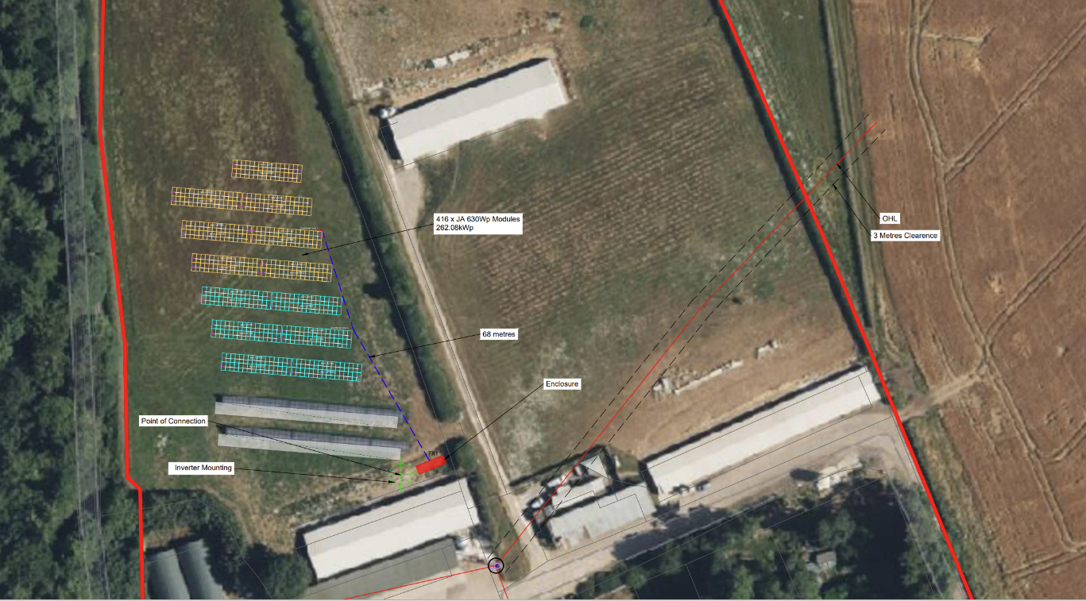

Site Access
Access to the site is via the existing farm access, no access from the lane to the west of the site is permitted. Upon entering the site, vehicles will be subject to a speed limit of 5 to 10 mph.

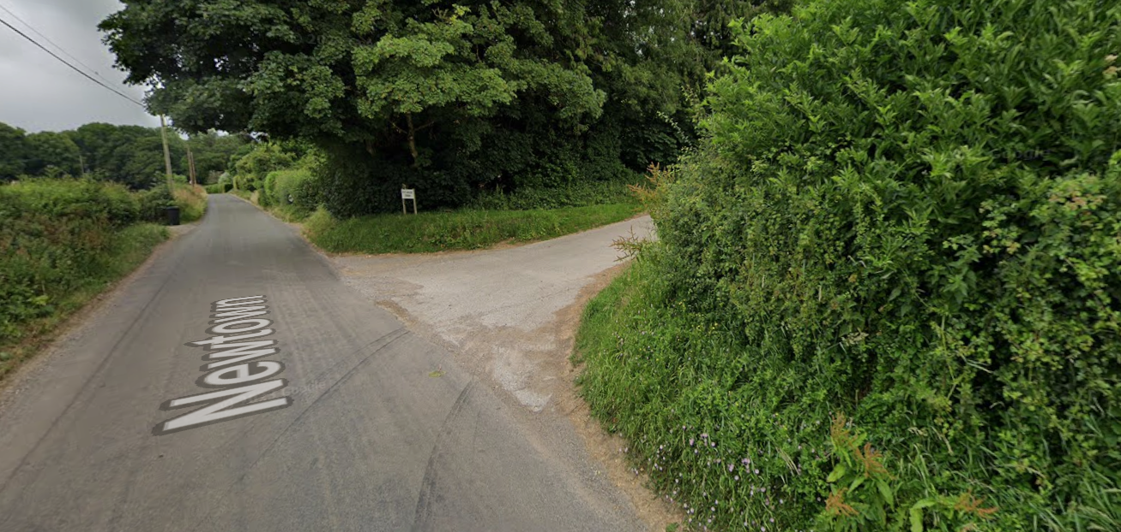

Existing Environment
The site is an agricultural field laid to grass with an existing solar array already installed in the south area of the field. The site is set within a working poultry farm with a wood to the west of the plot and hedge rows to the east. There are other live stock to consider on the site including a small number of cattle.

Care must be taken to consider the impact of any works that may impact on the existing environment.

Site Rules
These site rules will be made known to all persons on site through induction and by display in the welfare area. Individual workers are required to understand and comply with the following:
- All visitors to the site are to have read, understood and signed the Risk Assessment, Method Statement and any applicable Safe Systems of Work
- Mandatory Personal Protective Equipment is to be worn at all times
  - Safety boots/wellingtons
  - High visibility jacket/vest
  - Safety Helmet
- Additional activities must use PPE as stated in task specific Risk Assessment.
- Eye, ear and respiratory protection will be issued when the task requires and must be worn
- Any reversing of lorries, heavy plant or vehicles with restricted view must be done with a qualified banksman present
- Plant is only to be operated by trained, qualified and authorised personnel
- All vehicles must be parked in the designated areas
- No person is to undertake any task for which they are not trained nor have the necessary experience to make them competent
- All portable tools and lighting should be a maximum of 110v
- Good housekeeping practices are always to be followed
- When using chemicals, ensure that the COSHH assessment has been read and understood
- All accidents, injuries and near misses must be reported to the Construction manager and recorded in the accident report book
- Only operatives who have received manual handling training will be permitted to carry out work, involving lifting activities.
- No one will be permitted on site if it is believed that they are under the influence of alcohol or drugs. It is within the agreement of this project that we can carryout random tests.
- Keep welfare facilities clean and tidy
- Evidence of relevant activity training must be demonstrated, such as CSCS, SMSTS, relevant trade skills etc.

Management of Health and Safety

Coordination and Cooperation
SSWUK will appoint a Construction manager who will have the day-to-day responsibility for ensuring the site is run in a safe manner, as far as is reasonably practicable. The Organisation section of the Health and Safety Policy outlines the hierarchy of the management and their various responsibilities within the company.
SSWUK will ensure that regular liaison takes place between all parties on site. All documents shared between parties and with the client will be uploaded to a shared data room with shared access. Progress meetings will take place on a weekly basis or as required.

Communication
The Construction manager will carry out an induction with all workers new to the site. The Construction manager will conduct daily briefings to all site workers each morning. These briefings will include health and safety issues, daily objectives, permit to work requirements and any key points raised in the site diary.
The site rules, risk assessments, emergency procedure and fire plan will be on display in the site office. There will also be appropriate safety signage erected around the site, as required. Any health and safety concerns will also be discussed at the weekly progress meetings between the construction manager, SSWUK’s staff, contractors working on site and the customer.

Site Induction & Training
Personnel will not be allowed to carry out any works on site until they have received the induction training from the construction manager. All SSWUK’s engineers and electricians hold in date qualifications. All subcontractors will be required to provide their CSCS/ECS cards to the construction manager at the start of the project and to show any job-specific qualifications.

The construction manager will also carry out toolbox talks throughout the works, at least on a weekly basis. The construction manager will keep a record of those who have received the site induction training and any toolbox talks.

Permits to Work
A permit to work system will be in place to control high-risk activities. This includes work on high voltage equipment, excavations, complex lifting operations, hot works and work in proximity to overhead lines. Permits to work will be issued by the construction manager and a record of permits kept in the site file.

Emergency Procedures

Fire Assembly Points and Extinguisher Locations

The fire assembly point is located outside the welfare unit as marked on the site map. Here is where the fire extinguishers will be found.

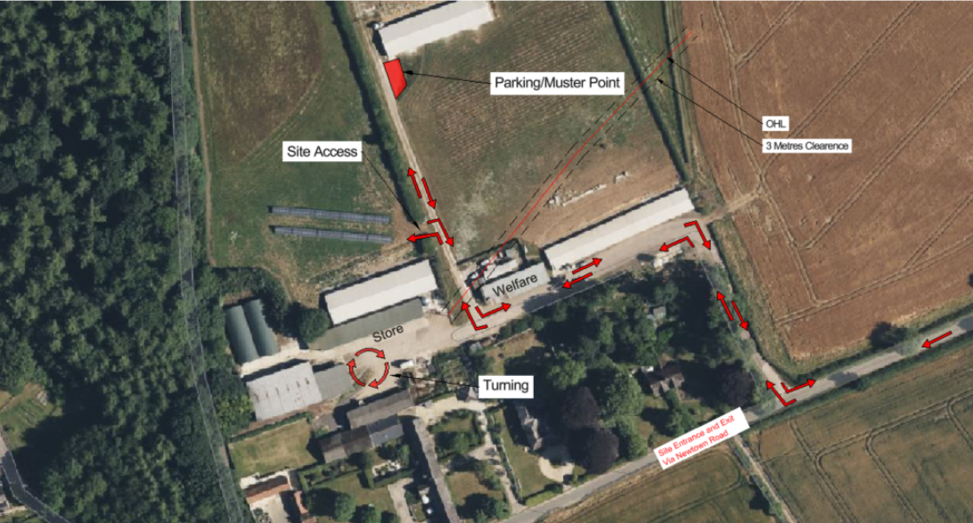

Fire and Emergency Procedures
The fire procedure will be displayed on the site notice board and will be shown as part of the site induction. The fire procedure will detail the locations of fire assembly point, fire extinguishers and the arrangements for any fire emergencies. The emergency procedure will also be displayed, which will cover the arrangements to follow in the case of any dangerous occurrence or injury to persons. This will include a map and directions to the nearest emergency department.

The nearest Accident & Emergency Dept can be found in Salisbury:
Salisbury District Hospital, Odstock Road, Salisbury, SP2 8BJ

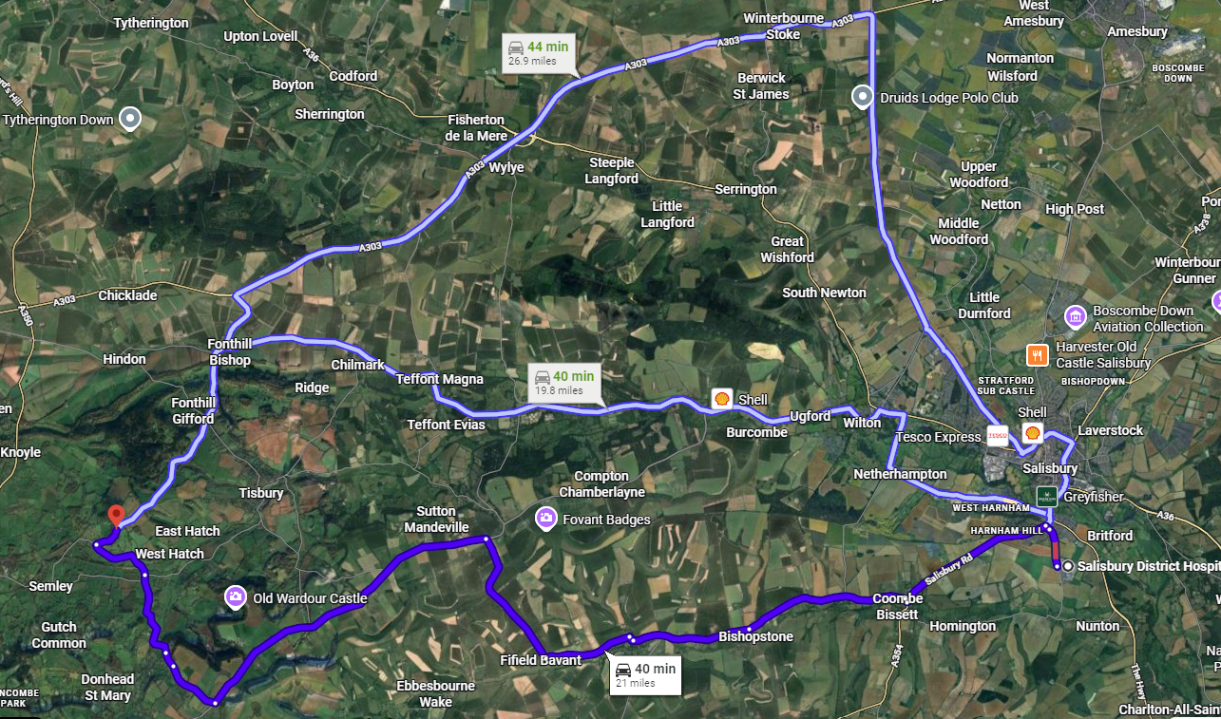

Fire Prevention
Fire prevention will be an important consideration from the outset. A fire risk assessment will be written ahead of the works and the construction manager will be responsible for its implementation and monitoring. Fire drills and training will be undertaken, and fire arrangements will be checked as part of the daily and weekly site inspections. The fire assembly point will be shown during the site induction. Hot works will be controlled with a permit to work, only once the appropriate method of works has been approved.

Site Establishment and Welfare Provisions

Site Layout and Setup

The site compound will include a site office, drying room, canteen, toilet block and storage units. Non-drinking water and fuel will be bought to site in the form of bowsers and tanks, which can be refilled when required. Drinking water will be bought to site in the form of bottled water, by a suitable supplier.

Welfare Arrangements
SSWUK will provide welfare facilities in line with the requirements of the Construction (Health and Welfare) Regulations. This will consider the numbers of contractors and subcontractors on site at any given time. Toilets, changing rooms, washing facilities, means of heating food and preparing hot drinks, a canteen and a supply of drinking water will be provided. Secure storage containers will also be provided, so that staff may store tools and equipment. The welfare facilities are to be kept clean and tidy and smoking is only permitted in designated areas.

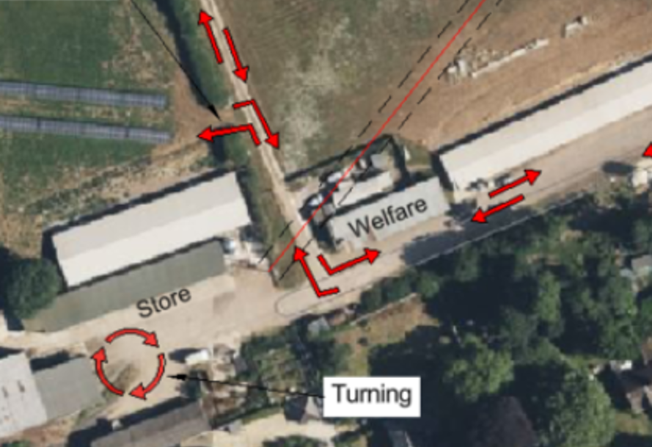

First Aid and Incident Reporting

First Aid Arrangements
First aid provisions are detailed on the noticeboard in the welfare unit, as well as the names and contact numbers of the nominated first aiders which are detailed above and on the site notice board. First aid boxes will be in the site office and welfare facility and will be stocked according to BS 8599-1: January 2019.

Injury Management
Where the injury is serious or urgent medical attention is required, the first aider will call the emergency services. The first aider will then administer first aid and will not leave the injured person until the emergency services arrive.
Where the injury is minor, first aid will be administered by the first aider.

Incident Reporting and Investigation
It is everyone’s responsibility to ensure that all of the following incidents are reported to
the construction manager:
    - Accidents
    - Incidents
    - Dangerous occurrences and/or dangerous working practices
    - Near Misses
The construction manager will record all incidents in the CDM site file. The incident will also be reported to SSW’s office, where it will be recorded on our accident log, in line with our H&S policy. If the incident triggers RIDDOR, it will be reported in accordance with RIDDOR guidelines.

All incidents will be investigated, starting with the construction manager completing an ‘Incident Report Form’. The construction manager will interview the injured person and witnesses and will record any observations and recommendations and make any changes to the method statement if deemed appropriate. The construction manager can seek advice from the professional health and safety advisor and raise any concerns with senior management. As per SSW’s health and safety policy, reactive monitoring and inspections may be required following an incident or accident.

Safe Systems of Work and Monitoring

Risk Assessments, Method Statements & Safe Systems of Work
Contractors will produce and submit their risk assessments and method statements (RAMS) to the project manager in advance of starting their works. This will allow the construction manager and project manager to review and make any amendments to the RAMS.

On acceptance, the construction manager will brief the relevant personnel on the RAMS. Personnel will sign the RAMS to confirm their acceptance and understanding. Works may commence once the RAMS have been signed. Risk assessments and method statements will be kept in the site file.

Monitoring
The construction manager is responsible for the day-to-day monitoring of health and safety on site. Weekly site inspections will be undertaken by the project manager and monthly site inspections will be carried out by the professional health and safety advisor. If the construction manager deems it necessary, inspections will be carried out at more regular intervals.

Issues of health and safety will also be discussed at the weekly site meeting and at the monthly health and safety meetings. Any signification health and safety issues will be raised with the client during the weekly client meetings.

Health and Safety Arrangements for Site Specific Risks

Manual Handling
All manual handling activities will be considered as part of the risk assessments and method statements and the necessary controls will be implemented. All SSW operatives and sub-contractors are required to have read and signed SSW’s manual handling risk assessment.

Wherever possible, mechanical aids will be used to assist with lifting and moving. Operatives will not lift beyond their capabilities and will use team lifting if necessary. Loads should be stable and secured and suitable PPE should be worn. Given the nature of the works, allowances will be made for rest breaks should there be repetitive manual handling tasks.

Lifting Equipment and Operations
All lifting operations will be planned and supervised by competent personnel. All lifting equipment will be fit for purpose and will have up-to-date safety certificates. Operatives will complete the heavy plant inspection check list daily to ensure that the lifting equipment is fit for use and all LOLER requirements are met.
Basic lifts may be covered by a risk assessment and method statement. If the lift is deemed intermediate or complex, a lifting plan will need to be put in place.

Operators of lifting equipment will hold valid CPCS cards for the category of lifting equipment they are using.

Plant and Vehicle Safety
Plant operators will conduct daily vehicle checks to ensure that all plant is safe and usable. Operatives will complete the plant daily check list. All daily check sheets will be saved in the site health and safety folder.

The construction manager will be responsible for ensuring that plant operators have the relevant certifications for the plant that they are using.

During the site induction, plant operators are to be shown the location of the refuelling area, Refuelling is not to take place outside of the designated area. The site induction

will also highlight the location of spill kits. Should any spills occur, the construction manager is to be informed immediately.

Site Traffic Management
A Construction Traffic Management Plan has been prepared.

The Construction Traffic Management Plan will be part of the site induction for
operatives, and it’ll be displayed on the notice board in the site office and welfare unit.
Access to the site is only via the existing farm entrance as marked below in red arrows.

Deliveries are to be scheduled and must only take place under supervision and with the aide of a qualified banksman.
Expected deliveries will include:
Welfare unit: 4X4 with a trailer
Solar Panels: 40ft curtain side 1No.
Metal framework: Flatbed lorry 1No.
Plant delivery: low loader plant trailer 2No.
Point of connection enclosure: HIAB lorry 1No.
Concrete lorry: 1No.
All other materials and operatives will arrive in small to medium sized vans: 4 or 5 vans per day expected

Maintenance of Tools and Equipment
All machinery and powered tools on site shall be maintained and inspected in line with the manufacturer’s recommendations and PUWER requirements. Operators will carry out pre-use checks, which will be detailed in the risk assessments and method statements. Should operators be unsure of how to carry out pre-use checks, the construction manager will provide a checklist.

The frequency and type of maintenance activities will depend on the following factors:
    - Manufacturer’s recommendations
    - Frequency of use
    - Operating environment
    - Age of equipment and any previous issues

Utilities and Services
Service checks have been carried out and an overhead mains electrical power lines are running across the site.

The following precautions will be taken:

Goal posts will be erected at the appropriate heights following the HSE GS6 Guidance.

Only plant that is below the recommended height and has a locking device fitted to any booms will be allowed to pass under the lines. They must also be under the supervision of a suitably trained banks man and only after a detailed risk assessment has been carried out accompanied by a permit to move plant.

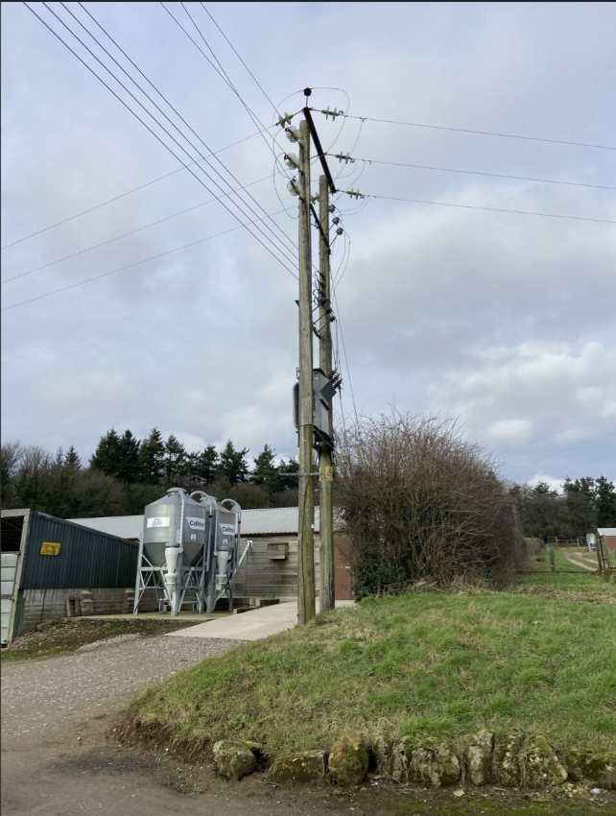

Should any plant or machinery come into contact with the overhead power line, the emergency procedure should be followed. A copy of the emergency procedure will be in the site health and safety file and will also be on display in the site office and welfare unit.

No other services are known to be on the site.

Excavations
A Risk Assessment and Method Statement (RAMS) will be produced and agreed with the Construction manager ahead of any excavations. Control measures will be put in place, which will include:

- CAT scanning the area prior to excavating.
- Obtaining a permit to dig before breaking ground.

    - Slips, trips and falls
    - Falling objects
    - Access and egress
    - Collapse of excavation
    - Underground services
    - A permit must be issued, to ensure we only excavate in the safe zones.

Control of Dust

Dust is not expected to be an issue on this site, however this will be monitored by the site manager and steps will be taken to address any dust should the need arise.

Contaminated Land
SSW’s employees and subcontractors are required to have current asbestos awareness training. The Construction manager may request certificates or issue the training, if required.
All operatives working on site are required to have received asbestos awareness training. The construction manager will check these qualifications during the site induction. Asbestos awareness will also form part of the site induction, which will be delivered to all operatives. Should any material suspected to contain asbestos be found on site, work must immediately stop and the Construction manager be informed.

Spill awareness will form part of the site induction, this will include showing operatives the location of spill kits. Operatives must try to avoid land contamination and spills, but any instances must be reported to the Construction manager. Spill kits will be available in the site office and can be used in an instance of spilled oils or fuels. Any significant land contamination should be reported to the Environment Agency.

Site Security

TBC

Storage of Materials
Tools and small equipment will be kept in designated storage containers. Components for the build will be kept in the storage containers or in designated areas of the compound. Materials will not be stored on transit routes nor on other walkways.
COSHH substances will be stored in designated COSHH cabinets. Flammable materials will be stored away from other materials which may risk accidental ignition.

Storage areas will be kept tidy, with good standards of housekeeping maintained and deliveries will be arranged to keep the number of materials kept on site to a minimum. If materials are to be stacked, consideration needs to be given to whether there is a risk of falling and if the materials can hold the weight.

Interaction with Members of the Public
If a member of the public should access the site, works should immediately cease, the member of the public escorted from the site and the Construction manager informed. The Construction manager will review the security measures and additional measures will be put in place, if required.

Working with Electricity
Operatives will be notified of the dangers of working with electricity during the site induction. All electrical works will be carried out under permit, all MV/HV works must be carried out by an Authorised person only with demonstratable qualifications.
Only qualified electricians are permitted to make final connections on DC or AC cables.

Any questions in relation to DC cabling on site should be referred to the Electrical Manager or Supervising Electrician. IF IN DOUBT ASK will be featured on signage and made clear during induction.

All electrical works will be in compliance with BS 7671:2018 Wiring Regulations (18th Edition). Electricians will use test probes and equipment that is calibrated and proven operational and all electrical work will be tested on completion.

Site File and Documentation

Documents on Display
The following documents will be displayed in the site office and welfare area for the duration of the works:
    - Site layout plan
    - First aiders
    - Fire Procedure
    - Emergency Procedure
    - Accident Reporting
    - Hospital Location
    - Site Rules
    - Contact Details
    - Health and Safety Policy
    - Environmental Policy
    - Site Management Chart
    - Employer’s Insurance
    - F10 HSE Notification of Works
    - Health and Safety Law Poster

Signs on Display
The following signs will be displayed externally, outside of the site office and welfare area for the duration of the works:
    - Mandatory Health and Safety Sign
    - No Unauthorised Persons
    - Mandatory PPE sign
    - Speed Limit
    - Muster point

Site File
Throughout the works, all project specific information and documentation will be held on SSW’s File Server. The Construction manager will also maintain a physical copy of the health and safety file on site. Each week, the Project Manager will scan all physical documents which have been completed on site, and these will also be stored on the File Server.

The site file will be compiled by SSW. Should the client require any specific documentation, this will also be included in the site file.

The file will contain the following:
    - Induction register
    - Sign in/out register
    - Construction Phase Plan
    - Risk assessments
    - Method statements
    - COSHH assessments
    - Sub-contractor Risk Assessments and Method Statements
    - Company’s insurance documents
    - Subcontractor’s insurance documents
    - Permits to work
    - Permits to work register
    - Machinery and equipment register
    - HAVS register
    - Tool-box talks
    - Tool-box talk log
    - Site diary
    - Works programme
    - Incident report log
    - Incident investigation report
    - Health and safety policy
    - Disciplinary diary
    - Weekly safety inspection reports
    - Statutory inspection reports
    - Heavy plant inspection checklist
    - Minutes of safety meetings
    - Health and safety consultant’s reports
    - Record of fire alarm testing/Emergency evacuation drills
    - Staff training certificates

Appendices

Appendix 1 – Waste Management Plan

Introduction
This Waste Management Plan outlines the procedures and practices to be followed during the construction phase of the project. The objectives are:
- To minimise waste generation
- To maximise reuse and recycling of materials
- Ensure proper handling of waste and recycling
- To comply with environmental regulations

The Waste Hierarchy
The Waste (England and Wales) Regulations 2011 priorities the prevention of waste and obliges businesses who produce or handle waste to apply the ‘Waste Hierarchy’ to their operations.
Dispose
Recover
Recycle
Reuse
Reduce
Prevent

Waste Prevention and Reduction
Waste prevention and reduction has been considered from the design phase of the project. Our primary aim is to keep potential waste to a minimum.

Waste Separation for Reuse and Recycling
Where possible, the separation of waste will be carried out on site to maximise the possibility of reuse and recycling. The segregation of waste will form part of the site induction and there will be Toolbox talks regarding waste management.

Waste Storage and Disposal
All areas used for the storage of waste on site will comply with DEFRA and EA guidelines. Any hazardous waste will be stored in separate, secure containers. Disposal of waste will be carried out safely and in line with the Landfill Directive 1999.

Types of Waste
We anticipate the following waste steams:
- Construction waste
  - Soil and earth
  - Concrete
  - Metals and cable
  - Wood
  - Plastics
- Hazardous waste
  - Paints and solvents
  - Oils and lubricants
  - Electronic waste
- General waste
  - Paper and cardboard
  - Food waste
  - Sanitary waste
- Waste water

Waste Management Procedures

Waste Reduction
The project has been designed with a mind to longevity and components have been selected for their quality. Designs have been optimised to minimise material use. In particular, cable lengths and table sizes have been selected for effective material management.

Through quality management and planning, materials will be ordered to a high level of accuracy, keeping waste to a minimum. Any spare materials are also likely to be used in future projects.

Waste Segregation
Where possible, waste will be separated on site into four categories: reusable, recyclable, non-recyclable and hazardous. Waste segregation will form part of the site induction and operatives will be made aware of their responsibility to handle waste correctly. There will be clear signage to show where these categories of waste should be stored on site.

In the welfare unit, there will be bins for general waste and for recyclable materials. It will be the responsibility of the construction manager to ensure that the general waste and recyclable materials are kept separate in the welfare areas.

Waste Storage
In the site compound, there will be designated areas for the storage of waste. There will be individual skips for the following types of waste:
        - General waste
        - Metal – recycling
        - Domestic recycling
The skips will be clearly marked so that operatives are clear where the waste should be stored. Waste from the welfare unit must be moved into the general waste and domestic recycling skips on a daily basis.

Hazardous waste such as containers of paints, solvents and lubricants will stored in a separate COSHH container. Broken PV modules will be stored separately on pallets within the site compound.

Waste Collection, Transportation and Disposal
Waste transportation will take place at regular intervals during the project to avoid a build-up of waste on site. Where possible, deliveries will remove wate materials to minimise return trips.

Only registered waste carriers will be authorised to transport waste from the site. A Waste Transfer Notice (WTN) will be completed for each collection of waste. The Construction manager must keep copies of the WTNs within the site file. Should there be any hazardous waste movements, including any used spill kits, Waste Consignment Notes (WCNs) will be purchased and the waste removed from site.

Recycling and Reuse
In the establishment of the compound, there will be a small excess of soil and rock. This spoil will be placed in small heaps around the perimeter of the site. At the conclusion of the works, the spoil will be put back in place. The gravel used in the construction of the compound will be transported to another site for reuse.
It is likely that there will be an excess of metal and cable from the mounting system and the off-cuts of AC and DC cabling. These will be kept to a minimum through careful planning and modular construction techniques. However, any waste metal will be stored in metal recycling skips before being removed from site.
Broken PV modules will be collected by a designated solar panel recycling company. A WTN will be completed for each collection and records maintained. Domestic recycling will be removed from site by a registered waste carrier, in order to avoid the build-up of

landfill. Where possible, pallets will be reused and removed from site for the purposes of reuse. Should the pallets not be in a condition for reuse, they shall be dealt with as general waste.

A.1.4.7 Waste Water Reduction and Disposal
Toilets and handwashing facilities in the welfare area will utilise septic tanks. These will be emptied at weekly intervals during the construction phase.

Monitoring and Reporting
The Construction manager will keep a copy of all Waste Transfer Notices in the site file. These will also be shared with the Project Manager, who will keep a record of the types and quantities of waste that have been removed from site. The Project Manager will also keep a record of waste on the ‘ESG Environmental Report’, which will be shared with the client at regular intervals.

The Project Manager will make regular site visits to ensure that the Waste Management Plan is being followed. The Waste Management Plan may be updated to reflect any changes on site.

Emergency Procedures
Operatives must be vigilant to avoid spills of hazardous materials. Any instances of spills of hazardous material must be reported to the construction manager. Spill kits are available in the site office and are to be used in the instance of spilled oils or fuels. Any significant land contamination should be reported to the Environment Agency.

Appendix 2 – Emergency Procedure

Emergency Procedure

In the event of a dangerous occurrence or an injury to persons, the following procedure is to be followed:
- A First Responder is to attend to the injured person and an Appointed Person is to contact the following:
  - Emergency services
  - Operations Manager
  - Health & Safety Manager
  - The injured person’s employer, if a subcontractor
- Post a person at the site entrance to direct the emergency services to the accident site.
- Ensure the area around the incident is cleared of non-essential personnel.
- Keep a record of the events and take photographs of the accident area.
- Ensure details of the injured person and their injuries are kept and entered into the accident log.
- Record where the injured person has been taken for treatment.

- Notify the HSE, in conjunction with the safety advisor, where appropriate.

Appendix 3 – Environmental Management Plan

Introduction
The Environmental Management Plan provides the overarching principles in relation to how environmental issues that arise will be handled to ensure compliance with the relevant legislation. The aim is to minimise environmental impacts, ensure compliance with the relevant regulations and to promote sustainability.

Environmental Aspects and Impacts
The potential environmental aspects and impacts associated with the construction works are as follows:
- Land disturbance
  - Soil erosion
  - Habitat disruption and bio
- Air quality
  - Dust generation
  - Emissions from construction equipment and vehicles
- Water quality
  - Wastewater discharge
  - Stormwater runoff
- Waste management
  - Construction waste generation
  - Hazardous waste generation
- Disruption to the public
  - Light pollution
  - Noise pollution

Environmental Management Procedures

Land Disturbance
There are no plans to clear any vegetation as part of the construction works. The site is surrounded by hedgerows, and these are to remain undisturbed for the duration of the works. Should any trees or hedges be disturbed during the works, the client will be notified and subject to approval, they will be replaced with native plants as quickly as possible.

Air Quality
With regards to emissions, all plant shall be serviced and maintained in line with the manufacturer’s recommendations, to ensure proper use. Operators will ensure that engines are turned off when plant, vehicles and machinery are not in use. Deliveries to site will be planned and timed to avoid unnecessary journeys to and from site.
Wheel washing facilities will be available on site and will be used should there be a build up of dust or mud at the site entrance. This will prevent a spread of dust and mud onto the roads. Should the Construction manager notice a significant build-up of dust or mud at the site entrance, additional measures such as sprinklers may be required.

Skips containing dusty materials will be covered and stored materials liable to dust generation shall also be covered or contained.

Water Quality
The initial site surveys have not identified any bodies of water that might be affected by the construction works.

COSHH items will be stored in a secure cabinet, away from water sources and a log will be kept of the items stored inside. Spill kits will be used should there be any spill incidents on site. Should there be any concerns with plant or equipment leaking plant nappies will also be available for use.

Waste Management
A Waste Management Plan has been developed, with the aim of reducing, reusing and recycling as much waste as possible. Any waste to be disposed of shall be done in a safe and appropriate manner.

Disruption to the Public
All construction works, including deliveries of materials and equipment shall only take place between the following hours:
        - 0800hrs to 1800hrs – Monday to Friday
        - 0800hrs to 1300hrs – Saturdays
        - No work shall take place on Sundays or Public Holidays.

Plant and machinery capable of generating significant noise and vibration levels will be operated in a manner to restrict its duration. Plant operators will ensure that engines are not left running when not in use. The Construction manager will ensure that generators are only left running when the welfare unit is in use of when battery operated equipment requires charging. Wherever possible, battery-operated equipment shall be used instead of fuel powered generators.
The site induction will make all operatives aware that no stereos shall be audible beyond the site boundary. Outside of working hours, there will be manned security at the site.
Noise must be kept to a minimum and the generator must only be used when the welfare unit is in use.
Flood lighting will not be used outside of working hours.

Monitoring and Reporting
The Project Manager will make regular site visits to ensure that the Environmental Management Plan is being followed. The Environmental Management Plan may be updated to reflect any changes on site.
The Project Manager will also keep a record of waste on the ‘ESG Environmental Report’, which will be shared with the client at regular intervals.

Appendix 4 – Traffic Management Plan

Site Location

The site should be accessed via the A303 following the route marked on the maps below.

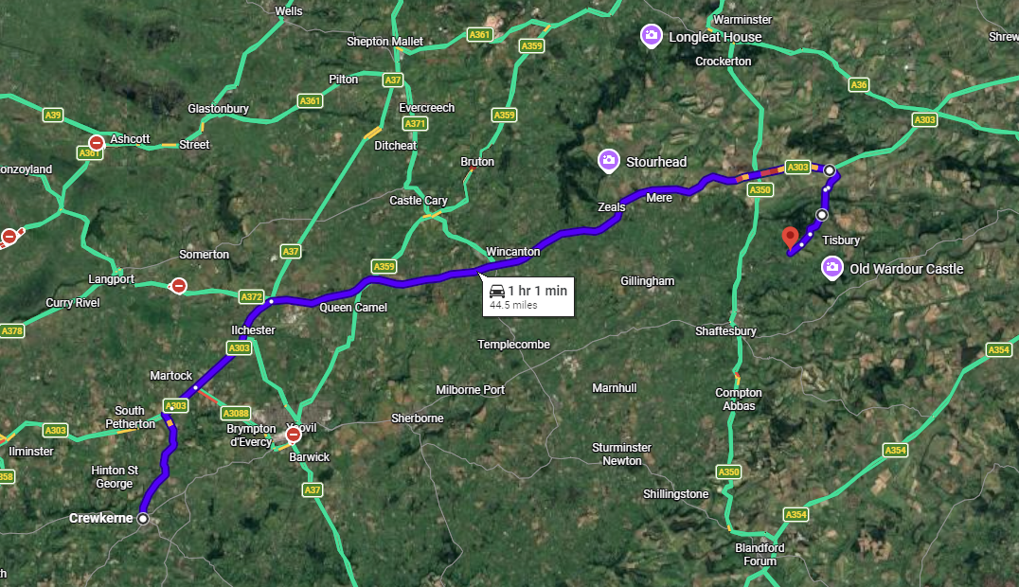

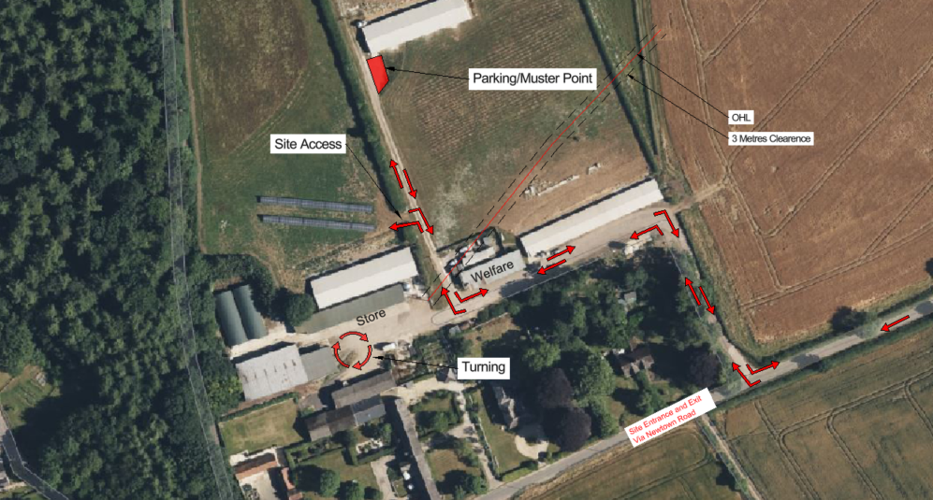

Pre-Construction Works
Prior to the commencement of works, photographic or video evidence will be taken to show the condition of the access roads.

The Traffic Management Plan will be submitted to the client for approval ahead of the works. Once the Plan has been approved by the client, it will be submitted to the Highways Authority for their approval.

Construction Schedule

Working Hours
The construction works will last for a period of 4 to 5 weeks. All construction works, including deliveries of materials and equipment shall only take place between the following hours:
        - 0800hrs to 1800hrs – Monday to Friday
        - 0800hrs to 1300hrs – Saturdays
        - No work shall take place on Sundays or Public Holidays.

Schedule of Works

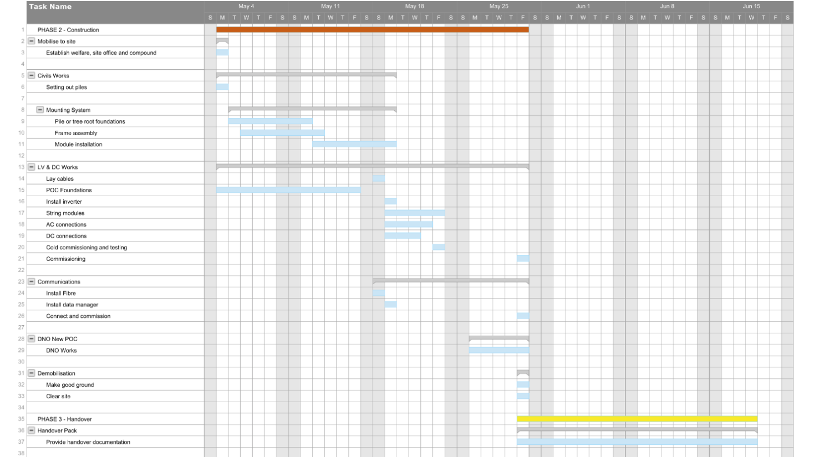

Workforce
It is anticipated that there will be between 10 and 15 operatives on site during the construction works.

Delivery Schedules and Loading/Offloading
In so far as possible, deliveries will be scheduled to arrive outside of the peak hours of 0800hr-0900hrs and 1600hrs – 1700hrs. This should minimise disruption to the local flow of traffic.

Deliveries will be staggered so that no more than one HGV will be on site at any given time. This is due to there being only one turning area within the site compound. A telehandler will be used to offload deliveries. A qualified banksman will direct the plant operator and HGV driver in the safe offloading of deliveries.

Designated Routes

All routes must be followed as per the traffic management plan.

Parking

Parking areas will be marked out on site once the works have begin

Traffic Control Measures
A speed limit of 10mph will be in force within the boundary of the site. The speed limit will be in place to enhance the safety of pedestrians whilst on site. Signs showing the speed limit will be erected at the site entrance, within the site compound and at intervals along the access track.
All welfare facilities will be located at the western edge of the site compound. This will ensure that most of the pedestrian movements within the compound are concentrated in one area, away from the parking area and turning area for HGVs. Fencing will be erected across the front of all welfare facilities to prevent vehicles from approaching. Pedestrians will also not be permitted to cross the turning area. Warning signs will be
erected within the site compound to direct the flow of traffic and pedestrians. Operatives will also be required to always wear high-visibility clothing.

A qualified banksman will be used during critical operations, including deliveries and loading and offloading. For daily traffic movements, spotters may be used during busy periods should there be a build-up of traffic.

Emergency Access
It is the responsibility of the Construction manager to ensure that the site entrance is always clear. This provides clear access for emergency vehicles, should any incidents occur. Should there be any dangerous occurrences or incidents on site, the access track must also be kept clear and a signaler will be posted at the site entrance to direct the emergency services.

Monitoring and Reporting
The Construction manager will keep a record of all deliveries in the site file. These will also be shared with the Project Manager, who will be responsible for the delivery schedule.
The Project Manager will make regular site visits to ensure that the Traffic Management Plan is being followed. The Traffic Management Plan may be updated to reflect any changes on site.

Should any traffic incidents occur, these will be recorded in the accident/near miss log and reported to the relevant authorities.

Post-Construction Works
At the conclusion of the works, a further survey of the condition of the roads will be undertaken. In the event of any damage, roads will be restored to the condition that they were in prior to the commencement of works.

Appendix 5 – Project Management Plan

Organisation

Project Management Structure
TBC

Responsibilities

Project Director
        - Responsible for directing and leading the team throughout the project.
        - Hold overall responsibility for health and safety and ensuring all SSWUK’s policies
are understood by the team and adhered to.
        - Assume overall responsibility for strategic decision making.
        - Overall monitoring of the projects progress and managing any business risks.

Operations Manager and Electrical Manager
        - Ensure that works are delivered safely and within the given timeframe and budget.
        - Appointment of persons to ensure suitable and sufficient resources for the duration of the project.
        - Responsible for the site being properly supervised and secured.
        - Assume overall responsibility for the review of designs and quality assurance.
        - Approval of components and products.

Project Manager
        - Ensuring that suitable risk assessments and method statements are prepared.
        - Tracking the progress of the project through the Project Management Interface, identifying any risks and developing mitigating actions.
        - Preparation of a Construction Phase Health and Safety and Environmental Plan, programme and site management reports.
        - Ensure Contractor’s Documentation is prepared and shared with relevant
parties.
        - Responsible for the provision of welfare facilities.
        - Liaison between the client, contractors, principal designer and site team.

Principal Designer and Project Designer
        - Design, review and approve required drawings and plans.
        - Liaise with the Project Manager and wider team to ensure that all appropriate information for the Construction Phase Health and Safety and Environmental Plan is shared.
        - Maintain records of designs and version history.

Electrical Supervisor
        - Monitoring and inspection of all electrical contractors working on site.
        - Ensuring electrical works are carried out in accordance with electrical safety standards and guidance.
        - Testing and commissioning of the electrical systems on site.

Construction manager
        - Ensure that the works carried out comply with the requirements in this plan, the
H&S documentation, RAMS and SSWUK’s policies.
        - Responsible for site inductions and keeping records of contractors’ attendance.
        - Ensure site diary and all other H&S documentation is kept up-to-date.
        - Responsible for checking that contractors and operators have the relevant qualifications and certificates.
        - Ensure that all accidents and near misses are recorded in the accident log and
reported according to SSWUK’s policy.
        - Ensure that contractors have appropriate personal protective equipment (PPE).

H&S Manager
        - Provide professional advice and support on health and safety.
        - Review all Risk Assessments and Method Statements.
        - Monitor health and safety performance.
        - Carry out monthly visits to site to ensure health and safety procedures are being followed.

All Staff and Subcontractors
        - Ensure they are working in accordance with SSWUK’s Health and Safety Policy,
Procedures, Risk Assessments and Method Statements.
        - Report any unsafe conditions to the Construction manager.
        - Only undertake tasks for which they have been trained and have the necessary experience and qualifications.
        - Ensure tools and equipment are maintained and in a safe condition.
        - Wear PPE as directed and required.
        - Take care of their own health and safety and that of others affected by their work.

Project Management Interface

Overview
SSWUK utilises a Project Management Interface, hosted by Smartsheet. The dashboard (pictured below) is fed by the project plan, project metadata and project milestones.
Smartsheet is cloud based, meaning that multiple people can input data onto the interface in real-time and changes can be tracked using the activity log. It is possible to create summary reports to demonstrate the current status of the project and these can be shared with the wider project team and the client. There is also a file storage system, on which files from Dropbox and OneDrive can be attached.
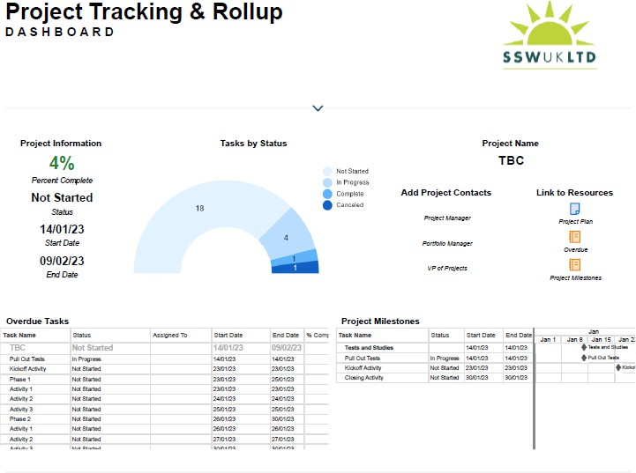

The Project Plan
The Project Plan is based on the delivery schedule and project milestones. The project is split into phases and then into tasks and activities. Each task is allocated to a member of the team. The target dates will be populated by senior management and are based on the programme of works. There is a traffic light system, which the Project Manager will use to highlight any risk factors and overdue tasks. The Project Plan feeds into a Gantt chart, which records the schedule and can feed into the team’s calendar.

Updating and Managing the Interface
It is everyone’s responsibility to keep the Project Management Interface up to date. Members of the team will record their actions on their allocated task on the Project Plan. They can also make notes and attach files to share with the project team. Should a task or action need to be added to the Project Plan, the Project Manager will be notified and will decide where it needs to be included, who it should be allocated to and the target date.

It is the responsibility of the Project Manager to make daily checks of the Project Management Interface and to ensure that it is fully updated. The Project Manager will also update the traffic light system and will use the automations on the interface to notify a member of the team if their tasks are overdue or at risk of being delayed.

Project Phases

Design
The principal designer and project designer are responsible for developing the designs for the project, storing the designs on Dropbox and recording any changes made on the interface. This includes general arrangement drawings, detailed designs and calculations. Some designs required for the project will be provided by Solar Port Systems, HVUS and KJ Hobbs Construction. The principal designer shall ensure that Dropbox files are kept up-to-date and old designs are placed into archive folders. The principal designer shall use Smartsheet to record changes to and versions of the designs. The Operations Manager, Electrical Manager or Project Manager will review all designs prior to internal approval. The designs will then be submitted to Bluefield, allowing 14 days for review and submission to the Local Planning Authority.

Throughout the design phase, SSWUK and its subcontractors will adhere to the conditions specified in the planning permission and will take into account any issues raised in the site investigation reports. SSWUK will also design the Solar PV system in accordance with the Employer’s Requirements and applicable UK and European Standards.

Procurement and Subcontracting
Once Bluefield have received the designs and decided which components are preferred, SSWUK are responsible for sourcing and procurement. This will involve negotiating contracts and agreements with manufacturers, suppliers and subcontractors. The procurement stage of the project will also inform the construction programme, so it is important to ascertain lead times early on.

Subcontractors will be required to sign the Collateral Warranty Agreement and will also be required to complete SSWUK’s Contractor Competence Questionnaire and provide any supporting documentation.

The Managing Director and Project Manager will liaise with suppliers and manufacturers to establish costs, lead times, shipment, delivery and warranties. They will also be required to provide evidence that their products and services comply with the standards and quality specified in the Employer’s Requirements. Any evidence and documents provided will be saved in the project file and made available to Bluefield. Manufacturers will also be required to provide installation instructions and recommendations for use, along with their warranties. The Project Manager will ensure that manufacturer’s warranties are assigned to Bluefield during the project handover.

Construction
Prior to construction, SSWUK will submit a programme to Nadder Community Energy detailing the timings of the build, from procurement to handover. Prior to mobilisation, SSWUK will take photographs of the area to document the state of the ground, roads, and site. The Project Manager will will ensure that welfare and storage facilities are hired and available.

The works will be carried out in accordance with the Construction Phase Plan, Construction Environmental Management Plan and Construction Traffic Management Plan. The Project Manager will liaise with the Construction manager to make sure that the construction is compliant with CDM regulations and the Health and Safety CDM file is completed.
Progress Meetings will be held weekly, either on site or virtually. These meetings will be an opportunity to assess actual progress against the programme of works and any risks to the construction programme. Should any significant changes to the programme be required, an updated programme will be submitted to Nadder Community Energy for review and comment. If any risks are identified during the Progress Meeting, the Project Manager will include these in the fortnightly Progress Reports and record them on the Project Management System.

Throughout the construction phase, the Electrical Manager and Operations Manager will carry out inspections to ensure the quality of the works and that installation has been carried out in line with manufacturers’ recommendations.

Testing and Commissioning
All testing will be carried out in accordance with applicable UK and European Standards.

Handover
Following the successful completion of the tests, the Project Manager is responsible for compiling the handover documentation. The detailed test and commissioning results
will be checked against the ‘as-built’ designs to ensure that they are correct. The Electrical Manager, Operations Manager and Principal Designer will quality check there ahead of them being sent to the client. ‘As built’ drawings will also be obtained from subcontractors regarding their works and checked for quality.
The Project Manager will also provide the client with an Operation and Maintenance Manual for overall plant operation this will also refer to and include detailed technical information from manufacturers.

Once all handover documentation has been provided, punch list items complete and Tests on Completion passed, the client will send SSWUK a Works Completion Certificate. Once this has been received, SSWUK will arrange Completion Performance Tests to be carried out.

Communications
      - Communication Methods

From | To | Function | Frequency
Construction manager | All Staff and Subcontractors on  site | Daily briefings, Toolbox Talks, Health and Safety  issues | Daily
Construction manager & Electrical  Supervisor | Project Manager and/or Senior Management | Status of works and deliverables, risk factors, Health and  Safety | Daily
Principal Designer | Project Manager | Reviews of any designs,  drawings or plans | Weekly, or as  required
Project Manager | Senior Management | Status of works and deliverables, risk factors, Health and  Safety | Weekly, or as required
Project Manager | Subcontractors | Status of works and deliverables, risk factors, Health and  Safety | Weekly, or as required
Project Manager | H&S Manager | Health, Safety and  Environment | Fortnightly, or  as required
Project Manager | Client | Progress report (as per  Schedule 12 EPC) | Weekly, or as  required

      - Standing Meetings
Meeting | Who | Description
Site Meeting | Construction manager, Project Manager, Electrical Supervisor and Subcontractors (as  required) | Weekly discussion on status, schedule, deliveries, risks and Health and Safety
Progress Meeting | Project Manager, Electrical Manager, Operations Manager and Subcontractors (as  required) | Weekly discussion on schedule, risks, costs, and anything raised at site meeting
Client Meeting | Project Manager and  Client | Monthly discussion on progress reports  and status of deliverables
H&S Meetings | Construction manager, Project Manager and  H&S Manager | Monthly visit to discuss Health and Safety on site

      - Recording
At the start of the meeting, a person will be designated as the note-taker. They will upload their notes from the meeting into the project folder. The Project Manager will also record any actions required from the meeting onto the interface.

Coordination with Subcontractors
In the design phase of the project, SSWUK will select subcontractors for the works who have the experience to complete the works in line with good industry practice.
Subcontractors will be required to complete a pre-qualifying questionnaire and all records of competence, training and insurance will be held on file.
Ahead of construction, the Project Manager and Electrical Manager will liaise with the subcontractors so that their works can be included in the programme of works.
Subcontractors will be required to provide risk assessments and method statements ahead of their works. Depending on the nature of the works, an individual programme from each subcontractor may be required.
Once the subcontractor is on site, the Construction manager and Project Manager will maintain daily contact in the form of in-person or telephone conversations.

Subcontractors will also be required to attend site meetings and progress meetings, as required.

Timeline and Milestones

Programme of Works
Insert Smartsheet

Milestones
Milestone table

Risk Management

Risk Identification
Risk identification begins at the quoting stage of the project and continues throughout the delivery. It is the process of identifying any situations that could impact on the delivery, cost, and quality of the project. A potential risk can be highlighted by a member of the team, raised in a meeting, or reported to the Project Manager or Construction manager. The Senior Management will assess the probability and impact of the risk and any potential implications on the project and delivery.

Risk Mitigation and Response
Risk mitigation depends on the severity of the risk and its impact on the project. The Project Manager will coordinate with other members of the team to determine the mitigation actions and who will be responsible for managing the response. A further impact assessment will be undertaken, and the Project Manager will liaise with the persons responsible for the mitigation actions and inform the client of any critical issues. The risk will be recorded on the project management interface, along with any actions recommended and a timetable in which they are to be completed.

Risk Monitoring and Resolution
Risks are reviewed and discussed during project meetings and the Project Manager continually monitors risk mitigation actions and plans. If a risk is realised and becomes an issue, the project schedule will be reviewed, and re-planning may be required. The client will be informed of the risk, the mitigating actions taken and the impact on the project. If a risk is not realised, the Project Manager will inform the wider team that no further action is required.

Quality Management

Design Quality Management
During the design phase of the project, the Principal Designer will check all construction- issue designs. The designs will also be checked by the Electrical Manager and Operations Manager, against the relevant British Standards and Building Regulations. Should there be any questions regarding the quality of the designs, SSWUK will ask an independent party to assess the designs.
SSWUK will establish the quality policy of any manufacturers or subcontractors completing any design work for this project.

Quality Management During Construction
During construction, the Electrical Manager and Operations Manager will refer to the manufacturers’ guidelines, standards, and installation manuals to check the quality of the works. Weekly inspections of the works will be carried out, to ensure that the construction meets the quality standards provided by the manufacturer and set out in the employer’s requirements.
Any concerns raised regarding the quality of the work shall be reported to the Construction manager and Project Manager and depending on the urgency will be raised with staff and subcontractors immediately or during the Site Meeting. SSWUK will develop a plan to rectify any quality issues and will provide staff and subcontractors a target date for rectifying the issue. The Project Manager will assess any implications on the programme.

SSWUK will also invite all manufacturers to assess the installation and provide any photographic or video evidence, if required. Should a manufacturer’s ‘sign off’ be required, SSWUK will facilitate this and will record any quality issues raised and plan for these to be rectified.

Snagging
At the conclusion of the works and following the weekly site inspections, the Project Manager will develop a snagging list of any outstanding quality issues. This list will be shared with the Construction manager and any relevant subcontractors, along with a timeline for the completion of any snagging works. When SSWUK are happy that the works have been completed to the required standard, the project will move into the handover stage

Foot note:
The project may be subject to an O/M contract. This would involve engineers attending the site once a year for a day to carry out cleaning and maintenance. Also, on an ad hock basis to deal reactively to any issues with the system.
Any visits to site are not expected to be any longer than one day at a time.

Traffic Management:

In all cases engineers will attend site in a large van or 4X4. No other vehicular traffic is expected to be used during the O/M contract period. They will also continue to follow the traffic management plan that is listed above.

