APPLICATION FOR FULL - PLANNING PERMISSION
CASE OFFICER REPORT

APPLICATION REFERENCE: | PL/2025/08747
APPLICATION TYPE: | Full planning permission
SITE ADDRESS: | Land at Elms Farm, Elms Cross, BA15 2AL
DEVELOPMENT DESCRIPTION: | Erection of a self-build dwelling with hard and soft landscaping, parking and associated works following demolition of the existing agricultural barn.
RECOMMENDATION: | REFUSE

SITE DESCRIPTION/CONTEXT: The application site is located at Elms Cross, Westwood. The wider existing site comprises a dog day care use (subject to regulation under application reference PL/2025/09768), and historic equestrian and agricultural use. The site is in open countryside and located outside the defined limits of development for Westwood.

The subject site is located within the Green Belt and within various core roost buffer zones associated with the Bath and Bradford on Avon Bat Special Area of Conservation (SAC).

The application site is not shown to be at risk of surface water flooding and is entirely within Flood Zone 1 according to the Environment Agency’s Flood Map for Planning. However, with reference to the Council’s Strategic Flood Risk Assessment (SFRA), the site is shown to be at high risk of groundwater flood risk, as shown in the extract provided below. The areas at risk of high groundwater flooding are depicted by the dark orange and red shading. As shown below, the entire site is washed over by dark orange, confirming that the site is within an area at risk of groundwater flood risk:

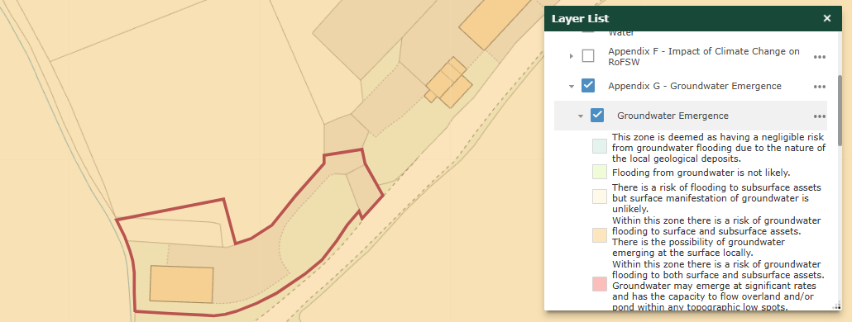

The building that is subject to demolition is located within the south-west corner of the site and has been formerly used for agricultural storage.

PROPOSAL: This application is seeking planning permission for the demolition of the existing agricultural barn and the construction of one self-build dwelling with associated hard and soft landscaping and on-site car parking provision. With reference to the completed application form, the proposed dwelling would be completed in rubble stone, under a slate and clay roof.

Extracts of the proposed elevations for the new dwelling are provided below:

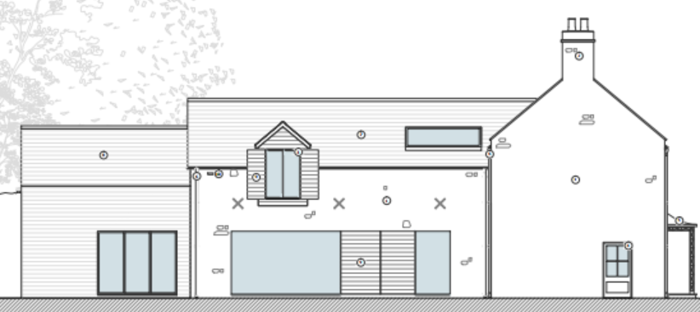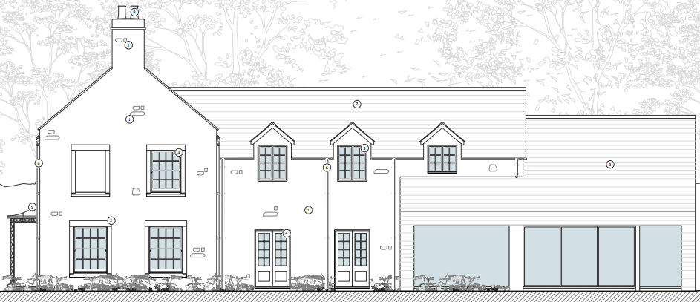

Proposed south and north elevations

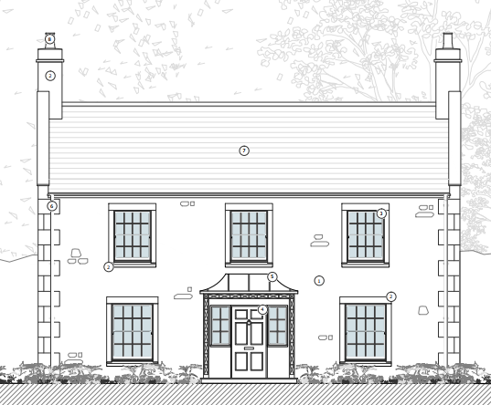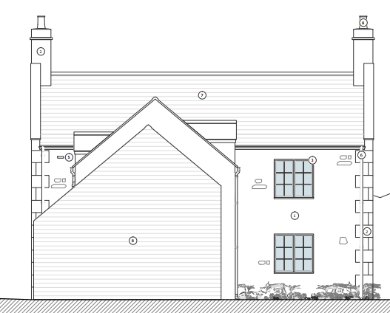

Proposed front (west) and rear (east) elevations

The agricultural building that is to be demolished as part of this application was subject to a Class Q Prior Approval application (reference PL/2024/02742) for the change of use of the existing agricultural building to a dwellinghouse, which was granted in September 2024. The proposed dwelling would be sited to the north of where the current agricultural building is located.

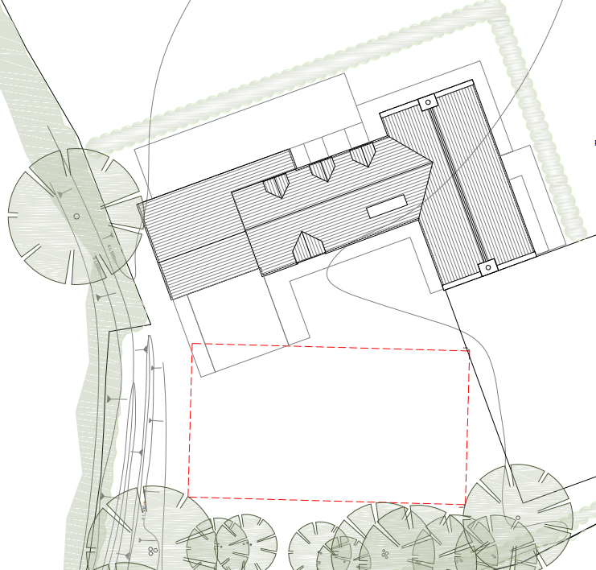

Proposed landscaping plan – the red dashed line represents the footprint of the agricultural building to be demolished as part of this application

RELEVANT PLANNING HISTORY

PL/2024/02742 - Class Q change of use of 1 no. agricultural building to a use class C3 (dwellinghouse) together with building operations reasonably necessary to convert the building - Prior Approval Granted

PL/2021/09419 - Variation of condition 1 on W/11/02028/FUL to allow for some livestock to be housed in building - Approved with conditions

W/11/02028/FUL - Retrospective application for an agricultural building for the storage of animal fodder and farm machinery – Approved with conditions

W/02/00237/FUL - Proposed erection of stables and haystore/tack room - Approved with conditions

RELEVANT LEGISLATION, POLICIES AND GUIDANCE

National Planning Policy: National Planning Policy Framework (NPPF); Planning Practice Guidance (PPG); National Design Guide

Development Plan: The development plan for Wiltshire comprises the Wiltshire Core Strategy (WCS) (adopted January 2015) and any made neighbourhood plans, which remain the principal statutory planning document guiding development across the county. In line with Section 38(6) of the Planning and Compulsory Purchase Act 2004, planning decisions must be made in accordance with the development plan unless material considerations indicate otherwise.

Though the development plan is considered as a whole, those parts deemed to be particularly relevant to this application are listed below:

The adopted Wiltshire Core Strategy (WCS), with particular regard to: CP1 - Settlement Strategy; CP2 - Delivery Strategy; CP7 - Spatial Strategy: Bradford on Avon Community Area; CP50 - Biodiversity and Geodiversity; CP51 – Landscape; CP57 - Ensuring High Quality Design and Place Shaping; CP60 - Sustainable Transport; CP61 - Transport and New Development; CP64 - Demand Management; CP67 - Flood Risk

Wiltshire Local Plan Pre-Submission Draft 2020-2038 (at Regulation 24 Stage) – The Council’s draft Local Plan has reached Regulation 24 stage, although at the time of writing this report, the examination has been paused by the examining inspectors and the hearing sessions postponed.

Emerging Policies:
Policy 1 – Settlement strategy
Policy 2 – Delivery strategy
Policy 4 – Addressing climate change
Policy 70 – Sustainable transport
Policy 71 – Transport and new development
Policy 73 – Demand management
Policy 78 – Meeting Wiltshire’s housing needs
Policy 82 – Housing in the countryside
Policy 85 – Sustainable construction and low carbon energy
Policy 88 – Biodiversity and geodiversity
Policy 89 – Biodiversity net gain
Policy 91 – Conserving and enhancing Wiltshire’s landscapes
Policy 95 – Flood risk
Policy 98 – Ensuring high quality design and place shaping
Policy 99 – Ensuring the conservation and enhancement of the historic environment

Supplementary Planning Documents and other Guidance:
- Wiltshire Design Guide, adopted April 2024
- Wiltshire Local Transport Plan 2011-2026 (LTP3), adopted 2015 and includes the Car Parking Strategy and Cycling Strategy, adopted 2015
- Wiltshire Local Transport Plan 4 2025-2038 (LTP4), endorsed at Full Council on 11 March 2025

ISSUES: The main issues that need to be addressed in this case include: principle of the development; principle of the development in the Green Belt; impact on the openness of the Green Belt; visual impact; neighbour amenity; ecology issues; highways; drainage.

CONSULTATION RESPONSES

Councillor Nigel White: Submitted a call-in request if officers are minded to recommend the application for approval due to the visual impact and design of the proposal. The Councillor also cited the following reason for their call-in request:

“The applicant cites a Class Q fallback position, but this is misleading. The approved fallback (PL/2024/02742) was for a single storey barn conversion whereas this proposal is for a two-storey, four-bedroom house with a different footprint, scale and design.”

Westwood Parish Council: Object – “Westwood parish Council strongly objects on grounds of Scale of Design, Overdevelopment, Application on green belt, inaccuracies in the application and if linked to Class Q plans do no replace the current footprint”.

Wiltshire Council Arboricultural Officer: No objection, subject to conditions

Wiltshire Council Ecology: No objection, subject to conditions. An Appropriate Assessment was carried out which had a positive conclusion, which Natural England agreed with.

Wiltshire Council Highways: No objection

Wiltshire Council Public Protection: No objection subject to conditions

REPRESENTATIONS
In accordance with the requirements of the Town and Country Planning (Development Management Procedure) (England) Order 2015 (as amended), the application was publicised by way of:

- Neighbour notification letters sent to adjoining and nearby properties; and
- A site notice displayed near the site;

These methods were used to inform interested parties and provide a period of 21 days for comments to be submitted.

Below is a summary of the representations received during the consultation period. Only material planning considerations have been taken into account in the assessment of this application. Non-material issues, such as property values or private legal disputes, cannot be considered in the determination process.

A total of 7 third-party representations have been received, with 6 raising objections to the proposal and one letter in support. A summary of the received objections and concerns is provided below:

- The proposal does not utilise the existing footprint of the agricultural building
- Demolishing the existing building
- New footprint for dwelling
- Class Q consent would not be a fallback
- The proposal would be greater in terms of footprint, siting, volume, height and a different design to what was approved under the Class Q
- Other Class Q dwellings in the area
- Represents a change of use
- New dwelling in the open countryside
- Out of scale
- Fails to comply with Green Belt policy, representing inappropriate development
- A substantial, visually prominent two‑storey dwelling is now proposed
- Urbanising impact
- Increase in visual and landscape impact
- Ecology impacts
- Noise impacts from dog day care use
- Light spill

The letter of support considers that the positioning of the new dwelling would be further from the road and hedgerows, which would reduce potential ecological impacts. The proposed siting would have limited visibility from Westwood Road and only partial visibility from a distant footpath until landscaping matures.

ASSESSMENT

Section 38(6) of the Planning and Compulsory Purchase Act 2004 states:

"If regard is to be had to the development plan for the purposes of any determination to be made under the planning Acts, the determination must be made in accordance with the plan unless material considerations indicate otherwise."

In accordance with this statutory requirement, this application has been assessed against the relevant policies of the Development Plan, including the Wiltshire Core Strategy (2015) and, where applicable, any made Neighbourhood Plans. Consideration has also been given to the policies of the National Planning Policy Framework (NPPF) as a material consideration in the assessment.

Principle of Development: This application follows a Class Q prior approval, which sought to change the use and convert an existing agricultural building into one dwelling (reference PL/2024/02742). The Class Q sought to convert the existing building into a three-bed single-storey dwelling. A structural report was submitted as part of the Class Q submission, which concluded that the barn was structurally sound enough to be converted in accordance with the proposed plans submitted as part of the prior approval without requiring major rebuilding.

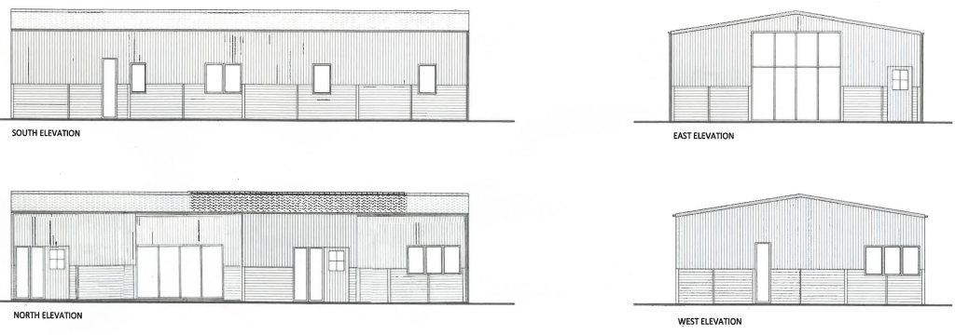
Proposed elevation drawing pursuant to PL/2024/02742 to show the agricultural building in its converted form

This application seeks to demolish the existing agricultural building and construct a replacement two-storey dwelling to the north of where the existing building is currently located.

Policy CP1 of the adopted WCS establishes a hierarchy of settlements to guide where development should be focused. The policy prioritises growth in:
- Principal Settlements (e.g., Salisbury, Chippenham, Trowbridge) – main focus for strategic growth.
- Market Towns – support local services and employment; suitable for sustainable development.
- Local Service Centres – smaller towns and villages with a range of services; limited development supported.
- Large and Small Villages – development should be limited and respond to local needs.
- Outside the defined settlements – development is strictly controlled and generally not supported unless exceptional circumstances apply.

Policy CP2 of the WCS sets out how development will be distributed and delivered across Wiltshire. The policy emphasises:
- Sustainable patterns of growth, reducing the need to travel and supporting local services.
- Development should be plan-led, aligning with the settlement strategy and supported by infrastructure.
- Windfall development (not allocated in plans) must still comply with the principles of sustainable development.
- Development outside settlement boundaries is generally not permitted, unless it meets specific policy exceptions (as set out in paragraph 4.25 of the WCS).

Together, CP1 and CP2 ensure that new development is strategically located, sustainable, and supports the character and function of Wiltshire’s communities.

Whilst Westwood is listed in CP7 as a ‘large village’, which does have a defined settlement boundary, the application site is located entirely outside of this and in planning policy terms is located in open countryside, where there is a presumption against new residential developments outside the defined limits of development as directed by CP1 and CP2 of the adopted WCS, unless one of the ‘exception policies’ listed in paragraph 4.25 of the supporting text of CP2 applies. The proposed dwelling is not considered to satisfy any of the 'exception policies' listed in paragraph 4.25, which comprise of:

• Additional employment land (CP34)
• Military establishments (CP37)
• Development related to tourism (CP39 and CP40)
• Rural exception sites (CP44)
• Specialist accommodation provision (CP46 and CP47); and, development that
• Supports rural life (CP48)

The construction of a new dwelling in this location would be deemed unacceptable in principle, due to the above-identified conflict with the spatial policies of the adopted WCS.

In this case, an extant prior approval exists, following assessment against Schedule 2, Part 2, Class Q of the Town and Country Planning (General Permitted Development) Order 2015 (GPDO) for the conversion of the existing agricultural barn to create one dwelling (reference PL/2024/02742).

It was considered in the determination of PL/2024/02742 that the existing agricultural barn would be capable of being converted to a residential dwelling. It has been generally accepted elsewhere (through case law/appeal decisions – some examples have been referenced in the applicant’s Planning Statement) that the existence of a prior approval under Class Q of the GDPO, where the subject building is considered capable of being converted, is a valid fall-back position.

It is acknowledged that the submitted Planning Statement identifies the extant Class Q as a material consideration in the determination of this full planning application. However, the Class Q is fundamentally different from what is being proposed as part of this application. The Class Q was seeking prior approval for the conversion of the existing agricultural building into a single-storey dwelling, whereas this application is seeking to demolish the existing building and construct a new two-storey dwelling elsewhere within the site. Not only would the proposed dwelling occupy a different siting/footprint, but the new dwelling would fail to retain an agrarian appearance and is shown on the submitted plans to have a greater height and volume compared to the Class Q scheme.

Case law and established appeal precedent confirms that a fallback position is a material planning consideration when assessing proposals for full planning permission and in this case that would extend to the 2024 consented Class Q approval.

In Mansell v Tonbridge and Malling BC [2017] EWCA Civ 1314, the Court of Appeal held that a fallback can be given weight where:
(i) there is a realistic prospect of it being implemented, and
(ii) the alternative development proposed is judged against the baseline impacts of that fallback.

In this case, the approved Class Q scheme established that a residential property could be created on the site under permitted development provisions as established through the prior approval assessment (referenced earlier in this report), and there is no evidence to suggest that the fallback is not realistically capable of being delivered, and consequently when tested against Mansell, criterion i) is satisfied.

As such, it is appropriate to consider whether the proposed dwelling under this fresh application would result in impacts that are neutral or beneficial when compared with the prior approval Class Q scheme.

It is widely accepted that the fallback position would in principle be found to be acceptable in cases where the proposed development would constitute a betterment when compared against a consented Class Q design, and/or by improving the layout, appearance, or energy performance of the proposed dwelling, or where it broadly replicates the scale, footprint, and siting of the Class Q conversion such that the external impacts, particularly in respect of landscape character, highway safety, and ecological considerations, do not exceed those established by the fallback.

Where the proposal largely retains the defining parameters of the Class Q scheme, and demonstrably avoids materially greater effects, it can be reasonable in planning terms to support full applications notwithstanding a policy conflict due to the overriding weight of an extant fallback.

Accordingly, while the development conflicts with the spatial strategy of the development plan, the existence of a credible Class Q fallback is a significant material consideration.

However, this proposal seeks to demolish the existing building that was subject to the Class Q prior approval and construct a replacement dwelling in a different location within the site. This includes land which is located outside of the curtilage of the consented Class Q dwelling, where the principle of residential use has not been previously established.

The extracts below of the submitted site location plans and proposed landscape site plan demonstrate that much of the footprint of the proposed dwelling is sited on agricultural land to which the fallback permission for residential use does not apply.

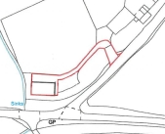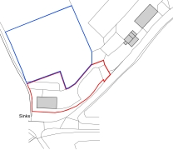
Application site which benefits from ‘fallback’ Proposed application site

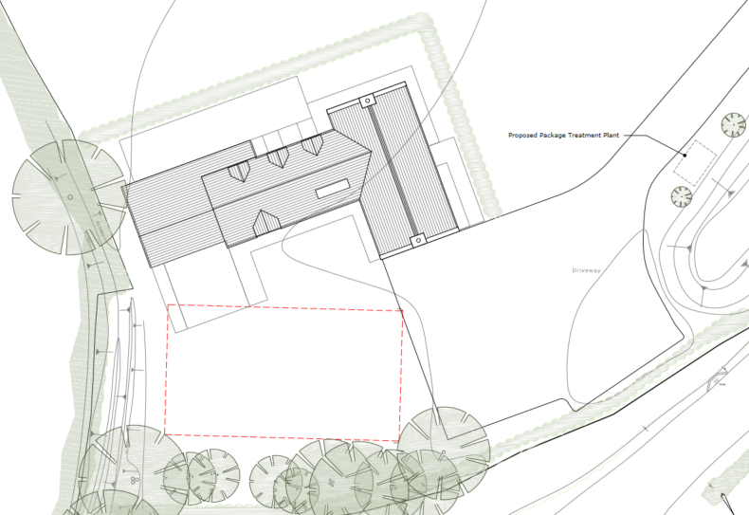 Proposed landscaping site plan

As this application seeks to demolish the building that benefits from Class Q permitted development rights and to construct a replacement dwelling elsewhere on the site, the proposal must be assessed solely on its own planning merits in accordance with the development plan and the NPPF. The acceptability of the proposal, therefore, turns on whether the impacts of the new dwelling and enlargement of the site area (as proposed under this fresh application) would be comparable to, or constitute an improvement over, when compared against the permitted Class Q development. In this case, officers consider the principle of a new dwelling in the open countryside, which as outlined above, would not be considered acceptable in principle as a result of the fundamental differences to the fallback conversion scheme for the reasons set out below.

5 Year Housing Land Supply: The Wiltshire Housing Land Supply Statement (published in June 2025) provides the latest position on the Council’s ability to demonstrate a five-year supply of deliverable housing land, which is a material consideration in the determination of planning applications.

The NPPF was revised in December 2024. This has reintroduced the requirement to meet five years’ worth of deliverable sites and a buffer to be applied to the five-year housing requirement in all circumstances and has revised the Local Housing Need calculation to establish the five-year housing requirement. These factors have resulted in a substantial increase in the five-year housing requirement to be met from the previous calculation. When this is assessed against the housing land supply which can be delivered within five years, the recalculation shows a significant reduction in the number of years' supply. The resulting position shows that the Council can currently demonstrate a 2.42 years housing land supply at a unitary authority level. This is considered to be a substantial shortfall.

The absence of a five-year housing land supply is a material consideration in the determination of this application. In accordance with Paragraphs 78 and 11(d) of the NPPF, for applications involving the provision of housing, where there is a shortfall in the supply of deliverable housing sites, the most important policies for determining the application should be considered out of date. The current housing land supply shortfall is a factor that must be considered in the planning balance, and in this case, as a five-year housing land supply cannot be demonstrated, the weight that can be applied to the most important policies for determining this application should be assessed and altered in the light of the shortage in housing land supply.

As set out in paragraph 11d) of the NPPF, planning permission should be granted for new housing unless i) the application of policies in the Framework that protect areas or assets of particular importance detailed in Footnote 7 provides a strong reason for refusing the development proposed or ii) any adverse impacts of doing so would "significantly and demonstrably outweigh the benefits when assessed against the policies in this Framework taken as a whole, having particular regard to key policies for directing development to sustainable locations, making effective use of land, securing well-designed places and providing affordable homes, individually or in combination".

Therefore, whilst the presumption in favour of sustainable development may apply, this is not definitive and can be disengaged if a site falls within an area or asset protected by policies listed in Footnote 7 of the NPPF, which includes the Green Belt.

In this instance, the application site is located within the Green Belt, and thus the tilted balance does not apply, and as set out in the section below, the application must be assessed against relevant Green Belt policy, which seeks to avoid inappropriate development, unless “very special circumstances” can be demonstrated.

Additionally, the benefits of the scheme towards housing land supply are met by the dwelling which benefits from extant Class Q conversion. As this scheme is for the demolition of the existing building and construction of a single dwelling, there is no additional benefit or weight to be attributed to the provision of a single dwelling since that is already established.

Principle of the Development in the Green Belt: The entire application site is located within the West Wiltshire Green Belt. As the Council does not have a specific Green Belt policy within the adopted WCS, regard must be given to Chapter 13 of the NPPF.

Paragraph 153 of the NPPF establishes that inappropriate development is, by definition, harmful to the Green Belt, and should not be approved except in ‘very special circumstances.’

Paragraph 153 also states that ‘substantial weight’ should be afforded to any harm to the Green Belt, including harm to its openness, and that ‘very special circumstances’ would not exist unless the potential harm to the Green Belt by reason of inappropriateness, and any other harm, is clearly outweighed by other considerations.

Subject to a number of exceptions, as listed in Paragraph 154, the NPPF is clear that the construction of new buildings should be regarded as ‘inappropriate’ in the Green Belt.

As this proposal is seeking planning permission for the construction of a new dwelling, the exception listed under (d) in Paragraph 154 is not relevant, as it covers the replacement of a building “provided the new building is in the same use and not materially larger than the one it replaces”. In this instance, the Class Q has not been implemented, and the existing building is still in agricultural use (at the time of the case officer's site visit in December 2025). Moreover, even if the residential use of the agricultural building had been established through the grant of the Class Q permission for its conversion and subsequent occupation of the building, the proposed dwelling is materially larger, and in a different location, to the building it would replace.

The Class Q proposal would convert the existing building into a single-storey dwelling, occupying a volume of c.779m3, a height of 4.7m, and a footprint of 190m2, as measured from the submitted plans. The proposed dwelling would have a volume of c.1135m3, a height at its highest point of 8.2m, and a footprint of 196m2, demonstrating that the proposed new development would be materially larger, by c.46%, compared to the building to be demolished. As a matter of fact and degree, the proposal cannot be understood as a replacement of the existing building.

It is not considered that any of the other exceptions listed in Paragraph 154 apply to this proposal, and there are no other considerations to outweigh this harm; thus, the development would represent inappropriate development in the Green Belt, contrary to the NPPF.

In terms of the Grey Belt considerations, the proposed siting of the new dwelling would be on undeveloped land in the open countryside, and therefore the application site does not represent or comprise of previously developed land.

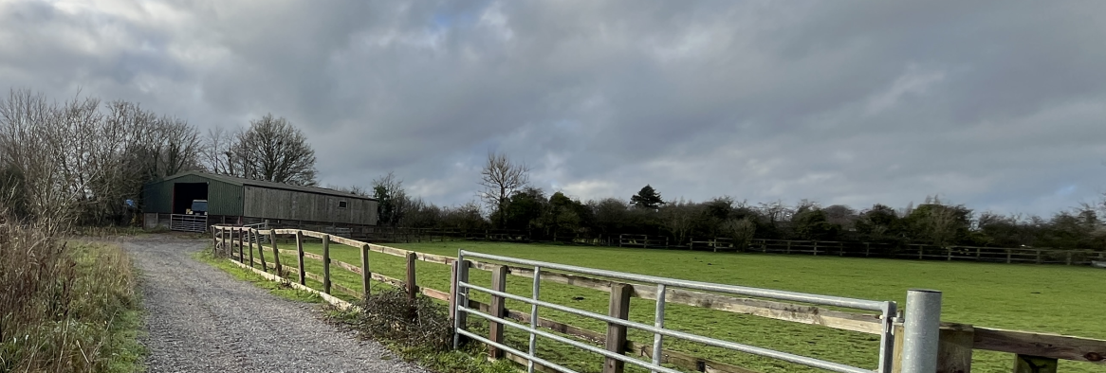Site photo taken from the existing access serving the agricultural building subject to this application to the left of the image – the proposed dwelling would be sited to the right of this

The NPPF does not support unrestricted new housing in the open countryside and, similar to the WCS, new housing is to be directed to sustainable locations until an exception applies; none are considered to be relevant to this application.

Impact on the Openness of the Green Belt: The fundamental aim of Green Belt policy is to prevent urban sprawl by keeping land permanently open. The essential characteristics of Green Belts are their openness and permanence. Development within the Green Belt is generally considered inappropriate unless it falls within specific exceptions set out in the NPPF Chapter 13. Any proposal that constitutes inappropriate development must demonstrate very special circumstances, which clearly outweigh the harm to the Green Belt and any other harm resulting from the proposal.

In assessing the impact of a proposal on the openness of a Green Belt, this must include both a spatial and visual aspect, as Planning Inspectorates have previously identified that an adverse impact to either can harm the openness of the Green Belt as a whole.

The introduction of a new two-storey dwelling on this site, together with the associated boundary treatments and domestic paraphernalia generally commonplace with residential uses, would adversely impact the spatial and visual aspects of openness.

The proposed altered siting and increase in the curtilage compared to the Class Q scheme would contribute to an urbanising impact of the open countryside.

Paragraph 153 of the NPPF is clear that any harm to the Green Belt should be given substantial weight, and in this instance, the proposal would result in the diminution of the openness of the Green Belt, thus representing inappropriate development, which is by definition harmful.

In addition to the built form being both materially larger and taller than the existing building, the proposed new dwelling would introduce a larger amenity space and revised siting, which differs from the Class Q scheme. With the proposed dwelling being sited to the north of the existing agricultural building, the proposal would be encroaching within previously undeveloped land, representing a material diminution of the openness of the Green Belt and wider domestication of the site, which would represent inappropriate development that would, by definition, be harmful to the Green Belt. It is therefore considered that the development would have a greater impact on the openness of the Green Belt when compared to the Class Q prior approval.

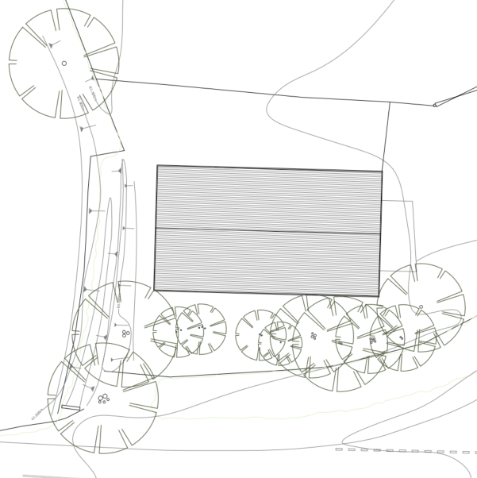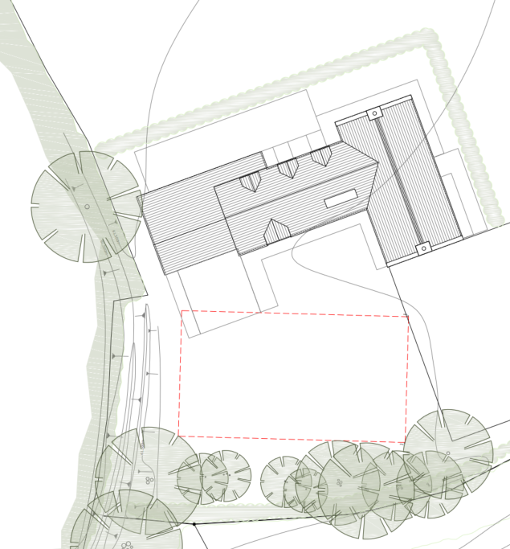
Existing layout and landscaping left and proposed layout and landscaping to the right

Based on the submitted landscape site plans, the area surrounding the existing agricultural building that is subject to the extant Class Q measures c.305m2, compared to the area around the proposed new dwelling, which measures 907m2, representing an increase of 602m2 residential use and encroachment into the Green Belt.

In this case, it is not considered that ‘very special circumstances’ exist to justify the unwarranted erosion and encroachment into the Green Belt. Whilst the Council acknowledges its current housing land supply shortfall and recognises the need to consider speculative proposals to address this, it does not mean that all housing developments should be accepted without appropriate scrutiny and appraisal, particularly where the contribution to housing land supply can be achieved without such harm through the conversion of the existing built form.

To conclude, the introduction of a new dwelling in this location, together with the increase in residential curtilage and associated domestic paraphernalia in open countryside, does not outweigh the harm posed to the Green Belt. Therefore, the proposal constitutes inappropriate development, contrary to the NPPF.

Design and Impact on the Character and Appearance of the Area and Visual Impact: Policy CP57 of the adopted WCS requires a "high standard of design” for all new developments and for developments “to create a strong sense of place through drawing on the local context and being complementary to the locality”.

Policy CP51 required developments to “protect, conserve and where possible enhance landscape character and must not have a harmful impact upon landscape character, while any negative impacts must be mitigated as far as possible through sensitive design and landscape measure”.

In addition to the above, the NPPF has a focus on delivering high-quality design and sets out in paragraph 131 that the "creation of high quality, beautiful and sustainable buildings and places is fundamental to what the planning and development process should achieve".

Paragraph 135 moreover sets out a series of six criteria including ensuring development is of high quality over the lifetime of the development, is visually attractive and sympathetic to the local character and history and creates a strong sense of place.

Furthermore, NPPF paragraph 187 requires planning policies and decisions to protect and enhance the natural and local environment by safeguarding valued landscapes, biodiversity sites, geodiversity and soils; recognising the intrinsic character and beauty of the countryside and the wider benefits of natural capital, including high-quality agricultural land, trees and woodland; maintaining the character of undeveloped coastlines where relevant; securing biodiversity net gains through resilient ecological networks and features that support priority species; preventing development from causing or being exposed to unacceptable pollution or land instability while seeking improvements to local environmental conditions; and, where appropriate, remediating degraded, derelict or contaminated land.

The Wiltshire Design Guide encourages sensitivity to local character, materials, and architectural styles and supports modern living standards while maintaining aesthetic and functional quality.

Building for a Healthy Life Framework promotes healthy, inclusive, and sustainable places. The document encourages:

- Walkability.
- Access to green space.
- Active design principles for well-being.

With reference to the submitted Planning Statement, the design of the proposed dwelling would be of a style to reflect existing dwellings found within the wider area and would be completed in complementary materials such as stone, timber for the wall materials and clay and slate for the roof.

Whilst it is appreciated that the proposed dwelling would be of a design and appearance that would be sympathetic to other residential buildings within the wider area, the construction of a new dwelling on this site of the design and siting proposed would introduce a residential built form in the open countryside, which does not reflect the existing agrarian character.

The proposed dwelling would measure 3.5m greater in height (as measured from its highest point) compared to the existing agricultural barn to be demolished. The proposed dwelling would comprise a variety of ridge heights (the lowest ridge height would measure 6.4m) that would contribute towards reducing its visual impact and in turn break-up the mass of the proposed dwelling to ensure the proposed dwelling does not have a bulky appearance, but this does not alter that the dwelling is significantly more prominent in its setting.

Whilst the actual footprint of the proposed new dwelling would not be significantly different compared to the existing agricultural building, the proposed dwelling would have a greater height and overall volume (as previously discussed) compared to the Class Q fallback. The proposal also seeks a significant increase in the curtilage and therefore residential use of the site when compared to the prior approval scheme. Despite the proposal incorporating a landscaped belt along the north and east boundaries, the proposal would result in an increased visual impact compared to the Class Q fallback, which is contrary to CP51 and CP57 of the WCS and NPPF paragraph 187, which require proposals to relate positively to its landscape setting and to not have a harmful impact on landscape character or the intrinsic character and beauty of the countryside.

As above, it is appreciated that the proposal would also introduce additional planting along the northern and eastern boundaries of the proposed dwelling, which would provided some screening of the proposed dwelling, and the Council’s arboricultural officer has raised no objection to the proposal. However, this would not outweigh the harm that the proposed dwelling would have to the wider openness of the Green Belt (as discussed above) or the increased visual impacts of the height of the dwelling, and this is not considered to outweigh the identified harm. It is also considered likely that such landscaping measures would be utilised to enclose and screen the curtilage to the approved conversion scheme if implemented. The landscaping is considered a neutral factor in the proposal.

Amenity: Criterion vii of CP57 of the adopted WCS requires development to respect the amenity of existing occupants and ensure appropriate amenity levels for future residents.

Criterion f) of paragraph 135 of the NPPF meanwhile, requires the creation of “places that are safe, inclusive and accessible and which promote health and well-being, with a high standard of amenity for existing and future users”.

With due regard to the separation distance between a proposed dwelling and existing properties within the facility of the site, it is not considered that the proposal would result in any adverse impacts upon neighbouring amenity to warrant refusal of this application.

In terms of the living conditions for the future occupiers of the dwelling, the submitted floor plans show all habitable rooms to be served by windows, with the submitted plans showing the proposed dwelling to have a private garden to the south. The proposed garden would be enclosed and would be of a size that would exceed the requirements of the Wiltshire Design Guide (WDG), which requires, as a minimum, for garden areas for all houses to be equivalent to the footprint of the house. Also, section 9.2 of the WDG requires south-facing gardens such as this to be a minimum of 10m deep, which is also met.

Officers are aware that the proposed dwelling would be sited in close proximity to a dog day care business. Whilst the planning application to regularise the continued use of part of the site for such a use remains underdetermined (pursuant to application reference PL/2025/09768), this is a material consideration.

The Council’s Public Protection department was consulted on the application and initially raised concerns with the impact of noise on future occupiers of the dwelling. The applicant provided a copy of a noise report (produced by MACH Acoustics Ltd, reference 2069 Rev03, dated November 2025) associated with the current dog day care application (reference PL/2025/09768), which included proposed mitigation, as specified in section 5.5 of the noise impact assessment provided.

The proposed mitigation measures include the erection of a 2.2m high acoustic fence along the western boundary and 2m high acoustic fence for a 10m section along part of the northern boundary. Also, the noise report has recommended that no more than 5 dogs are permitted within the external exercise area at any one time and for the dogs to remain within the indoor shelter between the hours of 07:00 and 09:00.

Subject to the identified mitigation measures being incorporated and completed prior to occupation of the proposed development, no objection is raised, as it is considered that the proposed mitigation measures put forward within the noise report would ensure the predicted noise levels would be equal to or lower than the existing background noise level. Such measures, however, are contingent on a separate permission, and the occupancy of the dwelling cannot be conditioned as such.

Highways Impacts and Parking: Transport implications are a key factor in assessing planning applications, especially for larger developments. Proposals must demonstrate:

- Safe and suitable access for all users, including pedestrians, cyclists, and those with mobility impairments.
- No severe residual impacts on the surrounding highway network.
- Promotion of sustainable travel, reducing reliance on private vehicles.
- Adequate parking and cycle provision, in line with adopted standards.
- Protection and enhancement of public rights of way and active travel routes.

Relevant policies include Core Policies 60–64 of the Wiltshire Core Strategy, supported by the Wiltshire Local Transport Plan, Car Parking Strategy, and Cycling Strategy. The Local Cycling and Walking Infrastructure Plan (LCWIP) and LTN 1/20 (DfT) provide further design guidance for active travel infrastructure.

The proposal would utilise the existing access to the site via the Elm Cross road and include the provision of on-site car parking spaces. As such, the development is not anticipated to give rise to any notable impacts on the local highway network, and the level of vehicle movements generated would be comparable to those associated with the extant Class Q scheme.

The Council’s highways department were consulted on the application and have raised no highway objections to the proposal.

Ecology and Biodiversity: The ecological impact of development is a key planning consideration. Proposals must assess and address potential effects on:

- Protected species
- Priority habitats
- Ecological networks
- Green and blue infrastructure

Core Policy 50 of the Wiltshire Core Strategy requires development to:

- Avoid harm to ecological assets.
- Deliver measurable Biodiversity Net Gain (BNG), in line with the Environment Act 2021.
- Support habitat restoration and connectivity.
- Integrate biodiversity into site design.

The Green & Blue Infrastructure Strategy (2022–2030) promotes nature recovery, ecosystem services, and habitat connectivity through development.

The application has been submitted with a Preliminary Ecological Appraisal (produced by Pro Vision, reference 8810 Version 1, dated May 2025), which concludes that the site comprises primarily modified grazed grassland with scattered scrub, a tree belt, and the subject agricultural building, all of which have limited ecological value.

The agricultural building to be removed has been assessed as having ‘negligible potential’ to support roosting bats, although the surrounding boundary vegetation does offer some low‑value foraging and commuting habitat. Appropriate lighting design measures would ensure that this habitat remains functional and protected for bat species.

The tree line and scrub on site offer suitable nesting opportunities for common bird species, and vegetation clearance would therefore be timed to avoid the breeding season unless inspected by an ecologist prior to the commencement of works.

Bath and Bradford-on-Avon Bats Special Area for Conservation (SAC): The application site lies within various buffer zones associated with the Bath and Bradford-on-Avon Bats SAC. The proposed new dwelling, therefore, has the potential to result in a significant adverse impact on the special features of that site. An Appropriate Assessment (AA) under Section 63 of the Habitats Regulations must be carried out by the relevant Competent Authority (in this instance, the Council as the local planning authority (LPA)) to determine the potential significant effects and the suitability of any measures proposed to avoid or mitigate those effects.

The completed AA concludes that the proposed development would have no adverse effects on the SAC site, subject to mitigation measures being secured and implemented.

Protected species: The Council’s ecologist has confirmed that the existing agricultural building would have a negligible potential to host roosting bats as it is open-fronted, with corrugated metal sides and roof, which contains skylights.

The submitted ecology report acknowledges that there would be a minor loss of foraging habitat, which has been described as “sub-optimal”. The loss of grassland is considered further within the associated AA.

Subject to a sensitive lighting scheme, biodiversity enhancement condition (including wildlife-friendly plantings and habitat creation) and Construction Method Statement (CMS), if officers are minded to recommend the application for approval, the Council’s ecologist has raised no bat-related objections.

The Council’s ecologist has commented to say that there “are two historical records of Great Crested Newts (GCN) within 1km of the site. A ditch is present at the western site boundary, but noted to be dry, likely permanently. Approximately 210m east is a small pond. Considering this as well as the habitats present, and using Natural England’s rapid risk assessment tool, the risk posed to GCN is considered to be low”.

It is considered that the grassland to be lost could be of some value to reptiles. However, the site is considered to be frequently disturbed, given the use of the wider site for agricultural/equestrian, with the existing grassland grazed by horses, and therefore is maintained as short. The Council’s ecologist has commented that there “are sufficient habitats surrounding for reptiles to disperse into, if present, given a precautionary working method is adhered to, as suggested in Section 5.8 of the ecology report. The ecology report also recommends precautions for dormice, which might be present in the wider landscape. As such, precautionary measures for reptiles, amphibians, nesting birds, bats and dormice should be included within the CMS”.

The applicant’s ecology report includes enhancement measures from section 5.14, which include the planting of trees and shrubs, the inclusion of a wildflower grassland area, and integrated bat, swift and bee bricks. The Council’s ecologist welcomes such measures and considers these to be in line with the NPPF and CP50.

Biodiversity Net Gain: From 12 February 2024 Biodiversity Net Gain (BNG) became mandatory under Schedule 7A of the Town and Country Planning Act 1990 (as inserted by Schedule 14 of the Environment Act 2021). Based on the information available, the biodiversity gain planning condition is not considered to apply to this application, as it is for self-build development.

Based on the above assessment, it is considered that the proposal would comply with CP50 and the requirements of the NPPF.

Flood Risk and Drainage: Core Policy 67 of the Wiltshire Core Strategy and NPPF paragraphs 170–182 require:
- Avoidance of increased flood risk.
- Use of appropriate mitigation measures.
- Application of the sequential and exception tests for developments in Flood Zones 2 or 3.

Sustainable Drainage Systems (SuDS) are required for all major developments and must:
- Manage runoff near its source.
- Improve water quality.
- Support biodiversity and amenity.
- Be integrated into the site layout and green infrastructure.

As detailed above, the application site is located in an area at high risk of groundwater flooding, a constraint that was picked up as part of the extant Class Q prior approval application. However, this application has not been supported by a site-specific Flood Risk Assessment, and on that basis, it cannot be determined that the development would be safe over its lifetime, would not increase flood risk elsewhere, and would incorporate suitable mitigation measures.

The absence of the FRA conflicts with CP67 of the WCS and paragraph 181 of the NPPF, which requires applications to be supported by a site-specific flood-risk assessment where the site is subject to flood risk from all sources of flooding and where development would introduce a more vulnerable use. This would form a reason for refusing the application.

PLANNING BALANCE AND CONCLUSION: At the heart of the NPPF there is a presumption in favour of sustainable development requiring local planning authorities to approve development proposals that accord with an up-to-date development plan without delay; and where there are no relevant development plan policies, or the policies which are most important for determining the application are out-of-date, permission should be granted unless (taken from paragraph 11d of the NPPF):

- The application of policies in the NPPF that protect areas or assets of particular importance provides a strong reason for refusing development proposed; or
- any adverse impacts of doing so would significantly and demonstrably outweigh the benefits, when assessed against the policies in the NPPF taken as a whole having particular regard to key policies for directing development to sustainable locations, making effective use of land, securing well-designed places and providing affordable homes, individually or
in combination;

The proposed development lies outside any defined settlement boundary, where new residential development is strictly controlled, as set out in CP1 and CP2 of the adopted WCS. The application site does not constitute infill or any form of acceptable countryside development listed within the exception policies in paragraph 4.25 of the WCS.

The proposal involves the demolition of the existing agricultural building previously subject to Class Q approval (reference PL/2024/02742) for conversion to a dwelling and the erection of a larger, taller replacement of that dwelling in a different position and on a larger site which extends o beyond the approved residential curtilage that was considered under the extant Class Q scheme. The fallback position establishes the principle of a dwelling on only part of the application site and is a material consideration in the consideration of the principle of development. By virtue of the increased site area, its increased bulk, height, massing, revised siting, associated domestic paraphernalia, and larger garden area, the development would result in a material loss of openness and the urbanisation of this part of the Green Belt.

The development, therefore, constitutes inappropriate development in the Green Belt, which is by definition, harmful as directed by NPPF paragraph 153. No very special circumstances have been demonstrated which would outweigh the harm to the openness and purposes of the Green Belt. The proposal is therefore contrary to the NPPF.

In accordance with paragraph 11 of the NPPF, the presumption in favour of sustainable development is disengaged where Footnote 7 applies. As the site lies within the Green Belt, Footnote 7 is triggered, and the tilted balance does not apply. The proposal is inappropriate development in the Green Belt and the harm to the openness of the Green Belt provides a strong reason for refusal and the development therefore, remains unacceptable in principle and conflicts with CP1 and CP2 of the WCS and the sustainable development aims of the NPPF having regard to the location of new development.

Additionally, the application site is identified within the Council’s Strategic Flood Risk Assessment as being at high risk of groundwater flooding. No site‑specific FRA has been submitted, contrary to the requirements of national policy.

In the absence of an FRA, the Council cannot be satisfied that the development would be safe for its lifetime, would not increase flood risk elsewhere, or would incorporate appropriate mitigation measures. The proposal, therefore, conflicts with CP 67 and the requirements of NPPF.

It is acknowledged that this proposal is for the construction of a self-build dwelling, which, as set out above, would make the proposal exempt from mandatory BNG requirements. Whilst this proposal would provide one self-build unit that would contribute towards the unmet need on the Council’s self-build register, a suitable mechanism to secure the self-build element has not been agreed and therefore the contribution towards the provision of self-build dwellings is a neutral factor in the planning balance. The identified conflict with the WCS and the NPPF in terms of the principle of the development and Green Belt harm is not outweighed by the benefit of one additional dwelling, particularly since such benefits would be achieved by the extant scheme for conversion of the existing building without such harm.

RECOMMENDATION: REFUSE

  - The proposed development would result in the creation of a new dwelling in the open countryside outside any defined settlement boundary. Although part of the site benefits from an extant Class Q prior approval for converting the existing agricultural building, this proposal is materially different to the Class Q fallback position, as it seeks to extend the site area and introduce a larger new dwelling with a larger curtilage, altered siting, footprint, scale and built form. This would result in a significantly greater visual impact on the site and surrounding landscape than the approved fallback. The development therefore conflicts with Core Policies 1 and 2 of the adopted Wiltshire Core Strategy (WCS), which direct new housing to sustainable, plan-led locations, and it does not fall within any of the exception categories in paragraph 4.25 of the WCS that would justify a dwelling in this location. As the proposal is not justified by the reuse of an existing building, does not occupy previously developed land, and offers no betterment over the approved Class Q conversion scheme, it is contrary to the overarching aims of sustainability embodied in the National Planning Policy Framework.

  - The proposed demolition of the existing agricultural building and construction of a new two-storey dwelling constitutes inappropriate development in the Green Belt by reason of the increased site area, altered siting, and proposed bulk, mass and height of the proposed dwelling and the resulting domestication of the site. Such development would result in demonstrable harm to and the diminution of the openness of the Green Belt, to a significantly greater extent compared to that which would result from the implementation of the approved Class Q scheme for the conversion of the existing building.

In the absence of any very special circumstances, this proposal is not considered to represent appropriate development in the Green Belt and is therefore contrary to paragraphs 142, 153, 154 and 187 of the National Planning Policy Framework, as well as CP51 and CP57 of the adopted Wiltshire Core Strategy through the increased visual impact the proposed dwelling would have when compared to the Class Q fallback.

Furthermore, in accordance with National Planning Policy Framework paragraph 11(d)(i), the identified Green Belt harm provides a clear reason for refusal and the tilted balance does not apply. The benefits arising from the new dwelling carry little weight, as these could be achieved through the extant Class Q prior approval to convert the existing building.

  - The application site is located within an area identified on the Council’s Strategic Flood Risk Assessment as being at high risk of groundwater flooding. No site-specific Flood Risk Assessment has been submitted to demonstrate that the development would be safe over its lifetime, and would not increase flood risk elsewhere, and would incorporate suitable mitigation measures. The proposal therefore conflicts with Core Policy 67 of the Wiltshire Core Strategy and the requirements of the National Planning Policy Framework.

