APPLICATION FOR HOUSEHOLDER PLANNING PERMISSION
DELEGATED REPORT

APPLICATION REFERENCE: | PL/2026/00139
APPLICATION TYPE: | Householder planning permission
SITE ADDRESS: | 1 The Lodge, Alanbrooke Road, Larkhill, Wiltshire, SP4 8PH
DEVELOPMENT DESCRIPTION: | Demolition of existing single storey side extension and replacement with a larger single storey side extension
RECOMMENDATION: | That Planning Permission be GRANTED

PROPOSAL

The proposal seeks planning permission for the demolition of a single storey side extension and the erection of a larger single storey side extension in a similar location.

SITE DESCRIPTION/CONTEXT
The site is located outside the settlement boundary of Larkhill which is defined as a Market Town by Wilshire Core Strategy (WCS) policies CP1, CP2 and CP4. Whilst the site is in Flood Zone 1 and is not in the immediate vicinity of any rivers, it is situated within the Hampshire River Avon Catchment. It is located within the Salisbury Plain SPA and Stonehenge World heritage Site.

The application site relates to one of a pair of two storey semi-detached dwellings located on the eastern side of Alanbrooke Road in Larkhill, a second pair of similar semi-detached dwellings is located to the north. The property is bounded by fields to the east with other residential properties to the north and west. The property is set back from the road with an open front garden which is partly laid to lawn and partly hardstanding providing off road parking for the property.

PLANNING HISTORY
There have not been any previous submitted planning applications for works at the application site.

RELEVANT POLICIES AND GUIDANCE
The National Planning Policy Framework (NPPF)

Wiltshire Core Strategy:

Core Policy 1: Settlement Strategy
Core Policy 2: Delivery Strategy
Core Policy 4: Spatial Strategy: Amesbury Community Area
Core Policy 51: Landscape
Core Policy 57: Ensuring high quality design and place shaping
Core Policy 59: Stonehenge WHS

Salisbury District Local Plan (SDLP)
C24 & H31 Extensions to Dwellings in the Countryside

The Planning Practice Guidance

National Design Guide

Wiltshire Local Transport Plan 2011-2026 - Car Parking Strategy Council Draft

CONSULTATION RESPONSES

World Heritage Sites: Comment. (This is discussed in the relevant section below.)
Durrington Town Council: None received.
Archaeology: No Objection.

Thank you for consulting Wiltshire Council’s Archaeology Service regarding this planning application. Please note that my comments relate solely to the buried archaeological heritage and not to any impacts on the Outstanding Universal Value (OAV) of the Stonehenge World Heritage Site (WHS) and I note that you have consulted the Stonehenge and Avebury World Heritage Site Co-ordination Unit in this regard.

No. 1 The Lodge is a 1950s(?) semi-detached dwelling that lies within the Stonehenge World Heritage Site and there are several significant archaeological monuments in the wider vicinity. There are no known heritage assets close to No. 1 The Lodge and the HER only notes modern military remains nearby, bar two undated ditches recorded during the installation of a water pipeline to the east of the property.

The proposed new extension extends beyond the existing side extension, which is proposed for demolition, but the overall scale of below ground impacts is modest. I note also that a similar extension was approved in 2017 for No. 4 The Lodge without any recommendation from the Archaeology Service for archaeological oversight. On this basis, I have no archaeological concerns with this proposal, and no further action is required as regards the buried archaeological heritage in relation to this application.

REPRESENTATIONS
No comments were received.

ASSESSMENT

Section 38(6) of the Planning and Compulsory Purchase Act 2004 states:

"If regard is to be had to the development plan for the purposes of any determination to be made under the planning Acts, the determination must be made in accordance with the plan unless material considerations indicate otherwise."

In accordance with this statutory requirement, this application has been assessed against the relevant policies of the Development Plan, including the adopted Wiltshire Core Strategy (2015) and, where applicable, any made Neighbourhood Plans.

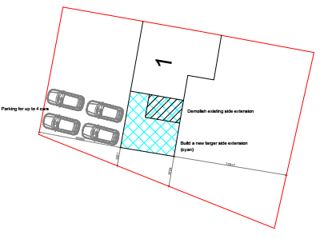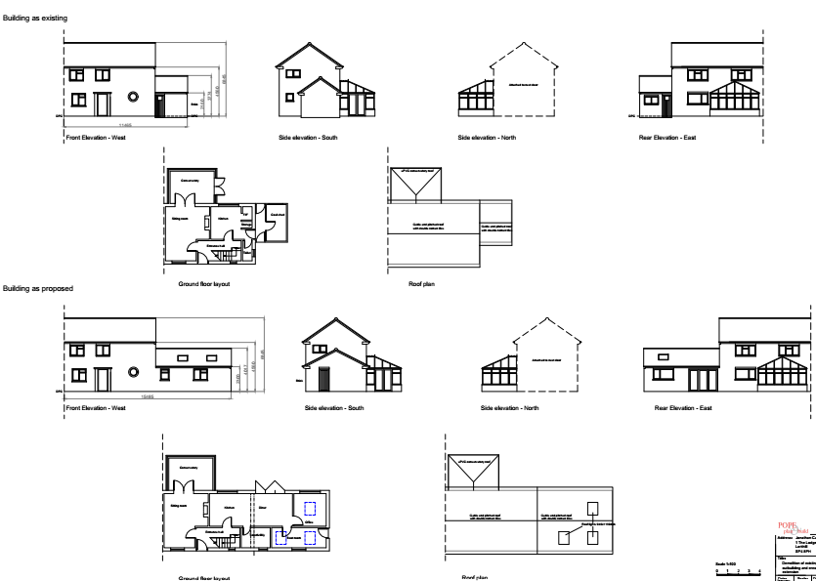

Design and Impact upon the character and context of the area

Core Policy 57 - Ensuring High Quality Design and Place Shaping of the Wiltshire Core Strategy seeks to ensure that all new development is of high design quality, reflecting local context, character, and distinctiveness.

The application site consists of a two-storey semi-detached dwelling with an existing single storey element used as a coal shed. This application proposes to demolish the existing single storey coal shed and construct a replacement single storey side extension to create a boot room, larger dining area and a home office room. The proposed single storey side extension measures approximately 4 metres to the ridge and is proposed to have a gable end pitched roof similar to the host dwelling.

Saved Policy C24 states that extensions and additions to buildings in the countryside will only
be permitted if they are sympathetic in scale and character with the existing building and surroundings and fall within the existing curtilage. The proposed extension minimally increases the extent of the footprint of the side extension from being approximately 3 metres in length to 7 metres in length. The width of the proposed side extension follows the width of the existing host dwelling. It is considered that increase in footprint is minimal and has been designed to be in keeping with the host dwelling. The extensions lie solely within the curtilage of the application site and has allowed for a 2.2 metre set back from the extent of the boundary of the application site. The height of the proposed extension is single storey and is subservient to the two-storey host dwelling. The masing of the proposed single storey extension is proposed to be a pitched gable end roof in keeping with the host dwelling’s pitched gable end roof. The proposed works are considered to be subservient in scale, utilises suitable materials, has been designed to complement the existing style of the dwelling, and would not be of harm to the visual amenity of the streetscape. The proposed alterations would not cause any significant impact on the wider area and are acceptable accordingly. Having regard to the above, the proposal complies with the design principles set out in Core Policy 57 of the Wiltshire Core Strategy and Appendix D of the Wiltshire Design Guide.
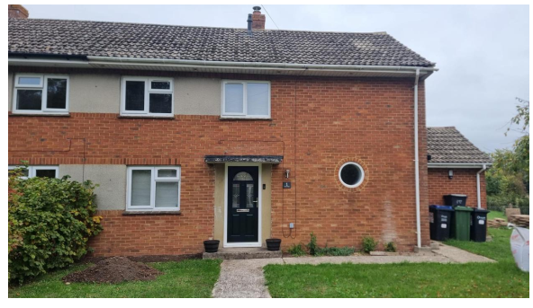
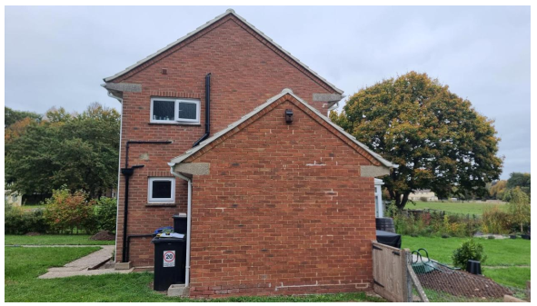
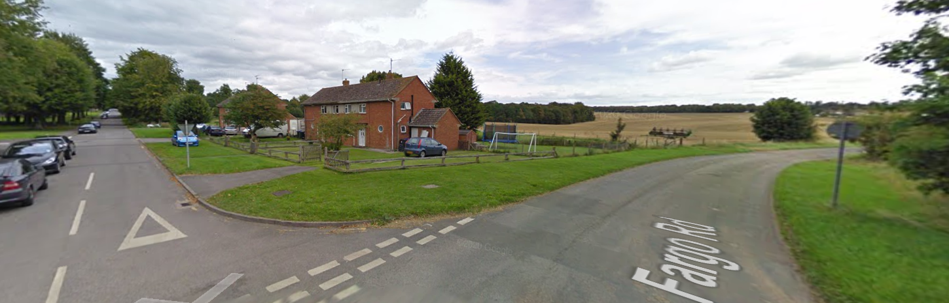
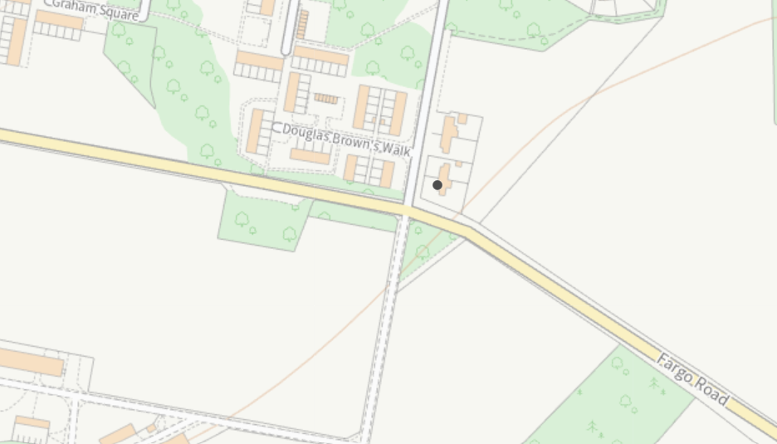
Amenity

Point vii of Core Policy 57 - Ensuring High Quality Design and Place Shaping of the Wiltshire Core Strategy seeks to ensure that developments do not adversely affect neighbouring properties.

The National Planning Policy Framework (NPPF), particularly Paragraph 135(f), stresses that planning decisions should ensure developments provide a high standard of amenity for existing and future users.

The proposed development has been assessed in terms of its potential impact on the residential amenity of neighbouring properties, with particular regard to loss of light, overshadowing, loss of privacy, and overbearing effects.

The application site is located on the corner of Fargo Road and Alanbrooke Road. The proposed side extension is located on the southern side of the host dwelling and is adjacent to both the highways on the south and west. Due to the location and the single storey nature of the proposed side extension, it is not considered that this proposed extension would detrimentally impact the existing residential amenity of the neighbouring dwellings with regard to loss of light/overshadowing, loss of privacy or would it have an overbearing impact. The proposal therefore accords with Core Policy 57 point vii in respect of safeguarding residential amenity and Appendix D of the Wiltshire Design Guide.

Highways Impact
Core Policy 57 (xiv) of the Wiltshire Core Strategy seeks to ensure that development must meet the requirements of Core Policy 61. This policy requires proposals to be capable of being served by safe access to the highway network. Core Policy 64 seeks to ensure compliance with parking standards set out in the Local Transport Plan.

The National Planning Policy Framework (NPPF), particularly Paragraph 115 and 116, requires that development proposals do not have an unacceptable impact on highway safety and that safe and suitable access to the site can be achieved for all users.

The proposed side extension does not propose any additional bedrooms; therefore, no additional parking spaces are required. The location of the proposed side extension allows for the front driveway to be retained. The existing front driveway can accommodate 4 car parking spaces.

The proposal is therefore considered to comply with Core Policies 57 (xiv), 61 and 64 of the Wiltshire Core Strategy, the NPPF, and the Wiltshire Local Transport Plan.

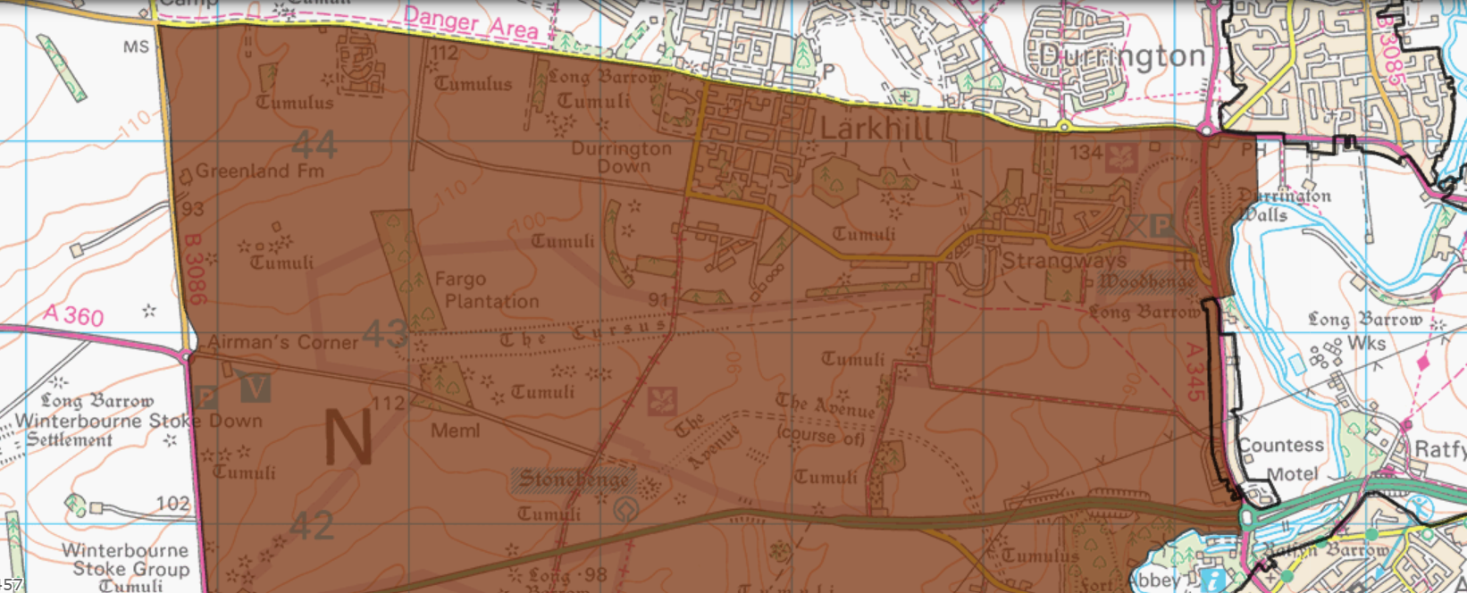Stonehenge World heritage Site
The application site is located within The Stonehenge, Avebury, and Associated Sites World Heritage Site. This householder planning application is for a single storey side extension to an existing semi-detached residential dwelling. The WHS officer commented to say:

It is noted that the proposal comprises of the same wall and roof materials as existing and as a result presents no or minimal change to the visual experience within the WHS. Lighting is also specified as low-elighting. To limit any cumulative impact of light spill, the provision of any new external lighting should be compliant with best practice for dark skies preservation.

The proposed elevations show how the design introduces three roof lights to the dwelling, and an increase in glazing to the bi-fold doors. Any increase to light spill from the design will be experienced alongside the conservatory, and so equates to a minor increase in potential light spill to the east and west. We assess that any potential impact to the OUV of the WHS from the design to be less than substantial, with no design modification required to mitigate impact.

The comments received from the WHS officer attached above have been taken into account. A condition to restrict any new lighting to be dark skies compliant has been included in the recommendation.

Biodiversity Net Gain

Householder planning applications are exempt from the requirement to deliver Biodiversity Net Gain under Schedule 7A, Section 4(2)(a) of the Town and Country Planning Act 1990, as inserted by the Environment Act 2021.

CONCLUSION

The proposed development is considered to be acceptable in terms of its design, scale, and relationship with the surrounding area. It would not result in any unacceptable harm to the character of the locality, the amenities of neighbouring occupiers, or the interests of highway safety, heritage, or ecology.

The proposal is therefore considered to comply with the relevant policies of the Wiltshire Core Strategy, the Wiltshire Local Plan, and the National Planning Policy Framework. As such, the application is recommended for approval, subject to the conditions set out below.

RECOMMENDATION: That Planning Permission be GRANTED subject to conditions.

1.The development hereby permitted shall be begun before the expiration of three years from the date of this permission.

REASON: To comply with the provisions of Section 91 of the Town and Country Planning Act 1990 as amended by the Planning and Compulsory Purchase Act 2004.

2.The development hereby permitted shall be carried out in accordance with the following approved plans and documents:

Existing and Proposed Ground Floor Plans, Roof Plans and Elevations Drawing No. 01/26 Received: 06 January 2026
Location and Block Plan Drawing No. 02/26 Received: 06 January 2026

REASON: For the avoidance of doubt and in the interests of proper planning.

3. The materials to be used in the construction of the external surfaces of the development hereby permitted shall match those detailed on the application form and approved plans.

REASON: In the interests of visual amenity and the character and appearance of the area.

4. Any new external artificial lighting installed anywhere on the building hereby approved shall be in accordance with the appropriate Environmental Zone standards set out by the Institute of Lighting Engineers in their publication GN01:2021, ‘Guidance for the Reduction of Obtrusive Light’ (ILP, 2021). Lighting shall be downward facing.

REASON: To protect the amenity of the International Dark Skies Reserve and World Heritage Site.

