APPLICATION FOR A NON-MATERIAL AMENDMENT
CASE OFFICER REPORT

APPLICATION REFERENCE: | PL/2026/00754
APPLICATION TYPE: | NON-MATERIAL AMENDMENT
SITE ADDRESS: | 8 St Lawrence Close, Stratford Sub Castle, Salisbury, SP1 3LW
DEVELOPMENT DESCRIPTION: | Non-material amendment of PL/2025/03688 to allow changes of window style and configuration and renewal of roof material
RECOMMENDATION: | That the non-material amendment be GRANTED

PROPOSAL
An initial application with reference PL/2025/03688 was approved which allowed a proposed two-storey extension over the existing single storey garage and a proposed replacement garage located adjacent to the host dwelling. This non-material amendment now proposes to changes to glazing bars and detailing of some windows, changes to the size of two windows and renewal of the roof material of the existing host dwelling.

PLANNING HISTORY

S/1984/0445 – CONVERT GARAGE INTO LIVING ROOM & ADDITION OF NEW GARAGE – AC

PL/2025/03688 - PROPOSED TWO STOREY EXTENSION OVERBUILDING EXISTING GARAGE STRUCTURE, REPLACEMENT GARAGE AND ALTERATIONS TO EXISTING DWELLING. - AC

RELEVANT LEGISLATION AND GUIDANCE

Town and Country Planning Act 1990 (as amended):
- Section 96A: This section provides the legal basis for non-material amendments to an existing planning permission. It allows Local Planning Authorities (LPAs) to make changes to a planning permission without the need for a new application, provided that the changes are considered to be "non-material."
- The Act does not define "non-material," and it is at the discretion of the LPA to determine whether a proposed amendment qualifies as such, considering the specific context of the development and its impacts.

CONSULTATION
As an application for a non-material amendment is not a full planning application, the provisions under the Town and Country Planning (Development Management Procedure) (England) Order 2015 relating to statutory consultation and publicity do not apply. Consequently, local planning authorities have discretion regarding whether and how to inform interested parties or seek their views.

Given that the changes proposed are by definition non-material, consultation or publicity are typically not required. Additionally, as the proposed amendments are minor in nature, there are generally no significant effects that would necessitate consideration under the Environmental Impact Assessment Regulations 2011. In this instance, it has not been considered necessary to consult.
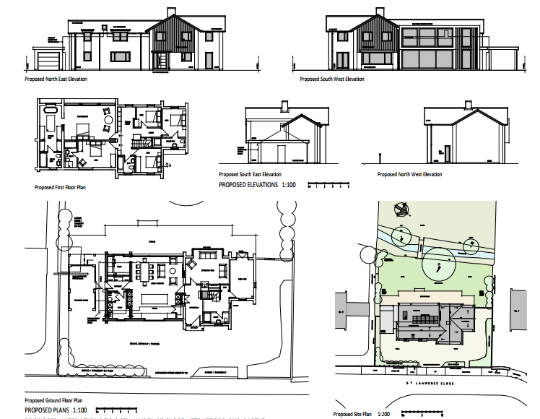
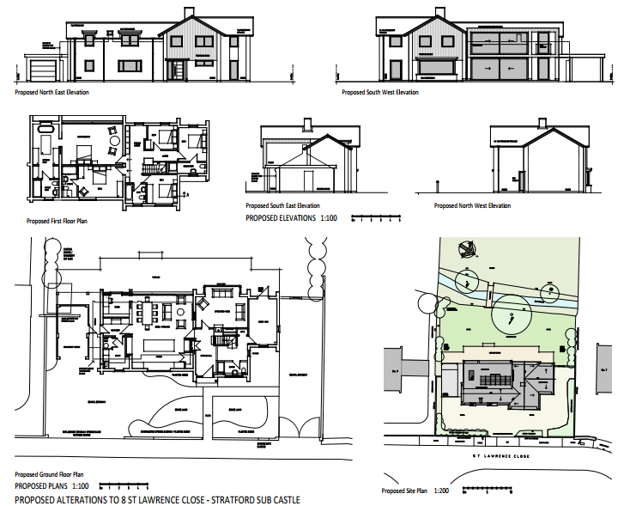
Extant permission
Current NMA

ASSESSMENT
Non-material amendments are changes that do not significantly alter the scheme's overall impact. They can involve minor adjustments to the design or other aspects of the development but should not fundamentally change its character, scale, or overall effect on the surrounding area.

Assessing the Nature of the Amendment:
- Minor Design or Layout Changes: This nonmaterial application includes revisions to alter the window detailing of some of the approved windows under the extant permission. Two windows on the front elevation (1 on the ground floor and 1 on the second floor) are proposed to be enlarged in width by approximately 600 mm. A ground floor window is proposed to be reduced in length. While a size increase to extant planning permissions are not normally considered as non material, a 600 mm increase to two windows in this application site are not considered to be significant enough to be considered material. Additionally, the existing tiled pitch roof is proposed to be replaced with like for like roof material in the same tile and colour. These changes are not considered to be material changes with the replacement of like to like roof material of the existing roof potentially being permitted development.

- Proportionality: The scale of the change is proportionate to the original permission. The changes to the window size and glazing bars are minimal. There is no additional footprint as part of this application.

Evaluating Compliance with Planning Policy:
- The proposed changes do not undermine the principles of sustainable development or other policy objectives, such as design quality, sustainability, and amenity.

Visual Impact on the Local Area and Neighbours:
- Visual Impact: The amendments propose the existing roof tiles to be replaced with similar roof tiles in materials and colour. The changes to the size and glazing bars are minimal and similar to other windows of the host dwelling and proposed extension. These changes are in keeping with the overall appearance of the host dwelling and extant extensions. It is not considered that the minimal changes to the glazing bars, size of the windows and replacement of roof tiles have an impact development’s overall appearance and character.

- Neighbouring Properties and Amenity Impact: During the consultation process of the extant planning application, no comments were received from the neighbours. Nonmaterial amendment applications do not require neighbour consultation. This application has assessed the impact the proposed amendment has to the amenity of the neighbouring dwelling. The alterations to the glazing bars and replacement tiles does not change the impact of the proposed development to the neighbouring dwelling. The proposed approximately 600 mm width increase in the window size of 1 ground floor window and 1 first floor window on the front elevation faces the highway. This size increase is minimal and is not considered to increase overlooking to the neighbouring dwellings.

- Therefore, it is considered that there is no material change proposed in this non material application which would impact the amenity of the neighbouring dwelling.

Consistency with Original Permission
- Overall Integrity of the Scheme: The non-material amendment maintains the integrity of the original approved development. This includes considering whether the changes align with the original design principles and whether the broader objectives of the planning permission remain intact.

CONCLUSION

In conclusion, based on the assessment, it is recommended that the non-material amendment application be granted.

SUMMARY OF REASONS FOR RECOMMENDATION:
The proposed changes are considered to be minor and non-material in nature for the following reasons:

This nonmaterial amendment proposes replacing the roof tiles of the host dwelling with a similar material and colour. Some of the windows of the dwelling are also proposed to have the design of the glazing bars altered and amended. Lastly, two windows on the front elevation are proposed to be increased in size by approximately 600 mm in width. There are no proposed changes to the scale, height, size or use of materials of any of the previously approved works aside from the above. The proposed works can be considered a nonmaterial amendment.

I can confirm that having had regard to the effect of the proposed change, the Council is
satisfied that the amendment is not material and accordingly has APPROVED the request
for a non-material change to the planning permission. Any alterations to the conditions attached to the original planning permission as a result of this change are set out below.

This letter acts as official confirmation and therefore I suggest you attach it to the Decision Notice already in your possession. Please note that this decision relates solely to the change described above. Any other change, regardless of whether or not it is shown on the Non-Material Amendment drawings, is not covered by this decision.

2.The development hereby permitted shall be carried out in accordance with the following approved plans:
Proposed Elevations, Floor Plans & Block Plan Drawing No. 541-50 Received: 10 Feb 2026
Design & Access Statement Received: 11 April 2025
Location Plan Received: 11 April 2025
REASON: For the avoidance of doubt and in the interests of proper planning.

