APPLICATION FOR FULL PLANNING PERMISSION DELEGATED REPORT

APPLICATION REFERENCE: | PL/2025/10033
APPLICATION TYPE: | Full planning permission
SITE ADDRESS: | Southill Vets, Manor Road, Mere, BA12 6HZ
DEVELOPMENT DESCRIPTION: | Proposed Change of Use from Vets to Dwelling
RECOMMENDATION: | That Planning Permission be GRANTED

PROPOSAL

The proposal seeks planning permission for the change of use from a vet to a single 1 bed dwelling; there are no proposed external alterations or extensions to the property.

Existing/proposed elevations below-

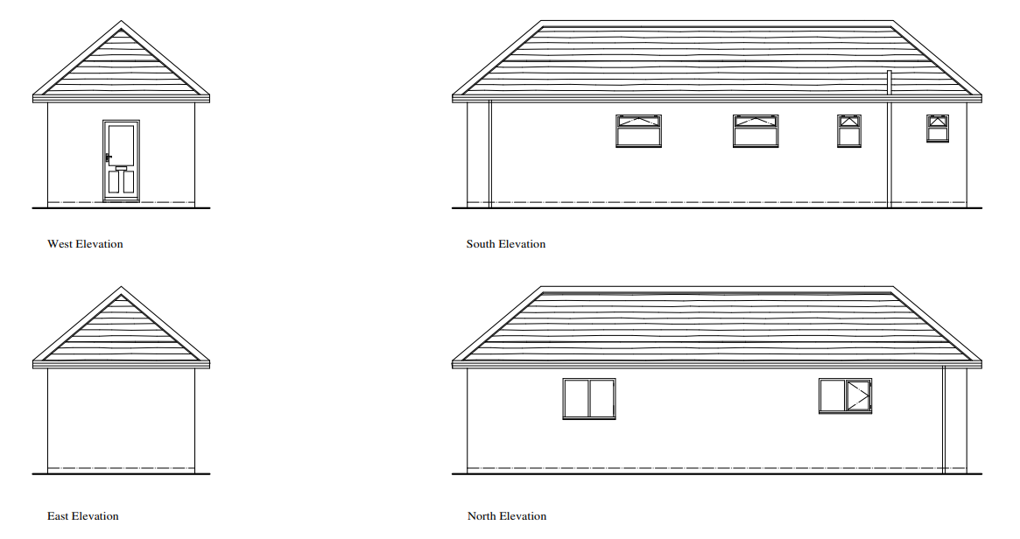

Existing and proposed floor plan shown below.

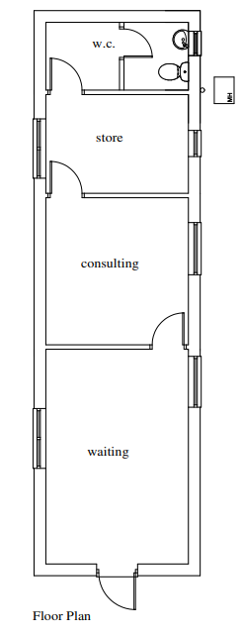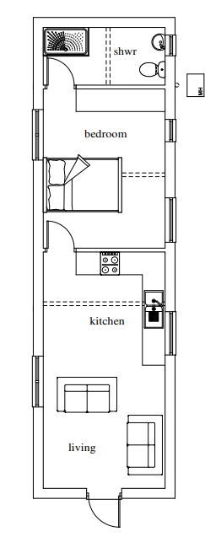

SITE DESCRIPTION/CONTEXT

The application site relates to a modest single storey brick built building under a clay tiled roof measuring approx. 12.23 metres by 3.23 metres. The building was originally a telephone exchange which has been used as an office with storage and most recently as a veterinary surgery (Southill Vets). The building is located within a small plot of land as can be seen in the extract from the location plan below.

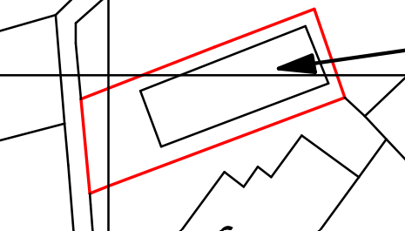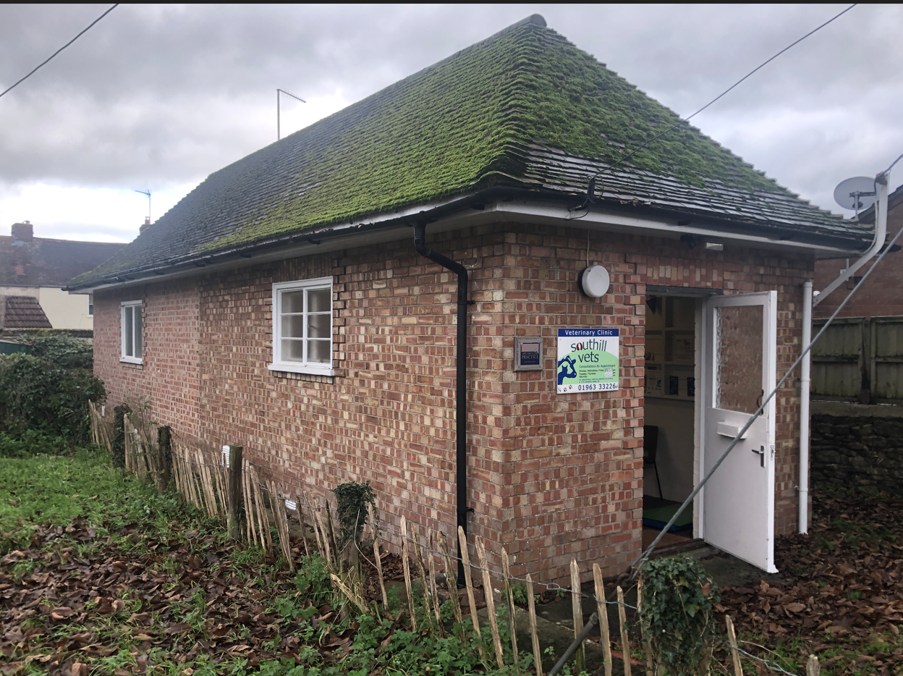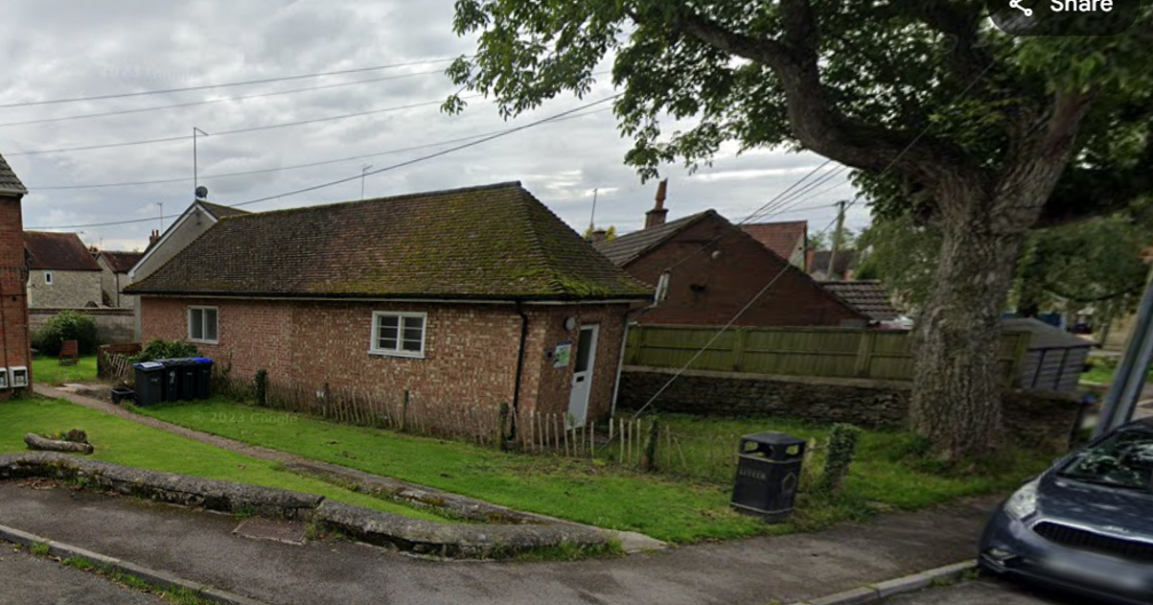

The site is located within the settlement boundary of Local Service Centre of Mere as defined by Core Polices 1, 2 and 17 of the Wiltshire Core Strategy. The application site is surrounded by other residential properties. The site is not listed nor is it located adjacent to any other listed buildings; it is not in a conservation area or within the National Landscape but is located within a Special Landscape Area.

PLANNING HISTORY

Proposal / Summary
S/1986/1285 - Full planning permission Decision - Approve with Conditions Date: 15/10/1986 – change of use of telephone exchange to office & storage
S/1991/1806 - Full planning permission Decision - Approve with Conditions Date: 12/2/1992 – change of use from offices to veterinary surgery

RELEVANT POLICIES AND GUIDANCE

The National Planning Policy Framework (NPPF)
The Planning Practice Guidance
National Design Guide

Wiltshire Core Strategy:

Core Policy 1: Settlement Strategy
Core Policy 2: Delivery Strategy
Core Policy 17: Mere Community Area
Core Policy 35: Existing Employment Land
Core Policy 38: Retail and Leisure
Core Policy 48: Supporting rural life
Core Policy 49: Protection of rural services and community facilities
Core Policy 50: Biodiversity and Geodiversity
Core Policy 51: Landscape
Core Policy 57: Ensuring High Quality Design and Place Shaping
Core Policy 61: Transport and New Development
Core Policy 64: Demand Management

Saved policy of the Salisbury District Local Plan - C6 Special Landscape Area

Wiltshire Design Guide
Creating Places Design Guide
Wiltshire Local Transport Plan 2015-2026

CONSULTATION RESPONSES

Town Council: Object for the following reasons.

Inaccurate Highways and Parking Assessment. The Highways Officer’s report suggests that because the current vet surgery generates a level of parking then conversion to a residential dwelling is acceptable. We strongly disagree with this logic. The current surgery operates only three hours per week (Monday afternoons), creating a negligible impact on local street capacity. Converting this to a dwelling creates a 24/7 parking demand that the site cannot accommodate, representing a significant intensification of use and a detriment to highway safety.

Loss of Vital Commercial Space. There is a documented shortage of small, affordable commercial units in this area. No evidence has been provided to demonstrate that the property was robustly marketed for re-letting as a business (e.g., for a start-up or local office) before seeking residential conversion. We object to the permanent loss of this commercial asset.

Impact on Visual Amenity and Greenery. A prominent, high-value Ash tree is situated immediately outside the property. This tree contributes significantly to the character of the street scene. We are concerned that converting the building into a residence will lead to future pressure to prune or remove the tree due to leaf litter or light obstruction, which would be a loss to the local environment

Highways: No objection

I note the proposed change of use of the existing vets to a one bedroom dwelling unit. No car parking provision is available at the property; however, the extant use would also have generated a level of car parking demand, and I do not believe therefore that the overall impact of the change of use would have an unacceptable highway safety impact. As such, I recommend that no Highway objection is raised.

REPRESENTATIONS

No comments were received.

ASSESSMENT

Section 38(6) of the Planning and Compulsory Purchase Act 2004 states:

"If regard is to be had to the development plan for the purposes of any determination to be made under the planning Acts, the determination must be made in accordance with the plan unless material considerations indicate otherwise."

In accordance with this statutory requirement, this application has been assessed against the relevant policies of the Development Plan, including the adopted Wiltshire Core Strategy (2015) and, where applicable, any made Neighbourhood Plans.

Principle

The NPPF confirms that planning law requires that applications for planning permission be
determined in accordance with the development plan, unless material considerations indicate otherwise.

The proposals are therefore to be considered in the context of the National Planning Policy
Framework (NPPF) which sets out Central Government’s planning policies, and the adopted Wiltshire Core Strategy (WCS), saved policies of the Salisbury District Local Plan and the Wiltshire Local Transport Plan.

At the heart of the NPPF is a presumption in favour of sustainable development and the Adopted Wiltshire Core Strategy seeks to build resilient communities and support rural communities, but this must not be at the expense of sustainable development principles. The Settlement and Delivery Strategies of the Core Strategy are designed to ensure new development fulfils the fundamental principles of sustainability

This means focusing growth around settlements with a range of facilities, where local housing, service and employment needs can be met in a sustainable manner. A hierarchy has been identified based on the size and function of settlements, which is the basis for setting out how the Spatial Strategy will deliver the levels of growth.

Core Policy 1 of the Wiltshire Core Strategy sets out the 'Settlement Strategy' for the county, and identifies four tiers of settlement - Principal Settlements, Market Towns, Local Service Centres, and Large and Small Villages. Only the Principal Settlements, Market Towns, Local Service Centres and Large Villages have defined limits of development/settlement boundaries.

Core Policy 2 of the Wiltshire Core Strategy sets out the 'Delivery Strategy'. It identifies the scale of growth appropriate within each settlement tier, stating that within the limits of development, as defined on the policies map, there is a presumption in favour of sustainable development at the Principal Settlements, Market Towns, Local Service Centres and Large Villages.

Core Policy 17 confirms that development in the Mere Community Area should be in accordance with the Settlement Strategy set out in Core Policy 1 and growth in the Mere Community Area over the plan period may consist of a range of sites in accordance with Core Policies 1 and 2. The settlement boundaries have undergone a more recent review as part of the Wiltshire Housing Site Allocations Plan which was adopted in February 2020, and the site is within the boundary for Mere, a local service centre within the WCS. Accordingly, a presumption in favour of new residential development would apply subject to site specific constraints and considerations these include (but not limited to) scale, design, impact on character of the area, impact on highway safety and neighbour amenity.

The existing property is currently used as a veterinary surgery; it is understood from the submitted documentation that this is open for 3 hours a week. A vet is classed as retail under use Class E of the Town and Country Planning (Use Classes) Order 1987, as amended in 2020. Therefore, the proposals are technically seeking consent for change of use from retail to residential.

Core Policy 49 of the Wiltshire Core Strategy seeks to protect rural services and community facilities. This policy requires a marketing exercise to be undertaken for a minimum of 6 months to evidence that there are no other interests for using the property for either retail or community focused uses. No such evidence has been submitted as part of the application.

In this instance, the existing building comprises of a floor area of 39 metres square and is therefore a small property. Whilst located within the settlement boundary of Mere and close to the town centre, it is in essence separated from the town centre and other retail units and is located within a predominantly residential area and surrounded by other residential properties and has no off road parking. Given the location of the application site, context and relationship with surrounding properties it is considered that residential use is more compatible than retail use or community use, both of which are likely to result in a significant impact on residential amenity, via parking, and general noise and disturbance. In this instance, it is considered that whilst the proposals do not accord with the general aim of CP49, its reuse as a small dwelling is likely to accord more with the aims of CP57 and also CP1, CP2 and CP17 and therefore Officers have no objection to the principle of the change of use to residential.

Furthermore, Wiltshire Council currently have a shortfall in housing land supply, whilst the proposals will only provide a single one bed dwelling, this is also given more weight when balancing the various policy, guidance and materials considerations to reach a recommendation.

The Town Council’s objection to the loss of commercial space is noted but in this instance the Council do not consider it reasonable to object to the principle of this change of use given the location of the site.

Impact upon the character and context of the area

Core Policy 57 - Ensuring High Quality Design and Place Shaping of the Wiltshire Core Strategy seeks to ensure that all new development is of high design quality, reflecting local context, character, and distinctiveness.

The proposed development relates to a material change of use only with no external works. The application site will result in a residential property located in a residential area; therefore, the proposed residential use is compatible with the overall character and context of the area. Having regard to the above, the proposal complies with the design principles set out in Core Policy 57 of the Wiltshire Core Strategy and the Wiltshire Design Guide.

Amenity

Point vii of Core Policy 57 - Ensuring High Quality Design and Place Shaping of the Wiltshire Core Strategy seeks to ensure that developments do not adversely affect neighbouring properties.

The National Planning Policy Framework (NPPF), particularly Paragraph 135(f), stresses that planning decisions should ensure developments provide a high standard of amenity for existing and future users.

The proposed development has been assessed in terms of its potential impact on the residential amenity of neighbouring properties, with particular regard to loss of light, overshadowing, loss of privacy, and overbearing effects.

The proposed development relates to a material change if use only with no external extensions or alterations proposed. The building is existing and single storey, therefore given its siting and relationship with adjacent and nearby properties it is unlikely that there will be any overshadowing or overbearing impacts.

In terms of privacy, as existing all windows in the existing building appear to be obscure glazed, given the close proximity to the site boundaries due to the application site having little in the way of external land around the building obscure glazing is appropriate to minimise overlooking towards the nearest dwelling to the south known as 3 Manor Road. It is also noted that there is a boundary treatment comprising a stone wall with close board timber fence over which provides screening between the application site and 3 Manor Road. Therefore, there are no amenity impact concerns in relation to 3 Manor Road.
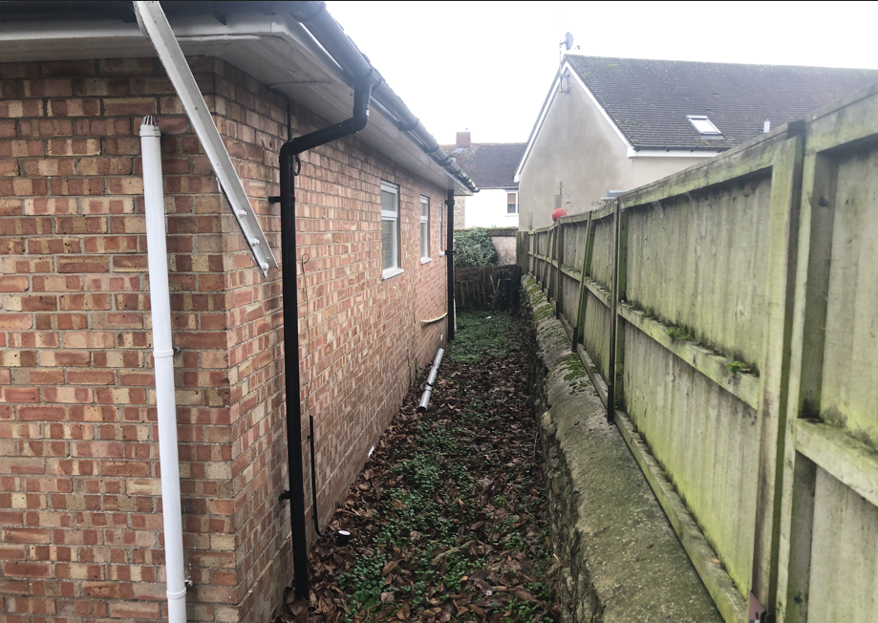

In terms of the impacts to the nearest properties to the north, specifically flats 4, 5, 6 and 7 Manor Road. The Google Maps image below shows the application site and relationship with these four properties. The application site is set forward of these adjacent buildings but the windows on the north elevation of the application site which will serve the bedroom and living room are located almost on the boundary of the site. The window to serve the proposed bedroom is particularly close to this adjacent block of four flats. However, as previously mentioned, all windows in the existing building are currently obscure glazed, this is considered necessary due to the relationship of the application sit and neighbouring properties to minimise overlooking. Currently, there is a low fence along the north boundary of the application site, it is considered prudent that a condition be added to any approval to erect a 2m high boundary fence along the north side of the property to improve the amenity of both occupiers for the existing property but also neighbouring properties.

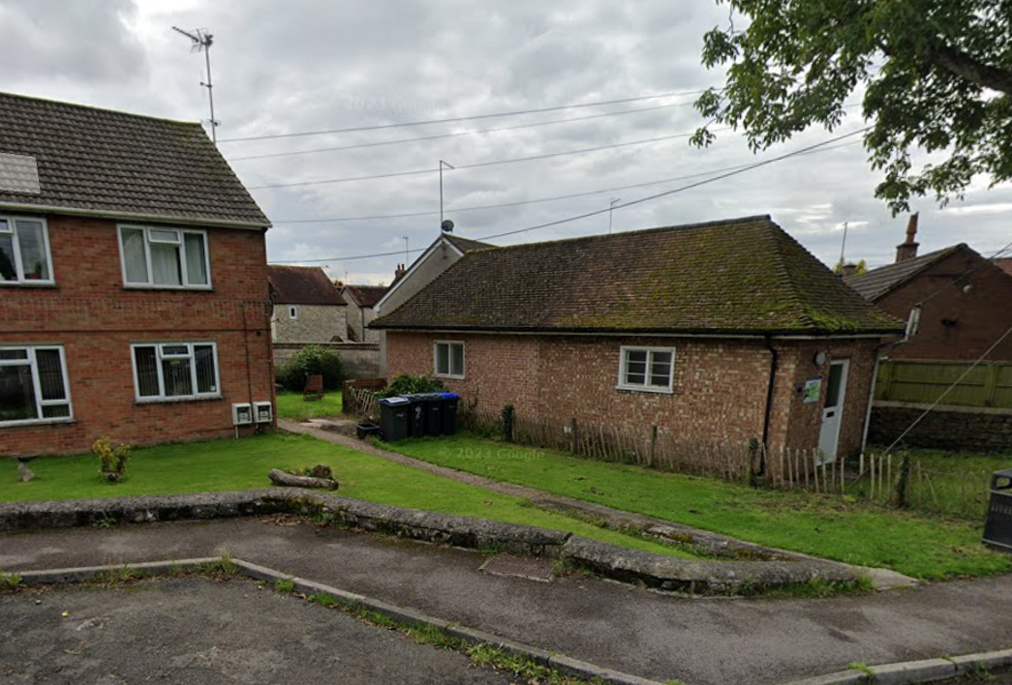

Similarly, given that the application site has little outside amenity space and therefore the elevations are close to the site boundaries, the erection of suitable boundary treatments and obscure glazing will protect the amenity of future occupiers of the new dwelling. A further concern regarding amenity for occupiers of the new dwelling relates to the outside amenity space of the property, as mentioned above, there is little outside amenity space and is generally less than would be required for proposals for the erection of new dwellings. However, as this application is for a change of use, the site is limited and there isn’t scope to increase the amenity space without potentially purchasing land from neighbouring properties. As the property is a single bed property and modest in scale it is likely that it will be occupied by a single person or at most a couple, therefore the lack of amenity space is on balance not considered to be a reason to refuse the application.

The proposal therefore accords with Core Policy 57 point vii in respect of safeguarding residential amenity and the Wiltshire Design Guide.

Linked to amenity is the nationally described space standard, whilst this is not a policy within the development plan it is something officers take note of as part of the assessment for development of this nature. For a one bed dwelling, the nationally described space standard requires a minimum floor space of 39 square metres for one person or 50 metres square for 2 persons. The application documentation shows the property with an internal floor area of 39 metres square which therefore meets the nationally described space standard for a one bed property occupied by one person and therefore Officers have no concerns in this regard.

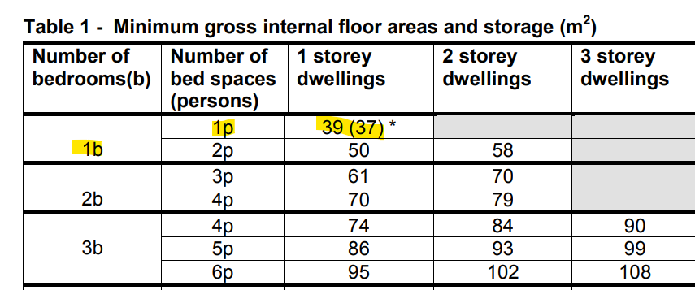

Highways Impact

Core Policy 57 (xiv) of the Wiltshire Core Strategy seeks to ensure that development must meet the requirements of Core Policy 61. This policy requires proposals to be capable of being served by safe access to the highway network. Core Policy 64 seeks to ensure compliance with parking standards set out in the Local Transport Plan.

The National Planning Policy Framework (NPPF), particularly Paragraph 115 and 116, requires that development proposals do not have an unacceptable impact on highway safety and that safe and suitable access to the site can be achieved for all users.

A one bedroomed dwelling to meet Wiltshire Council parking standards is required to provide one off road parking space. However, in this instance the proposals are for a change of use and not the erection of a new build dwelling, there is currently no on site parking and also no room to create an off site parking space. The roads around the property are not restricted in terms of parking. The Council’s highways officer has not objected to the proposals in terms of lack of parking provision.

The Town Council objection in relation to parking is noted and the fact they disagree with the highway’s officers no objections. As the highways officer is a statutory consultee and has not objected, it would be unreasonably for Officers to refuse the development on parking/highway safety grounds.

Ecology Impact

Core Policy 50 of the Wiltshire Core Strategy seeks to protect and enhance biodiversity and geodiversity, including through ensuring that development avoids harm to protected species and habitats.

The National Planning Policy Framework (NPPF), in Paragraphs 193, requires that development minimises impacts on and provides net gains for biodiversity, including ensuring mitigation is secured where harm cannot be avoided.

As of 2nd April 2024, the requirement for Biodiversity Net Gain (BNG) on all new sites came into force. Any small scale (non-major)/major scheme will need to demonstrate no net loss and a minimum of 10% net gain in biodiversity on the site, in line with the requirements of the NPPF, WCS policy CP50 (Biodiversity and Geodiversity) and the Environment Act.

However based on the information available the biodiversity gain planning condition is not considered to apply to this application as the development meets the following exemption criteria and is therefore below the de minimis threshold, meaning the development: − does not impact an onsite priority habitat (a habitat specified in a list published under section 41 of the Natural Environment and Rural Communities Act 2006); and − impacts less than 25 square metres of onsite habitat that has biodiversity value greater than zero and less than 5 metres in length of onsite linear habitat (as defined in the statutory metric).

The application site is not subject to any statutory or non-statutory ecological designations, and the scale and nature of development is such that significant harm to biodiversity is unlikely. No objections have been raised by the Council’s Ecologist.

As such, the development complies with Core Policy 50 of the Wiltshire Core Strategy and the relevant provisions of the NPPF.

Other

There is a mature tree to the front of the property, the Town Council have commented that this is a “prominent, high-value Ash tree is situated immediately outside the property. This tree contributes significantly to the character of the street scene. We are concerned that converting the building into a residence will lead to future pressure to prune or remove the tree due to leaf litter or light obstruction, which would be a loss to the local environment”.

The tree is not located within a conservation area and is not subject to a tree preservation order, therefore works to the tree do not require consent. The development as proposed does not involve external works and therefore the in this regard does not pose a threat to the tree. It is noted that the tree does cause shading of the existing building, particularly of the front garden and front elevation of the building; it is however not considered that this is a reason to object to the proposed development.

CONCLUSION

The proposed development is considered to be acceptable in terms of its relationship with the surrounding area. It would not result in any unacceptable harm to the character of the locality, the amenities of neighbouring occupiers, or the interests of highway safety or ecology.

The proposal is therefore considered to comply with the relevant policies of the Wiltshire Core Strategy and the National Planning Policy Framework. As such, the application is recommended for approval, subject to the conditions set out below.

RECOMMENDATION: That Planning Permission be GRANTED subject to conditions.

1. The development hereby permitted shall be begun before the expiration of three years from the date of this permission.

REASON: To comply with the provisions of Section 91 of the Town and Country Planning Act 1990 as amended by the Planning and Compulsory Purchase Act 2004.

2. The development hereby permitted shall be carried out in accordance with the following approved plans

Application form received 30/12/2025
Site and location plan Drg no 5.0 received 09/01/2026
Proposals drawing Drg no 3.0 received 09/01/2026
Site plan and roof plan proposed Drg no 4.0 received 09/01/2026

REASON: For the avoidance of doubt and in the interests of proper planning

3. Notwithstanding the approved plans, the development hereby permitted shall not be first bought into use until details of proposed boundary treatment fence or wall (to include materials, location and elevations) for the north boundary of the application site has been submitted to and agreed in writing buy the Local Planning Authority.

The agreed boundary treatment shall be installed prior to occupation of the approved dwelling and shall be retained for the lifetime of the development,

REASON: In the interests on residential amenity.

4. The windows in the north and south elevations of the development hereby permitted shall retain obscure glazing for the lifetime of the development.

REASON: In the interests on residential amenity.

Informatives

1. BNG not required
The effect of paragraph 13 of Schedule 7A to the Town and Country Planning Act 1990 is that planning permission granted for development of land in England is deemed to have been granted subject to the condition (biodiversity gain condition) that development may not begin unless:

(a) a Biodiversity Gain Plan has been submitted to the planning authority, and
(b) the planning authority has approved the plan.

The planning authority, for the purposes of determining whether to approve a Biodiversity Gain Plan, if one is required in respect of this permission would be Wiltshire Council.

There are statutory exemptions and transitional arrangements which mean that the biodiversity gain condition does not always apply. For further information on exempt developments please refer to:
https://www.gov.uk/guidance/biodiversity-net-gain-exempt-developments
Based on the information available this permission is considered to be one which will not require the approval of a biodiversity gain plan before development is begun because one or more of the statutory exemptions or transitional arrangements is considered to apply.

