APPLICATION FOR HOUSEHOLDER PLANNING PERMISSION
DELEGATED REPORT

APPLICATION REFERENCE: | PL/2025/10008
APPLICATION TYPE: | Householder planning permission
SITE ADDRESS: | 101, Bradford Leigh, Bradford on Avon, BA15 2RW
DEVELOPMENT DESCRIPTION: | Proposed Demolition of Existing Conservatory and Erection of Single Storey Extension
RECOMMENDATION: | That Planning Permission be GRANTED

PROPOSAL

The proposal seeks planning permission for a single storey extension to be erected on the rear elevation of the host dwelling. An existing conservatory positioned on the north side elevation of the host dwelling would be removed.

SITE DESCRIPTION/CONTEXT

The proposal relates to a domestic property known as 101 Bradford Leigh, a two-storey detached dwelling set back from the public highway within the hamlet of Bradford Leigh near Bradford on Avon. The host dwelling benefits from an off-road parking area to the front elevation and an attached garage.

The application site is located within the West Wiltshire Green Belt and falls within the recreational impact zone of the Bath and Bradford on Avon Special Area of Conservation for bats. To the south of the application sits a Grade II listed building, 102 Bradford Leigh.

PLANNING HISTORY
Proposal / Summary
W/91/00643/FUL - Full planning permission Decision - Approved Date: 18/6/1991 – Extension to dwelling - conservatory
W/06/02301/FUL - Full planning permission Decision - Approve with Conditions Date: 15/9/2006 – Two storey extension
W/06/01111/FUL - Full planning permission Decision - Approve with Conditions Date: 1/6/2006 – A small first floor extension

RELEVANT POLICIES AND GUIDANCE

Wiltshire Core Strategy:
Core Policy 2 Delivery Strategy
Core Policy 7 Spatial Strategy for the Bradford on Avon Community Area
Core Policy 50 Biodiversity and Geodiversity
Core Policy 51 Landscape
Core Policy 57 Ensuring High Quality Design and Place Shaping
Core Policy 58 Ensuring the Conservation of the Historic Environment
Core Policy 67 Flood Risk
Wiltshire Design Guide: Appendix D – Design Guidance for Householder extensions
The National Planning Policy Framework (NPPF)
The Planning Practice Guidance
National Design Guide

CONSULTATION RESPONSES
South Wraxall Parish Council: No objection

REPRESENTATIONS
No comments were received.

ASSESSMENT
Section 38(6) of the Planning and Compulsory Purchase Act 2004 states:

"If regard is to be had to the development plan for the purposes of any determination to be made under the planning Acts, the determination must be made in accordance with the plan unless material considerations indicate otherwise."

In accordance with this statutory requirement, this application has been assessed against the relevant policies of the Development Plan, including the adopted Wiltshire Core Strategy (2015) and, where applicable, any made Neighbourhood Plans.

Principle of Development in the Green Belt
There are no relevant development plan policies relating to the Green Belt at local level therefore the NPPF provides policy direction. The NPPF (paragraph 153) states that “inappropriate development is, by definition, harmful to the Green Belt and should not be approved except in very special circumstances”.

Paragraph 154 states development in the Green Belt is inappropriate unless one of the following exceptions applies. These exceptions include, amongst others, the extension or alteration of a building provided that it does not result in disproportionate additions over and above the size of the original building. However, the NPPF does not quantify what disproportionate extensions constitute, and the Council does not prescribe a volume/percentage maximum in any policy. Consequently, each case must be assessed on its own merits.

The fundamental aim of Green Belt policy is to prevent urban sprawl by keeping land permanently open, the essential characteristics of Green Belts are their openness and their permanence. Openness is the absence of development notwithstanding the degree of visibility of the land in question from the public realm and has both spatial and visual aspects.

The NPPF does however define ‘original building’ as “a building as it existed on 1 July 1948 or, if constructed after 1 July 1948, as it was originally built.”

It is not easy to determine when the existing dwelling as it exists was erected but the Council’s historic mapping illustrates that there was certainly some form of residential dwelling on site during the period of 1868-1899 as illustrated on the map insert below.

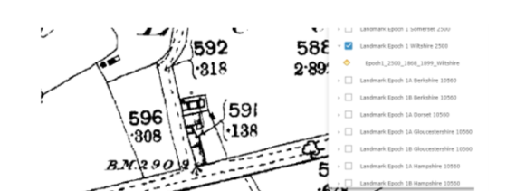

Planning history reveals that 101 Bradford Leigh has been extended since it was originally built, with the addition of a conservatory in 1991 (W/91/00643/FUL), a first-floor extension approved under (W/06/01111/FUL) and a two-storey extension approved under (W/06/02301/FUL)

The officer's report for the two-storey extension sets out the original volume of the property and estimates the proposed green belt volumes of the previous additions built (where sufficient information exists) to which the following refers:

Original dwelling – 531m3
Conservatory – 36.4m3
First floor extension – 30.2m3 – not implemented
Two storey extension – 38.7m3
Total existing built volume on site = 606m3 which is a 14% increase on the original building.

With the removal of the conservatory the volume of the building would decrease marginally, and the additional extension would give a built volume (once implemented) of 690m3

606.98m3 - minus 36.4m3 (conservatory) plus 120m3 (proposed single storey extension) = 690m3

This proposed development (once implemented) would give a 29% increase of built form from the volume of the original building. Based on these green belt volumes the erection of the single storey extension would not constitute as a disproportionate addition above the volume of the original building (or as of January 1948).

Officers have analysed the proposal and the site and have concluded that the proposed development would not result in material harm to the openness of the Green Belt given the extension would be seen against the back drop of the main dwelling when viewed from the north and east, and would not be visible when viewed from the west and south/ highway. In addition, the extension would be single storey only and would occupy only a small footprint.

As such it is considered the proposal would be considered appropriate development in the Green Belt and would accord with the NPPF.

Design and Impact upon the character and context of the area
Core Policy 57 - Ensuring High Quality Design and Place Shaping of the Wiltshire Core Strategy seeks to ensure that all new development is of high design quality, reflecting local context, character, and distinctiveness.

The proposal seeks to erect a single storey extension on the rear elevation of the host dwelling. The existing conservatory positioned on the north side elevation of the host dwelling would be removed.

The extension would consist of a flat roof form with two roof lanterns inserted, with the elevations aligning with the existing elevations of the host dwelling, to sit within an open void on the east elevation. Patio doors and a window would be inserted on the rear elevation of the extension and a window inserted on the east elevation. The applicant also seeks to insert additional fenestration on the existing dwelling with two ground floor windows inserted on the front elevation and a set of patio doors on the north side elevation.

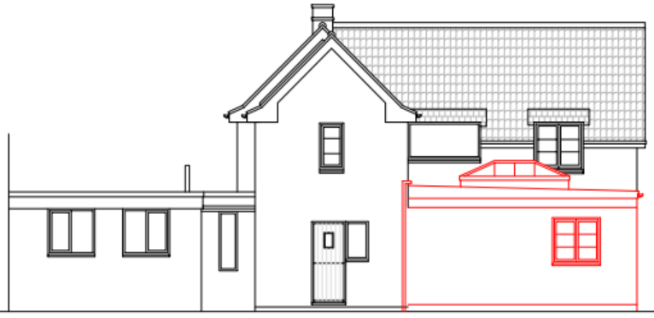
Proposed rear elevation of the host dwelling
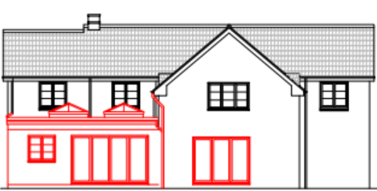
Proposed north side elevation of the host dwelling

The elevations would consist of rubble stone to match the existing materials of the host dwelling with matching UPVC fenestration and doors and a rubber membrane flat roof. Officers support the use of the natural (rubble stone) materials that would integrate into the existing environment, and consider that the extension would by virtue of its height, scale and design constitute a complementary addition to the host dwelling that would appear commensurate to the size of the property and plot.

Having regard to the above, the proposal complies with the design principles set out in Core Policy 57 of the Wiltshire Core Strategy and Appendix D of the Wiltshire Design Guide.

Amenity
Point vii of Core Policy 57 - Ensuring High Quality Design and Place Shaping of the Wiltshire Core Strategy seeks to ensure that developments do not adversely affect neighbouring properties.

The National Planning Policy Framework (NPPF), particularly Paragraph 135(f), stresses that planning decisions should ensure developments provide a high standard of amenity for existing and future users.

The proposed development has been assessed in terms of its potential impact on the residential amenity of neighbouring properties, with particular regard to loss of light, overshadowing, loss of privacy, and overbearing effects.

The host dwelling occupies a large residential plot with an extended residential curtilage. Officers raise no concerns in relation to any overlooking, overbearing or overshadowing to any neighbouring occupiers given the single storey nature of the building and the position of the proposed extension, with any additional fenestration proposed at ground floor level only.

The proposal therefore accords with Core Policy 57 point vii in respect of safeguarding residential amenity and Appendix D of the Wiltshire Design Guide.

Heritage Impact
From the point of view of the historic environment the main statutory tests are set out within the Planning (Listed Building and Conservation Areas) Act 1990.

Section 66 requires that special regard be given to the desirability of preserving listed buildings, their settings or any features of special architectural or historic interest which they possess.

Section 72(1) of the Act requires the Council to pay special attention to the desirability of preserving or enhancing the character or appearance of designated Conservation Areas.

The Council’s Core Strategy Policy CP58 ‘Ensuring the conservation of the historic environment’ requires that designated and non-designated heritage assets and their settings will be conserved, and where appropriate enhanced, in a manner appropriate to their significance and encourages proposals which improve the condition of heritage assets at risk.

The Council’s Core Strategy CP 57: Ensuring high quality design requires a high quality of design in all new developments. The policy requires applicants to “demonstrate how the proposal will make a positive contribution to the character of Wiltshire through (amongst other things) responding to the value of the natural and historic environment and being sympathetic to and conserving historic buildings and landscapes. Development is required to respond positively to the existing in terms of building layouts, built form, height, mass, scale, building line, plot size, elevational design, materials, streetscape and rooflines to effectively integrate the building into its setting.

The NPPF outlines government policy for planning. Chapter 16 of the NPPF 'Conserving and enhancing the historic environment' sets out the Government's high-level policies concerning heritage and sustainable development.

To the south of the application site lies a detached Grade II listed property known as 102 Bradford Leigh, the dwelling occupies a prominent position positioned at the entrance to the cul-de-sac abutting the public highway to the south.

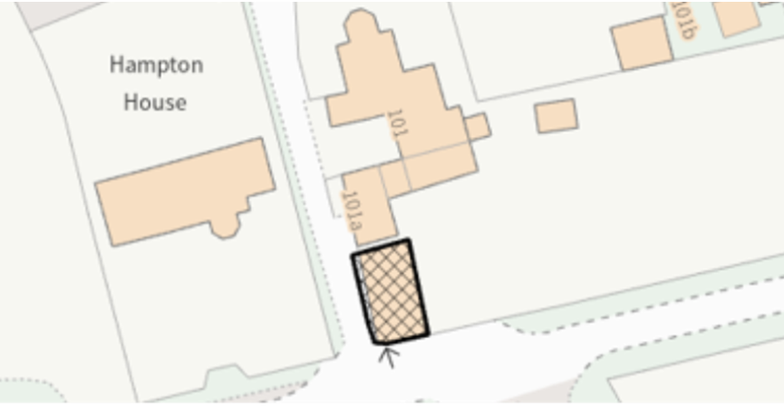

Position of the listed building (hatched black) in relation to the host dwelling

The host dwelling occupies a setback position from the public highway and the extension proposed would be obscured from view by the existing built form of the host dwelling and would not be readily visible from the public realm.

The proposed development would utilise materials to match existing that would be reflective of the host property and local character to comply with WCS CP57 and 58. The proposed height and scale of the development is considered to be commensurate to the size of the generous application site and would therefore not adversely impact the setting of the listed building nearby.

The development is therefore considered to comply with Core Policy 58 of the Wiltshire Core Strategy and Sections 66 and 72 of the Planning (Listed Buildings and Conservation Areas) Act 1990, as well as the relevant provisions of the NPPF.

Ecology Impact
Core Policy 50 of the Wiltshire Core Strategy seeks to protect and enhance biodiversity and geodiversity, including through ensuring that development avoids harm to protected species and habitats.

The National Planning Policy Framework (NPPF), in Paragraphs 193, requires that development minimises impacts on and provides net gains for biodiversity, including ensuring mitigation is secured where harm cannot be avoided.

The application site is located within several consultation zones for bats associated with the Bath & Bradford on Avon Special Area of Conservation (SAC) and therefore has potential to result in significant adverse impact on the special features of that site.

However, given the limited development proposed, erection of a single storey extension sited close to the existing built form of the host dwelling, and the established residential nature of the location it is considered highly unlikely that any bats would be affected and significant effects relating to the disturbance to bats can be ruled out.

The removal of the conservatory building raises no concerns in regard to negative impacts on any roosting bats given the highly glazed nature of the building to demolished which would be unlikely to support bats. As a precautionary measure an informative would be added to any decision that in event any evidence of bat activity is detected that the applicant should follow the advice of a professional ecologist or contact Natural England.

As such, the development complies with Core Policy 50 of the Wiltshire Core Strategy and the relevant provisions of the NPPF.

Biodiversity Net Gain
Householder planning applications are exempt from the requirement to deliver Biodiversity Net Gain under Schedule 7A, Section 4(2)(a) of the Town and Country Planning Act 1990, as inserted by the Environment Act 2021.

CONCLUSION
The proposed development is considered to be acceptable in terms of its design, scale, and relationship with the surrounding area. It would not result in any unacceptable harm to the character of the locality, the amenities of neighbouring occupiers, or the interests of heritage, or ecology.

The proposal is therefore considered to comply with the relevant policies of the Wiltshire Core Strategy, the Wiltshire Local Plan, and the National Planning Policy Framework. As such, the application is recommended for approval, subject to the conditions set out below.

RECOMMENDATION: That Planning Permission be GRANTED subject to conditions.

Conditions
- The development hereby permitted shall be begun before the expiration of three years from the date of this permission.
REASON: To comply with the provisions of Section 91 of the Town and Country Planning Act 1990 as amended by the Planning and Compulsory Purchase Act 2004.

- The development hereby permitted shall be carried out in accordance with the following approved plans and documents:
Location Plan, Existing & Proposed Elevations & Proposed Block Plan DWG No AH2024/59 Sheet 1 of 3
Proposed Floor Plans DWG No AH2024/59 Sheet 2 of 3
Existing Floor Plans DWG No AH2024/59 Sheet 3 of 3
All Plans Received 24.12.2025
REASON: For the avoidance of doubt and in the interests of proper planning.

Informative
If bats or evidence of bats are found during the works, the applicant is advised to stop work and follow advice from an independent ecologist or to contact Natural England’s Bat Line through the internet.

