File Note – Preliminary Roost Assessment

Site name: Notton House School, Notton, Chippenham, SN15 2NF
Ref: N/A
Recipients: Mr. Clive Hall
Author: Tom Hird, BSc (Hons) MRSB – Licensed Ecologist (bat licence No. 2022-10598-CL17-BAT)

Site Background:
Works are to be undertaken at the above-named site, which are understood to involve the removal and replacement of the roof over the main school building. Mr. C Hall has been contracted to oversee the works and as part of the initial design phase, has contracted a licensed bat ecologist to undertake a preliminary assessment of the roof.
This survey is to determine whether bats are present or likely absent from the roof and if further survey may be required.
It is understood that permission to begin the works on the roof has previously been granted by Wiltshire Council

Survey Effort:
The survey was undertaken by Tom Hird, BSc (Hons) MRSB on 6th February 2026. Tom holds a class 1 bat licence 2025-82877-CL17-BAT. All building(s) that will be impacted by the project proposals (the survey area) were assessed for their potential to support roosting bats. The surveyor systematically searched for features suitable for roosting bats and signs of bat activity, by conducting a non-intrusive visual appraisal from the ground using binoculars, inspecting the external features of the buildings for potential access/egress points, and for signs of bat use. An internal inspection of the building was also made, including the living areas of derelict or abandoned buildings and the roof spaces of all building(s), using a torch and ladder. The surveyor paid particular attention to the floor and flat surfaces, window shutters and frames (where applicable), lintels above doors and windows, and carried out a detailed search of numerous features within the roof space.
Due to the construction of the building, and the presence of a parapet wall around the wall top, the full roof area was not visible from the ground. However, this was not considered a limitation due to fact the parapet wall itself would impede bats from utilising nearby adjacent features if present.

Survey Result:
The roof, while weather and with mosses present, appeared in good condition throughout, with no observable slipped, missing or cracked tiles. Internally, a bitumen felt liner was present and with a few small tears, whilst the wooden rafters and beams were well fitted, with no observable cervices.
No evidence of any current or historic bat use was observed during the survey (droppings, urine stains etc)
Due to the lack of any potential roosting features, both internally and externally, along with a lack of any evidence of bat activity, it is considered that this building offers negligible roosting potential to both crevice dwelling and free hanging bat species.
Additionally, no evidence of any current or historic breeding birds was observed at the time of survey.

Recommendations:
No further survey effort is recommended at this point, and the works are cleared to continue. However, if bats are found during any stage of the development, work should stop immediately and a suitably qualified ecologist should be contacted to seek further advice.

Appendix
Photo 1: Showing western elevation of the building. | 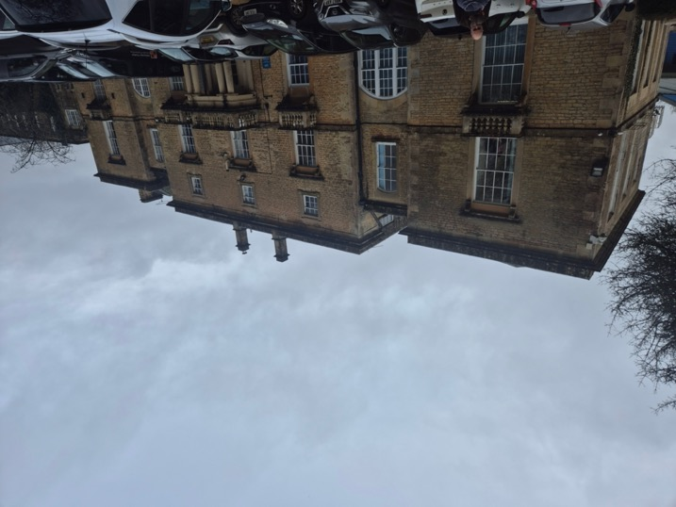
Photo 2: Showing interior of roof space facing north. | 