APPLICATION FOR FULL PLANNING PERMISSION AND
LISTED BUILDING CONSENT DELEGATED REPORT

APPLICATION REFERENCE: | PL/2025/09621 and PL/2025/09622
APPLICATION TYPE: | Full planning permission and Listed Building Consent
SITE ADDRESS: | 22/24 Market Place, Warminster, BA12 9AN
DEVELOPMENT DESCRIPTION: | Demolition of rear (south) modern extension to No. 24 and reinstatement of original lower section of gable wall. Reconstruction of original ground floor internal front section of party wall together with adaptations and repairs to shop windows.
RECOMMENDATION: | That Planning Permission/ Listed Building Consent be GRANTED

This is a joint report for PL/2025/09621 (FULL) and PL/2025/09622 (LBC)

PROPOSAL

The proposal seeks planning permission and listed building consent for demolition of a modern extension to the rear of No. 24 Market Place with reinstatement of the original lower section of the gable wall. Reconstruction of the original ground floor internal front section of the party wall together with adaptations and repairs to the shop windows.

SITE DESCRIPTION/CONTEXT

The application relates to two properties No.22 and No.24 Market Place located within the town centre in Warminster. The two properties are Grade II listed, and function as commercial units sitting within the Warminster Conservation Area. Both properties are currently empty but comprise of commercial premises on the ground floor and a mixture of storage and residential on the first floor together with a former brewery building with access onto Chinns Court to the south.

The properties sit within the recreational impact zone of the Salisbury Plain Special Protection Area for birds and are located within the Hampshire catchment area of the River Avon SAC.

PLANNING HISTORY

Proposal / Summary
15/12654/LBC - Listed building consent Decision - Approve with Conditions Date: 8/2/2016 – Fire safety works and alterations
16/04493/LBC - Listed building consent Decision - Approve with Conditions Date: 5/7/2016 – Fire safety works and alterations
W/05/00845/LBC - Listed building consent Decision - Approve with Conditions Date: 14/7/2005 – Alterations and repairs to southern boundary wall and fence
W/05/01612/FUL - Full planning permission Decision - Approve with Conditions Date: 30/8/2005 – Alterations and repairs to southern boundary wall and fence
W/06/03848/LBC - Listed building consent Decision - Approve with Conditions Date: 14/2/2007 – Internal/structural repairs
W/87/00514/LBC - Listed building consent Decision - Approved Date: 26/5/1987 – Alteration to shop front

RELEVANT POLICIES AND GUIDANCE

Wiltshire Core Strategy:
Core Policy 2 Delivery Strategy
Core Policy 31 – Spatial Strategy for the Warminster Community Area
Core Policy 38 – Retail and Leisure
Core Policy 50 – Biodiversity and Geodiversity
Core Policy 57 – Ensuring High Quality Design and Place Shaping
Core Policy 58 – Ensuring the Conservation of the Historic Environment
Core Policy 67 – Flood Risk
Core Policy 69 – Protection of the River Avon SAC
Warminster Neighbourhood Plan 2015- 2026 Made November 2016

Wiltshire Design Guide

The National Planning Policy Framework (NPPF)

The Planning Practice Guidance

National Design Guide

CONSULTATION RESPONSES

Warminster Town Council: No objection

Wiltshire Council Ecology team: No objection

Wiltshire Council Conservation officer: No objection subject to conditions, further comments below.

REPRESENTATIONS
No comments were received.

ASSESSMENT
Section 38(6) of the Planning and Compulsory Purchase Act 2004 states:

"If regard is to be had to the development plan for the purposes of any determination to be made under the planning Acts, the determination must be made in accordance with the plan unless material considerations indicate otherwise."

In accordance with this statutory requirement, this application has been assessed against the relevant policies of the Development Plan, including the adopted Wiltshire Core Strategy (2015) and, where applicable, any made Neighbourhood Plans.

Principle of Development
Policy CP38 of the Core Strategy seeks to enhance the vitality and viability of the town centres in Wiltshire through policies promoting the regeneration of central areas and delivery of new growth at settlements to support the vitality of centres.

The proposed development comprises an upgrading and renovation to existing commercial premises set within the settlement boundary of Warminster. The proposed works are wholly within the application site and as such the principle of development is acceptable subject to the detailed assessment of heritage impacts, design, amenity, and other material considerations set out below.

Heritage, Design and Impact upon the character and context of the area:
From the point of view of the historic environment the main statutory tests are set out within the Planning (Listed Building and Conservation Areas) Act 1990.

Section 66 requires that special regard be given to the desirability of preserving listed buildings, their settings or any features of special architectural or historic interest which they possess.

Section 72(1) of the Act requires the Council to pay special attention to the desirability of preserving or enhancing the character or appearance of designated Conservation Areas.

The Council’s Core Strategy Policy CP58 ‘Ensuring the conservation of the historic environment’ requires that designated and non-designated heritage assets and their settings will be conserved, and where appropriate enhanced, in a manner appropriate to their significance and encourages proposals which improve the condition of heritage assets at risk.

The Council’s Core Strategy CP 57: Ensuring high quality design requires a high quality of design in all new developments. The policy requires applicants to “demonstrate how the proposal will make a positive contribution to the character of Wiltshire through (amongst other things) responding to the value of the natural and historic environment and being sympathetic to and conserving historic buildings and landscapes. Development is required to respond positively to the existing in terms of building layouts, built form, height, mass, scale, building line, plot size, elevational design, materials, streetscape and rooflines to effectively integrate the building into its setting.

The NPPF outlines government policy for planning. Chapter 16 of the NPPF 'Conserving and enhancing the historic environment' sets out the Government's high-level policies concerning heritage and sustainable development.

The host buildings are Grade II listed and lie within the vicinity of a number of listed buildings that line the Market Place, the principal route through the town centre. The application site is also located within the Warminster Conservation Area, which covers the historic core of the of the town.
The proposal relates to limited development to the rear of No.24 Market Place removing an existing non-original extension (as illustrated within the plan inserts below) with reinstatement of the original lower section of the gable wall. The proposal also seeks to construct the original ground floor internal front section of the party wall together with adaptations and repairs to the shop windows.
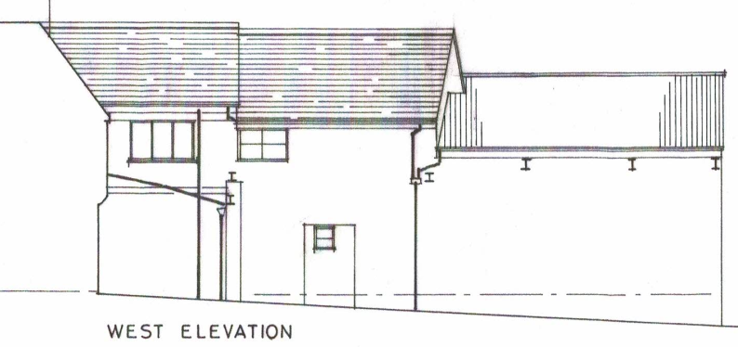
Existing west elevation
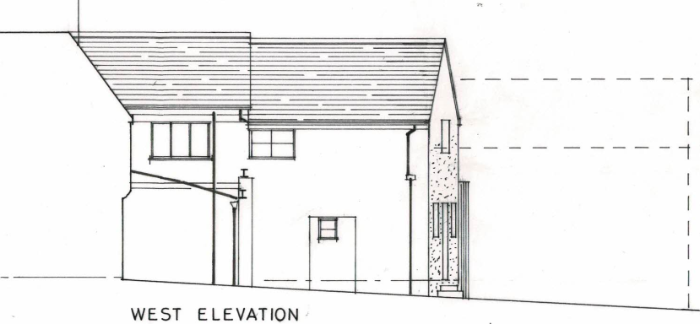
Proposed west elevation
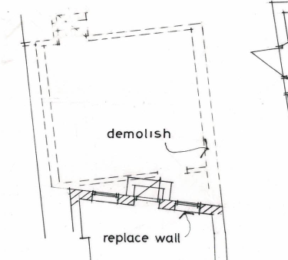
Proposed floor plan illustrating removal of the extension

The Local Authority Conservation officer was consulted on the proposal and offered the following response.

“Site and assets considered:
22-24 Market Place is a grade II listed building, together with numbers 16 and 18 and a former malthouse to the rear. The list description reads as follows:

‘Mid-late C18. No 22 of 3 storeys, No 24 of 2 storeys. Painted front of ashlar, now with continuous shop front on ground floor with large fascia, No 22 probably late C19 with spindly colonnettes dividing plate glass windows. Glazing bar sash windows with keystones. No 22 has 2 ranges with band over 1st floor, centre blind. No 22 has hipped old tile roof and hipped return above No 24 which has slate roof. 2 brick chimneys. Nos 16 and 18 are at the rear of Nos 24 and 22 respectively: they form 2 and 3 storey extensions at rear reached from alleyway which starts between Nos 14 and 20 (qv). A variety of maltster's workshops including small scale malthouse of coursed squared rubble form continuous extensions beyond No 18 and have a staggered frontage to the alleyway’.

The site is within the Warminster conservation area.

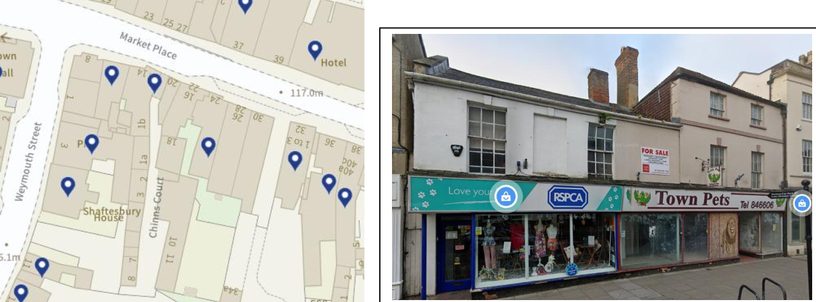

Proposal:
The D&A statement says: ‘Provisionally, the applicant would like to maintain the current ground floor commercial use of both properties together with the former brewery and possibly extend this use to the first floor. However, in order to possibly make use of the rear courtyard and garden, the relatively modern extension to the rear of 24 will need to be taken down and the original end gable reconstructed.
However, the description of works is:
‘Demolition of rear (south) modern extension to No. 24 and reinstatement of original lower section of gable wall. Reconstruction of original ground floor internal front section of party wall together with adaptations and repairs to shop windows.’

Issues: impact on the listed building, impact on the setting of neighbouring listed buildings, impact on the conservation area.

Information considered/provided:
Paragraph 207 requires that applicants describe the significance of any heritage assets affected, including any contribution made by their setting. This should include sufficient information to provide a clear understanding of the significance of the heritage asset and its setting and the potential impact of any proposals on that significance.

In this case, whilst the applications are accompanied by a “Heritage Statement” (Michael Heaton – dated November 2025). The requirements of the NPPF are therefore met in this respect.

However, paragraph 208 also provides for the local planning authority to make its own assessment of impact and the following heritage recommendations are offered on this basis.

Significance of assets and contribution of setting:
The NPPF defines significance as the “value of a heritage asset to this and future generations because of its heritage interest. The interest may be archaeological, architectural, artistic or historic. Significance derives not only from a heritage asset’s physical presence, but also from its setting.” Historic England assesses significance in a similar manner, referring to evidential, historic, aesthetic and communal values of a place.

I have not visited or inspected the properties in conjunction with these applications. As such, I am responding only to those elements of significance which relate to the current proposals.

The heritage statement notes:
That the Market Place is a ‘planned’ 13th century extension of the Anglo-Saxon settlement or Worgemynster (no Anglo-Saxon remains have been identifies). As such it has evidential/historic interest.

That the narrow rectilinear plots reflect the character of burgage plots, as such the form of the plots are of interest and medieval boundaries may survive; In particular, in respect of 22-24, Mr Heaton notes ‘the outlines of Nos 22 and 24 appear to have remained essentially unaltered’ As such it has evidential/historic interest.

Present buildings from early 18th century; architectural/evidential interest;

Originally likely houses with malthouse behind, adapted to shops in 19th century? As such, the presence of a shopfront is of interest in that it is part of the commercial development of the Market Place; evidential/historic interest;

Survival of a courtyard area; evidential/historic interest;
The survival of a section of bath stone wall which is part of the original party wall dividing the two properties (evidential value). Evidential interest.

Not of interest Existing shopfront;
Rear ‘cell’ to number 24 was not present in 1924 (as noted in heritage statement).

Of interest
That the two buildings were originally separated by a passageway (evident in the treatment of the first-floor elevation of number 24)..

Assessment:
Reinstatement of two shopfronts
As the heritage consultant notes, existing large shop front is not historic and detracts from the appearance of the building. Two shopfronts would enhance the interest of the buildings and reinstate a former arrangement.
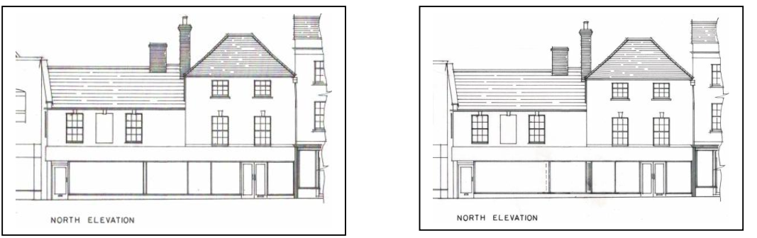
The current proposal looks to utilise elements of the existing shopfronts. The shopfront frame to the former ‘Town Pets’ (number 22) is reasonably attractive and decorative (ie painted red) although the fascia is too deep and detracts from the elegance of the framing.

The proposal is to replace an existing slender mullion with a wider pilaster/column (or masking panel detail as per the drawing) which would conceals the new internal ground floor party wall. A detail of this has been supplied.
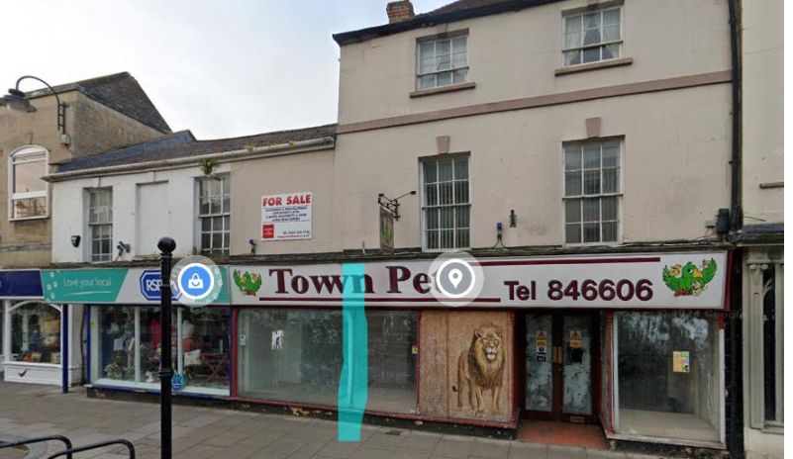

In respect of number 24 (former RSPCA shop), the ‘existing drawings’ do not evidence the two vertical mullions, which break up the large area of glass. I would wish to see these vertical divisions, or some sort of division (one would be better), reinstated. Could clarification please be provided.
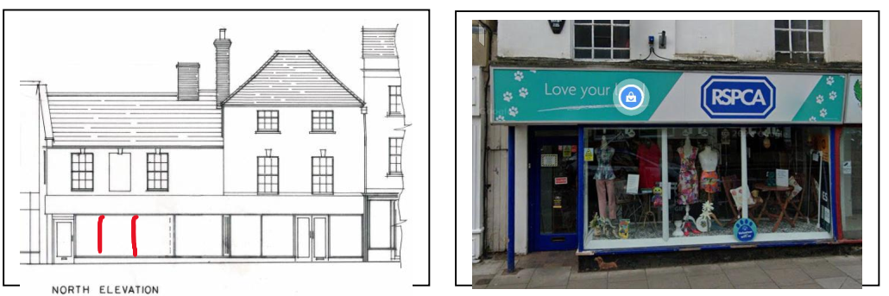

The drawings and statements suggest the fascia is not to be replaced. This seems to be unlikely (given its condition) and a missed opportunity (given its unsightliness) which again is a shame as it is overly deep for the two buildings.

Reinstatement of party wall on ground floor
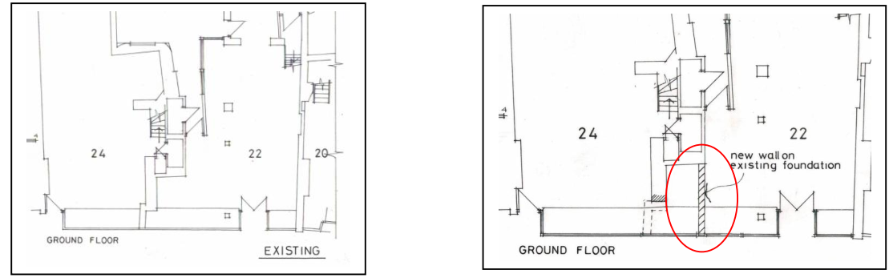There are no details of the ‘existing foundation’ nor any photos. I am unable to assess the impact of the proposals on say the ceiling, as no details are provided. However, I have no objection in principle.

Demolition of the furthest extension to number 24
Again, this is proven to be a 20th century addition of no interest so no objection.

Reconstruction of the rear gable wall following removal of structure
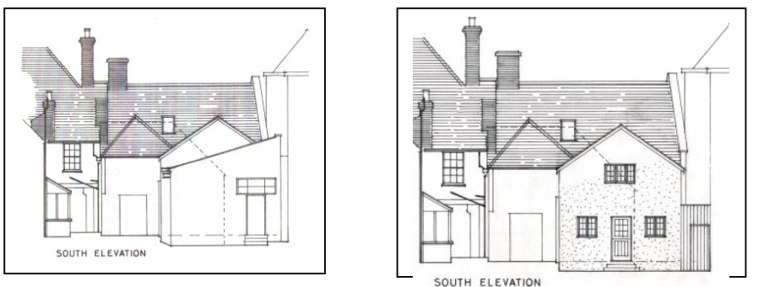

This is a significant element of work ie rebuilding a gable wall (how is the rest of the building supported?). There is no information in the application ie a methodology.

In respect of the ‘new’ elevation, I would expect window and door details at a scale of no less than 1:20 including full sections (ie so we know we have proper run-through glazing bars).

Summary & conclusion:
I have no objection in principle to the applications, and indeed welcome the reinstatement of two shop fronts, however in view of the lack of detail or supporting documents, I am unable to properly assess their impact. Of particular concern is the lack of information and a methodology for the rebuilding of a rear wall following the demolition of an existing structure.
In respect of the shopfront, I am not entirely clear what is proposed in respect of number 24. Furthermore, it is clear that the fascia, which is an unattractive feature, is very tired and potentially is causing problems in terms of water ingress along its top edge. The application makes no mention of works to this and yet it would seem inevitable that it should be addressed if there are to be works to the shop windows and frame? The NPPF confirms that when considering the impact of a proposed development on the significance of a designated heritage asset, great weight should be given to the asset’s conservation (and the more important the asset, the greater the weight should be). It makes clear that any harm to a designated heritage asset requires clear and convincing justification. However, the NPPF (paragraph 210) also requires that new development should make a positive contribution to local character and distinctiveness.

As it stands, I consider the proposals, as described, would preserve the character of the conservation area (in accordance with section 72 of the Planning LBCA Act 1990) and that in respect of the listed buildings, the proposals would be largely neutral. On this basis no specific justification is required however it is considered the works will assist in securing the future use of a heritage asset in support of its long-term conservation. The requirements of current conservation legislation, policy or guidance are considered to be met and there is therefore no objection to the approval of the application.”

Officers are of the opinion that the proposals would not result in harm to the significance of any heritage assets, and subject to a number of relevant conditions (relating to extra detail in regards to a construction methodology for the party wall, methodology for the new gable wall and window and door details, and retention of the existing shopfront frame to No.22) being added, no objections have been raised by the Conservation Officer.

The development is therefore considered to comply with Core Policy 57 and 58 of the Wiltshire Core Strategy and Sections 66 and 72 of the Planning (Listed Buildings and Conservation Areas) Act 1990, as well as the relevant provisions of the NPPF and the Wiltshire Design Guide.

Amenity
Point vii of Core Policy 57 - Ensuring High Quality Design and Place Shaping of the Wiltshire Core Strategy seeks to ensure that developments do not adversely affect neighbouring properties.

The National Planning Policy Framework (NPPF), particularly Paragraph 135(f), stresses that planning decisions should ensure developments provide a high standard of amenity for existing and future users.

The proposed development has been assessed in terms of its potential impact on the residential amenity of neighbouring properties, with particular regard to loss of light, overshadowing, loss of privacy, and overbearing effects.

The proposal relates to small scale works to the rear of the buildings with the removal of an existing extension, and internal works to the party wall. Due to the nature of the works no neighbouring amenity impacts are raised. The proposal therefore accords with Core Policy 57 point vii in respect of safeguarding residential amenity and Appendix D of the Wiltshire Design Guide.

Ecology Impact
Core Policy 50 of the Wiltshire Core Strategy seeks to protect and enhance biodiversity and geodiversity, including through ensuring that development avoids harm to protected species and habitats.

The National Planning Policy Framework (NPPF), in Paragraphs 193, requires that development minimises impacts on and provides net gains for biodiversity, including ensuring mitigation is secured where harm cannot be avoided.

This proposal falls within the recreational impact zone of the Salisbury Plain Special Protection Area for birds and located within the Hampshire catchment area of the River Avon SAC where phosphates and nutrients are carefully controlled and monitored. An Ecological Assessment was submitted within the application documents, and the Local Authority Ecology team were consulted and commented as such.

“Protected and Notable Species/Habitats
An ecological assessment was submitted in support of the proposals which is welcomed. The report assessed the areas to be impacted by the proposed works to have negligible potential to support roosting bats and no additional recommendations were made.
There is a low risk that bats may occur at the development site. Many species of bat depend on buildings for roosting, with each having its own preferred type of roost. Most species roost in crevices such as under ridge tiles, behind roofing felt or in cavity walls and are therefore not often seen in the roof space. Bat roosts are protected all times by the Conservation of Habitats and Species 2017 (as amended) even when bats are temporarily absent because, being creatures of habit, they usually return to the same roost site every year. Planning permission for development does not provide a defence against prosecution under this legislation or substitute for the need to obtain a bat licence if an offence is likely. If bats or evidence of bats is found during the works, the applicant is advised to stop work and follow advice from an independent ecologist or the applicant is advised to follow the advice of a professional ecologist or to contact Natural England’s Batline through the internet.
Salisbury Plain Special Protection Area SPA 6.4km Buffer
This development falls within the 6.4km recreational zone around the Salisbury Plain SPA. A test of likely significance has been carried out by the relevant Competent Authority (Wiltshire Council) as required by Regulation 63 of the Conservation of Habitats and Species Regulations 2017 (as amended). This concluded that given the scale and nature of the development, there is no mechanism for adverse effect. The HRA has concluded that the application is not likely to have significant impacts on the SPA and subsequently the application is screened out of Appropriate Assessment.
BNG
From 12 February 2024 Biodiversity Net Gain (BNG) became mandatory under Schedule 7A of the Town and Country Planning Act 1990 (as inserted by Schedule 14 of the Environment Act 2021). Based on the information available the biodiversity gain planning condition is not considered to apply to this application as the development meets the following criteria and is therefore below the de minimis threshold, meaning the development:
• does not impact an onsite priority habitat (a habitat specified in a list published
under section 41 of the Natural Environment and Rural Communities Act 2006);
and
• impacts less than 25 square metres of onsite habitat that has biodiversity value
greater than zero and less than 5 metres in length of onsite linear habitat (as
defined in the statutory metric).
Habitat Regulations Assessment: River Avon Special Area of Conservation (SAC) Hampshire Catchment
This development falls within the catchment of the River Avon SAC and has potential to cause adverse effects alone or in combination with other developments through discharge of phosphorus in wastewater. Appropriate Assessment must be carried out by the relevant Competent Authority (the LPA) to determine the potential significant effects and the suitability of any measures proposed to avoid or mitigate those effects.
A test of likely significance has been carried out by the relevant Competent Authority (Wiltshire Council) as required by Regulation 63 of the Conservation of Habitats and Species Regulations 2017 (as amended). This concluded that given the scale and nature of the development there is no mechanism for adverse effect. The HRA has concluded that the application is not likely to have significant impacts on the SAC and subsequently the application is screened out of Appropriate Assessment”

The scale and nature of development is such that significant harm to biodiversity is unlikely and no objections have been raised by the Council’s Ecologist. As such, the development complies with Core Policy 50 of the Wiltshire Core Strategy and the relevant provisions of the NPPF.

Drainage and Flood Risk
Core Policy 67 of the Wiltshire Core Strategy and paragraph 181 of the NPPF requires that all new development avoids increasing flood risk on-site or elsewhere and, where appropriate, incorporates sustainable drainage measures. Development must also comply with national policy on flood risk management and drainage design. Paragraph 176 (via footnote 62) of the NPPF states that householder development should not be subject to the sequential test, nor the exception test.

Paragraph 170 of the National Planning Policy Framework (the Framework) states that inappropriate development in areas at risk of flooding should be avoided by directing development away from areas at highest risk (whether existing or future). Where development is necessary in such areas, the development should be made safe for its lifetime without increasing flood risk elsewhere.
Paragraph 181 of the Framework states that when determining any planning applications, local planning authorities should ensure that flood risk is not increased elsewhere. Where appropriate, applications should be supported by a site-specific flood risk assessment. The footnote to this paragraph states that a site-specific flood risk assessment should be provided for all development in Flood Zones 2 and 3.
Paragraph 051 of the Planning Practice Guidance (Reference ID: ID: 7-051-20220825) states that minor developments “are unlikely to raise significant flood risk issues unless; they would have an adverse effect on a watercourse, floodplain or its flood defences; they would impede access to flood defence and management facilities, or; where the cumulative impact of such developments would have a significant effect on local flood storage capacity or flood flows”.
The area where the works are to be completed is located within flood zone 1 however it does lie within an area subject to surface water flooding. Therefore, officers need to appraise the development to ensure the development would not increase flooding from surface water.
The proposal relates to limited development and would involve the removal of an existing extension to the rear of one of the properties that is set within an enclosed courtyard area, bounded by existing brick elevations on all sides. Once the extension is removed the existing gable wall would be reinstated with a pedestrian door and windows inserted at both ground and first floor.
Officers consider that the proposal would relate to limited development with the gable wall reinstated over an existing concrete hardstanding, and the vulnerability of use is not increasing, therefore no concerns are raised in relation to any risk to surface water flooding. Officers are satisfied that the works to be undertaken would not exacerbate flood risk, and the development would not be at risk from flooding as outlined in Paragraphs 170 and 181 of the NPPF 2024.
The proposal therefore complies with Core Policy 67 of the Wiltshire Core Strategy and the policy in the NPPF, ensuring that flood risk is not increased and that surface water drainage is appropriately managed.

CONCLUSION
The proposal has been assessed to have a neutral impact on the significance of the designated heritage assets and would not harm the setting of listed buildings nor the special character of the Conservation Area.

The proposed development is considered to be acceptable in terms of its design, scale, and relationship with the surrounding area. It would not result in any unacceptable harm to the character of the locality, the amenities of neighbouring occupiers, or the interests of heritage, or ecology.

The proposal is therefore considered to comply with the relevant policies of the Wiltshire Core Strategy, the Wiltshire Local Plan, and the National Planning Policy Framework. As such, the application is recommended for approval, subject to the conditions set out below.

RECOMMENDATION: That Planning Permission/ Listed Building Consent be GRANTED subject to conditions.

