APPLICATION FOR ADVERTISEMENT CONSENT
CASE OFFICER REPORT

APPLICATION REFERENCE: | PL/2025/09182
APPLICATION TYPE: | Consent to display an advertisement
SITE ADDRESS: | The Three Horseshoes, Frome Road, Bradford On Avon, BA15 1LA
DEVELOPMENT DESCRIPTION: | New signage to the front elevation & at the rear carpark access with lighting over (Retrospective)
RECOMMENDATION: | Approve with Conditions

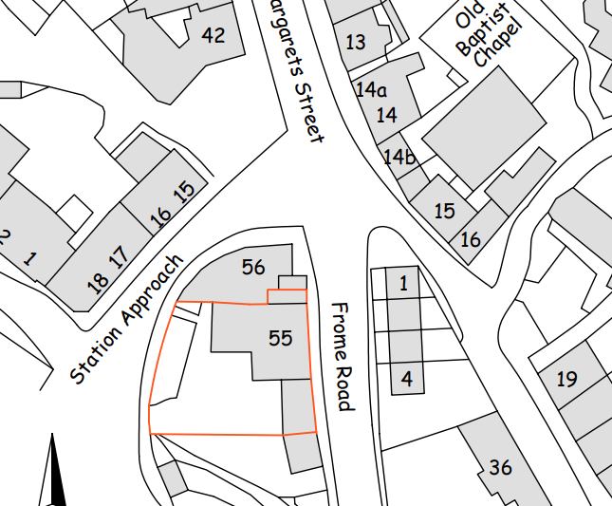

SITE DESCRIPTION/CONTEXT

The application site comprises The Three Horseshoes Public House, a Grade II listed building (1364513) situated on Frome Road, Bradford on Avon. The pub occupies a prominent corner position at the junction of Station Approach and Frome Road, within the Bradford on Avon Conservation Area (CA/W/31). Immediately adjacent to the site, on the eastern side of Frome Road, are the Men’s Almshouses (Nos. 1–4), which are themselves Grade II* listed (1200482). The proposed development seeks advertisement consent relating to signage associated with the public house.

PROPOSAL

The application seeks advertisement consent for the retrospective installation of two traditional painted timber signs at The Three Horseshoes Public House, a Grade II listed building within the Bradford on Avon Conservation Area, comprising a new frontage sign positioned above the main entrance on the Frome Road elevation and a secondary sign at the rear access. Currently not in place, the application proposes both to be externally illuminated by traditionally styled swan-neck light fittings finished to match the sign colour; the submitted Design and Access / Heritage Statement explains that the signs replace earlier signage and reflect the public house’s current branding, with no alterations proposed beyond the fixing of the signboards and lighting units.

RELEVANT LEGISLATION, POLICIES AND GUIDANCE

The Town and Country Planning (Control of Advertisements) (England) Regulations 2007

National Planning Policy Framework (NPPF)
- Paragraph 141

Planning Practice Guidance (PPG)
- Advertisements

Wiltshire Core Strategy 2015 (WCS):
- Core Policy 51 Landscape
- Core Policy 57 Ensuring High Quality Design & Space Shaping
- Core Policy 58 Ensuring the Conservation of the Historic Environment
- Core Policy 62 Development Impacts on the Transport Network

Bradford on Avon Neighbourhood Plan 2013-2026

Supplementary Planning Documents:
Institute of Lighting Professionals: The Brightness of Illuminated Advertisements (2014) PLG 05.

RELEVANT PLANNING HISTORY:
Reference | Description | Decision
20/10418/FUL  20/11296/LBC | Proposed conversion of part first floor to holiday | Approved
W/79/00839/FUL  W/79/00025/LBC | Bar alteration including Restaurant, kitchen and toilet facilities within existing building | Approved
W/94/00471/LBC | Replacement four panel door painted black | Approved

ISSUES

The issues that are relevant to the consideration of an application for consent to display advertisements are the effects of the proposal on ‘amenity’ and ‘public safety’.

CONSULTEE RESPONSES

The following consultees were invited to comment on this application:

Bradford on Avon Town Council – No Objection

Wiltshire Council’s Ecology – No Objection

Wiltshire Council’s Conservation – Objection

RESPRESENTATIONS

One comment was received from the Bradford on Avon Preservation trust stating no objection.

ASSESSMENT
Regulation 3 of The Town and Country Planning (Control of Advertisements) (England) Regulations 2007 requires that local planning authorities exercise their powers in relation to the display of advertisements in the interests of amenity and public safety, taking into account the provisions of the development plan, in so far as they are material, and any other relevant factors.

The NPPF (141) is clear that the quality and character of places can suffer when advertisements are poorly sited and designed and should be subject to control only in the interests of amenity and public safety, also considering the cumulative impacts.

Impact on Amenity:
Although the Town and Country Planning (Control of Advertisements) (England) Regulations 2007 do not define “amenity” exhaustively, the term is generally understood to encompass both visual and aural amenity, including the character and appearance of the surrounding area and the presence of features of historic, architectural, cultural, or similar interest. More broadly, in line with the National Planning Policy Framework, amenity refers to the quality and character of an area and the factors that contribute to its overall enjoyment and sense of place. Core Policy 57 requires all development, including advertisements, to achieve a high standard of design and to ensure that signage is sensitively integrated into its context. Core Policy 58 seeks to protect, conserve and where possible enhance the historic
environment.

The proposed signage consists of painted timber boards finished in a deep teal green background with warm golden‑amber lettering in a deliberately eclectic “cut‑and‑paste” typographic style. Three wall‑mounted lights are proposed to illuminate the front sign and one to illuminate the rear sign; all are low‑profile and traditional in design. The chosen colours are characteristic of the building and have historically formed part of its established palette, as evidenced by long‑standing imagery of the site, resulting in a cohesive continuation of the public house’s visual identity. With regard to the typographic style, although the mixed‑letter “ransom‑style” font is unconventional, advertisement consent relates to the overall impact of the sign rather than the commercial or branding content. In this case, the irregular font contributes to a characterful, eclectic aesthetic commonly associated with traditional public houses and reflects the personalised, informal character typical of such premises.

The design—including scale, typography, and form—is typical of commercial signage associated with public houses and sits comfortably within the established pattern of pub frontage presentation. The chosen colour palette is sympathetic to the existing tones of the building, avoiding visual dominance and maintaining a coherent relationship with the architectural character of the frontage. In terms of wider setting, the building forms part of a group with nearby heritage assets, including the listed almshouses located to the north east and is within the Bradford on Avon Conservation Area. The signage does not interrupt or alter key views towards or from these assets, nor does it introduce visual clutter of a scale that would compete with their architectural expression. The modest nature of the signage ensures that the contribution of the almshouses to the historic streetscape is preserved, and their appreciation is unaffected. Within the Conservation Area, the works represent a continuation of an established commercial frontage and do not introduce materials, lighting forms, or colours that would erode the area’s special character. The signage remains subordinate to the building’s historic façades and respects the town’s vernacular appearance, ensuring no diminution of the Conservation Area’s visual or historic qualities. It is not considered to be visually harmful nor to detract from the setting of the listed building or the wider conservation area which are integral to the visual amenity of this locality.

The proposal includes the installation of three swan-neck lights to illuminate the signage on the Frome Road elevation, and a single swan-neck light to illuminate the Station Approach sign. Guidance from the Institute of Lighting Professionals for illuminated advertisements identifies a maximum luminance level of 300 cd/m² for Suburban E3 lighting zones. The applicant’s Design and Access Statement confirms that the proposed lights would not exceed this level and would use warm-white bulbs.

Given the modest luminance, the proposal is considered to have a low visual impact and is acceptable in this location. This is particularly the case given the busy nature of the junction at which the public house is situated, where neighbouring commercial premises—such as Harlees Restaurant and Takeaway—already utilise similar external lighting. Additionally, the nearby train station remains illuminated into the evening to accommodate rail users, contributing to the existing level of ambient lighting in the area.

In conclusion, it is considered that the proposed signage and associated illumination reflects a traditional and sympathetic design appropriate to a historic public house and would result in no harm to the character and appearance of the area. The proposed swan neck lighting is of a form and material commonly accepted in historic contexts, and comparable examples exist within the immediate vicinity. Accordingly, the proposed advertisement is not considered to adversely affect the visual amenity of the locality, including the setting of heritage assets (of which it is one), and therefore complies with the relevant provisions of the Town and Country Planning (Control of Advertisements) (England) Regulations 2007.

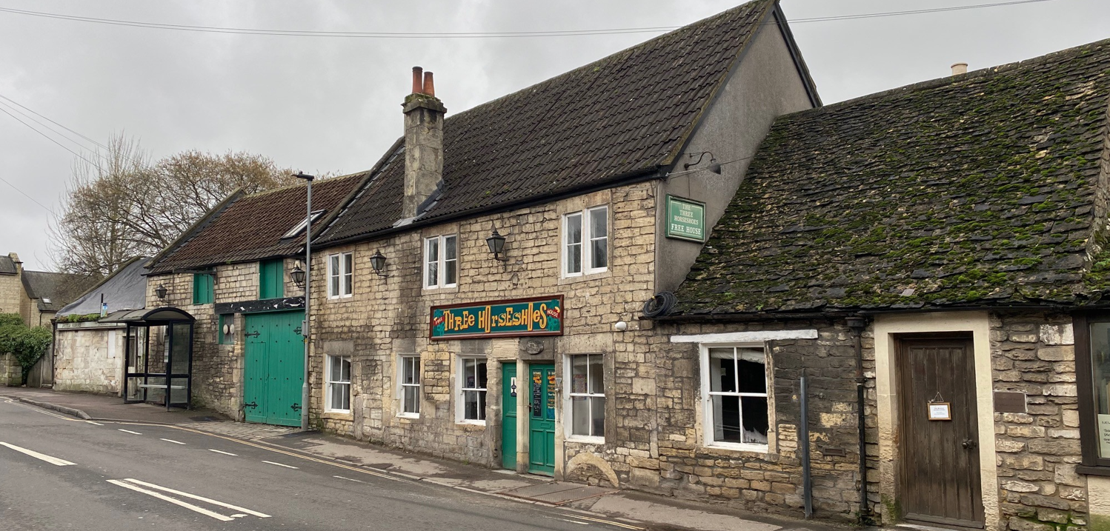
Site Visit Frome Road Signage

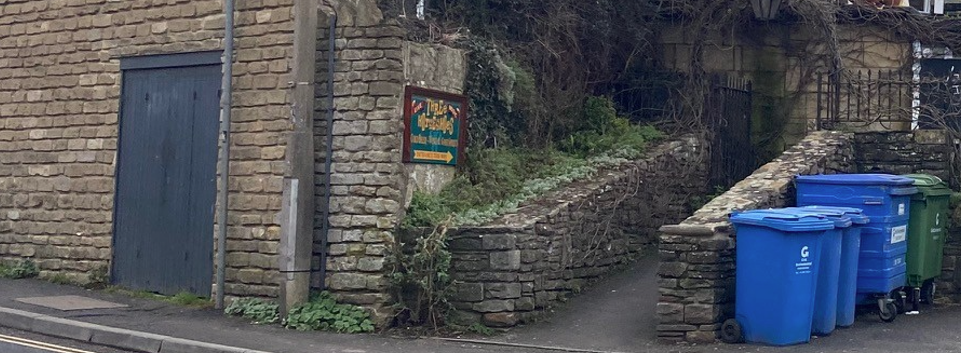
Site Visit Station Approach Signage

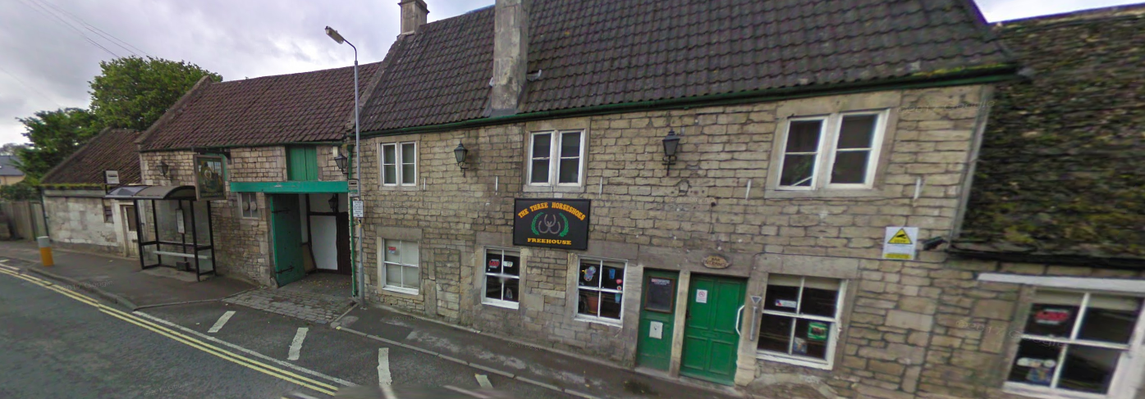
Streetview 2009
Impact on Public Safety
Although the Town and Country Planning (Control of Advertisements) (England) Regulations 2007 do not define “public safety” exhaustively, the term is generally understood to relate to the safe use and operation of public spaces, including the highway, footpaths, and areas routinely accessed by the public. In assessing advertisement proposals, the Local Planning Authority considers matters such as whether a sign may obstruct visibility for drivers or pedestrians, cause distraction or confusion near junctions or crossings, interfere with existing traffic signs or street lighting, or present a physical hazard due to its siting or structural characteristics.

The National Planning Policy Framework reinforces that planning decisions should promote environments that are safe, inclusive, and accessible, and which do not compromise public safety. In addition, Core Policy 62 expects proposals to incorporate mitigation where necessary to ensure no unacceptable impact on the transport network during implementation or operation.

The proposed signage does not project over the highway or footway and therefore poses no risk of obstruction to vehicle or pedestrian movements. The illumination is limited to low‑level, hooded fittings angled downward to focus light solely on the signs, thereby avoiding glare or distraction for road users. As a result, it is considered that the signage would not give rise to any unacceptable public safety concerns, either individually or cumulatively, and the proposal complies with the relevant requirements of the Town and Country Planning (Control of Advertisements) (England) Regulations 2007.

Other matters
Several comments were provided by the Conservation Officer are addressed further in the officer report for the associated Listed Building Consent. which require addressing further. This section of the report will cover each point respectively.

CONCLUSION

The proposed advertisement has been assessed in accordance with the relevant provisions of the Town and Country Planning (Control of Advertisements) (England) Regulations 2007.

It is considered that the advertisement, by reason of its design, scale, siting, and method of illumination, would not result in harm to the visual amenity of the area, including the setting of any nearby or associated heritage assets. Furthermore, the proposal is not considered to pose a risk to public safety, either individually or cumulatively with other signage in the vicinity.

Subject to the recommended conditions, the proposal is therefore considered acceptable and it is recommended that advertisement consent be granted.

RECOMMENDATION

It is recommended that advertisement consent be GRANTED subject to the following condition(s):

CONDITIONS

1.
This consent shall expire at the end of the period of 5 years from the date of this Notice.

REASON: To comply with Regulations 14 (7) and (8) of the Town and Country Planning (Control of Advertisements) (England) Regulations 2007.

2.
The development hereby permitted shall be carried out in accordance with the following approved plans:

Site Plan and Proposed Elevations THS-PS-02 (20 November 2025)
Location Plan THS-PS-03 (20 November 2025)
Design and Access Statement Rev A (13 February 2026)

REASON: For the avoidance of doubt and in the interests of proper planning.

3.
No advertisement is to be displayed without the permission of the owner of the site or any other person with an interest in the site entitled to grant permission.

No advertisement shall be sited or displayed so as to—

  - endanger persons using any highway, railway, waterway, dock, harbour or aerodrome (civil or military);
  - obscure, or hinder the ready interpretation of, any traffic sign, railway signal or aid to navigation by water or air; or
  - hinder the operation of any device used for the purpose of security or surveillance or for measuring the speed of any vehicle.

Any advertisement displayed, and any site used for the display of advertisements, shall be maintained in a condition that does not impair the visual amenity of the site.

Any structure or hoarding erected or used principally for the purpose of displaying advertisements shall be maintained in a condition that does not endanger the public.

Where an advertisement is required under these Regulations to be removed, the site shall be left in a condition that does not endanger the public or impair visual amenity.

REASON: To comply with Regulation 14 (7) of the Town and Country Planning (Control of Advertisements) (England) Regulations 2007.

4.
The illumination of the sign(s) hereby permitted shall be static and shall not be of a flashing type.
REASON: In the interests of amenity and/or public safety.

5.
The intensity of the illumination of the advertisements hereby approved shall be no greater than 300cd/m2.

REASON: In the interests of amenity.

