APPLICATION FOR LISTED BUILDING CONSENT
DELEGATED REPORT

APPLICATION REFERENCE: | PL/2025/09183
APPLICATION TYPE: | Listed Building Consent
SITE ADDRESS: | The Three Horseshoes, Frome Road, Bradford On Avon, BA15 1LA
DEVELOPMENT DESCRIPTION: | New signage to the front elevation & at the rear carpark access with lighting over (Retrospective)
RECOMMENDATION: | That Listed Building Consent be GRANTED

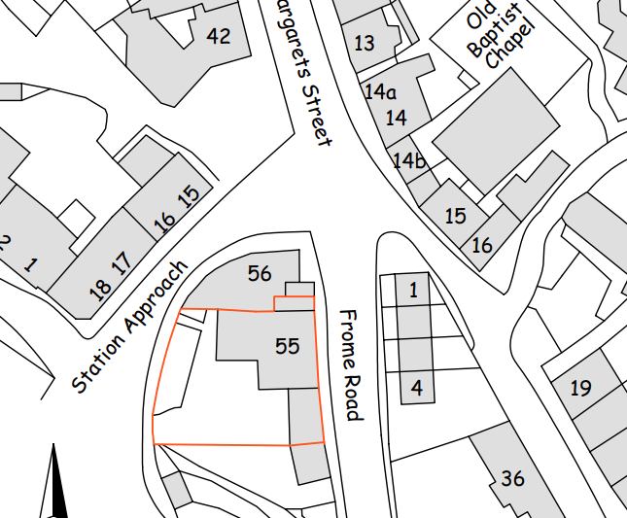

SITE DESCRIPTION/CONTEXT

The application site comprises The Three Horseshoes Public House, a Grade II listed building (1364513) situated on Frome Road, Bradford on Avon. The pub occupies a prominent corner position at the junction of Station Approach and Frome Road, within the Bradford on Avon Conservation Area (CA/W/31). Immediately adjacent to the site, on the eastern side of Frome Road, are the Men’s Almshouses (Nos. 1–4), which are themselves Grade II* listed (1200482). The proposed development seeks advertisement consent relating to signage associated with the public house.

PROPOSAL

The application seeks listed building consent for the retrospective installation of two traditional painted timber signs at The Three Horseshoes Public House, a Grade II listed building within the Bradford on Avon Conservation Area, comprising a new frontage sign positioned above the main entrance on the Frome Road elevation and a secondary sign at the rear access. Currently not in place, the application proposes both to be externally illuminated by traditionally styled swan-neck light fittings finished to match the sign colour; the submitted Design and Access / Heritage Statement explains that the signs replace earlier signage and reflect the public house’s current branding, with no alterations proposed beyond the fixing of the signboards and lighting units.

RELEVANT PLANNING HISTORY

Reference | Description | Decision
20/10418/FUL  20/11296/LBC | Proposed conversion of part first floor to holiday | Approved
W/79/00839/FUL  W/79/00025/LBC | Bar alteration including Restaurant, kitchen and toilet facilities within existing building | Approved
W/94/00471/LBC | Replacement four panel door painted black | Approved

POLICIES

Under the provisions of section 70(2) of the Town and Country Act 1990 and section 38(6) of the Planning and Compulsory Purchase Act 2004, applications for planning permission must be determined in accordance with the development plan, unless material considerations indicate otherwise.

DEVELOPMENT PLAN

Wiltshire Core Strategy:

- Core Policy 57 Ensuring High-Quality Design and Place Shaping;
- Core Policy 58 Ensuring Conservation of the Historic Environment;

NATIONAL PLANNING POLICY

National Planning Policy Framework (NPPF)
Planning Practice Guidance (PPG)
National Design Guidance

SUPPLEMENTARY PLANNING DOCUMENTS

Wiltshire Design Guide (Adopted April 2024)

STATUTORY LEGISLATION

Section 16 of the Planning (Listed Buildings and Conservation Areas) Act 1990 (listed building consent for any works – preserving the building or its setting)

The Town and Country Planning (General Permitted Development) (England) Order 2015

CONSULTEE RESPONSES

The following consultees were invited to comment on this application:

Bradford on Avon Town Council – No Objection

Wiltshire Council’s Ecology – No Objection

Wiltshire Council’s Conservation – Objection

RESPRESENTATIONS

One comment was received from the Bradford on Avon Preservation trust stating no objection.

ASSESSMENT

Section 70(2) of the Town and Country Planning Act 1990 and section 38(6) of the Planning and Compulsory Purchase Act 2004, require that the determination of planning applications must be made in accordance with the Development Plan, unless material considerations indicate otherwise.

In this case the application is for Listed Building Consent and therefore the consideration is limited to the effect on the listed building. Issues relating to public safety and amenity are addressed in the associated application for advertisement consent.

Impact upon the Grade II listed building

The proposal seeks retrospective listed building consent for the installation of two painted timber signs with associated lighting to the front and rear elevations of The Three Horseshoes, a Grade II listed public house positioned prominently within the Bradford-on-Avon Conservation Area. In assessing works to a listed building, Section 16(2) of the Planning (Listed Buildings and Conservation Areas) Act 1990 requires the Local Planning Authority to have special regard to the desirability of preserving the building, its setting, and any features of special architectural or historic interest it possesses. Likewise,

The signs comprise painted timber boards fixed to existing façades without the removal of historic fabric. Their installation does not involve cutting into, altering, or obscuring any architectural features, and the works remain entirely reversible without harm to the underlying fabric. The design—including scale, typography, and form—is typical of commercial signage associated with public houses and sits comfortably within the established pattern of pub-frontage presentation. The chosen colour palette is sympathetic to the existing tones of the building, avoiding visual dominance and maintaining a coherent relationship with the architectural character of the frontage.

In terms of wider setting, the building forms part of a group with nearby heritage assets, including the listed almshouses located to the north-east. The signage does not interrupt or alter key views towards or from these assets, nor does it introduce visual clutter of a scale that would compete with their architectural expression. The modest nature of the signage ensures that the contribution of the almshouses to the historic streetscape is preserved, and their appreciation is unaffected.

The proposal includes the installation of three swan-neck lights to illuminate the signage on the Frome Road elevation, and a single swan-neck light to illuminate the Station Approach sign. Guidance from the Institute of Lighting Professionals for illuminated advertisements identifies a maximum luminance level of 300 cd/m² for Suburban E3 lighting zones. The applicant’s Design and Access Statement confirms that the proposed lights would not exceed this level and would use warm-white bulbs.

Given the modest luminance, the proposal is considered to have a low visual impact on the character and appearance of the listed building. It is considered that the proposed signage and associated illumination would result in no harm to the special architectural or historic interest of the listed building. The signage is of a temporary, fully reversible nature, introduces no loss of historic fabric, and reflects a traditional and sympathetic design appropriate to a historic public house. The proposed swan-neck lighting, while requiring fixings to the building, similarly avoids harm: it would not obscure or erode fabric and is of a form and material commonly accepted in historic contexts

Notwithstanding this conclusion, and in recognition of the concerns raised by the Conservation Officer, if one were to adopt a more precautionary position and conclude that the works cause less than substantial harm (NPPF 208), such harm would be at the very lowest end of the scale. In such circumstances, the public benefits — including the improved legibility and identification of the public house, and support for its ongoing community function — would clearly and demonstrably outweigh any such harm.

Taking the above into account, the proposed signage is considered to preserve the special interest of the listed building and its group value with adjacent heritage assets. As such, the works are considered acceptable in heritage terms and compliant with the statutory duties under the 1990 Act.

Having regard to the above, the proposal complies with the design principles set out in Core Policy 57 and 58 of the Wiltshire Core Strategy and Section 16 of the Planning (Listed Buildings and Conservation Areas) Act 1990.

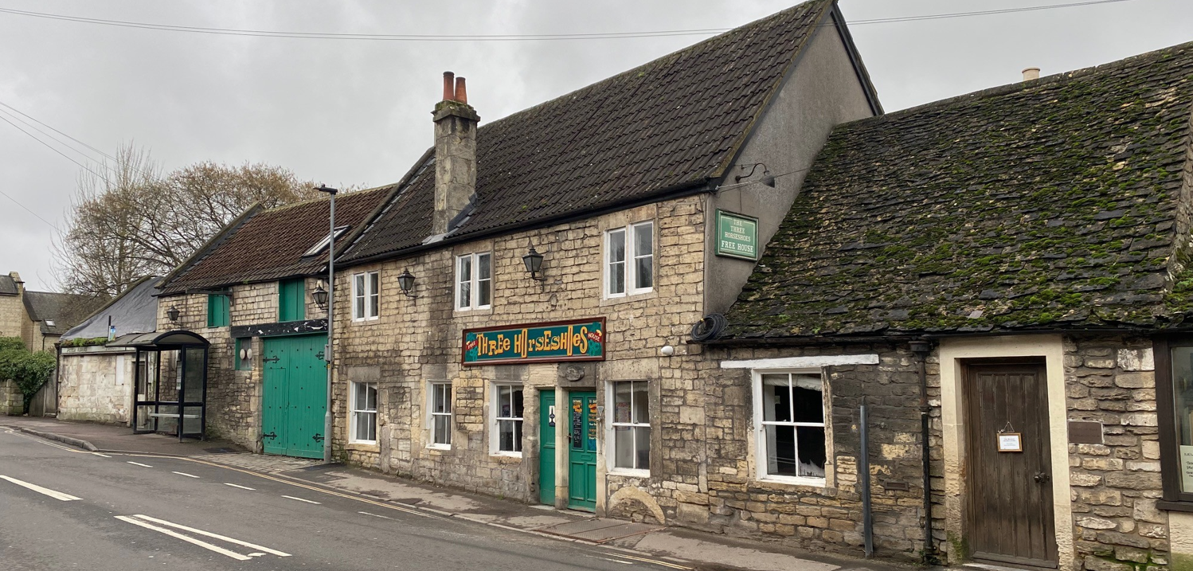
Site Visit Frome Road Signage

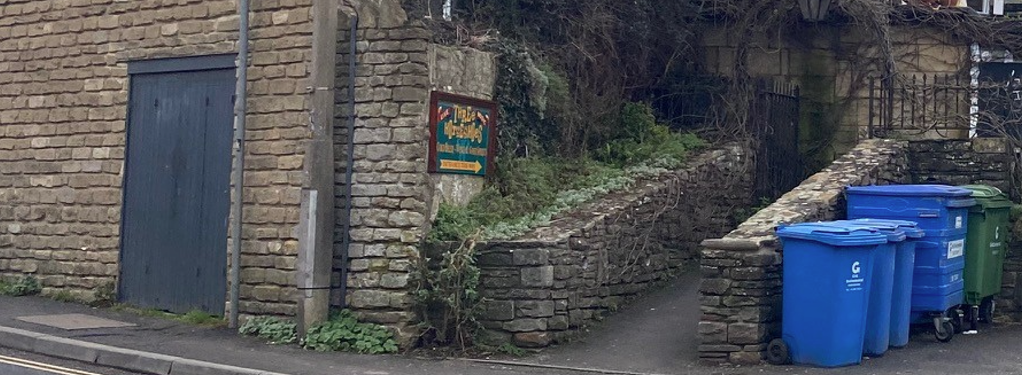
Site Visit Station Approach Signage

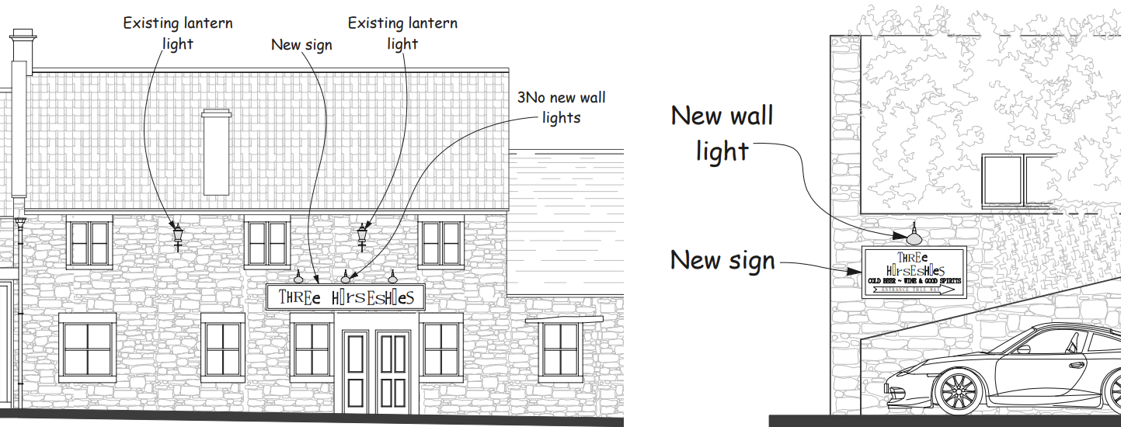
Proposed Elevations

Other matters

Several comments were provided by the Conservation Officer which require addressing further. This section of the report will cover each point respectively.

The Conservation Officer has identified what they believe to be unauthorised CCTV cameras, door‑mounted signage and lantern lights on the building and has requested clarification on these items; however, these elements do not form part of the current applications and cannot be brought into their scope, as the Planning (Listed Buildings and Conservation Areas) Act 1990 requires the authority to assess only the works specifically applied for, with any unrelated alterations instead falling under separate enforcement powers. Accordingly, this application can only consider the proposed new signage and lighting, and any potentially unauthorised fixtures noted by the Officer would need to be addressed independently through the Council’s enforcement process. The Conservation Officer has also sought clarification regarding other existing signage and whether it is intended to be removed; however, as these elements do not form part of the current applications, they are not material to the assessment and fall outside the scope of what can be considered, with only the proposed development before the Council forming the basis of determination.

The Conservation Officer has also noted minor discrepancies between the elevation drawings and the signage as it exists on site, including differences in colour, some lettering, and slight variations in scale; however, the application is retrospective in nature, and the submitted material enables a proper understanding of the development as a whole. National guidance confirms that retrospective applications are treated “in the usual way”, without any special requirement for revised drawings where the proposal is clear and its dimensions and siting are accurately represented. Furthermore, minor or de minimis discrepancies do not invalidate an application or require formal amendment; differences can lawfully be disregarded where they do not alter the substance of what is applied for. Given that the plans correctly show the size and position of the sign and that accompanying photographs clearly illustrate the as‑installed details, it is considered that the application is sufficiently clear for determination without requiring revised drawings.

The Conservation Officer has requested additional heritage-impact information on the basis that the submitted Design & Access Statement does not, in their view, fully address the requirements of NPPF paragraph 207, which requires applicants to describe the significance of any heritage assets affected to a level of detail proportionate to their importance and sufficient to understand the potential impact of the proposal. While this expectation is noted, the current application concerns only the installation of two new painted timber signs and associated lighting—works which do not involve permanent alteration to historic fabric, do not remove or damage any architectural features, and are of a scale and form consistent with commercial signage traditionally found on public houses. The proposed colours are sympathetic to the existing palette of the building as shown in the submitted DAS and photographs, and the signage does not materially detract from the character, appearance, or setting of the listed building when assessed against the proportionality guidance in Historic England Advice Note 12, which confirms that the level of heritage information required should be “no more than is sufficient” to understand the impact of the works. Given the signage is reversible and non-permanent in its method of fixing, and the clarity already provided through the submitted plans and photographic evidence of the existing signs. As the only part of the proposal which is yet to be undertaken is external lighting, which is considered appropriate for the reasons set out above, it is considered that requiring further historical or contextual information would not reasonably alter the assessment or lead to a different conclusion on heritage impact

CONCLUSION

The proposal is considered acceptable as it preserves the special architectural and historic interest of the Grade II listed building. The works accord with Section 16 of the Planning (Listed Buildings and Conservation Areas) Act 1990, Core Policies 57 and 58 of the Wiltshire Core Strategy, and the relevant heritage provisions of the National Planning Policy Framework. Listed Building Consent is therefore justified.

RECOMMENDATION

That listed building consent be GRANTED subject to the following conditions:

CONDITIONS

1.
The works for which Listed Building Consent is hereby granted shall be begun before the expiration of three years from the date of this consent.

REASON: To comply with the provisions of Section 18 of the Planning (Listed Building and Conservation Areas) Act 1990 as amended by the Planning and Compulsory Purchase Act 2004.

2.
The development hereby permitted shall be carried out in accordance with the following approved plans:

Site Plan and Proposed Elevations THS-PS-02 (20 November 2025)
Location Plan THS-PS-03 (20 November 2025)
Design and Access Statement (13 February 2026)

REASON: For the avoidance of doubt and in the interests of proper planning.

