APPLICATION FOR FULL-PLANNING PERMISSION
CASE OFFICER REPORT

APPLICATION REFERENCE: | PL/2025/09318
APPLICATION TYPE: | Full planning permission
SITE ADDRESS: | Wiltshire Police Headquarters, London Road, Devizes, SN10 2DN
DEVELOPMENT DESCRIPTION: | Construction of an emergency only gated vehicle access onto Quakers Road and internal temporary access track at Wiltshire Police Headquarters, London Road, Devizes, SN10 2DN.
RECOMMENDATION: | Approve with Conditions

SITE DESCRIPTION/CONTEXT

The application relates to part of the wider Wiltshire Police Headquarters complex at London Road, Devizes. The Headquarters occupies a substantial site of approximately 5.85 ha positioned on the eastern side of Devizes, within the defined Limits of Development for the town. The surrounding area is predominantly residential, with Devizes Sports Club situated immediately to the west and south of the wider police estate.
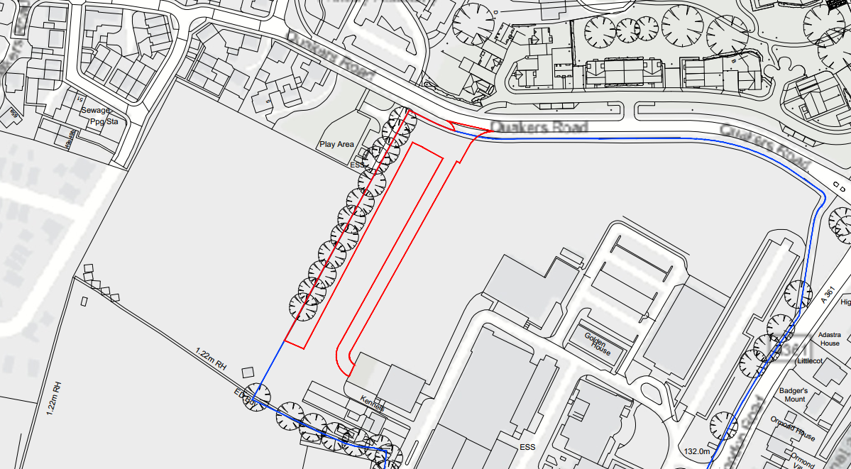
Site Location

The application site itself comprises an area on the northern edge of the Headquarters grounds, adjacent to Quakers Road. It currently forms part of a grassed area used for police dog training and contains no existing buildings. The land is predominantly mown grass, enclosed by established boundary vegetation. A mature tree belt defines the western boundary of the police site and is protected under Tree Preservation Order E/330/G2. The northern frontage onto Quakers Road contains a dense hedgerow with several small trees, including those identified in the submitted arboricultural survey.

The site is well-located in terms of accessibility, positioned approximately a ten-minute walk from Devizes town centre and served by multiple bus routes along London Road (1C, 2, 42 and 49). It lies within Flood Zone 1 and is identified as being at very low risk of fluvial and surface water flooding. The Headquarters site is also subject to longstanding policy designations: 4.65 ha is allocated as existing employment land under Core Policy 35, while the western portion (1.2 ha) is designated as sport and recreation land under saved Policy TR17, although this land is in operational police use and not publicly accessible. Overall, the site forms part of an established operational police facility within an urban context, surrounded by residential development and adjacent community sports uses.

PROPOSAL

The proposal is for the construction of an emergency only gated vehicle access onto Quakers Road and internal temporary access track at Wiltshire Police Headquarters. The proposed emergency-only access would be positioned on an existing vegetated frontage onto Quakers Road and would connect into the internal estate roads within the Headquarters.

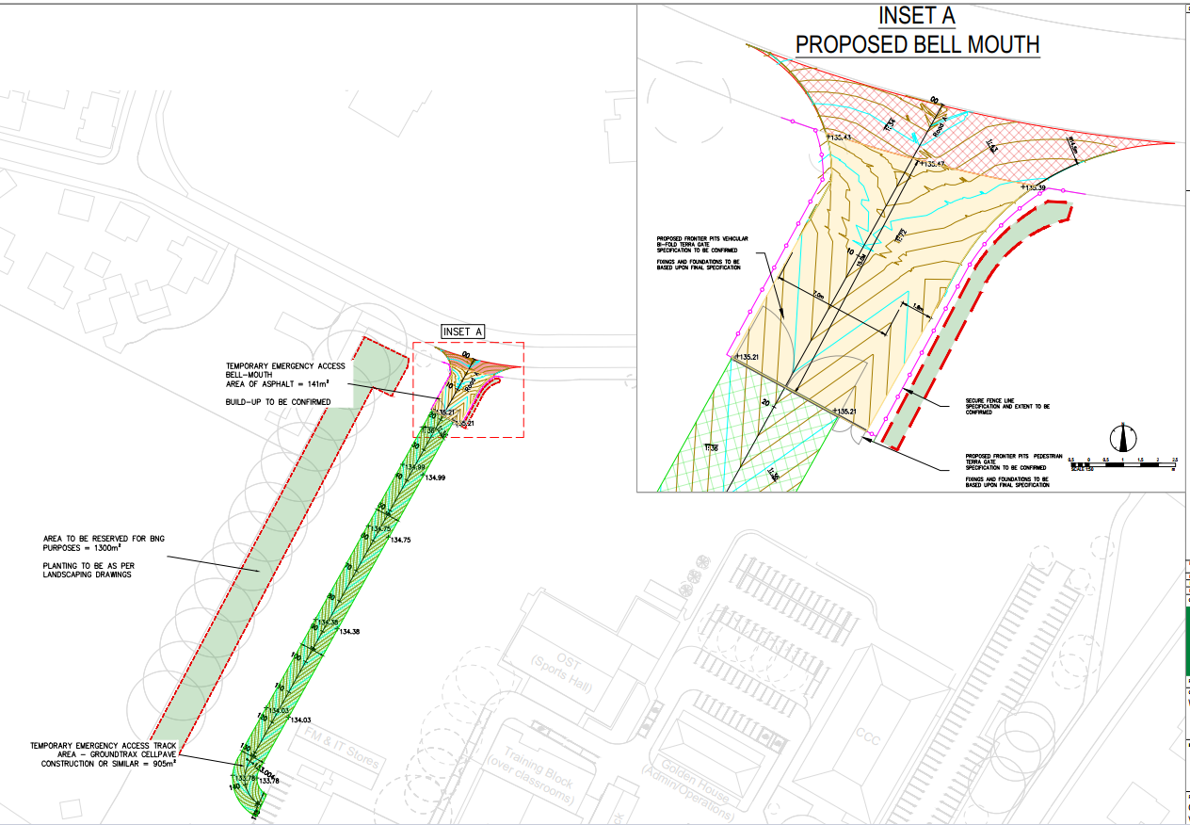
General arrangement

An area within the site is proposed to be set aside specifically to deliver the biodiversity net gain required as part of the development. This would be located to the west of the proposed access, running adjacent to the existing area of trees that protected under tree preservation order.

PLANNING HISTORY

Proposal / Summary

A number of planning applications have previously been submitted in relation to the wider Police Headquarters site; however, none of these relate to, or materially affect, the current proposal for a new vehicular access and associated parking. The earlier applications concerned operational or building-specific matters within the established police complex and do not influence the assessment of the acceptability of the new access arrangements now under consideration.

RELEVANT LEGISLATION, POLICIES AND GUIDANCE

Statutory Legislation:

National Planning Policy:
- National Planning Policy Framework (NPPF)
- Planning Practice Guidance (PPG)
- National Design Guide
Development Plan:
The development plan for Wiltshire comprises the Wiltshire Core Strategy (WCS) (adopted January 2015) and any made neighbourhood plans, which remains the principal statutory planning document guiding development across the county. In line with Section 38(6) of the Planning and Compulsory Purchase Act 2004, planning decisions must be made in accordance with the development plan unless material considerations indicate otherwise.

Though the development plan is considered as a whole, those parts deemed to be particularly relevant to this application are listed below:

The adopted Wiltshire Core Strategy (WCS), with particular regard to:
- Core Policy 1 Settlement Strategy;
- Core Policy 2 Delivery Strategy;
- Core Policy 3 Infrastructure Requirements;
- Core Policy 12 Spatial Strategy Devizes Community Area
- Core Policy 50 Biodiversity and Geodiversity;
- Core Policy 51 Landscape
- Core Policy 52 Green Infrastructure
- Core Policy 55 Air Quality;
- Core Policy 57 Ensuring High Quality Design and Place Shaping;
- Core Policy 58 Ensuring the Conservation of the Historic Environment;
- Core Policy 60 Sustainable Transport;
- Core Policy 61 Transport & Development;
- Core Policy 64 Demand Management
- Core Policy 67 Flood Risk;
- Core Policy 68 Water Resources;

Draft Wiltshire Local Plan Policies
- Policy 4: Addressing climate change
- Policy 5: Securing infrastructure provision from new development
- Policies 64 – 75: Economic, tourism, retail and transport
- Policies 85 – 101: Sustainability, ecology, water and landscape, heritage, air quality

The draft Wiltshire Local Plan remains under prolonged examination and has not progressed to adoption, so only limited weight can currently be afforded to its emerging policies.

Devizes Area Neighbourhood Plan:
- Policy T1 – Getting Around
- Policy ESD1 – Environment & Sustainability
- Supporting text in Sections 2.4 and 3.2 concerning the local road network

Supplementary Planning Documents and other Guidance:
- Wiltshire Design Guide (adopted April 2024)
- Wiltshire Local Transport Plan 2011-2026, adopted 2015 - including the Car Parking Strategy and Cycling Strategy, adopted 2015
- A Green & Blue Infrastructure Strategy for Wiltshire: Wiltshire’s Natural Environment Plan 2022-2030
- Wiltshire Local Cycling and Walking Infrastructure Plan (LCWIP)
- Active travel infrastructure design standards 2022
- Active travel parking standards and design guide 2022
- Air Quality SPD (July 2023)

ISSUES
The main issues that need to be addressed in this case include:
- Whether the development is acceptable in principle (CP 1 and 2)
- Whether the scheme constitutes high quality design (CP 57)
- Whether the scheme would have an acceptable impact upon the reasonable living conditions of the adjoining occupants (CP 57)
- Whether the scheme would preserve or enhance the historic environment (CP 58)
- Whether the scheme would have an acceptable landscape impact (CP 51)
- Whether the proposal would have a negative effect upon highway safety, including if there is sufficient parking for the proposed development (CP 61 and 64)
- Whether the site can be adequately drained without increasing flood risk elsewhere (CP 67)
- Whether there would be any harmful impacts upon protected species or priority habitats (CP 50)
- Whether there will be any land contamination / air quality issues (CP 55)
- Are there any other planning issues raised by the development?

CONSULTATION RESPONSES

WC Highways: No objection
WC Ecology: No comment received
WC Archaeology: No objection
WC Landscape: No comment
WC Drainage: No objection
WC Arboricultural: No objection
Parish/Town Council: No objection

REPRESENTATIONS
In accordance with the requirements of the Town and Country Planning (Development Management Procedure) (England) Order 2015 (as amended), the application was publicised by way of:
- Neighbour notification letters sent to adjoining and nearby properties;
- A site notice displayed near the site.

These methods were used to inform interested parties and provide a period of 21 days for comments to be submitted. No comments have been received from third parties at the time of drafting this report.

ASSESSMENT
Section 38(6) of the Planning and Compulsory Purchase Act 2004 states:
"If regard is to be had to the development plan for the purposes of any determination to be made under the planning Acts, the determination must be made in accordance with the plan unless material considerations indicate otherwise."

In accordance with this statutory requirement, this application has been assessed against the relevant policies of the Development Plan, including the Wiltshire Core Strategy (2015) and, where applicable, any made Neighbourhood Plans. Consideration has also been given to the policies of the National Planning Policy Framework (NPPF) as a material consideration in the assessment.

Environmental Impact Assessment (EIA) Screening
In accordance with the Town and Country Planning (Environmental Impact Assessment) Regulations 2017 (as amended), the local planning authority has considered whether the proposed development constitutes EIA development.

No Screening Opinion Issued
No formal screening opinion was requested or issued. However, the local planning authority has considered the scale and nature of the development as part of the application process and is satisfied that it does not constitute EIA development under the 2017 Regulations.

Principle of Development
Policy Context
Core Policy 1: Settlement Strategy of the WCS establishes a hierarchy of settlements to guide where development should be focused. The policy prioritises growth in:
- Principal Settlements (e.g., Salisbury, Chippenham, Trowbridge) – main focus for strategic growth.
- Market Towns – support local services and employment; suitable for sustainable development.
- Local Service Centres – smaller towns and villages with a range of services; limited development supported.
- Large and Small Villages – development should be limited and respond to local needs.
- Outside the defined settlements – development is strictly controlled and generally not supported unless exceptional circumstances apply.
.
Core Policy 2: Delivery Strategy of the WCS sets out how development will be distributed and delivered across Wiltshire. The policy emphasises:
- Sustainable patterns of growth, reducing the need to travel and supporting local services.
- Development should be plan-led, aligning with the settlement strategy and supported by infrastructure.
- Windfall development (not allocated in plans) must still comply with the principles of sustainable development.
- Development outside settlement boundaries is generally not permitted, unless it meets specific policy exceptions (as set out in paragraph 4.25 of the WCS).

Together, CP1 and CP2 ensure that new development is strategically located, sustainable, and supports the character and function of Wiltshire’s communities.

Assessment
The proposal seeks planning permission for an emergency-only gated vehicular access onto Quakers Road together with a temporary internal access track linking to the existing estate roads within the Wiltshire Police Headquarters. The Headquarters is a long-established operational policing facility serving Wiltshire and Swindon and is identified in the Wiltshire Core Strategy as existing employment land under Core Policy 35, with the western portion of the site also falling within land designated as outdoor sport and recreation under saved Policy TR17.

The proposed access is required to improve the operational resilience of the police estate by providing an alternative exit point when London Road (A361) is congested or unavailable. The accompanying Operational Statement confirms that the access forms part of wider estate-planning work and that Wiltshire Council previously indicated, through pre-application advice, that there was no objection in principle to an access at this location.

National policy gives significant weight to proposals that enhance public service infrastructure, including emergency services. Paragraph 101 of the NPPF requires local planning authorities to work proactively with service providers and recognises the importance of upgraded emergency-service facilities. Paragraphs 81 and 84 also support the growth and adaptation of operational premises.

Although part of the access track crosses land designated under saved Policy TR17, this land has been in continuous operational police use for many years, is not publicly accessible, and performs no recreational function. The Planning Statement demonstrates that the current use aligns more closely with the wider Police Headquarters planning unit and that the emerging Local Plan seeks to resolve this anomaly by identifying the whole site as a Principal Employment Area.

Conclusion
Given the strong operational justification, the absence of conflict with the site’s existing employment function, and the NPPF’s requirement to attach significant weight to essential public-service infrastructure, the principle of development is considered acceptable, subject to detailed matters addressed in the following sections.

Design and Impact on the Character and Appearance of the Area
Policy Context
Core Policy 57 of the WCS requires high-quality design that:
- Enhances local character.
- Responds to the natural, historic, and built environment.
- Retains important features (e.g., trees, hedges).
- Supports sustainable construction and compatibility with surrounding uses.
- Creates safe, legible, and accessible spaces.

Section 12 of the NPPF emphasises design that is:
- Visually attractive.
- Functionally effective.
- Contributes to the quality of the built environment.

The Wiltshire Design Guide encourages sensitivity to local character, materials, and architectural styles and supports modern living standards while maintaining aesthetic and functional quality.

Assessment
The application site forms part of the established Wiltshire Police Headquarters, an operational employment site characterised by a mix of administrative, operational and training buildings, extensive areas of hardstanding, and landscaped boundaries. The specific area affected by the proposal comprises mown grassland used for dog-training activities, enclosed on the northern boundary by a dense hedgerow and on the western edge by a mature tree belt protected under TPO E/330/G2.

The creation of the new emergency-only access requires a localised opening in the existing hedgerow on Quakers Road and the removal of one small tree and a short section of hedge. These works are limited in extent and would be softened through a proposed landscaping scheme that includes replacement tree planting and new hedgerow and meadow planting within the site.

The access gate would be 1.8 m in height to match the existing perimeter fencing and is designed to integrate with the existing security boundary. The temporary internal track would utilise a Groundtrax Cellpave system to minimise visual impact and maintain a grass-covered appearance where possible.

Conclusion
Given the screened nature of the site frontage, the modest scale of the works and the predominantly operational character of the wider Headquarters complex, the proposal would not result in any harmful change to the street scene or wider character of the area. Additional planting would ensure the development assimilates into its surroundings and maintains the established landscape structure along Quakers Road.

Impact on Heritage Assets
Policy Context
National policy in NPPF Chapter 16 requires the significance of heritage assets, including archaeological remains, to be understood and conserved in a proportionate manner. The NPPF places great weight on the conservation of heritage assets and expects clear justification for any harm, with impacts weighed against public benefits. The Planning Practice Guidance reinforces the need for proportionate investigation and appropriate recording where assets may be affected.

At the local level, Core Policy 58 of the Wiltshire Core Strategy seeks to ensure that both designated and non‑designated heritage assets, including archaeology, are conserved and, where appropriate, enhanced. The policy supports development where archaeological interest is properly assessed and any loss of significance is mitigated through investigation and recording. Core Policy 57 also requires proposals to demonstrate an understanding of, and responsiveness to, the historic environment as part of high‑quality design.

Assessment
A Desk‑Based Assessment (DBA), together with an archaeological addendum, has been submitted in support of the application. The DBA identifies that the wider Police Headquarters site lies within an area of known archaeological potential, including evidence of medieval ridge and furrow and possible historic field boundaries identified through LiDAR, particularly towards the northern part of the campus. However, it also concludes that substantial groundworks undertaken during the construction of the Police Headquarters in the 1950s are likely to have removed or significantly truncated archaeological remains across much of the southern part of the site.

The Council’s Archaeologist has reviewed the submitted assessment and concurs with its broad conclusions, confirming that the site retains some potential for sub‑surface archaeological remains in undisturbed areas. The Archaeologist advised that a geophysical survey prior to determination would have been preferable to inform any required mitigation strategy, but clarified in subsequent correspondence that this is not a requirement for issuing a planning decision and does not amount to an objection. Instead, the necessary archaeological investigation and any further work, whether an archaeological Strip, Map and Record (SMR) or archaeological monitoring, can be appropriately secured via a standard pre‑commencement condition.

Conclusion
The Archaeologist therefore raises no objection, subject to a condition requiring a Written Scheme of Investigation (WSI) and completion of the approved programme of archaeological work before development commences. This approach ensures compliance with the NPPF requirement that, where the loss of archaeological significance may occur, such remains are recorded in a proportionate and publicly accessible manner, and also satisfies Core Policy 58 of the Wiltshire Core Strategy. On this basis, and subject to the recommended condition, the proposal is considered acceptable in archaeological terms.

Amenity
Policy Context
Core Policy 57 (Point vii) of the Wiltshire Core Strategy requires development to respect the amenity of existing occupants and ensure appropriate amenity levels for future residents.

The National Planning Policy Framework (NPPF), particularly Paragraph 135, reinforces the need for development to provide a high standard of amenity for both existing and future users.

Assessment
In this case, the proposed emergency-only vehicular access and short length of internal access track do not introduce any buildings, habitable rooms or new areas of regular activity that could give rise to overlooking, loss of privacy, overshadowing, or overbearing effects. The site is located within an established operational police complex and is separated from the nearest dwellings by boundary vegetation and distance, such that no unacceptable change to outlook or enclosure would occur.

Given the “emergency-only” function of the access, no material increase in day-to-day vehicle movements is expected and therefore no harmful levels of noise or disturbance would arise. The proposal does not create any new residential accommodation and thus internal or external space standards are not applicable. Overall, the development would have no adverse impact upon residential amenity and complies with Core Policy 57 and the NPPF.

Highways Impacts and Parking
Policy Context
Core Policy 61 of the Wiltshire Core Strategy and Paragraph 115 of the NPPF require development to demonstrate that safe and suitable access can be achieved for all users and that no unacceptable impact on highway safety would arise.

Assessment
The proposal introduces a new emergency-only access onto Quakers Road designed to be used only when the existing London Road accesses are unavailable. The submitted Transport Statement confirms that suitable visibility splays can be achieved, that swept-path analysis demonstrates safe manoeuvring for emergency vehicles, and that junction modelling shows the access and surrounding network would continue to operate well within capacity even under a worst-case scenario where all HQ traffic uses the new access.

Conclusion
The Council’s Highways Officer raises no objection, confirming that the limited and infrequent use of the access is acceptable for this location and that the scale of works is minor enough to be delivered under a standard Vehicle Crossing Permission rather than a Section 278 agreement. Vehicular movements associated with emergencies are not expected to result in any material impact on traffic conditions or road safety along Quakers Road. As such, the proposal is considered to provide safe and suitable access in accordance with CP61 and the NPPF, and no adverse highway impacts are anticipated.

Ecology and Biodiversity
Policy Context
Core Policy 50 of the Wiltshire Core Strategy requires development to avoid harm to ecological assets, support habitat restoration and connectivity, and deliver measurable biodiversity enhancements in line with the Environment Act 2021. The Wiltshire Green & Blue Infrastructure Strategy (2022–2030) further seeks to strengthen ecological networks and promote nature-based solutions. Together, these policies ensure that proposals assess impacts on protected species, priority habitats and ecological corridors, and integrate biodiversity within site design. Unless exempt, National policy requires a minimum of 10% Biodiversity Net Gain (BNG).

Assessment
A Preliminary Ecological Appraisal (PEA) has been submitted which confirms that the site comprises mainly low-value amenity grassland, ornamental planting, hedgerows and boundary trees. No statutory designated sites lie within a zone likely to be affected by the proposal. The works involve only small-scale vegetation loss (a short hedgerow section and one small tree), with higher-value boundary trees retained.

The PEA found no protected species breeding or resting sites that would be affected, and only low-level wildlife movement across the site. Standard precautionary measures during construction are recommended to safeguard any animals that may be present. No evidence of roosting bats was recorded, and the two trees with low roost potential are outside the works area. Great Crested Newts and reptiles are considered unlikely or absent due to unsuitable habitats.

The proposal includes native replacement planting, a wildflower meadow and hedgerow enhancements. The submitted biodiversity metric demonstrates a 13.43% net gain in habitat units and 13.40% net gain in hedgerow units, exceeding statutory Biodiversity Net Gain requirements.

Conclusion
The development would not result in significant ecological impacts and incorporates proportionate mitigation and enhancement measures. With BNG delivery secured and standard wildlife-protection measures applied during construction, the scheme complies with Core Policy 50, the NPPF, and the Wiltshire Green & Blue Infrastructure Strategy (2022–2030).

Landscape and Visual Impact
Policy Context
Core Policy 51 of the Wiltshire Core Strategy requires development to:
- Protect, conserve, and enhance landscape character and quality.
- Respect local distinctiveness, key views, and visual receptors.

The Wiltshire Design Guide SPD (2024) promotes a context-led approach, encouraging integration with natural features and settlement patterns while avoiding visual intrusion.

The Green & Blue Infrastructure Strategy (2022–2030) supports landscape protection through green infrastructure, habitat connectivity, and nature-based solutions.

Assessment
With reference to the design section above given the operational character of the wider site, the screened frontage, and the mitigation offered, the development would not result in any harmful visual or landscape effects and aligns with the Wiltshire Green & Blue Infrastructure Strategy (2022–2030), which supports landscape protection, habitat connectivity and nature‑based design solutions. [Planning Statement | PDF]

Conclusion
The scheme is considered to comply with CP51 and respect the local distinctiveness of the sites character within this urban location.

Flood Risk and Drainage
Core Policy 67 of the Wiltshire Core Strategy and NPPF paragraphs 170–182 require development to avoid increasing flood risk on- or off-site and to incorporate appropriate mitigation. The proposed emergency-only access lies within Flood Zone 1, where the risk of fluvial flooding is low. The Drainage Technical Note confirms that the new asphalt bell-mouth (approximately 140 m²) has been designed with falls directing runoff back into the site, preventing discharge onto Quakers Road or the public highway network. Surface water entering the site will then drain onto the internal Groundtrax CellPave track, which is a permeable, no-dig system allowing infiltration at source and removing the need for a formal drainage network.

The Land Drainage Officer raises no objection, noting that the works are minor, will not create a meaningful increase in impermeable area, and will not elevate flood risk compared with existing conditions. The proposal does not affect any watercourses, culverts, or overland flow paths and does not trigger the need for sequential or exception testing. Given the small scale of development, the infiltration-based design, and the avoidance of off-site runoff, the scheme is considered to represent an appropriate and sustainable approach consistent with Core Policy 67 and national policy on flood risk and sustainable drainage.

Conclusion:
The development would not increase flood risk elsewhere and incorporates proportionate, sustainable drainage measures. The proposal therefore complies with Core Policy 67, relevant NPPF guidance, and raises no drainage objections.

Environmental Considerations (Noise, Air Quality, Contaminated Land, etc.)
Policy Context
Core Policies 55 and 56 of the Wiltshire Core Strategy require development to avoid unacceptable environmental impacts and to provide appropriate mitigation where risks are identified, and this approach is reinforced by the NPPF and Planning Practice Guidance, which expect proposals to prevent development that contributes to or is exposed to unacceptable pollution and to ensure safe development on potentially contaminated land. Wiltshire Council’s Air Quality SPD (2023) provides further guidance—particularly for development near Air Quality Management Areas—encouraging measures such as electric vehicle charging, green buffers, and sustainable transport options to minimise air-quality impacts and promote healthier environments.

Assessment
The proposed emergency-only access would not introduce any material increase in day-to-day vehicle movements, as it would be used solely during emergency situations. As such, no unacceptable noise, disturbance or direct amenity impacts are anticipated for nearby residents, including the emerging development north of Quakers Road. The site lies within an established employment setting where police operational activity is already characteristic. Given the absence of additional traffic generation and the limited physical extent of the works, there would likewise be no adverse effect on local air quality, including within the wider Devizes Air Quality Management Area. The proposal therefore raises no amenity or air quality concerns.

Pre-commencement Condition Agreement

This recommendation includes pre-commencement planning condition(s) relating to archaeology. In accordance with Section 100ZA of the Town and Country Planning Act 1990 and the Town and Country Planning (Pre-commencement Conditions) Regulations 2018, the Local Planning Authority formally notified the applicant/agent of the proposed condition(s) and sought their agreement. Written confirmation of agreement was received from the applicant’s agent.

PLANNING BALANCE AND CONCLUSION
The proposed emergency-only vehicular access and temporary internal track would support the operational resilience of the Wiltshire Police Headquarters and carries significant weight as essential public-service infrastructure in accordance with the NPPF. The development accords with the settlement and delivery strategies of the Wiltshire Core Strategy and does not conflict with the site’s established employment function.

The detailed assessments set out above confirm that the proposal would have no unacceptable impacts with respect to design, landscape, heritage and archaeology, residential amenity, ecology and biodiversity, highways safety, drainage or environmental quality. All technical consultees raise no objection, and any necessary safeguards can be secured through appropriately worded planning conditions.

The scheme delivers measurable benefits, including enhanced emergency-response capability and a biodiversity net gain above the statutory 10% requirement. There are no identified adverse impacts that would significantly and demonstrably outweigh these benefits when assessed against the development plan and the NPPF as a whole. Accordingly, the proposal is judged to represent sustainable development, and planning permission should be granted subject to conditions.

RECOMMENDATION: That Planning Permission be GRANTED, subject to conditions

