APPLICATION FOR FULL PLANNING PERMISSION
DELEGATED REPORT
APPLICATION REFERENCE: | PL/2025/09430
APPLICATION TYPE: | Full planning permission
SITE ADDRESS: | Grain Barn at Conkwell Grange Farm, Conkwell, Limpley Stoke, BA2 7FD
DEVELOPMENT DESCRIPTION: | Proposed change of use of building to domestic storage
RECOMMENDATION: | Approve with Conditions

PROPOSAL

The proposal seeks planning permission for the change of use of an existing former grain barn to that of ancillary residential storage to Conkwell Grange Farm and its associated cottages. From site inspection and the information given on the application form under the heading “Existing Use”, the application for change of use of the building is made retrospectively.

SITE DESCRIPTION/CONTEXT

The site is an existing grain barn at Conkwell Grange Farm, Conkwell, Limpley Stoke and is located within the Conkwell Grange Estate. The origins of the subject barn building is a 1950’s steel-frame former grain store which has more recently been finished externally with stone walls and topped with clay roof tiles, such that it has a more traditional appearance from the exterior. The building has large sized timber doors and white UPVC framed windows of a domestic nature. The subject building was granted permission in 1987 for conversion to a dwelling. This was subsequently varied in 2019 to include an extension and revised fenestration. The previously approved conversion accounts for the current appearance of the building, however it is evident that internally the works to form habitable accommodation are incomplete and that occupation as a dwelling has not occurred.

The main house at the site is Grade II listed property known as Conkwell Grange, which is located away from the barn at a distance of 140 metres. The barn is a later modern addition that is not curtilage listed and is not a heritage asset. There is no intervisibility with the principle main house, as the two are separated. It is more closely related to a group of worker’s cottages which form part of the estate.

The site is within the West Wiltshire Green Belt Land and the Cotswolds National Landscape. It is not within a Conservation Area.

RELEVANT PLANNING HISTORY
W/87/00360/FUL Conversion of existing steel structure barn to one dwelling. Approved.
W/19/04532/FUL Variation of W/87/0360/FUL to include extension following demolition of existing stone building substation and adjacent garage, amended internal layout and revised fenestration. Approved.

RELEVANT POLICIES AND GUIDANCE
Wiltshire Core Strategy:

- Core Policy 07: Spatial Strategy for Bradford on Avon.
- Core Policy 50: Biodiversity and Geodiversity
- Core Policy 51: Landscape
- Core Policy 57 Ensuring High Quality Design and Place Shaping
- Core Policy 58: Ensuring the Conservation of the Historic Environment
- Core Policy 61: Transport and New Development
- Core Policy 64: Demand Management
Green Belt, Cotswold National Landscape.

Wiltshire Design Guide: Appendix D – Design Guidance for Householder extensions
The National Planning Policy Framework (NPPF)
The Planning Practice Guidance
National Design Guide

Emerging Wiltshire Local Plan:
The emerging Wiltshire Local Plan has reached Regulation 24 stage. The examination is programmed to have more hearing sessions through 2026 and as such, the weight to be attributed to the emerging local plan is very limited at this stage.

CONSULTATION RESPONSES
Winsley Parish Council: No response received.

Highways: No objections.

REPRESENTATIONS
No comments were received.

ASSESSMENT
Section 38(6) of the Planning and Compulsory Purchase Act 2004 states:

"If regard is to be had to the development plan for the purposes of any determination to be made under the planning Acts, the determination must be made in accordance with the plan unless material considerations indicate otherwise."

In accordance with this statutory requirement, this application has been assessed against the relevant policies of the Development Plan, including the adopted Wiltshire Core Strategy (2015).

Principle of Development
The subject building is within the open countryside, but is subject to previous permissions for conversion to a dwelling and it is evident that works to the building have been undertaken which appear to relate to that permission although the building is not equipped for human habitation and is not occupied as a dwelling. The former agricultural building does not lie within the residential curtilage of Conkwell Grange, although it is closely related to a range of cottages which form part of the estate. The inclusion of this building as part of the range of ancillary buildings related to the residential occupation of the main dwelling and ancillary dwellings, does not raise any policy conflict in principle. Whilst it is not within the immediate environs of the main dwelling, as Conkwell Grange has a substantial estate and is not a typical dwelling and residential curtilage the separation distance between the dwelling and ancillary domestic storage/parking of vehicles etc would not be out of context. The retention of the building for storage purposes instead of as a separate dwelling as previously intended is therefore considered acceptable. A condition is recommended to define the scope of permission.

Design and Impact upon the upon the character and context of the area
Core Policy 57 - Ensuring High Quality Design and Place Shaping of the Wiltshire Core Strategy seeks to ensure that all new development is of high design quality, reflecting local context, character, and distinctiveness.

The proposals can be viewed within the plan snippets taken from the submitted plans:

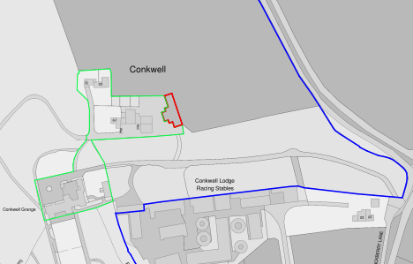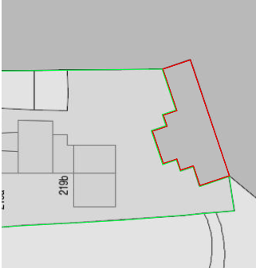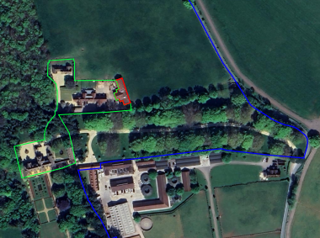
Location Plan Proposed Site Plan Aerial View of site

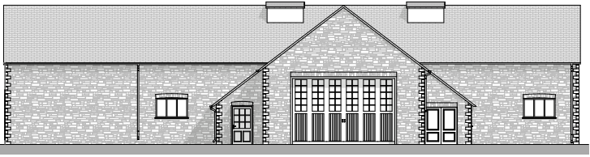 \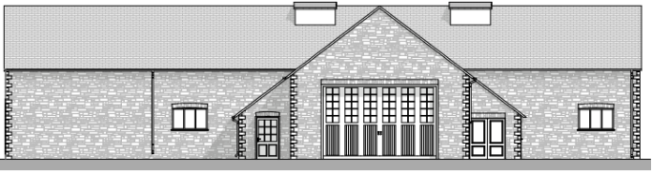
Existing & Proposed West Front Elevation

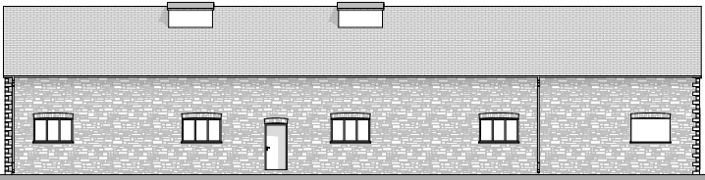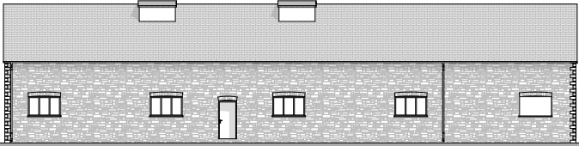
Existing & Proposed East Rear Elevation

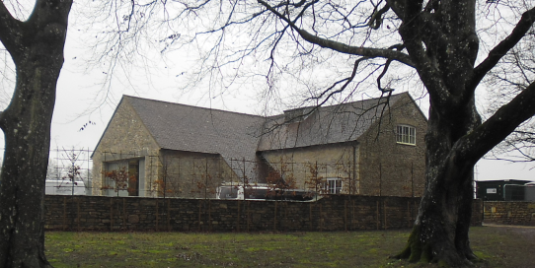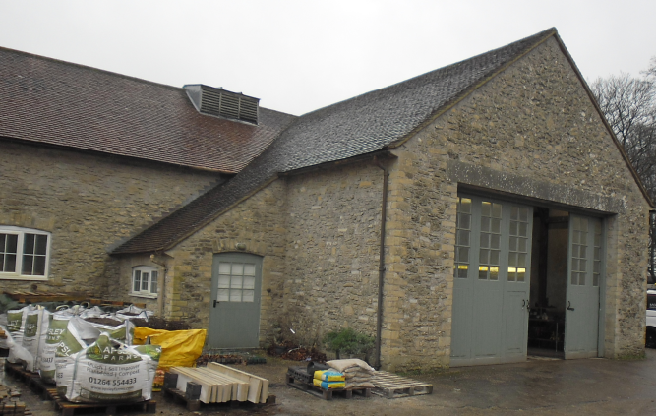
Photographs of Barn as existing

The wider site contains the main house of Conkwell Grange and also some residential terraced buildings directly opposite the barn, which are workers cottages, and which are in use and occupied. The location plan shows what is now the extent of the residential curtilage of Conkwell Grange, outlined in green and capturing the main dwelling and the workers cottages. It is these buildings and especially the principle dwelling which would use the barn for storage related to the residential uses, including storage of vehicles. The building relates to the overall context of the Grange estate as an ancillary building.

The proposal is purely for the proposed change of use of the building with no engineering works or any other works required to facilitate the use. Whilst the planning history shows that the barn obtained planning permission for use as a dwelling in 1987, the occupation as such was never implemented. The owner has no desire to resurrect this historic permission, with the preference now to utilise the building for residential storage for their own use. The wider site is utilised for residential use, with no agricultural activities or practices taking place. Officers visited the site with the storage use of the barn being evident at the time. The change of use has no visual or design impact and would be less impactful than the sub-division to a form a separate dwelling would have been.

Therefore, in summary, having regard to the above, the proposal complies with the design principles set out in Core Policy 57 of the Wiltshire Core Strategy and Appendix D of the Wiltshire Design Guide.

Amenity
Point vii of Core Policy 57 - Ensuring High Quality Design and Place Shaping of the Wiltshire Core Strategy seeks to ensure that developments do not adversely affect neighbouring properties. The National Planning Policy Framework (NPPF), particularly Paragraph 135(f), stresses that planning decisions should ensure developments provide a high standard of amenity for existing and future users.

The building is already in place, and no works are proposed to alter it. It lies directly opposite the rear of the existing workers cottages, with the storage use not introducing any new levels of overlooking or other conflict with amenity.

The proposal therefore accords with Core Policy 57 point vii in respect of safeguarding residential amenity and Appendix D of the Wiltshire Design Guide.

Heritage Impact
From the point of view of the historic environment the main statutory tests are set out within the Planning (Listed Building and Conservation Areas) Act 1990. The building is unlisted, having been adapted from a steel framed grain barn dating from the 1950’s, but it lies within the estate of the Grade II listed Conkwell Grange.

Section 66 requires that special regard be given to the desirability of preserving listed buildings, their settings or any features of special architectural or historic interest which they possess.

The Council’s Core Strategy Policy CP58 ‘Ensuring the conservation of the historic environment’ requires that designated and non-designated heritage assets and their settings will be conserved, and where appropriate enhanced, in a manner appropriate to their significance and encourages proposals which improve the condition of heritage assets at risk.

Conkwell Grange is a Grade II listed building and is the main residence. It is set away from the barn at a distance of 140 metres with intersecting land levels and vegetation being in place and so there is no direct interaction between the two buildings. There are no physical alterations to the building that would be capable of impacting on the setting of the listed building. Therefore, due to these factors it is concluded there would be no harmful impact on the setting, character or significance of the listed building.

Green Belt
The site is located within the Green Belt. There is no relevant WCS development plan policies relating to the Green Belt, therefore the NPPF provides the policy direction.
The recently revised NPPF (December 2024) sets out within paragraph 142 that “The Government attaches great importance to Green Belts. The fundamental aim of Green Belt policy is to prevent urban sprawl by keeping land permanently open with the essential characteristics of Green Belts being their openness and their permanence”. Openness is the absence of development and Paragraph 143 the NPPF sets out five key purposes of the Green Belt with one being to safeguard the open countryside from encroachment. The NPPF explains how to treat proposals within the Green Belt.

In this instance the proposal is for the re-use of an existing building, no engineering works or external works are proposed, consequently Paragraph 154 provides exception policy: H(iv) as being relevant, as it relates to the re-use of buildings provided that the buildings are of permanent and substantial construction.
The photographs show the subject building a being of sound and substantial construction and thereby qualifying for the exception.

In accordance with Paragraph 153 no inappropriate development would take place, with the openness and permanence characteristics of the green Belt being maintained and preserved.

Cotswolds National Landscape
The site lies within this landscape designation towards its southern aspect. However, for the above discussed reasons and due to the grain barn already being established and in place, with no works proposed, it is appraised that there would be no harm inflicted on the open character of the surrounding National Landscape.

Highways
Core Policy 57 (xiv) of the Wiltshire Core Strategy seeks to ensure that development must meet the requirements of Core Policy 61. This policy requires proposals to be capable of being served by safe access to the highway network. Core Policy 64 seeks to ensure compliance with parking standards set out in the Local Transport Plan.

The National Planning Policy Framework (NPPF), particularly Paragraph 115 and 116, requires that development proposals do not have an unacceptable impact on highway safety and that safe and suitable access to the site can be achieved for all users.

The proposed development would continue to use the established site access which would not be altered and would not have any adverse impact on highway safety. Adequate parking and turning provision is provided within the site and access arrangements would be associated with the existing residential uses rather than introduce new vehicular movements. As such the access arrangements are acceptable. The council’s highways officer has been consulted who has not raised any objections.

The proposal is therefore considered to comply with Core Policies 57 (xiv), 61 and 64 of the Wiltshire Core Strategy, the NPPF, and the Wiltshire Local Transport Plan.

Ecology Impact
CP50 requires no net loss of biodiversity on site. The site is located within the Bath and Bradford on Avon Bat SAC. The proposed change of use is considered unlikely to result in harm to bats or their habitat because no works are proposed, with the storage use of the barn continuing as it does currently. As such there would be no loss of habitat or disruption to protected species. Accordingly, the proposal is acceptable in this regard. As such, the development complies with Core Policy 50 of the Wiltshire Core Strategy and the relevant provisions of the NPPF.

Biodiversity Net Gain
This application is exempt from the requirement to deliver Biodiversity Net Gain under Schedule 7A, Section 4(2)(a) of the Town and Country Planning Act 1990, as inserted by the Environment Act 2021, because the proposal is for a change of storage use, with no works taking place.

CONCLUSION
The proposed development is acceptable in terms of its proposed use. It would not result in any unacceptable harm to the character of the locality, the amenities of neighbouring occupiers, or the interests of highway safety, heritage, or ecology.

The proposal is therefore considered to comply with the relevant policies of the Wiltshire Core Strategy, the Wiltshire Local Plan, and the National Planning Policy Framework. As such, the application is recommended for approval, subject to the conditions set out below.

RECOMMENDATION: Planning Permission be GRANTED subject to conditions.

