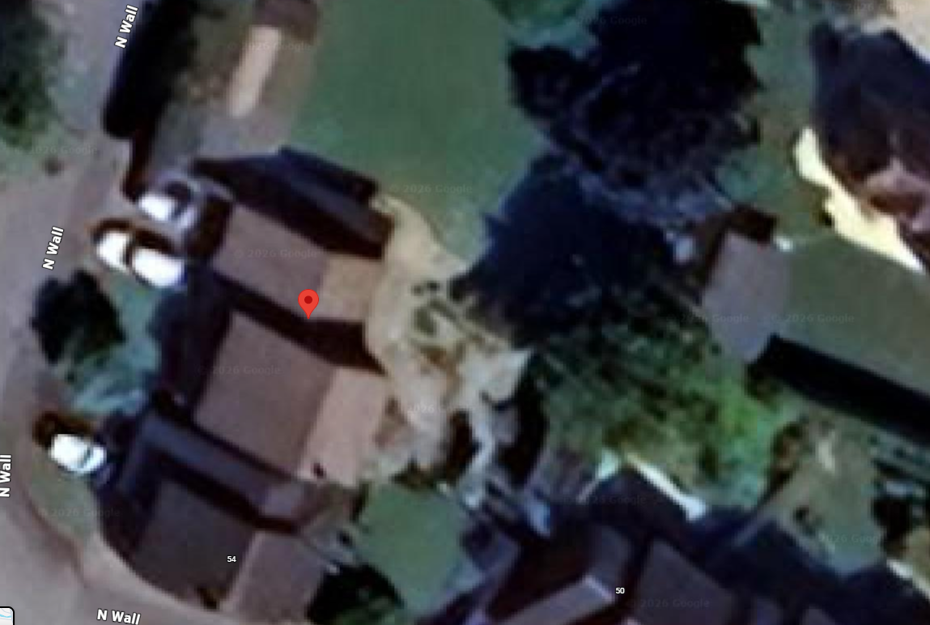
t

52, North Wall, Cricklade, SN6 6DU – T1 & T2 location within the red circle pictured

