APPLICATION FOR VARIATION/REMOVAL OF CONDITION
CASE OFFICER REPORT

APPLICATION REFERENCE: | PL/2025/09658
APPLICATION TYPE: | Removal/variation of conditions
SITE ADDRESS: | Rest Harrow, Low Road, Little Cheverell, Devizes, SN10 4JZ
DEVELOPMENT DESCRIPTION: | Variation of condition 2 (Approved Plans) relating to application PL/2022/03377 - to include relocation of approved dormer and roof light on the North elevation and installation of one additional rooflight.
RECOMMENDATION: | Approve with Conditions

SITE DESCRIPTION/CONTEXT

The site contains a detached two storey cottage with associated gardens and outbuildings. The original cottage is of linear design with a rendered finish and clay roof tiles set perpendicular to the road and is located to the north of the centre of Little Cheverall. The property is located within the Conservation Area and within the North Wessex Downs National Landscape (formally AONB). The property is defined within the Little Cheverell Conservation Area Statement as a significant unlisted building and is therefore a non-designated heritage asset. The gradient of the land is sloped, the dwelling sits within a large plot with gardens that wrap around the house to the south, west and north, sloping to the west. The boundaries of the site are defined by hedges and trees and a watercourse which runs parallel to the western side of the site.

The property has recently been developed by means of a large two storey replacement extension, and detached annexe building permitted under application PL/2022/03377. The works are contemporary in design offering a contrast to the existing historic dwelling.

PROPOSAL

This report considers a Section 73 application for the variation of a condition imposed on planning permission PL/2022/03377. The application relates to the site at Rest Harrow, Low Road, Little Cheverell, and seeks to vary condition 2 in relation to the ‘Approved Plans’ specifically seeking to revise the design of the proposed rear roof dormer.

The applicant initially sought a non‑material amendment(NMA) to replace the approved dormer with a wider, contemporary design to reflect the character of the new extensions. However, as the dormer had been a contentious element in the original permission, it was advised that an NMA was not appropriate and that a Section 73 application should instead be submitted to vary the approved plans.

Following submission of the S73 application, the conservation officer raised concerns, prompting several design revisions. The final iteration now proposes retention of the originally approved dormer in a slightly altered position on the roof slope, alongside one additional rooflight and minor adjustments to the position of an existing rooflight.

The scope of this S73 application is limited to assessing these design amendments only, rather than reconsidering the wider merits of the original scheme. This report therefore focuses on the relevant issues arising from the proposed changes, including their effects on design, heritage, and residential amenity.

The following assessment addresses each of these matters in turn.

RELEVANT PLANNING HISTORY

Proposal / Summary
PL/2022/03377 - Householder planning permission Decision - Approve with Conditions Date: 24/11/2022 – Demolition of garage and conservatory, replacement side extension, new rear extension and associated landscape works.
PL/2025/09225 - Non-Material Amendment Decision - Withdrawn by Applicant Date: 4/12/2025 – non-material amendment to PL/2022/03377 to allow internal and external adjustments to provide additional bedroom and bathroom

RELEVANT LEGISLATION, POLICIES AND GUIDANCE

Town and Country Planning Act. 1990 (as amended)

Section 73 of the Town and Country Planning Act. 1990 (as amended) relates to the determination of applications to develop land without compliance with conditions previously attached. It states that:

(2) On such an application the local planning authority shall consider only the question of the conditions subject to which planning permission should be granted, and—

- if they decide that planning permission should be granted subject to conditions differing from those subject to which the previous permission was granted, or that it should be granted unconditionally, they shall grant planning permission accordingly, and

- if they decide that planning permission should be granted subject to the same conditions as those subject to which the previous permission was granted, they shall refuse the application.

The National Planning Practice Guidance (PPG) states the following:

- Nature of the Application: A Section 73 application is treated as a new planning permission, although it does not alter the original permission itself. The original permission remains intact and can still be implemented unless it has expired or been superseded.
- Limitations:
  - Section 73 cannot be used to change the description of development or the operative part of the permission (e.g. the nature or extent of the approved use).
  - It cannot be used to extend the time limit for implementing the original permission.
  - If the proposed changes go beyond what can reasonably be considered under Section 73, a new planning application under Section 70 would be required.
- Decision-making: The local planning authority must consider the application only in relation to the conditions subject to which the original permission was granted. However, it may impose new or revised conditions if granting a new permission.
- Legal Agreements: Because a Section 73 application results in a new permission, any existing Section 106 agreement may need to be varied or replaced via a deed of variation to ensure obligations continue to apply to the new permission.

National Planning Policy:
- National Planning Policy Framework (NPPF)
- Planning Practice Guidance (PPG)
- National Design Guide
Development Plan:
The development plan for Wiltshire comprises the Wiltshire Core Strategy (WCS) (adopted January 2015) and any made neighbourhood plans, which remains the principal statutory planning document guiding development across the county. In line with Section 38(6) of the Planning and Compulsory Purchase Act 2004, planning decisions must be made in accordance with the development plan unless material considerations indicate otherwise.

Though the development plan is considered as a whole, those parts deemed to be particularly relevant to this application are listed below:

The adopted Wiltshire Core Strategy (WCS), with particular regard to:

- Core Policy 51 Landscape
- Core Policy 57 Ensuring High Quality Design and Place Shaping;
- Core Policy 58 Ensuring the Conservation of the Historic Environment;

Draft Wiltshire Local Plan Policies

- Policies 64 – 75: Economic, tourism, retail and transport
- Policies 76 – 84: Social, housing, community, public open space and wellbeing
- Policies 85 – 101: Sustainability, ecology, water and landscape, heritage, air quality

Supplementary Planning Documents:

- The Wiltshire Design Guide and Local Transport Plan
- Little Cheverell Conservation Area Statement 2007

ISSUES

The key considerations in the assessment of this application are as follows:

- Determining whether the proposed amendments fall within the scope of Section 73 of the Town and Country Planning Act 1990 which allows for the variation or removal of conditions attached to an existing planning permission.
- Assessing whether the development, as amended, remains in accordance with the relevant policies and provisions of the development plan, and whether the changes materially alter the nature or impacts of the approved scheme.

CONSULTATION RESPONSES

Wiltshire Council Conservation Officer – Objections to the initial proposal and second set of revisions. No objections raised to the final submission. Comments summarised within assessment section of report. Full comments can be read on the Councils website under the relevant application number.

Little Cheverell Parish Council:

No comments received.

REPRESENTATIONS

None received.

ASSESSMENT
Section 38(6) of the Planning and Compulsory Purchase Act 2004 states:

"If regard is to be had to the development plan for the purposes of any determination to be made under the planning Acts, the determination must be made in accordance with the plan unless material considerations indicate otherwise."

In accordance with this statutory requirement, this application has been assessed against the relevant policies of the Development Plan, including the Wiltshire Core Strategy (2015) and, where applicable, any made Neighbourhood Plans. Consideration has also been given to the policies of the National Planning Policy Framework (NPPF) as a material consideration in the assessment.

Principle of the Development – Do the proposed amendments fall within the scope of s73?

The proposed amendments have been reviewed and are considered to fall within the scope of Section 73 of the Town and Country Planning Act 1990. The changes do not result in a fundamentally different development from that originally approved, nor do they seek to alter the description of development or extend the time limit for implementation. As such, the application is valid under Section 73 and can be determined as a variation of condition attached to the original planning permission.

Compliance with the Development Plan
The initial submission raised concern with regards to non-compliance with the Development Plan, specifically CP 57 and 58 of the WCS. The following images show the evolution of the design through the various stages of revision:

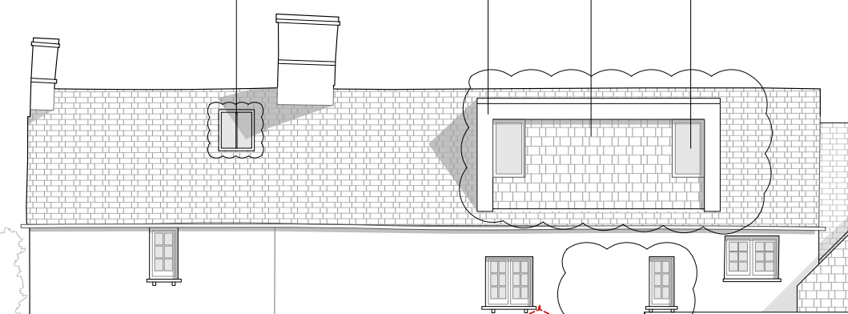

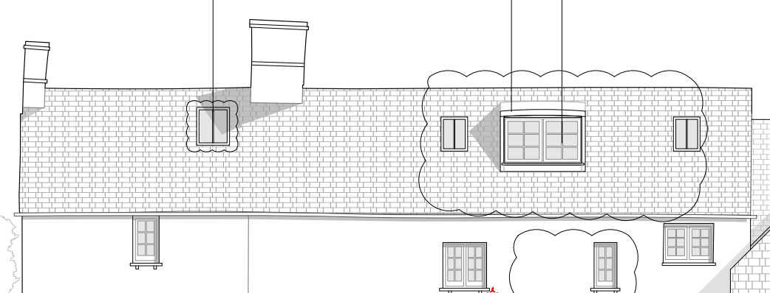

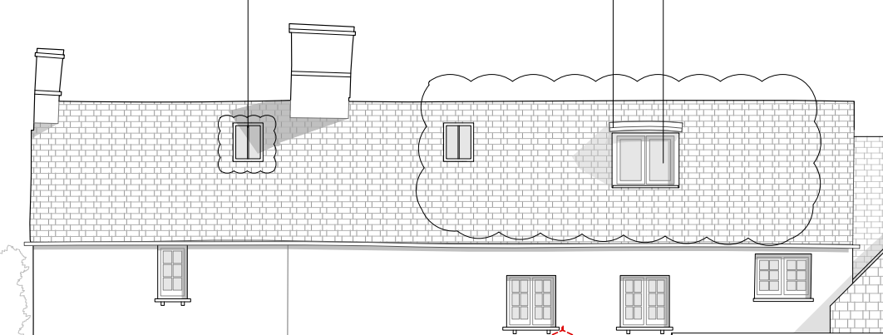

The conservation officer noted that the proposed large, box-form dormer would dominate the host building, disrupt its traditional vernacular proportions, and compromise the historic roofscape. The design was considered incongruous, lacking reference to the established dormer style on the front elevation and failing to remain subservient to the main structure. As a result, the proposal was assessed as causing less than substantial harm to both the non-designated heritage asset and the wider conservation area, with no public benefits identified to outweigh that harm. Accordingly, the Conservation Officer concluded that the proposal would conflict with national and local heritage policy and a refusal was recommended. Revisions were submitted which did not alleviate these concerns.

In response to the final set of revisions the conservation officer considered that the reduced dormer was now comparable in scale and impact to that previously approved and is better aligned with the first‑floor window arrangement, improving its overall composition. While the additional rooflights introduce some degree of visual clutter, this was not judged to result in harm to the significance of the building or the conservation area. In concluding, the officer confirmed that the scheme would result in a neutral impact on the relevant heritage assets and met the requirements of conservation policy and legislation and therefore raised no further objection to the proposal.

Assessment of Conditions

In conclusion, the proposed revisions are largely in line with that originally approved, there are not considered to be any new impacts in this case which would alter previous assessments regarding amenity, heritage, design or landscape. As such, the proposed variations to the approved plans are considered to be compliant with the relevant policies of the development plan and the variation is considered reasonable, necessary and justified. No other conditions will be affected by the variation.

PLANNING BALANCE AND CONCLUSION
In determining this application under Section 73 of the Town and Country Planning Act 1990, the Local Planning Authority has considered whether the proposed amendments fall within the scope of Section 73. The proposed amendments have been assessed against the relevant policies of the Wiltshire Core Strategy, and the National Planning Policy Framework. The assessment has also considered whether the development, as amended, materially alters the nature or impacts of the approved scheme.

The proposed variation of condition is considered acceptable. The proposal remains in accordance with the development plan and relevant national guidance, and there are no material considerations that indicate otherwise.

RECOMMENDATION:
That Planning Permission be GRANTED subject to conditions.

