CASE OFFICER REPORT

APPLICATION REFERENCE: | PL/2025/09805
APPLICATION TYPE: | Prior approval Part 14 Class J: Installation or alteration etc of solar equipment on non-domestic premises
SITE ADDRESS: | Chemring Countermeasures Ltd, Netton, Salisbury, SP4 6AS
DEVELOPMENT DESCRIPTION: | A Solar PV system totalling 250kWp on the roof of the Chemring Countermeasures buildings. Panels will be sited on two East/West facing roof areas, and one North/South facing roof. The proposed system will be on a shallow pitched roof so the visual impact and risk of glare will be very low. Panels will be mounted less than 200mm from the plane of the roof in all cases. Panels will not be sited within 1m of an external edge of the roof.
RECOMMENDATION: | That Prior Approval is REFUSED

SITE DESCRIPTION/CONTEXT

The application site is an existing manufacturing site located at High Post to the north of Salisbury. The existing access to the site is from the south off the minor road which connects High Post to Upper Woodford. The extent of the site is shown in the aerial photograph below:
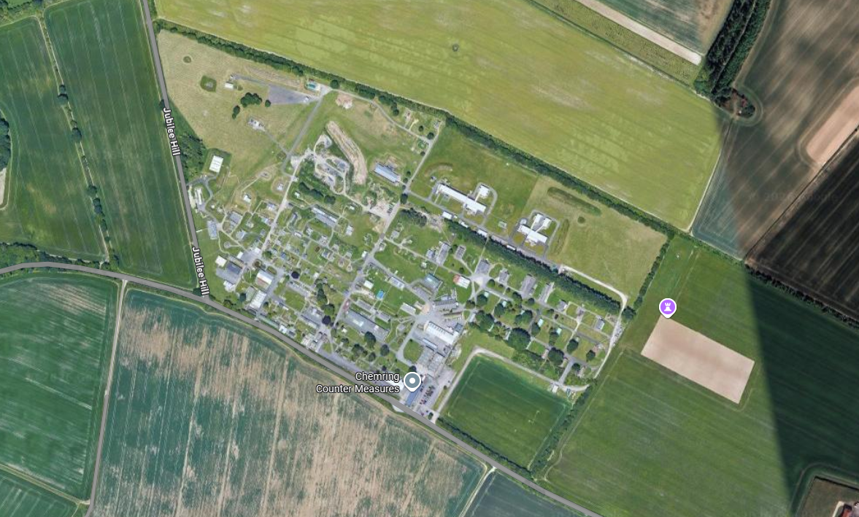

The proposed works are for the installation of solar panels on the roof slope of existing buildings located on the southern part of the site.
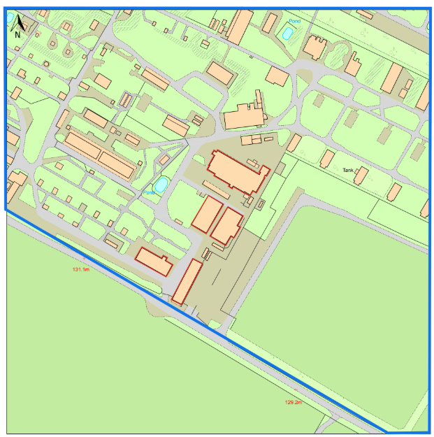
PROPOSAL
The application proposes installing a Solar PV system totalling 250kWp on the roof of 5 buildings part of Chemring Countermeasures.

RELEVANT LEGISLATION, POLICY AND GUIDANCE
This application is assessed under Article 3 of the Town and Country Planning (General Permitted Development) (England) Order 2015 (as amended), which grants planning permission for certain types of development described in Schedule 2 of the Order. The grant of permission is subject to the limitations, conditions, and provisions set out within the relevant Classes of permitted development.

Under Schedule 2, Part 14, Class J of the Town and Country Planning (General Permitted Development) (England) Order 2015 (as amended), certain changes of use and associated operations may be permitted subject to prior approval from the Local Planning Authority.

RELEVANT PLANNING HISTORY
There have been various applications for development at the existing manufacturing facility over many years. With regards to solar panels, an application with reference: PL/2023/04203 with a description of: Install ground mounted solar photovoltaic (PV) panels and associated infrastructure including access road, boundary treatments, CCTV surveillance and underground HV cable was approved. A further application with reference: PL/2025/01622 for the approval of details reserved by a condition with description: Discharge Conditions 5,6 and 7 on PL/2023/04203 - Install ground mounted solar photovoltaic (PV) panels and associated infrastructure including access road, boundary treatments, CCTV surveillance and underground HV cable was also approved.

CONSULTATIONS

Wiltshire Council Highways officer: No Objection.
Dunford Parish Council: None received.
Landscape: None received.
MOD Boscombe Down Applications: None received.
World Heritage Sites: Comment.
This application takes place c. 1.4km southeast of the Stonehenge part of the Stonehenge, Avebury and Associated Sites WHS.
The application does not include consideration of impact to the WHS. The proposal takes place in an
elevated position within c. 1.4km of the WHS, and within c. 1.4km of monuments located at high
points in the southern part of the WHS including Scheduled Monument Lake Down Round Barrow Cemetery.
While limited invisibility with the WHS could be assumed due to topography, the WHS Coordination
Unit is unable to confirm for the LPA whether the proposal presents harm to the WHS, and if so the
level harm and mitigations, without the applicant producing a form of Landscape Visual Impact
Assessment.
The solar PVs which could present a change to the WHS from a development within its setting are
the west elevation of Building 1 and potentially the north elevation of Building 2. It is noted that the
application describes how the angle of the roof is at a shallow pitch so the risk of glare is low. A more
detailed visualisation of the proposal would allow for full assessment.
PLANNING ISSUES

This submission is not a planning application, rather it is a prior notification application submitted pursuant to the Permitted Development rights enshrined within Schedule 2, Part 14 Class J of the Town and Country Planning (General Permitted Development) (England) Order 2015 (as amended) for the installation of, alteration or replacement of solar photovoltaic equipment on the roofs on non-domestic buildings producing up to a capacity of 1 megawatt. There is no requirement for planning permission for such development providing the conditions and caveats set out with Class J are satisfied. The legislation is shown below with comments related to the proposals added by the case officer in red.

Class J – installation or alteration etc of solar equipment on non-domestic premises

Permitted development

J. The installation, alteration or replacement of—
(a) microgeneration solar thermal equipment on a building;
(b) microgeneration solar PV equipment on a building; or
(c) other solar PV equipment on the roof of a building,
other than a dwellinghouse or a block of flats.

Development not permitted

J.1 Development is not permitted by Class J if—
(a) the solar PV equipment or solar thermal equipment would be installed on a
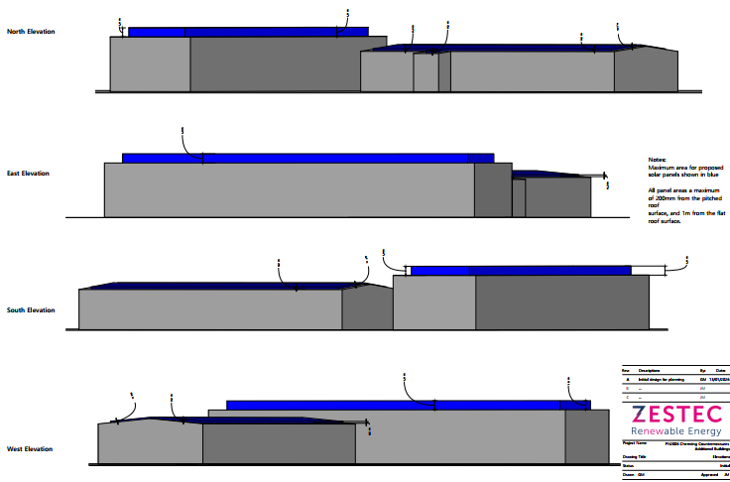
pitched roof and would protrude more than 0.2 metres beyond the plane of the roof slope when measured from the perpendicular with the external surface of the roof slope; The solar panels are not proposed to protrude more than 0.2 metres beyond the plane of the roof slope. This is demonstrated in the submitted documents as shown below.

(b) the solar PV equipment or solar thermal equipment would be installed on a flat
roof, where the highest part of the solar PV equipment would be higher than 1 metre above the highest part of the roof (excluding any chimney); The submitted documents demonstrate that the solar panels on a flat roof are not proposed to be higher than 1 metre above the highest part of the roof.

(c) the solar PV equipment or solar thermal equipment would be installed on a roof and within 1 metre of the external edge of that roof; The submitted documents have demonstrated that the application does not propose to conflict with this limitation.

(d) in the case of a building on article 2(3) land, the solar PV equipment or solar thermal equipment would be installed on a roof slope which fronts a highway; The site is not on article 2(3) land.

(e) the solar PV equipment or solar thermal equipment would be installed on a site designated as a scheduled monument; The site is not designated as a scheduled monument. However, it is located at close proximity to designated heritage assets. (including Old Sarum Scheduled Monument to the south, Ogbury Camp Scheduled Monument to the north, Stonehenge and Avebury World Heritage Site to the northwest and Great Durnford, Netton, Lower Woodford, Stratford Sub Castle and Old Sarum conservation areas).

(f) the solar PV equipment or solar thermal equipment would be installed on a listed building or on a building within the curtilage of a listed building. The proposals would not conflict with this limitation.
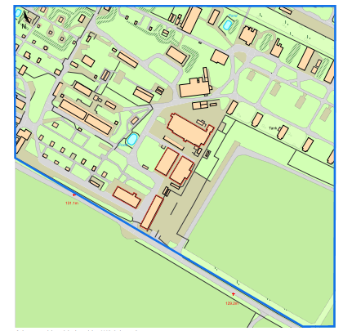
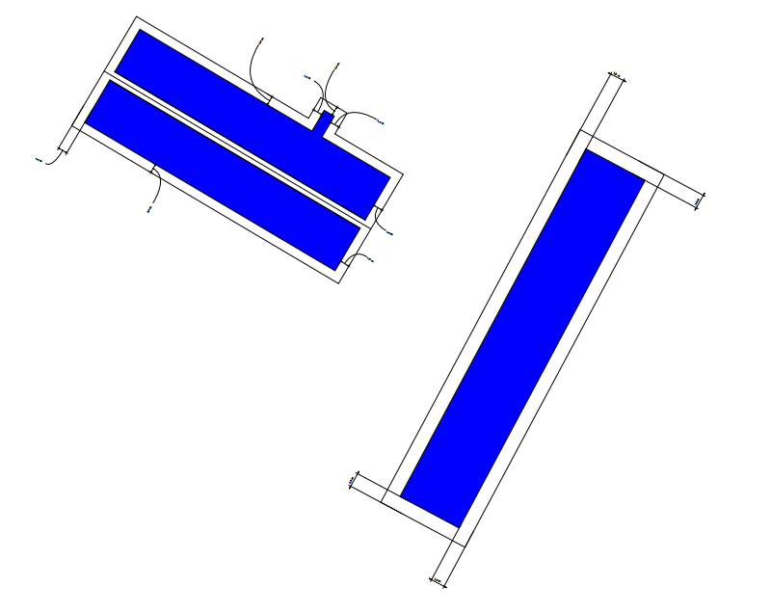
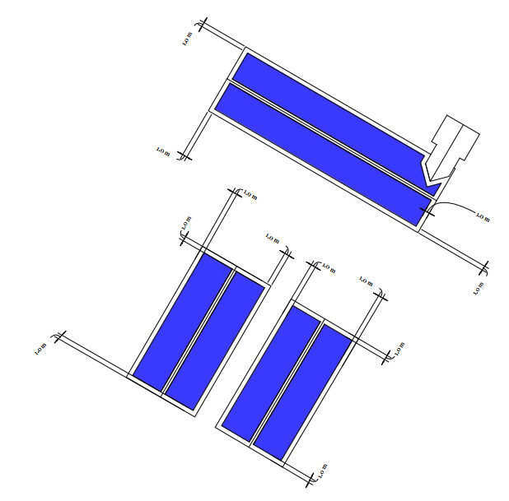
J.2 Development is not permitted by Class J(a) or (b) if—
(a) the solar PV equipment or solar thermal equipment would be installed on a wall and would protrude more than 0.2 metres beyond the plane of the wall when measured from the perpendicular with the external surface of the wall;
(b) the solar PV equipment or solar thermal equipment would be installed on a wall and within 1 metre of a junction of that wall with another wall or with the roof of the building; or
(c) in the case of a building on article 2(3) land, the solar PV equipment or solar thermal equipment would be installed on a wall which fronts a highway.

The proposals would not conflict with any limitations detailed in J.2.

J.3 Development is not permitted by Class J(c) if the capacity of the solar PV equipment installed (together with any solar PV equipment installed under Class J(b)) to generate electricity exceeds 1 megawatt.

The proposals would not conflict with this limitation as the capacity of the equipment is proposed to be 0.25 Megawatts.

Conditions

J.4— (1) Class J development is permitted subject to the following conditions—
(a) the solar PV equipment or solar thermal equipment must, so far as practicable, be sited so as to minimise its effect on the external appearance of the building and the amenity of the area; and
(b) the solar PV equipment or solar thermal equipment is removed as soon as reasonably practicable when no longer needed.
(2) Class J(c) development is permitted subject to the condition that before beginning the development the developer must apply to the local planning authority for a determination as to whether the prior approval of the authority will be required as to the design or external appearance of the development, in particular the impact of glare on occupiers of neighbouring land, and the following sub-paragraphs apply in relation to that application.

Design or external appearance of the development, in particular the impact of glare on occupiers of neighbouring land

As per paragraph J.4(1) a and J.4 (2), the local planning authority are required to assess the impact on the external appearance of the development, in particular the impact of glare on occupiers of neighbouring land.

The application site is located at a prominent location and lies in a sensitive landscape location being located within a Special Landscape area (a non-statutory designation under Saved policy C6 of the Salisbury District Local Plan (SDLP)) and the area has been identified as part of Salisbury Plain and West Wiltshire Downs National Character Area (NCA) 132; the High Chalk Plain Landscape Character Type and Salisbury Plain East Landscape Character Area within the Wiltshire Landscape Character Assessment 2005, and the Boscombe Down Chalk Downland Landscape Character Area within the South Wiltshire Landscape Character Assessment 2008. There are also designated heritage assets nearby (including Old Sarum Scheduled Monument to the south, Ogbury Camp Scheduled Monument to the north, Stonehenge and Avebury World Heritage Site to the northwest and Great Durnford, Netton, Lower Woodford, Stratford Sub Castle and Old Sarum conservation areas).

A representative from World Heritage Sites has commented on the application and notes that:

This application takes place c. 1.4km southeast of the Stonehenge part of the Stonehenge, Avebury and Associated Sites WHS.

The application does not include consideration of impact to the WHS. The proposal takes place in an elevated position within c. 1.4km of the WHS, and within c. 1.4km of monuments located at high points in the southern part of the WHS including Scheduled Monument Lake Down Round Barrow Cemetery.

While limited invisibility with the WHS could be assumed due to topography, the WHS Coordination Unit is unable to confirm for the LPA whether the proposal presents harm to the WHS, and if so the level harm and mitigations, without the applicant producing a form of Landscape Visual Impact Assessment.

The solar PVs which could present a change to the WHS from a development within its setting are the west elevation of Building 1 and potentially the north elevation of Building 2. It is noted that the application describes how the angle of the roof is at a shallow pitch so the risk of glare is low. A more detailed visualisation of the proposal would allow for full assessment.

With regard to glare, beyond a generalised and unevidenced/unsubstantiated assertion that no glare will occur, the applicant has not provided plans or specifications regarding glare impacts and therefore, the impact on neighbouring land cannot be assessed or concluded upon. As indicated above, the application site is located in a prominent and sensitive location. In addition to the heritage designations indicated above, Old Sarum airfield lies south of the application site. A Landscape Visual Impact Assessment will enable the LPA and the consultees to assess the impact of the proposed solar panels to the designations of the surrounding area.

In line with the GPDO:

(4) The local planning authority may refuse an application where, in the opinion of the authority—
(a) the proposed development does not comply with, or
(b) the developer has provided insufficient information to enable the authority to establish whether the proposed development complies with, any conditions, limitations or restrictions specified in Class J applicable to the development in question.

CONCLUSION

The application contains insufficient information to enable the local planning authority to fully and properly assess the design and appearance of the proposals; their potential impact for this sensitive landscape and heritage setting; and in particular the potential impact of glare from the proposed development on the setting of neighbouring sensitive heritage and landscape assets, and the adjacent airfield. The proposals are therefore contrary to the requirements of paragraph J.4(2) of Class J, of Part 14 of Schedule 2 the Town and Country Planning (General Permitted Development) Order 2015 (as amended), and Policy CP57 to the Wiltshire Core Strategy.

RECOMMENDATION: Prior Approval is REQUIRED and REFUSED.

