Photographic Supplement
Bourne Hill/ College St Car Park

T1
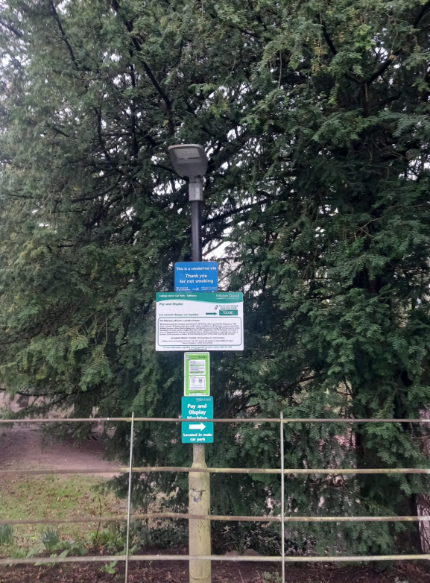

T2
