APPLICATION FOR HOUSEHOLDER PLANNING PERMISSION
DELEGATED REPORT

APPLICATION REFERENCE: | PL/2025/09936
APPLICATION TYPE: | Householder planning permission
SITE ADDRESS: | 111 The Hollow, Corsley, Warminster, BA12 7PD
DEVELOPMENT DESCRIPTION: | First‑floor extension over existing side extension, including installation of roof‑mounted solar photovoltaic panels
RECOMMENDATION: | That Planning Permission be GRANTED

PROPOSAL

The proposal seeks planning permission for first‑floor extension over existing side extension, including installation of roof‑mounted solar photovoltaic panels at 111 The Hollow, Corsley, Warminster. The extension would be clad with timber cladding under a plain concrete tiled roof. Solar panels are also proposed on each roof slope. The extension would be subservient to the main building but would extend across the existing side walls.

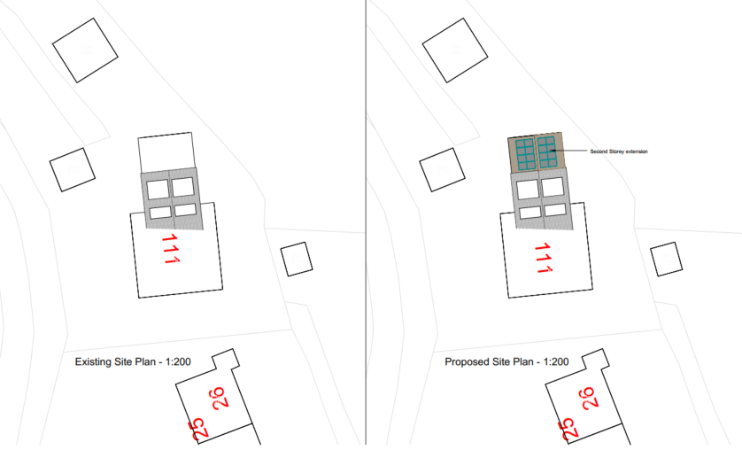

Existing and Proposed Site Plan

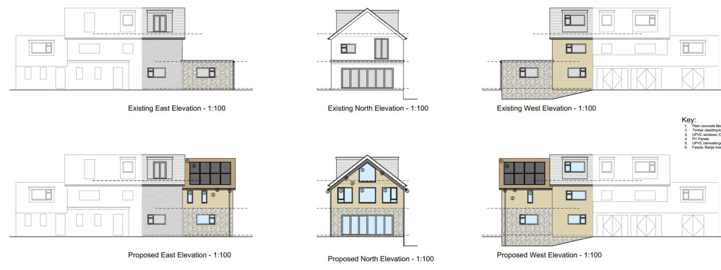

Existing and Proposed Elevations

SITE DESCRIPTION/CONTEXT

No 111 is a detached two storey dwelling that has also had a loft conversion allowing for an effective second floor. The proposal would add a first-floor extension over the existing flat roofed side extension on the northern elevation.

The elevation plans show a ‘second floor’ window on the northern side elevation of the extension but the applicant’s agent has confirmed via email that;

“It’s not an extension of the second floor. The first-floor extension will have a vaulted roof therefore the higher-level window in the North elevation is to allow additional light into the space above the bedroom. In no way is this a second-floor extension to the loft conversion.”

The application site is not subject to any policy constraints other than being in an area of ground water flood risk (Groundwater levels are between 0.025m and 0.5m below the ground surface).

No 111 is located on land that’s high above (circa 3-4m) The Hollow and is also screened by a mature hedgerow and trees on the embankment. As such No 111 is not readily visible from the Hollow. The site is visible from PRoW CORY29, running immediately adjacent to the eastern boundary, offering close-range views where changes to height, massing and materials are perceptible.

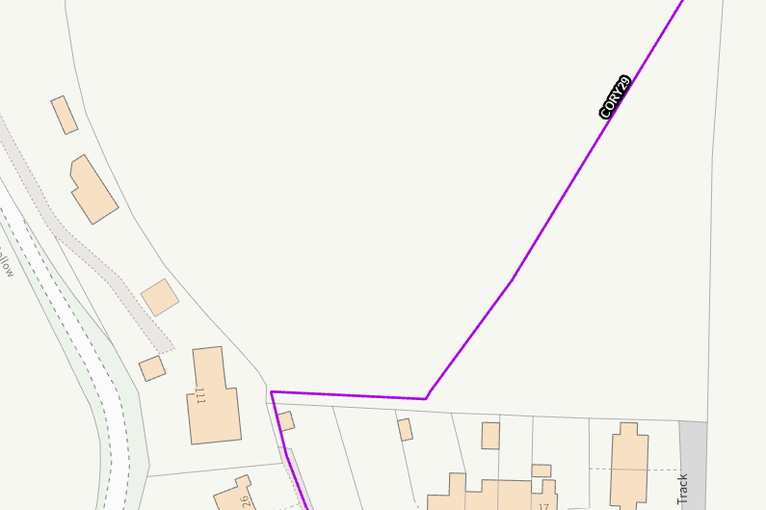

Site location in relation to the PRoW CORY29

No 111 has a fairly unbalanced appearance with the (likely) main two storey section of the building having had a flat roof side extension, another side extension with a pitched roof that also extends across the front elevation and three large flat roofed dormer windows on both roof slopes. Additionally, there are four different materials of painted render, recon stone, timber cladding and hanging wall tiles.

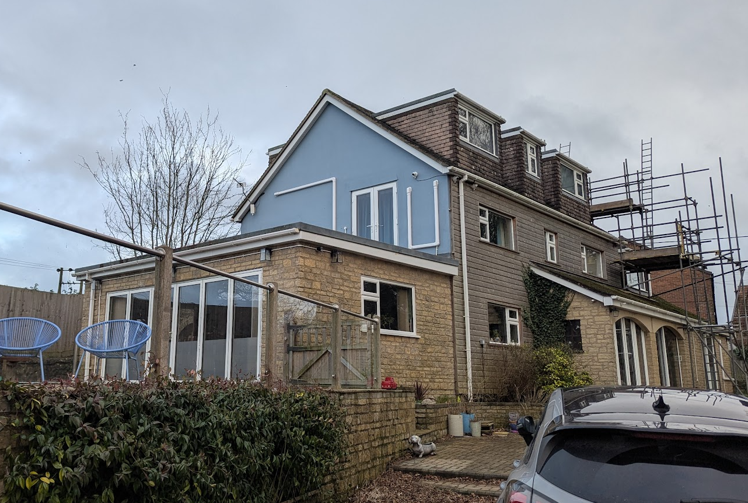

No 111

PLANNING HISTORY

Proposal / Summary
W/12/02132/FUL - Full planning permission Decision - Approved Date: 15/1/2013 – Proposed loft conversion
14/07369/FUL - Full planning permission Decision - Approve with Conditions Date: 24/9/2014 – Proposed side extension
15/07348/FUL - Full planning permission Decision - Approve with Conditions Date: 22/9/2015 – Conversion of existing garage to gymnasium and erection of attached building to contain swimming pool. Erection of replacement garage and attached conservatory.
14/10489/FUL - Full planning permission Decision - Approve with Conditions Date: 22/12/2014 – Proposed rear extension and porch

None of these permissions impose restrictions preventing an additional first-floor addition as proposed.

RELEVANT POLICIES AND GUIDANCE

National Context:

The National Planning Policy Framework (NPPF)

The Planning Practice Guidance

Local Context:

Wiltshire Core Strategy:

- Core Policy 51 Landscape
- Core Policy 57 Ensuring High Quality Design and Place Shaping
- Core Policy 67 Flood Risk

Corsley does not have a neighbourhood plan or area designation.

Wiltshire Design Guide: Appendix D – Design Guidance for Householder extensions

Wiltshire Strategic Flood Risk Assessment (2024)

CONSULTATION RESPONSES

For the avoidance of doubt, Officers changed the application description from ‘Second floor extension’ to that now described. However the public consultation was for ‘second floor extension’. Officers consider that as there are no changes to the proposal itself there is no need to re-consult as the description is a better reflection of what the proposal actually involves, a first floor extension and not a second floor extension, and to which the solar panels which are clearly visible on the plans, included in the description.

Corsley Parish Council: No objection

Wiltshire Council Rights of Way Officer: No comments received

REPRESENTATIONS

No comments were received.

ASSESSMENT

Section 38(6) of the Planning and Compulsory Purchase Act 2004 states:

"If regard is to be had to the development plan for the purposes of any determination to be made under the planning Acts, the determination must be made in accordance with the plan unless material considerations indicate otherwise."

In accordance with this statutory requirement, this application has been assessed against the relevant policies of the Development Plan, including the adopted Wiltshire Core Strategy (2015) and, where applicable, any made Neighbourhood Plans.

Design and Impact upon the character and context of the area

Core Policy 57 - Ensuring High Quality Design and Place Shaping of the Wiltshire Core Strategy seeks to ensure that all new development is of high design quality, reflecting local context, character, and distinctiveness.

The existing dwelling is architecturally irregular, with multiple roof forms and cladding types contributing to an unbalanced appearance. The proposed subservient extension would add another ‘unbalanced’ element to the existing host building. The solar panels and fenestration design (that is also completely at odds with the rest of the existing fenestration) would add further slightly discordant features to the host building. While these elements add minor discordance, they represent a continuation of the dwelling’s existing eclectic character rather than a harmful departure from it.

The extension itself would be built over the existing ground floor kitchen and would continue existing walls and materials (the timber cladding). Furthermore, due to No 111 being very well screened from the majority of public views from the road it would not cause harm to the street scene. Officers also note the Parish support and the lack of any public objections.

It is acknowledged that there would be some views from the public right of way, but users would predominantly see the eastern elevation, rather than the northern elevation which is subject to the very different fenestration design. As such users of the public right of way would only see the subservient extension, to which there would also not be sufficient harm in which to warrant the refusal of the application.

Solar panels are appropriate in principle (NPPF Chapter 14) and acceptable in this low-visibility context.

Having regard to the above, the proposal complies with the design principles set out in Core Policy 57 of the Wiltshire Core Strategy and Appendix D of the Wiltshire Design Guide.

Amenity

Point vii of Core Policy 57 - Ensuring High Quality Design and Place Shaping of the Wiltshire Core Strategy seeks to ensure that developments do not adversely affect neighbouring properties.

The extension sits on the northern side, with no neighbouring dwellings directly adjacent.

- No overshadowing impacts arise due to separation distances and topography.
- No overlooking arises, as windows face open countryside.
- No overbearing effects occur given existing massing and site layout.

No amenity harm identified.

Drainage and Flood Risk

Although the site is in Flood Zone 1, SFRA mapping identifies it as within an area susceptible to high groundwater levels. Normally a site-specific Flood Risk Assessment (FRA) may be required where development introduces a more vulnerable use or significantly alters floor levels.

However:

- The proposal creates no new footprint.
- There is no alteration to ground-floor slab, thresholds, external levels, or drainage paths.
- Vulnerability does not increase as no ground-floor accommodation is proposed.

Given these circumstances, the proposal does not require an FRA, and no flood risk increase arises.

Paragraph 176 of the NPPF states;

The proposal therefore complies with Core Policy 67 of the Wiltshire Core Strategy and the policy in the NPPF, ensuring that flood risk is not increased.

Biodiversity Net Gain

Householder planning applications are exempt from the requirement to deliver Biodiversity Net Gain under Schedule 7A, Section 4(2)(a) of the Town and Country Planning Act 1990, as inserted by the Environment Act 2021.

CONCLUSION

The proposed development is considered to be acceptable in terms of its design, scale, and relationship with the surrounding area. It would not result in any unacceptable harm to the character of the locality, the amenities of neighbouring occupiers.

The proposal is therefore considered to comply with the relevant policies of the Wiltshire Core Strategy, the Wiltshire Local Plan, and the National Planning Policy Framework. As such, the application is recommended for approval, subject to the conditions set out below.

RECOMMENDATION: That Planning Permission be GRANTED subject to conditions.

