APPLICATION FOR HOUSEHOLDER PLANNING PERMISSION DELEGATED REPORT

APPLICATION REFERENCE: | PL/2025/09897
APPLICATION TYPE: | Householder planning permission
SITE ADDRESS: | Haywood, Maddington Street, Shrewton, Salisbury, SP3 4JL
DEVELOPMENT DESCRIPTION: | Detached garage with side car port
RECOMMENDATION: | That Planning Permission be GRANTED

PROPOSAL

The proposal seeks planning permission for the erection of a single storey detached building to be located within the front garden of the host dwelling; the proposed building will form a garage and carport.

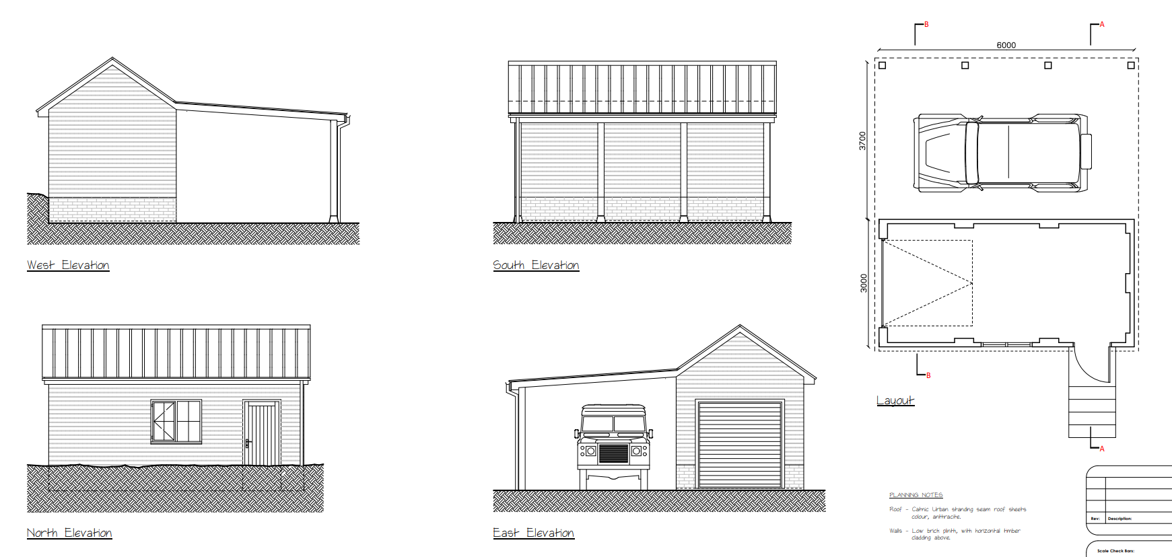

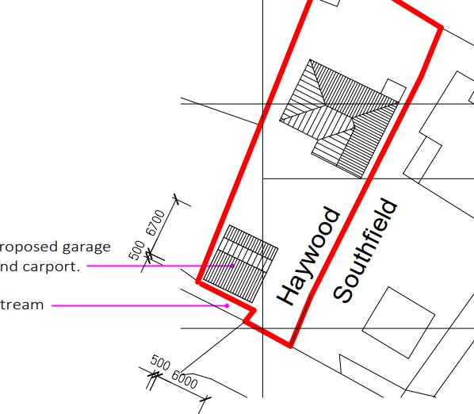

SITE DESCRIPTION/CONTEXT

The application site relates to an existing detached residential dwelling and its associated amenity land and parking. The site is located within the settlement boundary of the large village of Shrewton, as defined by Wiltshire Core Strategy (WCS) policies CP1 (Settlement Strategy), CP2 (Delivery Strategy) and CP4 (Amesbury Community Area). The site is located on the north side of the A360 and is bounded by residential properties to the east, west and south; the property backs onto fields/paddocks to the north.

The site is located within a Special Landscape Area; the front part of the site alongside the road to the south is situated within flood zones 2 and 3 as shown below.

Flood zone 2 Flood zone 3

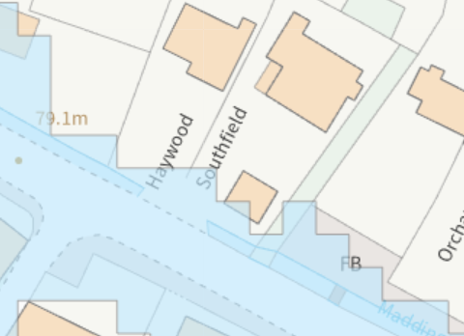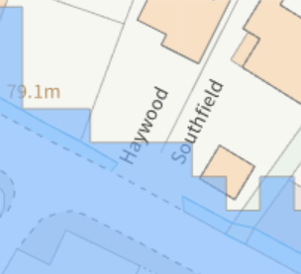

The site is located within the River Avon 20m buffer and within the River Avon SAC.

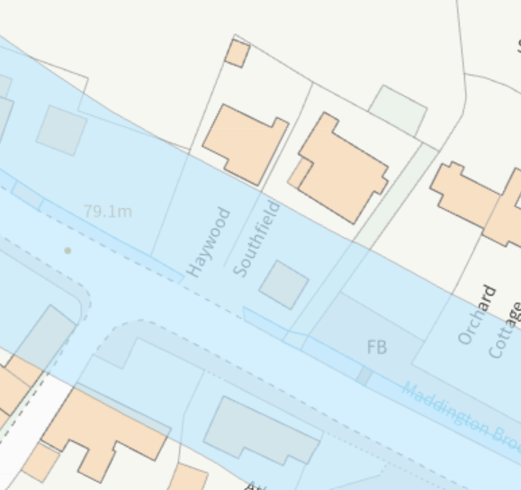

PLANNING HISTORY

None

RELEVANT POLICIES AND GUIDANCE

National Planning Policy Framework (NPPF)
National Planning Practice Guidance (NPPG)
National Design Guide (NDG)
Salisbury District Local Plan policies (Saved by Wiltshire Core Strategy) (SDLP):
C6 – Special Landscape Area
Wiltshire Core Strategy (January 2015) (WCS):
CP1 (Settlement Strategy)
CP2 (Delivery Strategy)
CP4 (Amesbury Community Area)
CP50 (Biodiversity and Geodiversity)
CP51 (Landscape)
CP57 (Ensuring High Quality Design & Space Shaping)
CP58 (Ensuring the Conservation of the Historic Environment)
CP67 (Flood Risk)
CP69 (River Avon SAC)
Supplementary Planning Documents:
Creating Places Design Guide SPG (April 2006)
Achieving Sustainable Development SPG (April 2005)
Wiltshire Local Transport Plan – Car Parking Strategy
Stonehenge and Avebury World Heritage Site Management Plan (2015)
Wiltshire Design Guide: Appendix D – Design Guidance for Householder extensions

CONSULTATION RESPONSES

Parish Council: No objection.

Highways: No highway objection subject to condition

Archaeology: No objection

The property of Haywood lies within the historic village of Shrewton. Wiltshire’s Historic Environment Record (HER) notes that earthworks of the former medieval village lie in the paddock north of and to the rear of Haywood, while a ditch containing 13th-century pottery was recorded in 2017 before the new dwellings west of Grove House were built on the south side of Maddington Street.
However, this application proposes a modest development to the front of the property with limited below ground impacts. On this basis, I have no archaeological concerns, and no further action is required as regards the buried archaeological heritage in relation to this planning application.

REPRESENTATIONS

No comments were received.

ASSESSMENT

Section 38(6) of the Planning and Compulsory Purchase Act 2004 states:

"If regard is to be had to the development plan for the purposes of any determination to be made under the planning Acts, the determination must be made in accordance with the plan unless material considerations indicate otherwise."

In accordance with this statutory requirement, this application has been assessed against the relevant policies of the Development Plan, including the adopted Wiltshire Core Strategy (2015) and, where applicable, any made Neighbourhood Plans.

Design and Impact upon the character and context of the area

Core Policy 57 - Ensuring High Quality Design and Place Shaping of the Wiltshire Core Strategy seeks to ensure that all new development is of high design quality, reflecting local context, character, and distinctiveness.

The proposed garage/car port will be constructed to the front of the existing property and will, due to its siting be prominent within the streetscene. The proposed building will be “side on” to the road with the south elevation comprising the open sided car port comprising a mono pitched roof leading to the pitched roof of the garage element. The garage will be constructed with a brick plinth and timber cladding for the walls under a Catnic Urban standing seam roof with the colour shown as anthracite. The design of the proposed structure is fairly standard; Officers note that other properties in the locality have outbuildings in the front gardens such as the adjacent dwelling to the east of the site (Southfield). Therefore, it is not considered that the proposed building will be out of keeping for the area and will not have a significant impact on the streetscene.

Officers note the recent works that have been under taken at the application site in relation to the gabion wall and excavation of part of the front garden to create a level surface. The gabion wall appears to be under 1 metre in height and therefore would be permitted development. The excavation works to the front garden have already been undertaken although not yet complete. The general arrangement plan submitted with the application provides details of how the front garden will be finished including the retention of the remaining lawned area.

Having regard to the above, the proposal complies with the design principles set out in Core Policy 57 of the Wiltshire Core Strategy and Appendix D of the Wiltshire Design Guide.

Amenity

Point vii of Core Policy 57 - Ensuring High Quality Design and Place Shaping of the Wiltshire Core Strategy seeks to ensure that developments do not adversely affect neighbouring properties.

The National Planning Policy Framework (NPPF), particularly Paragraph 135(f), stresses that planning decisions should ensure developments provide a high standard of amenity for existing and future users.

The proposed development has been assessed in terms of its potential impact on the residential amenity of neighbouring properties, with particular regard to loss of light, overshadowing, loss of privacy, and overbearing effects.

The proposed garage/car port is a single storey structure located to the front of the host dwelling alongside the western boundary of the site. Whilst the application site has neighbouring properties to the east, west and south, given the scale, design, siting and intended use of the proposed development there are no particular concerns raised in relation to neighbour amenity impacts through overshadowing, overbearing or loss of privacy.

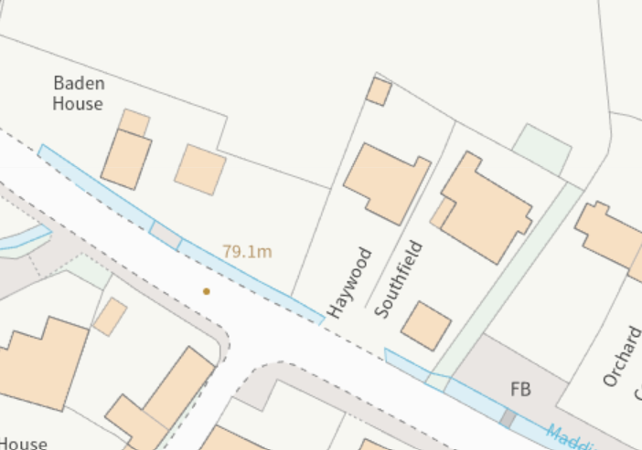
The proposal therefore accords with Core Policy 57 point vii in respect of safeguarding residential amenity and Appendix D of the Wiltshire Design Guide.

Highways Impact

Core Policy 57 (xiv) of the Wiltshire Core Strategy seeks to ensure that development must meet the requirements of Core Policy 61. This policy requires proposals to be capable of being served by safe access to the highway network. Core Policy 64 seeks to ensure compliance with parking standards set out in the Local Transport Plan.

The National Planning Policy Framework (NPPF), particularly Paragraph 115 and 116, requires that development proposals do not have an unacceptable impact on highway safety and that safe and suitable access to the site can be achieved for all users.

The development as proposed relates to the erection of a detached building to front of the property for use as a garage/car port, there are no changes proposed to the existing access. It is noted that there appears to have been recent works undertaken on site relating to the construction of a gabion wall along the front boundary, the height of this is under 1m. Further works have been undertaken including excavation works which have created a large level area for the construction of the proposed building, these can be seen in the case officer’s photos below.

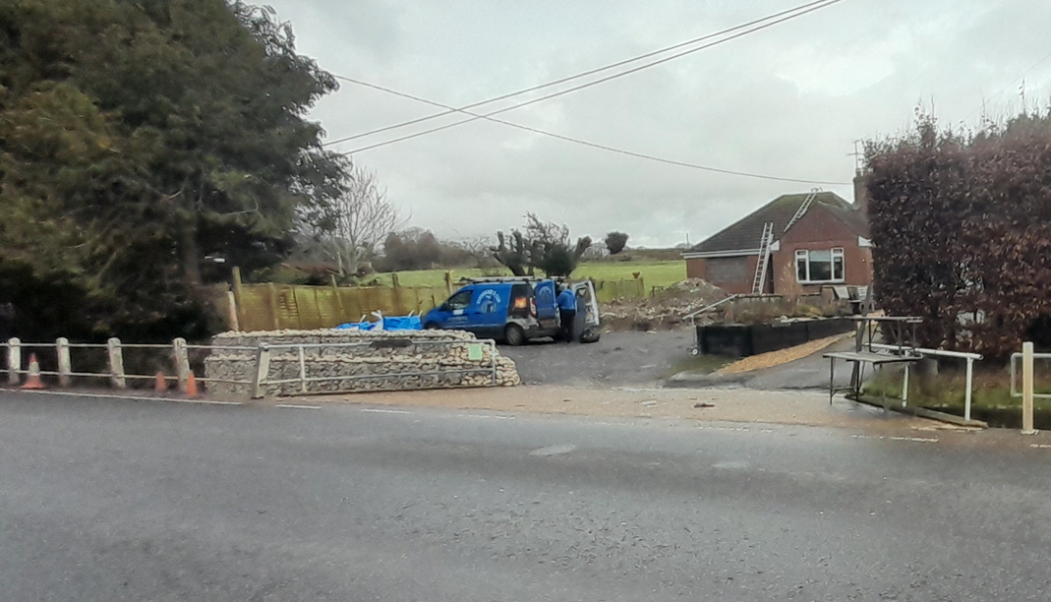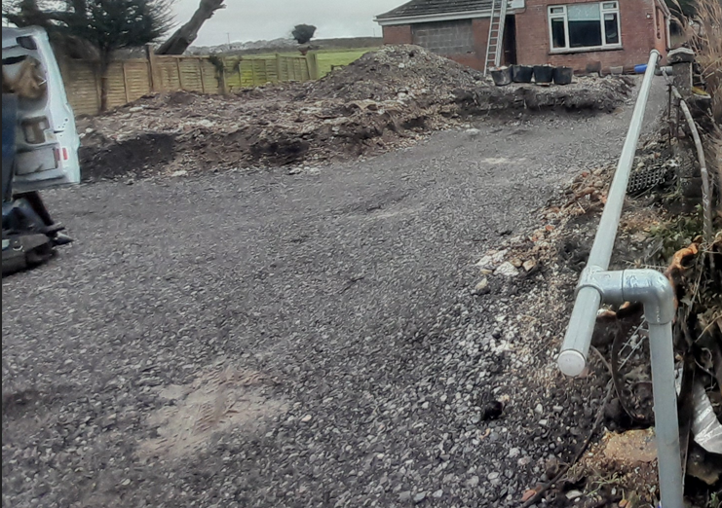

The Highway Authority has been consutled and has raised no objections to the proposed development and consdiers that there is sufficent space on site for the garage/car port to provide parking and turning. It is therefore consdiered that the proposed development would not result in any adverse impact on highway safety. Adequate parking and turning provision are provided in accordance with Wiltshire’s adopted parking standards, and access arrangements are acceptable.

The proposal is therefore considered to comply with Core Policies 57 (xiv), 61 and 64 of the Wiltshire Core Strategy, the NPPF, and the Wiltshire Local Transport Plan.

Ecology Impact

Core Policy 50 of the Wiltshire Core Strategy seeks to protect and enhance biodiversity and geodiversity, including through ensuring that development avoids harm to protected species and habitats.

The National Planning Policy Framework (NPPF), in Paragraphs 193, requires that development minimises impacts on and provides net gains for biodiversity, including ensuring mitigation is secured where harm cannot be avoided.

The site is located adjacent to Maddington Brook which feeds into the River Avon, the location of the garage is in the 20m buffer of the River Avon SAC. Core Policy 69 of the Wiltshire Core Strategy relates to the protection of the River Avon SAC and states:

In order to avoid and reduce potential environmental effects on the River Avon SAC, development will need to incorporate measures during construction and operation to avoid and prevent pollution and mitigate potential disturbance effects; appropriate measures may include consideration of suitable buffer zones along watercourses, habitat enhancements and river access management measures. All development within 20m of the river banks should submit a construction management plan to the local planning authority to ensure measures proposed during construction are satisfactory.

The applicant has submitted a construction management plan which is considered to contain sufficient measures to prevent pollution/harmful impacts on the River Avon SAC during construction, this will therefore be conditioned as part of any permission given,

As such, the development complies with Core Policy 50 and 69 of the Wiltshire Core Strategy and the relevant provisions of the NPPF.

Drainage and Flood Risk

Core Policy 67 of the Wiltshire Core Strategy and paragraph 181 of the NPPF requires that all new development avoids increasing flood risk on-site or elsewhere and, where appropriate, incorporates sustainable drainage measures. Development must also comply with national policy on flood risk management and drainage design. Paragraph 176 (via footnote 62) of the NPPF states that householder development should not be subject to the sequential test, nor the exception test.

In this instance the proposals relate to the erection of a detached garage/car port with no habitable accommodation proposed, a condition will be added to any permission given to restrict the use of the proposed building to garage/car port and not for habitable purposes. The proposed structure is partly open fronted and covers a modest area of existing hardstanding, the proposed building is unlikely to increase flood risk on-site or elsewhere and is considered acceptable in flood risk terms

The proposal therefore complies with Core Policy 67 of the Wiltshire Core Strategy and the provisions within the NPPF, ensuring that flood risk is not increased.

Biodiversity Net Gain

Householder planning applications are exempt from the requirement to deliver Biodiversity Net Gain under Schedule 7A, Section 4(2)(a) of the Town and Country Planning Act 1990, as inserted by the Environment Act 2021.

CONCLUSION

The proposed development is considered to be acceptable in terms of its design, scale, and relationship with the surrounding area. It would not result in any unacceptable harm to the character of the locality, the amenities of neighbouring occupiers, or the interests of highway safety, flood risk, or ecology.

The proposal is therefore considered to comply with the relevant policies of the Wiltshire Core Strategy, the Wiltshire Local Plan, and the National Planning Policy Framework. As such, the application is recommended for approval, subject to the conditions set out below.

RECOMMENDATION: That Planning Permission be GRANTED subject to conditions.

1) The development hereby permitted shall be begun before the expiration of three years from the date of this permission.

REASON: To comply with the provisions of Section 91 of the Town and Country Planning Act 1990 as amended by the Planning and Compulsory Purchase Act 2004.

2) The development hereby permitted shall be carried out in accordance with the following approved plans

Application form received 18/12/2025
Location plan Drg no 03 received 18/12/2025
Site plan Dr no 04 received 18/12/2025
Proposed garage and car port details Drg no 06 received 18/12/2025
Flood risk assessment received 23/01/2026
Construction method statement received 23/01/2026
General arrangement Drg no 07 received 27/01/2026

REASON: For the avoidance of doubt and in the interests of proper planning

3) The development hereby permitted shall not be first brought into use until the first 5m of the access, measured from the edge of the carriageway and/or whole of the parking area, has been consolidated and surfaced (not loose stone or gravel). The access shall be maintained as such thereafter.

REASON: In the interests of highway safety

4) Notwithstanding the provisions of the Town and Country Planning (General Permitted
Development) (England) Order 2015 (or any Order revoking or reenacting or amending that
Order with or without modification), the garage/carport hereby permitted shall only be used for
the parking of vehicles and shall not be converted to habitable accommodation.

REASON: To secure the retention of adequate parking provision, in the interests of highway
safety and due to the location of the development within an area at risk of flooding where new
habitable accommodation (more vulnerable use) would not be supported and to protect the
River Avon SAC.

Informatives to Applicant
BNG not required
The effect of paragraph 13 of Schedule 7A to the Town and Country Planning Act 1990 is that planning permission granted for development of land in England is deemed to have been granted subject to the condition (biodiversity gain condition) that development may not begin unless:

(a) a Biodiversity Gain Plan has been submitted to the planning authority, and
(b) the planning authority has approved the plan.

The planning authority, for the purposes of determining whether to approve a Biodiversity Gain Plan, if one is required in respect of this permission would be Wiltshire Council.

There are statutory exemptions and transitional arrangements which mean that the biodiversity gain condition does not always apply. For further information on exempt developments please refer to:
https://www.gov.uk/guidance/biodiversity-net-gain-exempt-developments
Based on the information available this permission is considered to be one which will not require the approval of a biodiversity gain plan before development is begun because one or more of the statutory exemptions or transitional arrangements is considered to apply.

Wildlife and countryside act
The applicant should note that under the terms of the Wildlife and Countryside Act (1981) and the Habitats Regulations (2010) it is an offence to disturb or harm any protected species, or to damage or disturb their habitat or resting place. Please note that this consent does not override the statutory protection afforded to any such species. In the event that your proposals could potentially affect a protected species you should seek the advice of a suitably qualified and experienced ecologist and consider the need for a licence from Natural England prior to commencing works. Please see Natural England’s website for further information on protected species.

Building Regulations
Any alterations to the approved plans, brought about by compliance with Building Regulations or any other reason must first be agreed in writing with the Local Planning Authority before commencement of work.

