APPLICATION FOR FULL-PLANNING PERMISSION
CASE OFFICER REPORT

APPLICATION REFERENCE: | PL/2025/09407
APPLICATION TYPE: | Full planning permission
SITE ADDRESS: | 3 The Arcade, Earls Court Road, Amesbury, Salisbury, SP4 7LY
DEVELOPMENT DESCRIPTION: | Covert takeaway shop into an off-licence.
RECOMMENDATION: | Planning Permission GRANTED subject to conditions

SITE DESCRIPTION/CONTEXT

This application relates to 3 The Arcade, situated within the settlement boundary of the Market Town of Amesbury, as defined by Wiltshire Core Strategy (WCS) core policies 1 (Settlement Strategy), 2 (Delivery Strategy) and CP 4 (Spatial Strategy for the Amesbury Community Area).

The application site is located within a modern commercial development, comprising of 5 shops with residential accommodation at first floor (13/04605/PNCOU). 3 The Arcade is in the centre of the development.

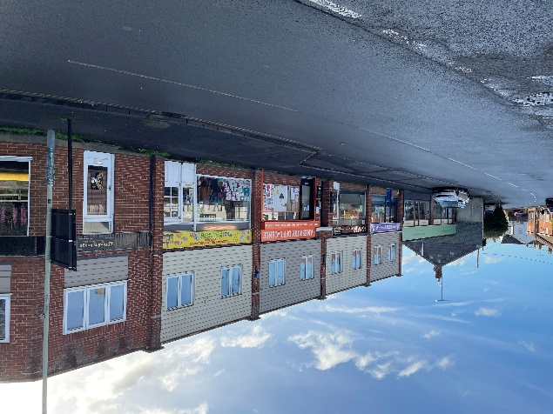

The application site is outside of, but adjacent to the Amesbury Conservation Area. It is opposite Grade II Listed ‘The Greyhound Tavern’, Grade II listed ‘Yew Cottage’ lies 65m to the east of the site.

Site location plan Plan showing extent of Conservation Area (green)

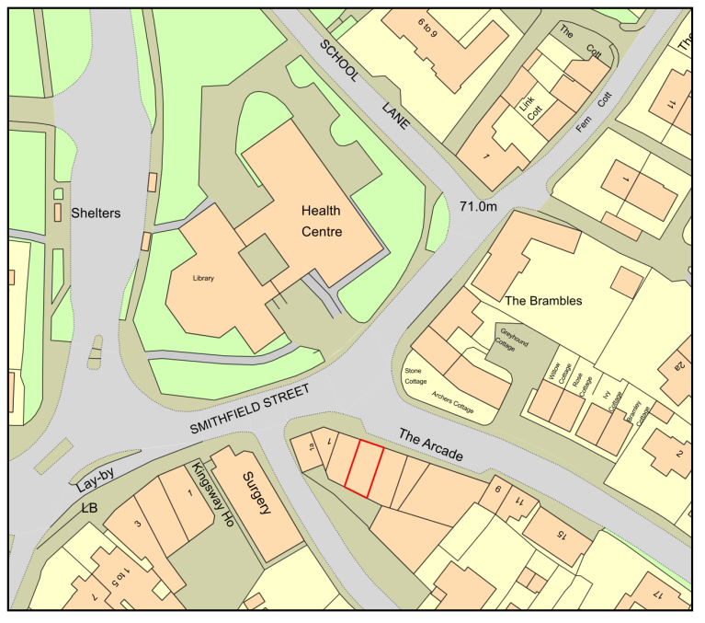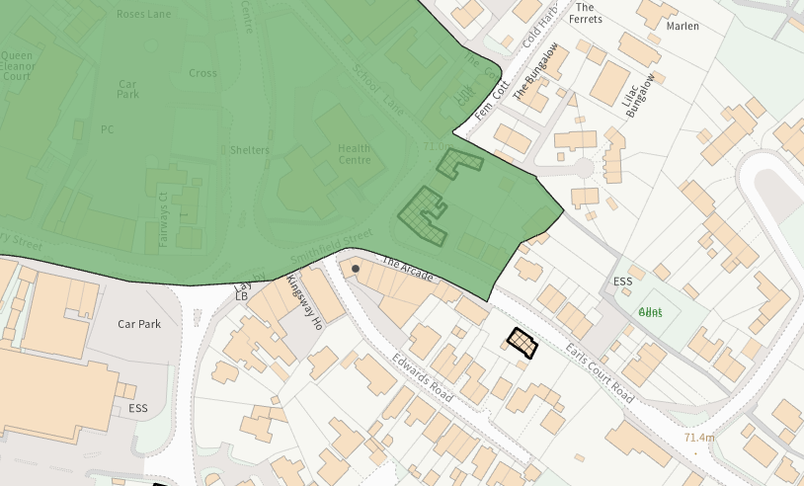

PROPOSAL
The application seeks planning permission for a change of use from a takeaway (Sui Generis) to an off-licence (Class E (a)). No alterations are proposed to the external building fabric

PLANNING HISTORY

Proposal / Summary
S/2005/1455 - Full planning permission Decision - Approve with Conditions Date: 6/9/2005 – CHANGE OF USE FROM A2 TO FAST FOOD TAKEAWAY (A5)
S/2005/2113 - Consent to display an advertisement Decision - Approved Date: 14/12/2005 – ILLUMINATED FASCIA SIGN
15/00423/FUL - Full planning permission Decision - Approve with Conditions Date: 9/3/2015 – Alter fenestration to first floor flats
13/04605/PNCOU - Notification Decision - Prior Approval Not Required Date: 14/11/2013 – Prior Approval notification for change of use of first floor office space (B1(a) Class) to 5 residential flats - (C3 Class)
S/2008/1345 - Full planning permission Decision - Refused Date: 23/9/2008 – CONVERSION OF EXISTING OFFICE SPACE INTO 5 NO 1 BED FLATS INCLUDING EXTERNAL ALTERATIONS
S/2009/1624 - Consent to display an advertisement Decision - Approve with Conditions Date: 7/12/2009 – FASCIA SIGN WITH DOWNLIGHTERS
14/10378/FUL - Full planning permission Decision - Refused Date: 2/1/2015 – Addition of second floor to existing two storey building to create 3 new flats (2 x 1 bed and 1 x 2 bed)
S/2009/1097 - Consent to display an advertisement Decision - Approve with Conditions Date: 16/9/2009 – VARIOUS SIGNAGE
S/2009/0473 - Full planning permission Decision - Approve with Conditions Date: 21/5/2009 – CHANGE OF USE OF FIRST FLOOR FROM OFFICES TO GYMNASIUM ( D2 USE). INTERNAL LAYOUT CHANGE TO CREATE CHANGING/SHOWER ROOMS.

RELEVANT LEGISLATION, POLICIES AND GUIDANCE

Statutory Legislation:
The Town and Country Planning (General Permitted Development) (England) Order 2015

National Planning Policy:
- National Planning Policy Framework (NPPF)
- Planning Practice Guidance (PPG)
- National Design Guide
Development Plan:
The development plan for Wiltshire comprises the Wiltshire Core Strategy (WCS) (adopted January 2015) and any made neighbourhood plans, which remains the principal statutory planning document guiding development across the county. In line with Section 38(6) of the Planning and Compulsory Purchase Act 2004, planning decisions must be made in accordance with the development plan unless material considerations indicate otherwise.

Though the development plan is considered as a whole, those parts deemed to be particularly relevant to this application are listed below:

The adopted Wiltshire Core Strategy (WCS), with particular regard to:

- Core Policy 1 Settlement Strategy;
- Core Policy 2 Delivery Strategy;
- Core Policy 3 Infrastructure Requirements;
- Core Policy 4 Spatial Strategy for the Amesbury Community Area
- Core Policy 35 Existing Employment Land
- Core Policy 57 Ensuring High Quality Design and Place Shaping;
- Core Policy 58 Ensuring the Conservation of the Historic Environment;

Salisbury District Local Plan policies (Saved by Wiltshire Core Strategy):
- S1 – Primary Shopping Areas
- S2 – Secondary Shopping Areas

Supplementary Planning Documents and other Guidance:
- Wiltshire Design Guide (adopted April 2024)
- Wiltshire Local Transport Plan 2011-2026, adopted 2015 - including the Car Parking Strategy and Cycling Strategy, adopted 2015

ISSUES
The main issues that need to be addressed in this case include:
- Principle of development
- Design and Impact on the Character and Appearance of the Area
- Amenity
- Highways Impacts and Parking

CONSULTATION RESPONSES

Public Protection Officer – Comments provided stating the following:
The applicant has now helpfully updated the application to clarify proposed opening hours. I therefore recommend upon any approval conditions are applied to restrict opening hours to those outlined in the application, and that deliveries/ collections to/ from the premise will be carried out strictly during opening hours.

Highways Officer – No objection with comments stating:
I do not believe the proposed change of use will have a detrimental impact to highway safety and as such, I recommend that no Highway objection is raised.

Amesbury Town Council – Support
Amesbury Town Council support this application

REPRESENTATIONS
In accordance with the requirements of the Town and Country Planning (Development Management Procedure) (England) Order 2015 (as amended), the application was publicised by way of:

- Neighbour notification letters sent to adjoining and nearby properties;
- A site notice displayed near the site;

These methods were used to inform interested parties and provide a period of 21 days for comments to be submitted.

No representations were received.

ASSESSMENT
Section 38(6) of the Planning and Compulsory Purchase Act 2004 states:

"If regard is to be had to the development plan for the purposes of any determination to be made under the planning Acts, the determination must be made in accordance with the plan unless material considerations indicate otherwise."

In accordance with this statutory requirement, this application has been assessed against the relevant policies of the Development Plan, including the Wiltshire Core Strategy (2015) and, where applicable, any made Neighbourhood Plans. Consideration has also been given to the policies of the National Planning Policy Framework (NPPF) as a material consideration in the assessment.

Principle of Development

The application site is within the Market Town of Amesbury, as defined by Core Policy 1 (Settlement Strategy) of the WCS, it is also within the settlement boundary as defined by Core Policy 2 (Delivery Strategy). The site is designated as a ‘Secondary Shopping Area’ through saved Policy S2 of the Salisbury District Local Plan.

The proposal for a change of use from a takeaway (Sui generis) to an off-licence (Class E (a) for the display or retail sale of goods, other than hot food, principally to visiting members of the public).

Permitted development Schedule 2, Part 3 Class A permits development consisting of a change of use of a building from (d) article 3(6)(r) (hot food takeaway) to a use falling within Class E via the Prior Notification route. This application is for Full Planning permission, but this would be the fall-back position.

The proposal is therefore considered acceptable in principle. Notwithstanding the principle acceptability, it is also necessary to consider the other relevant planning policies and the normal range of material considerations that have to be taken into account when determining a planning application. These matters are therefore addressed in more detail below.

Design and Impact on the Character and Appearance of the Area
Core Policy 57 - Ensuring High Quality Design and Place Shaping of the Wiltshire Core Strategy seeks to ensure that all new development is of high design quality, reflecting local context, character, and distinctiveness.

The proposals do not require any external alterations or modifications to the existing unit, and as the site is set within a run of existing shops, the proposal is considered acceptable within this context.

No proposals for signage or lighting have been included. Should signage or external lighting be required, it may be necessary to obtain consent from the LPA, and an informative related to this has been included on this consent.

The application site lies outside of, but adjacent to Amesbury Conservation area, opposite Grade II Listed ‘The Greyhound Tavern’. The proposals do not include for any changes to the external envelope, and the application site is a modern commercial building. The proposals are neutral to the character and appearance of the adjacent Conservation Area.

It is therefore concluded that the proposals will not result in harm to visual amenity or to the character and appearance of the area.

Amenity
Core Policy 57 (Point vii) of the Wiltshire Core Strategy requires development to respect the amenity of existing occupants and ensure appropriate amenity levels for future residents.

The National Planning Policy Framework (NPPF), particularly Paragraph 135, reinforces the need for development to provide a high standard of amenity for both existing and future users.

Due to the location of the application site, within the centre of a run of shops/commercial use with residential units above, the proposals have the potential to impact upon the amenity of the neighbours.

The application form states that the proposed hours of opening would be 8am to 10pm seven days a week. It is noted that there are no restrictions on opening hours for the current takeaway use granted under S/2005/1455.

The proposed change of use to Class E(a) would be expected have a similar or slightly reduced impact on amenity to the previous Sui Generis takeaway use as the off-licence will not be preparing or selling hot food.

The Public Protection Officer has reviewed the submission and has recommended two planning conditions (restricted opening hours and deliveries/collections to/ from the premises during opening hours) to ensure that there would be no loss of amenity.

In line with these conditions, it is considered that the proposal is acceptable in terms of its impacts upon amenity.

Highways Impacts and Parking
The proposals do not include for any changes to highways or parking. The Highway Officer has reviewed the submission and no objection is raised, commenting that it is not considered the proposed change of use will have a detrimental impact to highway safety.

The proposals are therefore considered acceptable in this regard.

Biodiversity Net Gain
As of 2 April 2024, the requirement for Biodiversity Net Gain (BNG) on all new sites came into force. Any small scale (non-major)/major scheme will need to demonstrate no net loss and a minimum of 10% net gain in biodiversity on the site, in line with the requirements of the NPPF, WCS policy CP50 (Biodiversity and Geodiversity) and the Environment Act.

However based on the information available the biodiversity gain planning condition is not considered to apply to this application as the development meets the following exemption criteria and is therefore below the de minimis threshold, meaning the development: − does not impact an onsite priority habitat (a habitat specified in a list published under section 41 of the Natural Environment and Rural Communities Act 2006); and − impacts less than 25 square metres of onsite habitat that has biodiversity value greater than zero and less than 5 metres in length of onsite linear habitat (as defined in the statutory metric).

CONCLUSION
The proposed change of use conforms to policy as outlined above and the proposal is considered acceptable in the context of its surroundings and in accordance with the general criteria set out in the aforementioned policies of the local development plan.

RECOMMENDATION:
That Planning Permission be GRANTED subject to the following conditions:

- The development hereby permitted shall be begun before the expiration of three years from the date of this permission.
REASON: To comply with the provisions of Section 91 of the Town and Country Planning Act 1990 as amended by the Planning and Compulsory Purchase Act 2004.

- The development hereby permitted shall be carried out in accordance with the following approved plans and documents:

Location Plan Amesbury Off Licence TQRQM25338154420066, received 04.12.2026
Application form, received 14.01.2026

REASON: For the avoidance of doubt and in the interests of proper planning.

- The use hereby permitted shall only take place between the hours of 08:00AM to 22:00PM Mondays to Sundays and no deliveries shall be made to or collections made from the development hereby approved except between the hours of 08:00AM and 22:00PM Mondays to Sundays.

REASON: To ensure the creation/retention of an environment free from intrusive levels of noise and activity in the interests of the amenity of the area.

- Notwithstanding the provisions of the Schedule to the Town and Country Planning (Use Classes) Order 1987 (as amended) or any statutory instrument revoking and re-enacting that Order with or without modification, the premises shall be used only for purposes falling within Use Class E(a) (Display or retail sale of goods other than hot food) and for no other purpose within Class E or any other class of the Order, unless further planning permission is granted by the Local Planning Authority.
REASON: To ensure the development is used only for the purpose specified and to enable the Local Planning Authority to retain control over future changes of use.

Informatives:
1) Please note that any advertisement or signage for the use hereby approved may require advertisement consent and will need to be applied for separately, accordingly.

2) The effect of paragraph 13 of Schedule 7A to the Town and Country Planning Act 1990 is that planning permission granted for development of land in England is deemed to have been granted subject to the condition (biodiversity gain condition) that development may not begin unless:
(a) a Biodiversity Gain Plan has been submitted to the planning authority, and
(b) the planning authority has approved the plan.
The planning authority, for the purposes of determining whether to approve a Biodiversity Gain Plan, if one is required in respect of this permission would be Wiltshire Council.
There are statutory exemptions and transitional arrangements which mean that the biodiversity gain condition does not always apply. For further information on exempt developments please refer to:
https://www.gov.uk/guidance/biodiversity-net-gain-exempt-developments
Based on the information available this permission is considered to be one which will not require the approval of a biodiversity gain plan before development is begun because one or more of the statutory exemptions or transitional arrangements is considered to apply.

