APPLICATION FOR LISTED BUILDING CONSENT
OFFICER DELGATED REPORT

APPLICATION REFERENCE: | PL/2025/09021
APPLICATION TYPE: | Listed building consent
SITE ADDRESS: | THE COURTHOUSE, CASTLE STREET, TROWBRIDGE, BA14 8AN
DESCRIPTION OF WORKS: | Erection of illuminated and non-illuminated signs to the exterior of the building and redecoration of the exterior of the building
RECOMMENDATION: | Approve with Conditions

SITE DESCRIPTION
The subject building is a GII listed, C19-fronted 3-storey rendered terraced building with wooden front listed as The Sun and a public house since the 1st epoch mapping. Castle Street is a medieval circuit around the historic site of Trowbridge Saxon Castle. The area is the historic urban core with the historic layout still legible. No’s 1-6 forms a prominent group with Trowbridge Conservation Area on a prominent bend within the one-way Castle Street.
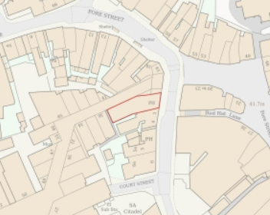
Location Plan
The building is designated for its special architectural and historic interest under the Planning (Listed Buildings and Conservation Areas) Act 1990.

PROPOSAL
The proposal is for the erection of illuminated and non-illuminated signs to the exterior of the building, including:
- fascia,
- pictorial sign fixed to an existing bracket,
- wall painted sign,
- chalkboards,
- 8x flood lights,
- slimline trough light,
- and exterior redecoration.

During the lifecycle of the application, amendments have been made in response to comments from the Conservation Officer, namely the reduction x5 additional down lights.

The proposal is for like for like replacements, but the 5 proposed downlights would have been new additions.
All as per plans and elevations below:
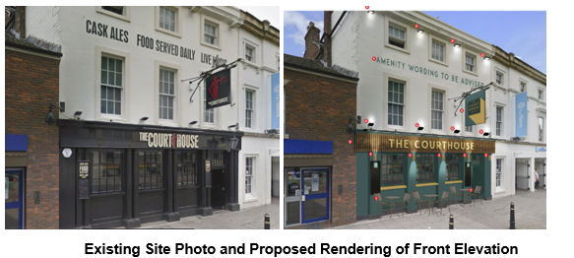
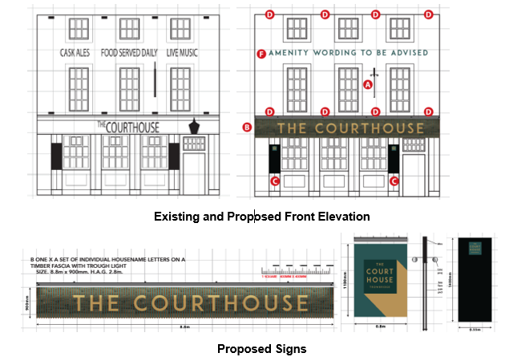

RELEVANT PLANNING HISTORY
W/75/00049/ADV - Consent to display an advertisement Decision - Approved Date: 8/12/1975 – An internally illuminated A.A. Box sign
W/95/01039/LBC - Listed building consent Decision - Approve with Conditions Date: 17/7/1996 – Internal and external alterations
W/95/00899/ADV - Consent to display an advertisement Decision - Approved Date: 4/9/1995 – New public house signs
W/95/01033/FUL - Full planning permission Decision - Approve with Conditions Date: 17/7/1996 – External and internal alterations
15/11373/LBC - Listed building consent Decision - Approve with Conditions Date: 4/1/2016 – Full internal ground foor refurbishment ( no structural alterations) ; existing floor coverings to be retained ; new light fittings throughout ; minor alterations to first floor area ; creation of fire escape ladder
15/10331/ADV - Consent to display an advertisement Decision - Approve with Conditions Date: 14/12/2015 – Replacement externally illuminated signage comprising hanging sign, fascia signs and sign written lettering
15/10400/LBC - Listed building consent Decision - Approve with Conditions Date: 14/12/2015 – Replacement externally illuminated signage comprising hanging sign, fascia signs and sign written lettering
PL/2024/05979 - Consent to display an advertisement Decision - Approve with Conditions Date: 3/10/2024 – Replacement external signage comprising new projecting hanging sign, new fascia signs and free standing A Board
PL/2024/06273 - Listed building consent (Alt/Ext) Decision - Approve with Conditions Date: 3/10/2024 – Replacement external signage comprising new projecting hanging sign, new fascia sign

RELEVANT LEGISLATION, POLICIES AND GUIDANCE
From the point of view of the historic environment the main statutory tests are set out within the Planning (Listed Building and Conservation Areas) Act 1990. Section 16 requires that special regard be given to the desirability of preserving listed buildings, their settings or any features of special architectural or historic interest which they possess.

Section 72(1) of the Planning (Listed Building and Conservation Areas) Act 1990 also requires the Council to pay special attention to the desirability of preserving or enhancing the character or appearance of designated Conservation Areas.

National Policy and Guidance
The National Planning Policy Framework (NPPF) sets out government policy, including in respect of the historic environment.

Section 16 of the NPPF ('Conserving and enhancing the historic environment') sets out the Government's high-level policies concerning heritage and sustainable development.

Paragraphs 213-215 of the NPPF require a balanced approach with any harm which would be caused being weighed against the potential public benefits which might be achieved. Paragraph 210 requires local planning authorities to take account of the desirability of sustaining and enhancing the significance of heritage assets and of new development making a positive contribution to local character and distinctiveness.

National Planning Practice Guidance provides guidance on interpreting the NPPF.

Historic England Advice Note 2: Making changes to Heritage Assets, illustrates the application of policies set out in the NPPF in determining applications for LBC (and planning permission).

Wiltshire Core Strategy:
Whilst not directly relevant to listed building consent applications, the below policies give an indication of the Council’s approach to development affecting heritage assets:

- Core Policy 57 ‘Ensuring high quality design and place shaping’: A high standard of design is required in all new developments, including extensions, alterations, and changes of use of existing buildings. Development is expected to create a strong sense of place through drawing on the local context and being complementary to the locality.

- Core Policy 58 ‘Ensuring the conservation of the historic environment’ requires that “designated heritage assets and their settings will be conserved, and where appropriate enhanced, in a manner appropriate to their significance.”

ISSUES
Impact upon the preservation of the listed building and any features of special architectural or historic interest.

CONSULTEE RESPONSES
The following consultees were invited to comment on this application:

Trowbridge Town Council: no objection.

Highways Engineer: no objection, subject to conditions.

Conservation Officer: no objection, subject to amendments.
The Courthouse is a public house dating from the early C19 and located within the conservation area that covers the centre of Trowbridge. Amendments to the current signage and lighting were previously granted consent in 2015 and 2024.
For the most part the proposed amendments to signage and lighting will mirror the existing situation and will have an overall neutral (or slightly positive due to the use of new fittings and traditional sign writing) impact on the significance of the building.
However, the additional lower level up-down lights would constitute an unwelcome proliferation of lighting on the elevation, with their location also conflicting with the column capitals which although part of a C20 frontage, are one of the architectural features of the elevation. I would suggest that these be omitted or, alternatively, the existing flood lights above the fascia removed.
Subject to this amendment, the impact of the proposal would be neutral and no specific justification required, in which case the requirements of current conservation legislation, policy or guidance would be considered to be met and there would be no objection to the approval of the application.

RESPRESENTATIONS
In accordance with the requirements of Section 5(1) of the Planning (Listed Buildings and Conservation Areas) Regulations 1990 (as amended) the application for listed building consent was publicised by way of:

- A site notice displayed near the site;
- An advertisement placed in the local press.

These methods were used to inform interested parties and to allow a statutory consultation period of 21 days for representations to be submitted.

No third-party comments were received.

ASSESSMENT
In accordance with Section 16(2) of the Planning (Listed Buildings and Conservation Areas) Act 1990, special regard has been given to the significance of the listed building, including its architectural and historic interest, and the desirability of preserving both the building and its setting. Relevant policies within the National Planning Policy Framework (NPPF), particularly Section 16: Conserving and Enhancing the Historic Environment, have also been taken into account. These policies require that any harm to the significance of a designated heritage asset must be clearly justified and weighed against the public benefits of the proposal.

In order to be acceptable, the application needs to be assessed against the following criteria:

Information considered/submitted
Paragraph 207 requires that applicants describe the significance of any heritage assets affected, including any contribution made by their setting. This should include sufficient information to provide a clear understanding of the significance of the heritage asset and its setting and the potential impact of any proposals on that significance.

The application is supported by a Heritage Statement which includes the listing details and comment that lighting has been positioned to highlight key architectural features, with a lighter redecoration colour and replication of sign sizes as appropriately scaled for the building.

Assessment of significance:
The detailing and materials of the visually prominent subject building result in clear legibility as a building built as a Public House and as such has architectural, aesthetic and social interest, together making a positive contribution to the Conservation Area.

Impact of proposals on the significance and setting of the building/structure:
Understanding the impact of proposed works on a listed building requires a careful and proportionate assessment of how those changes affect the asset’s heritage significance and its setting. This includes both the physical alterations to the building itself and any changes to its spatial or visual relationship with surrounding structures or spaces.

The significance of a heritage asset is not static; it is shaped by its architectural, historic, and communal values, and by how these are experienced in context. Therefore, any intervention must be considered in light of the asset’s identified significance, with attention given to both potential harm and benefits. Benefits may include repairs that support the long-term conservation of the building, improved energy performance, or enhanced public access and understanding.

This assessment is grounded in the statutory duty under Section 16 of the Planning (Listed Buildings and Conservation Areas) Act 1990, which requires special regard to be given to the desirability of preserving the building and its features of special interest. It is also informed by national policy, particularly paragraphs 199–208 of the National Planning Policy Framework (NPPF), and relevant local heritage policies and guidance.

The proposals are restricted to the front elevation.

Amendments received were in response to the Conservation Officer’s request to simplify the lighting so as to not challenge the architectural features of the front façade. The proposals therefore pose a replacement of existing, previously approved signage and lighting, but with improvements such as the traditional sign writing, lighter colour and scaled signage and so is assessed to have a neutral impact on the significance of the designated heritage asset.

There would be no harm to heritage fabric, with lighting aligned to highlight architectural detailing and seeks to ensure the long-term viability of the heritage Public House. As such, there would be no negative impact to the setting of neighbouring listed buildings nor character of the Conservation Area, meaning the proposals are considered appropriate and acceptable and so are policy compliant.

CONCLUSION
The NPPF confirms that when considering the impact of a proposed development on the significance of a designated heritage asset, great weight should be given to the asset’s conservation (and the more important the asset, the greater the weight should be). It makes clear that any harm to a designated heritage asset requires clear and convincing justification.

The overall impact of the proposals on heritage assets will be neutral, offering modern replacement to existing signage and lighting. On this basis no specific justification is required however it is considered the works will assist in securing the future use of a heritage asset in support of its long-term conservation. The requirements of current conservation legislation, policy or guidance are considered to be met.

RECOMMENDATION:
That Listed Building Consent be GRANTED, subject to conditions.

