APPLICATION FOR ADVERTISEMENT CONSENT
CASE OFFICER REPORT

APPLICATION REFERENCE: | PL/2025/09020
APPLICATION TYPE: | Consent to display an advertisement
SITE ADDRESS: | THE COURTHOUSE, CASTLE STREET, TROWBRIDGE, BA14 8AN
DEVELOPMENT DESCRIPTION: | Erection of illuminated and non-illuminated signs to the exterior of the building and redecoration of the exterior of the building
RECOMMENDATION: | Approve with Conditions

SITE DESCRIPTION
The subject building is a GII listed, C19-fronted 3-storey rendered terraced building with wooden front listed as The Sun and a public house since the 1st epoch mapping. Castle Street is a medieval circuit around the historic site of Trowbridge Saxon Castle. The area is the historic urban core with the historic layout still legible. No’s 1-6 forms a prominent group with Trowbridge Conservation Area on a prominent bend within the one-way Castle Street.

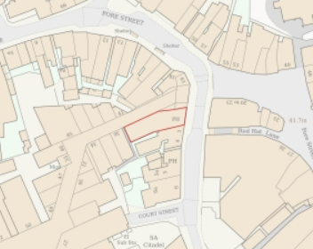
Location Plan
PROPOSAL
The proposal is for the erection of illuminated and non-illuminated signs to the exterior of the building, including:
- fascia,
- pictorial sign fixed to an existing bracket,
- wall painted sign,
- chalkboards,
- 8x flood lights,
- slimline trough light,
- and exterior redecoration.

During the lifecycle of the application, amendments have been made in response to comments from the Conservation Officer, namely the reduction x5 additional down lights.

The proposal is for like for like replacements, but the 5 proposed downlights would have been new additions.
All as per plans and elevations below:

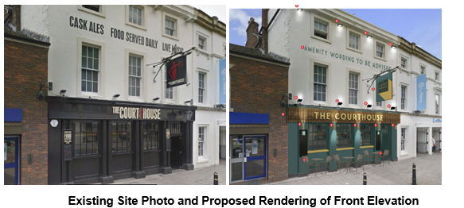

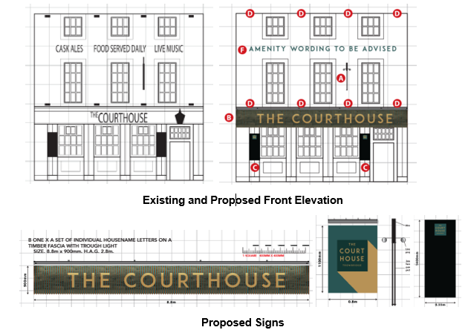

RELEVANT LEGISLATION, POLICIES AND GUIDANCE
The display of advertisements is subject to a separate consent process within the planning system. This is principally set out in the Town and Country Planning (Control of Advertisements) (England) Regulations 2007. Advertisements are controlled with reference to their effect on amenity and public safety only. Those parts of the development plan relevant to the determination of this application are as follow:

The Town and Country Planning (Control of Advertisements) (England) Regulations 2007

National Planning Policy Framework (NPPF)
- Paragraph 141

Planning Practice Guidance (PPG)
- Advertisements

Wiltshire Core Strategy 2015 (WCS):
- Core Policy 57 Ensuring High Quality Design & Space Shaping
- Core Policy 58 Ensuring the Conservation of the Historic Environment

Trowbridge has a designated Neighbourhood Plan area but no made plans as yet.

Supplementary Planning Documents:
Institute of Lighting Professionals: The Brightness of Illuminated Advertisements (2014) PLG 05.

RELEVANT PLANNING HISTORY:
W/75/00049/ADV - Consent to display an advertisement Decision - Approved Date: 8/12/1975 – An internally illuminated A.A. Box sign
W/95/01039/LBC - Listed building consent Decision - Approve with Conditions Date: 17/7/1996 – Internal and external alterations
W/95/00899/ADV - Consent to display an advertisement Decision - Approved Date: 4/9/1995 – New public house signs
W/95/01033/FUL - Full planning permission Decision - Approve with Conditions Date: 17/7/1996 – External and internal alterations
15/11373/LBC - Listed building consent Decision - Approve with Conditions Date: 4/1/2016 – Full internal ground foor refurbishment ( no structural alterations) ; existing floor coverings to be retained ; new light fittings throughout ; minor alterations to first floor area ; creation of fire escape ladder
15/10331/ADV - Consent to display an advertisement Decision - Approve with Conditions Date: 14/12/2015 – Replacement externally illuminated signage comprising hanging sign, fascia signs and sign written lettering
15/10400/LBC - Listed building consent Decision - Approve with Conditions Date: 14/12/2015 – Replacement externally illuminated signage comprising hanging sign, fascia signs and sign written lettering
PL/2024/05979 - Consent to display an advertisement Decision - Approve with Conditions Date: 3/10/2024 – Replacement external signage comprising new projecting hanging sign, new fascia signs and free standing A Board
PL/2024/06273 - Listed building consent (Alt/Ext) Decision - Approve with Conditions Date: 3/10/2024 – Replacement external signage comprising new projecting hanging sign, new fascia sign

ISSUES
The issues that are relevant to the consideration of an application for consent to display advertisements are the effects of the proposal on ‘amenity’ and ‘public safety’.

CONSULTEE RESPONSES
The following consultees were invited to comment on this application:

Trowbridge Town Council: no objection.

Highways Engineer: no objection, subject to conditions.

Conservation Officer: no objection, subject to amendments.
The Courthouse is a public house dating from the early C19 and located within the conservation area that covers the centre of Trowbridge. Amendments to the current signage and lighting were previously granted consent in 2015 and 2024.
For the most part the proposed amendments to signage and lighting will mirror the existing situation and will have an overall neutral (or slightly positive due to the use of new fittings and traditional sign writing) impact on the significance of the building.
However, the additional lower level up-down lights would constitute an unwelcome proliferation of lighting on the elevation, with their location also conflicting with the column capitals which although part of a C20 frontage, are one of the architectural features of the elevation. I would suggest that these be omitted or, alternatively, the existing flood lights above the fascia removed.
Subject to this amendment, the impact of the proposal would be neutral and no specific justification required, in which case the requirements of current conservation legislation, policy or guidance would be considered to be met and there would be no objection to the approval of the application.

RESPRESENTATIONS
No third-party comments.

ASSESSMENT
Regulation 3 of The Town and Country Planning (Control of Advertisements) (England) Regulations 2007 requires that local planning authorities exercise their powers in relation to the display of advertisements in the interests of amenity and public safety, taking into account the provisions of the development plan, in so far as they are material, and any other relevant factors.

The NPPF (141) is clear that the quality and character of places can suffer when advertisements are poorly sited and designed and should be subject to control only in the interests of amenity and public safety, also considering the cumulative impacts.

Impact on Amenity:
“Amenity” is not exhaustively defined in the Town and Country Planning (Control of Advertisements) (England) Regulations 2007 but is generally understood to include both visual and aural amenity. Factors relevant to amenity include the general characteristics of the locality, such as the presence of features of historic, architectural, cultural, or similar interest.

In broader planning terms, as reflected in the National Planning Policy Framework (NPPF), amenity refers to the quality or character of an area and the elements that contribute to the overall enjoyment and liveability of a place.

CP57 requires a high standard of design in all proposals, including (x) the sensitive design of advertisements and signage.

CP58 requires that “designated heritage assets and their settings will be conserved, and where appropriate enhanced, in a manner appropriate to their significance.”

The proposal site is surrounded by other listed buildings and is prominent within the Conservation Area. Amendments to the scheme were received in response to comments by the Conservation Officer.

The proposed lighting and signage is considered to mirror existing signage and lighting, and is considered an improvement by the traditional signwriting and new paler colour, so having an overall neutral impact on the significance of the listed building, setting of neighbouring listed buildings and the character of the Conservation Area.

A sister LBC application considers the impact upon the listed building.

The proposed signage is of an appropriate scale for the building itself and is very similar to that previously approved for the building, and on surrounding units.

The signs would be permanently fixed and so do not have the potential to create a noise disturbance and as such the proposals are acceptable in terms of aural and visual amenity impact.

It is considered that the proposed advertisement would not cause harm to the visual amenity of the area, noting the setting of the listed building, setting of neighbouring listed buildings and the character of the Conservation Area, and would therefore comply with the relevant provisions of the Town and Country Planning (Control of Advertisements) Regulations 2007.

Impact on Public Safety:
“Public safety” is not exhaustively defined in the Town and Country Planning (Control of Advertisements) (England) Regulations 2007, but it generally refers to the potential impact of a development or advertisement on the safe use and operation of public spaces, including roads, footpaths, and other areas accessible to the public.

The National Planning Policy Framework (NPPF) also supports the principle that planning decisions should ensure developments create places that are safe, inclusive, and accessible, and that they do not undermine public safety or security.

CP62 advises that proposals should provide appropriate mitigating measures to offset any adverse impacts on the transport network at both the implementation and operational stages.

Due to location of the site on an established commercial street and the signage replacing earlier forms, with projecting signs at a height to not raise any concerns, the proposal is not considered to result in any public safety concerns.

The proposals do not include additional signs or lighting and in combination with nearby signage does not pose cumulative visual clutter.

It is considered that the proposal would not result in an unacceptable impact on public safety, either individually or cumulatively, and would therefore satisfy the relevant provisions of the Town and Country Planning (Control of Advertisements) Regulations 2007.

CONCLUSION:
The proposed advertisement has been assessed in accordance with the relevant provisions of the Town and Country Planning (Control of Advertisements) (England) Regulations 2007.

It is considered that the advertisement, by reason of its design, scale, siting, and method of illumination, would not result in harm to the visual amenity of the area, including the setting of any nearby heritage assets. Furthermore, the proposal is not considered to pose a risk to public safety, either individually or cumulatively with other signage in the vicinity.

Subject to the recommended conditions, the proposal is therefore considered acceptable, and it is recommended that advertisement consent be granted.

