APPLICATION FOR PLANNING PERMISSION
DELEGATED REPORT

APPLICATION REFERENCE: | PL/2025/09789
APPLICATION TYPE: | Wiltshire Council R3
SITE ADDRESS: | Willows Pre-School, North Bradley Church of England School, Church Lane, North Bradley, Trowbridge, BA14 0TA
DEVELOPMENT DESCRIPTION: | To renew the Planning Permission for 5 years for the existing Mobile Classroom at North Bradley Primary School occupied by The Willows Pre-school, Mobile number 821(09).
RECOMMENDATION: | That Planning Permission be GRANTED

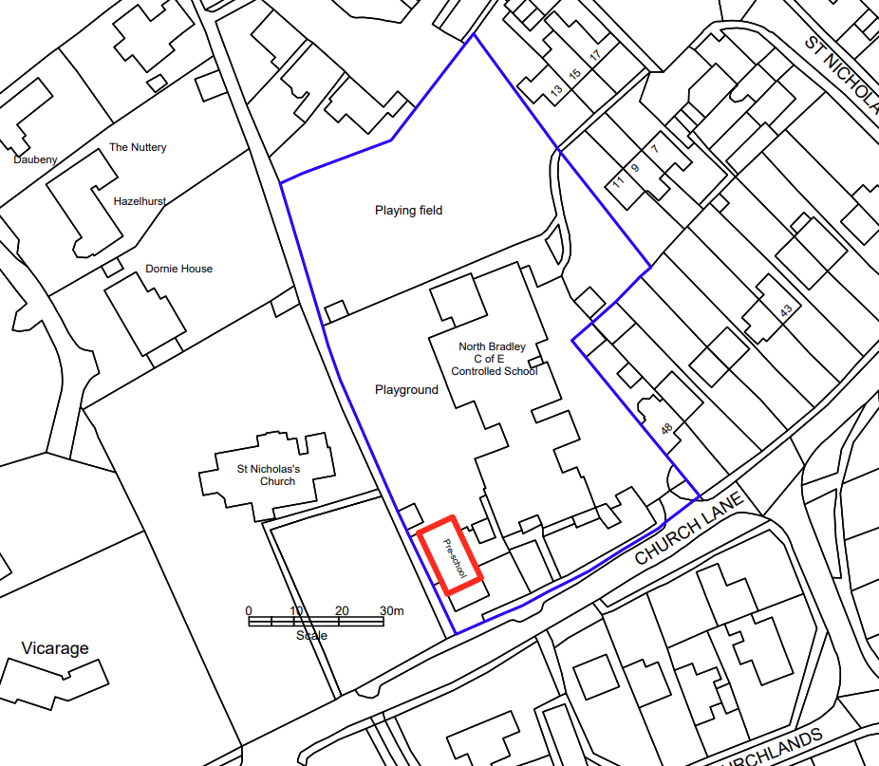

PROPOSAL

The proposal seeks renewal of planning permission for the continued use of temporary system‑built unit no. 821 (09), which provides nursery accommodation forming part of the wider educational facilities at North Bradley Church of England Primary School. The supporting statement identifies that the unit remains essential to maintaining the school’s established seven‑class structure, with forecast pupil numbers indicating ongoing demand for the existing level of provision. As set out in the previous 2020 assessment, temporary retention is sought due to the lack of available capital funding for permanent replacement buildings, and the current unit remains in active, well‑maintained use to support early years education without introducing any changes to its footprint, scale, or operational characteristics.

SITE DESCRIPTION / CONTEXT

The site is located within the grounds of North Bradley Church of England Primary School, positioned off Church Lane, an unclassified highway, with the temporary unit situated close to the western boundary where public right of way NBRA41 runs adjacent. The school sits immediately beside the Grade II* listed Church of St Nicholas and associated listed structures, forming a sensitive historic context where previous assessments have acknowledged some impact on the setting of the heritage assets. The area lies within the 6.4km buffer of the Salisbury Plain SPA, although the proposal represents no increase in capacity or activity beyond the established baseline. The surrounding environment includes areas of priority habitat within the neighbouring church grounds, but the school site itself is largely established educational land. Flood risk constraints are minimal, with the sFRA confirming negligible groundwater risk, no identified surface water hazard, and the site being entirely within Flood Zone 1.

PLANNING HISTORY

Reference No. | Proposal / Summary | Decision
W/77/00146/HIS | Renewal of limited permission for erection of single mobile classroom with toilets | Approved
W/92/00044/FUL | Erection of a single mobile classroom with toilets | Approved
W/00/01446/WCC | Retention of a single mobile classroom with toilets | Approved
W/00/01884/WCC | Single classroom extension | Approved
W/07/02631/FUL | Extension to the rear of the school hall to provide a kitchen | Approved
W/08/01158/FUL | Alterations to planning permission 07/02631/FUL | Approved
W/09/02505/FUL | Replacement of climbing frame (1.5m high) in early years playground and upgrading of ground space around new structure | Approved
W/09/01319/REG3 | New system built nursery building and associated play space | Approved
W/09/01511/FUL | Erection of a new perimeter fence at rear of school field | Approved
W/10/02858/FUL | New canopy | Approved
W/13/00369/FUL | Provision of new staff and pupil toilets, breakout room, storage facility and internal adaptations to form group room | Approved
15/10208/FUL | Installation of octagonal wooden outdoor classroom within school grounds | Approved
15/03063/DP3 | Renewal of mobile no. 821 (09) at North Bradley Primary School for a period of five years. | Approved
18/05122/FUL | New secure lobby to the existing school. | Approved
20/08506/DP3 | Retention of temporary building, system-built unit no.821 (09) | Approved

RELEVANT LEGILSATION, POLICIES AND GUIDANCE

Wiltshire Core Strategy:

Core Policy 1 Settlement Strategy;
Core Policy 2 Delivery Strategy;
Core Policy 29 Spatial Strategy: Trowbridge Community Area;
Core Policy 50 Biodiversity and Geodiversity;
Core Policy 51 Landscape;
Core Policy 57 Ensuring High-Quality Design and Place Shaping;
Core Policy 58 Ensuring Conservation of the Historic Environment;
Core Policy 60 Sustainable Transport;
Core Policy 61 Transport and Development;
Core Policy 64 Demand Management;
Core Policy 67 Flood Risk;

North Bradley Neighbourhood Plan 2018-2026

The National Planning Policy Framework (NPPF)

The Planning Practice Guidance (PPG)

Wiltshire Design Guide

The Wiltshire Local Transport Plan 2011 – 2026: Car Parking Strategy (March 2015).

The Wiltshire Local Transport Plan 4 (LTP4) (March 2025)

Emerging Policy – Wiltshire Local Plan Review

The Council’s emerging Local Plan has reached Regulation 24 stage, and is progressing through examination but the emerging plan carries limited weight at this stage with the hearing sessions currently being paused.

- Policy 1 Settlement Strategy
- Policy 85 Sustainable construction and low carbon energy
- Policy 88 Biodiversity and Geodiversity
- Policy 89 Biodiversity Net Gain
- Policy 95 Flood Risk
- Policy 98 High Quality Design and Place Shaping

CONSULTATION RESPONSES

North Bradley Parish Council – No Objection

REPRESENTATIONS

No comments received.

ASSESSMENT

Section 38(6) of the Planning and Compulsory Purchase Act 2004 states:

"If regard is to be had to the development plan for the purposes of any determination to be made under the planning Acts, the determination must be made in accordance with the plan unless material considerations indicate otherwise."

In accordance with this statutory requirement, this application has been assessed against the relevant policies of the Development Plan, including the adopted Wiltshire Core Strategy (2015) and, where applicable, any made Neighbourhood Plans.

The continued use of the existing temporary classroom remains acceptable in principle. Planning permission for this building has previously been granted on a temporary basis in 2009, 2015 and again under application 20/08506/DP3, thereby establishing the principle of its retention to support the operational needs of North Bradley C of E Primary School. The latest supporting statement confirms that the school will continue to operate a seven‑class structure and that all existing accommodation, including the temporary unit, is still required, with no funded or programmed permanent replacement currently available. Forecast pupil numbers are expected to rise to 207 by 2028, reinforcing the ongoing need for sufficient teaching space. In this context, and given the importance of maintaining adequate educational provision, the temporary retention of the building is considered acceptable in principle.

Design, Heritage, and Impact of Character and Appearance of the Area

Core Policy 57 Ensuring High Quality Design and Place Shaping of the Wiltshire Core Strategy seeks to ensure that all new development is of high design quality, reflecting local context, character, and distinctiveness. Policy 98 of the emerging Wiltshire Local Plan reiterates the position outlined in Core Policy 57, that new development must enhance local distinctiveness, and relate positively to its landscape setting, as well as demonstrating a positive response to existing townscape and built form features such as height, scale, massing, building line, materials, and appearance.

Core Policy 58 outlines development consideration with regard to the historic environment. The policy states that heritage assets and their settings must be conserved and, where appropriate, enhanced through any proposed development. Policy 99 of the emerging Wiltshire Local Plan outlines the need to conserve and protect heritage assets, and ensure that where proposals would affect historic environment, no harm would result.

The application site lies adjacent to the Grade II* listed Church of St Nicholas and several Grade II listed monuments, and therefore great weight must be given to the conservation of these designated heritage assets in accordance with Section 66(1) of the Planning (Listed Buildings and Conservation Areas) Act 1990 and relevant policies of the NPPF and Wiltshire Core Strategy. Previous applications noted the sensitivity of the location, and Historic England previously raised no objection to the temporary retention of the structure. Earlier assessments—particularly in 2009—identified the mobile classroom as an unsympathetic mass within the church’s setting, accentuated by the clearance of small woodland that had opened up wider views of the church from the road. At that time, the building was more visually prominent, and only minimal replacement planting was secured.

However, the current site visit for this application confirms that the visual relationship between the mobile classroom and the listed church has materially changed. Boundary planting has now matured substantially, creating a noticeably stronger and more effective vegetated screen. As observed on site, public views of the structure are now very limited: it is only appreciably visible when passing directly in front of it, and even then the screening reduces its presence considerably. When travelling west, the building is largely unseen, and when travelling east it presents only as a low‑level, timber‑clad elevation sitting above the church boundary, with a muted colour palette that blends unobtrusively into the backdrop. The structure does not draw the eye in the way previously identified, and the cumulative soft landscaping has significantly reduced its impact within the church’s wider setting.

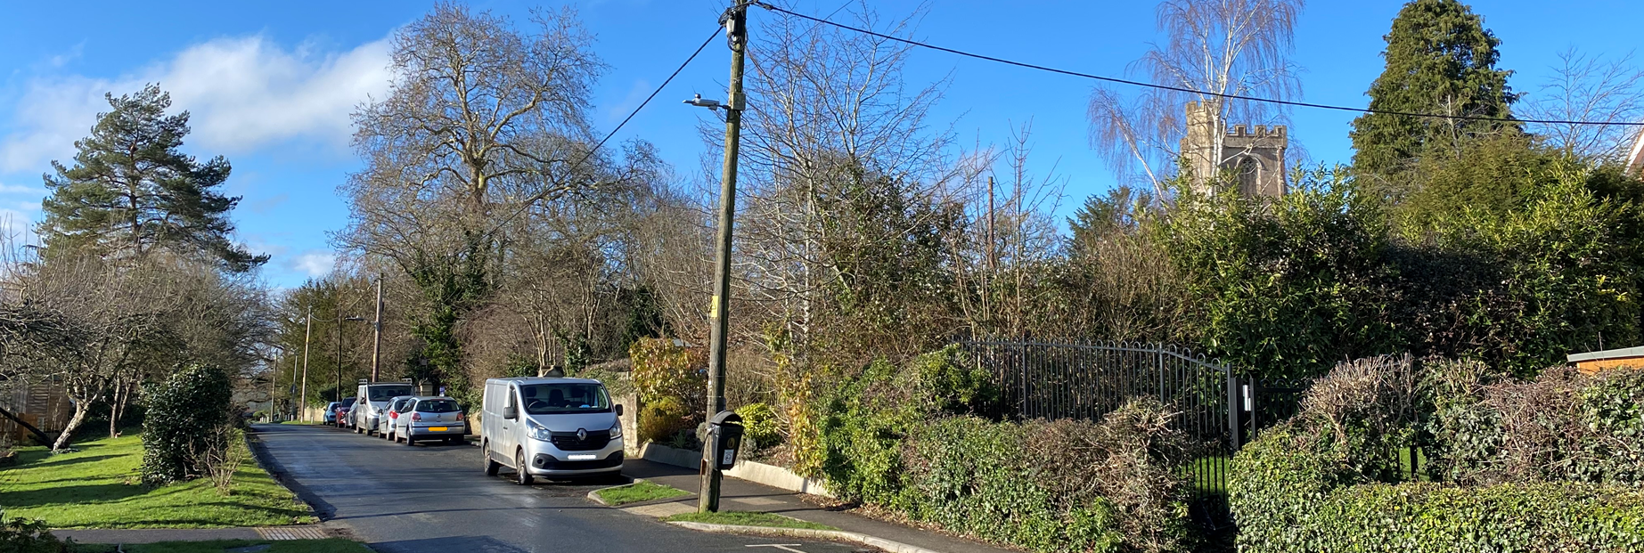
View of site moving West

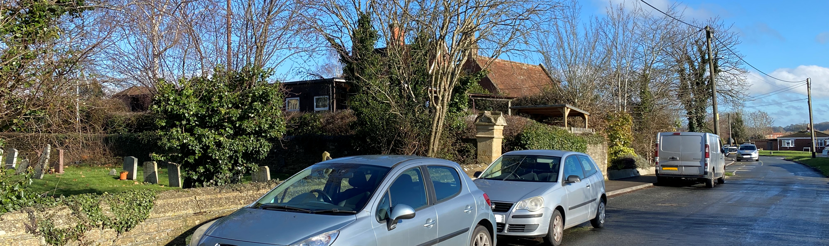
View of site moving East

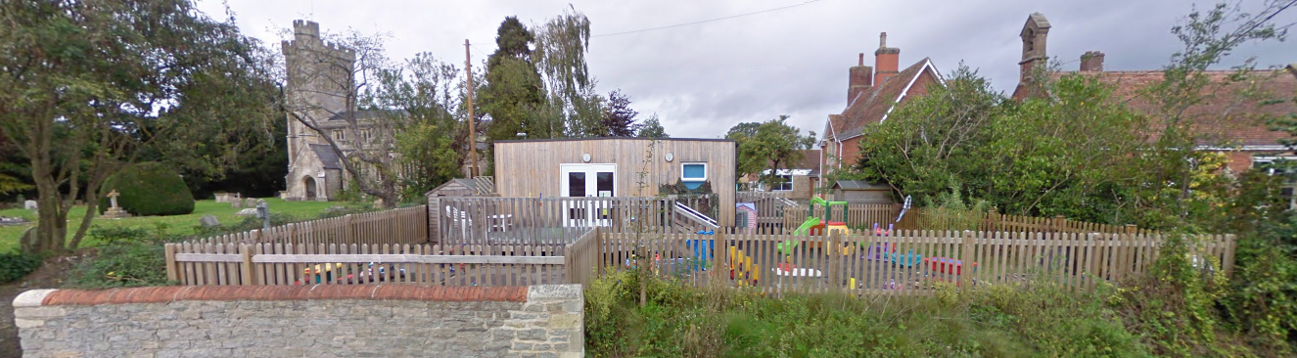
2011 Streetview

While the mobile classroom remains a non‑permanent structure with a finite lifespan, its current condition is satisfactory, well‑maintained, and appreciably better screened than at any point during earlier assessments. Some degree of less‑than‑substantial harm still arises due to its presence within the setting of a highly graded heritage asset, but the level of harm is now demonstrably lower than that identified under previous permissions. In weighing this against the ongoing educational need—acknowledged as an important public benefit, particularly in the absence of funding for a permanent alternative—the balance falls in favour of supporting a further temporary consent. Nonetheless, consistent with national guidance, it would not be appropriate to regularise the structure on a permanent basis, as temporary permissions should not become permanent by default. A further time‑limited consent will allow the Local Planning Authority to reassess both the condition of the building and any opportunities for improved long‑term solutions in the future.

Amenity

Point vii of Core Policy 57 Ensuring High Quality Design and Place Shaping of the Wiltshire Core Strategy seeks to ensure that developments do not adversely affect neighbouring properties.

The National Planning Policy Framework (NPPF), particularly Paragraph 135, stresses that planning decisions should ensure developments provide a high standard of amenity for existing and future users.

Given that the site does not adjoin any residential properties and the temporary classroom has been in situ and operating for a considerable period as part of the established school complex, there is no realistic pathway for adverse amenity impacts to arise. The proposal does not introduce any new built form, activity, or change in use that could affect outlook, privacy, noise levels, or access to light for neighbouring occupiers.

The proposal is appropriately sited, designed, and oriented to ensure that it would not result in unacceptable impact upon/to the amenities or living conditions of neighbouring residential occupiers, particularly in terms of outlook, privacy, or access to natural light.

The proposal therefore accords with Core Policy 57 point vii in respect of safeguarding residential amenity and Appendix D of the Wiltshire Design Guide.

Transport and Highways
Core Policy 60 of the WCS states that Council will support and encourage safe and efficient movement of people and, where necessary, mitigate the impact of development on transport users and local communities. Core Policy 61 specifies that development should demonstrate that consideration has been given to a hierarchy of transport users and that proposals must, where relevant, serve as a safe access to the highway network. Paragraph 116 of the NPPF states that “Development should only be prevented or refused on highways grounds if there would be an unacceptable impact on highway safety, or the residual cumulative impacts on the road network, following mitigation, would be severe, taking into account all reasonable future scenarios”.

In this case, the proposal is retrospective and does not give rise to any change in pupil numbers, vehicle movements, access arrangements, or on‑site circulation. As such, there is no mechanism by which the development could generate additional highway pressures or safety concerns. The development would therefore not result in any unacceptable impact on highway safety, nor would it give rise to severe residual cumulative impacts on the road network, and it is considered to comply with Core Policies 60 and 61 of the WCS and paragraph 116 of the NPPF.

Ecology
Core Policy 50 of the Wiltshire Core Strategy requires development to avoid, reduce or mitigate harm to biodiversity assets, with proposals expected to demonstrate how potential disturbance to sensitive species and habitats has been addressed. Biodiversity Net Gain (BNG) is now a mandatory consideration under Schedule 7A of the Town and Country Planning Act 1990 (as amended by the Environment Act 2021), and developments that meet the relevant thresholds must show how measurable enhancements to biodiversity will be delivered. In this case, the proposal relates to the continued retention of an existing temporary classroom which has been in situ for a considerable length of time and does not entail new land take or physical enlargement. Policy 88 of the emerging Wiltshire Local Plan reinforces the requirement for the mitigation hierarchy to be applied, and for development to safeguard features of ecological value.

As the proposal is effectively retrospective and involves no new development, it results in no loss of habitat and does not alter any existing soft landscaping. Government guidance confirms that developments are exempt from mandatory BNG where they do not affect priority habitat and impact less than 25m² of on‑site habitat or 5m of linear habitat. The classroom sits entirely on existing hardstanding, which carries a zero-biodiversity value, meaning its retention does not decrease biodiversity. Accordingly, the proposal meets the de minimis exemption and is not subject to the statutory BNG requirement.

The site forms part of an established primary school, with the surrounding area comprising maintained grounds, buildings and hardstanding. Although pockets of priority habitat are present within the adjacent churchyard, the school site itself is of low ecological sensitivity, and the proposal does not intensify activity or alter the existing baseline use. The site lies within the 6.4 km buffer of the Salisbury Plain SPA; however, as the development represents no increase in pupil capacity, staffing or operational activity, there is no pathway for likely significant effects alone or in combination. No vegetation removal is proposed, and the substantial boundary planting—now well established—provides incidental biodiversity value without being affected by the retention of the building.

Given the longstanding nature of the structure, the absence of any identified protected species constraints, and the lack of physical development or additional land take, the proposal is not considered to result in adverse ecological impacts. Opportunities for minor ecological enhancement (e.g., native planting or small-scale features such as bird or bat boxes) could be encouraged where proportionate, but overall the development is consistent with Core Policy 50, emerging Policy 88, and the requirements of national biodiversity legislation.

Flooding and Drainage
Core Policy 67 of the Wiltshire Core Strategy requires new development to be directed away from areas at highest risk of flooding and to ensure that appropriate surface water management measures are in place. Emerging Policy 95 of the Wiltshire Local Plan similarly aligns with the sequential, risk‑based approach set out in paragraph 172 of the NPPF, seeking sustainable drainage solutions and reduced surface‑water run‑off where relevant. The application site is located within Flood Zone 1, where the Strategic Flood Risk Assessment confirms no identified risk from ground or surface water flooding. The development has also been in situ for a considerable period without any reported drainage issues or evidence of increased flood risk. Given the low‑risk location, the established nature of the structure, and the absence of any change that would materially alter run‑off characteristics, the proposal raises no concerns in respect of flood risk or drainage, and the development is considered to comply with Core Policy 67 and national guidance.

CONCLUSION

The proposal is considered to be acceptable and in accordance with the relevant policies and guidance outlined above.

RECOMMENDATION: That Planning Permission be GRANTED subject to the following conditions:

1.
The building hereby permitted shall be removed and the land restored to its former condition on or before 23 November 2030 in accordance with a scheme of work to be submitted to and approved by the Local Planning Authority.

REASON: The subject building is a form of development which would not be appropriate on a permanent basis.

2.
The development hereby permitted shall be carried out in accordance with the following approved plans:

Plan, Elevations, Photographs, and Site Plan 577/116 Rev O (16 December 2025)
Location Plan (16 December 2025)
Supporting Statement (16 December 2025)

It being further noted that the landscaping approved and implemented under planning reference W/09/01319/REG3 shall be maintained.

REASON: For the avoidance of doubt and in the interests of proper planning.

