APPLICATION FOR HOUSEHOLDER PLANNING PERMISSION
DELEGATED REPORT

APPLICATION REFERENCE: | PL/2025/09644
APPLICATION TYPE: | Householder Planning Permission
SITE ADDRESS: | 1 Waterworks Road, Trowbridge, BA14 0AL
DEVELOPMENT DESCRIPTION: | Proposed front porch and single storey rear extension.
RECOMMENDATION: | That Planning Permission be GRANTED

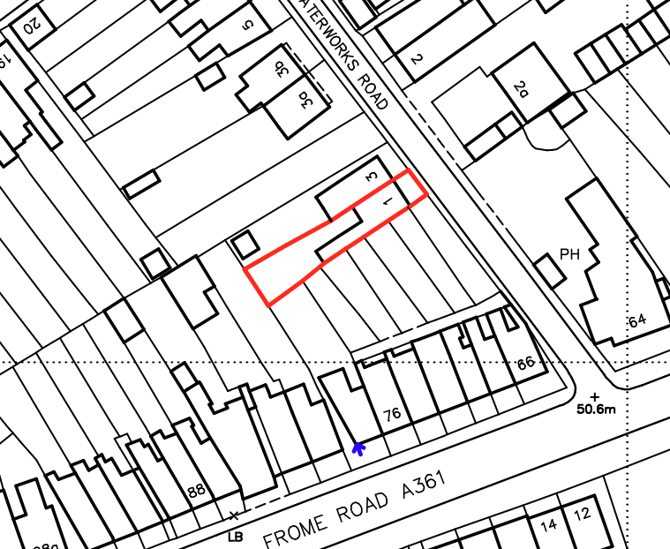

PROPOSAL

The proposal seeks planning permission for the erection of a front porch and a single‑storey rear infill extension at 1 Waterworks Road. The front porch would incorporate brick walls and clay pantile roofing to match the host dwelling and would mirror the form of an existing porch on the adjoining semi‑detached property. To the rear, the proposed extension would project 3.2 metres from the existing elevation between the host dwelling and the neighbouring two‑storey rear projection, featuring a flat roof with a central roof lantern and rendered walls to match the existing building. The scheme also includes the installation of timber French doors at ground‑floor level and the alteration of a first‑floor opening to form new doors providing access to the flat roof for maintenance purposes, enclosed by a low balustrade.

SITE DESCRIPTION / CONTEXT

The application site comprises a semi-detached mid-Victorian two-storey dwelling located on the southwest side of Waterworks Road within the Trowbridge (Newtown) Conservation Area (CA/W/204). The property lies approximately 15 metres south of the Grade II listed 2–4 Waterworks Road and is positioned within Trowbridge’s Principal Settlement boundary. The surrounding context consists of neighbouring residential properties, including terraced dwellings to the south and a two-storey extension at the adjoining property. The site falls within the Trowbridge and Westbury Bat Mitigation Strategy grey zone and lies within Flood Zone 1, with negligible surface and groundwater flood risk as identified in the Strategic Flood Risk Assessment. A small front amenity area provides pedestrian access only, with unrestricted parking available on the adjoining highway

PLANNING HISTORY

No relevant planning history has been identified for the site subject of this application.

RELEVANT LEGILSATION, POLICIES AND GUIDANCE

Wiltshire Core Strategy:

Core Policy 1 Settlement Strategy;
Core Policy 2 Delivery Strategy;
Core Policy 29 Spatial Strategy: Trowbridge Community Area;
Core Policy 50 Biodiversity and Geodiversity;
Core Policy 57 Ensuring High Quality Design and Place Shaping;
Core Policy 58 Ensuring the Conservation of the Historic Environment;
Core Policy 60 Sustainable Transport;
Core Policy 61 Transport & Development;
Core Policy 62 Development Impacts on the Transport Network;
Core Policy 64 Demand Management;
Core Policy 67 Flood Risk;

The National Planning Policy Framework (NPPF)

The Planning Practice Guidance (PPG)

Wiltshire Design Guide - Appendix D – Design Guidance for Householder extensions

The Wiltshire Local Transport Plan 2011 – 2026: Car Parking Strategy (March 2015).

The Wiltshire Local Transport Plan 4 (LTP4) (March 2025)

Emerging Policy – Wiltshire Local Plan Review

The Council’s emerging Local Plan has reached Regulation 24 stage, and is progressing through examination but the emerging plan carries limited weight at this stage with the hearing sessions currently being paused.

- Policy 1 Settlement Strategy
- Policy 85 Sustainable construction and low carbon energy
- Policy 88 Biodiversity and Geodiversity
- Policy 89 Biodiversity Net Gain
- Policy 95 Flood Risk
- Policy 98 High Quality Design and Place Shaping
- Policy 99 Ensuring the conservation and enhancement of the historic environment

CONSULTATION RESPONSES

Trowbridge Town Council – No Objection

REPRESENTATIONS

No comments received.

ASSESSMENT

Section 38(6) of the Planning and Compulsory Purchase Act 2004 states:

"If regard is to be had to the development plan for the purposes of any determination to be made under the planning Acts, the determination must be made in accordance with the plan unless material considerations indicate otherwise."

In accordance with this statutory requirement, this application has been assessed against the relevant policies of the Development Plan, including the adopted Wiltshire Core Strategy (2015) and, where applicable, any made Neighbourhood Plans.

Design and Impact upon the upon the character and context of the area
Core Policy 57 Ensuring High Quality Design and Place Shaping of the Wiltshire Core Strategy seeks to ensure that all new development is of high design quality, reflecting local context, character, and distinctiveness.

Policy 98 of the emerging Wiltshire Local Plan reiterates the position outlined in Core Policy 57, that new development must enhance local distinctiveness, and relate positively to its landscape setting, as well as demonstrating a positive response to existing townscape and built form features such as height, scale, massing, building line, materials, and appearance.

The application proposes a front porch and a single‑storey rear extension. The porch is designed to match the adjoining property in form, materials and roof design, utilising clay tiles and matching brickwork, thereby providing visual coherence to the pair of dwellings. To the rear, the proposed infill extension is positioned between the host dwelling and the neighbouring rear projection. Its flat‑roof form with lantern rooflight and rendered elevations corresponds appropriately with the existing rear façade.

A first‑floor balcony is proposed above the new rear extension, accessed through replacement French doors. The design remains visually subordinate and is located to the rear where visibility from the public realm is limited. The materials and detailing proposed are considered sympathetic to the dwelling and its setting.

Overall, it is considered that the development would integrate acceptably with the character and appearance of the host dwelling and surrounding area and therefore complies with CP57 and the design principles of the NPPF.

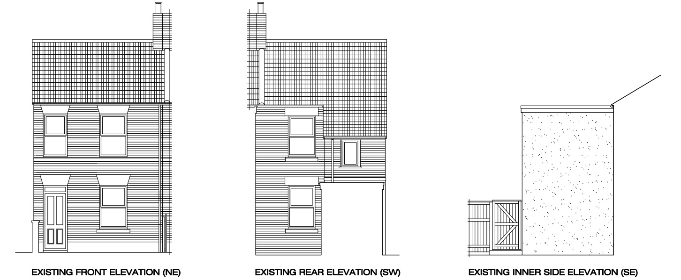
Existing Elevations

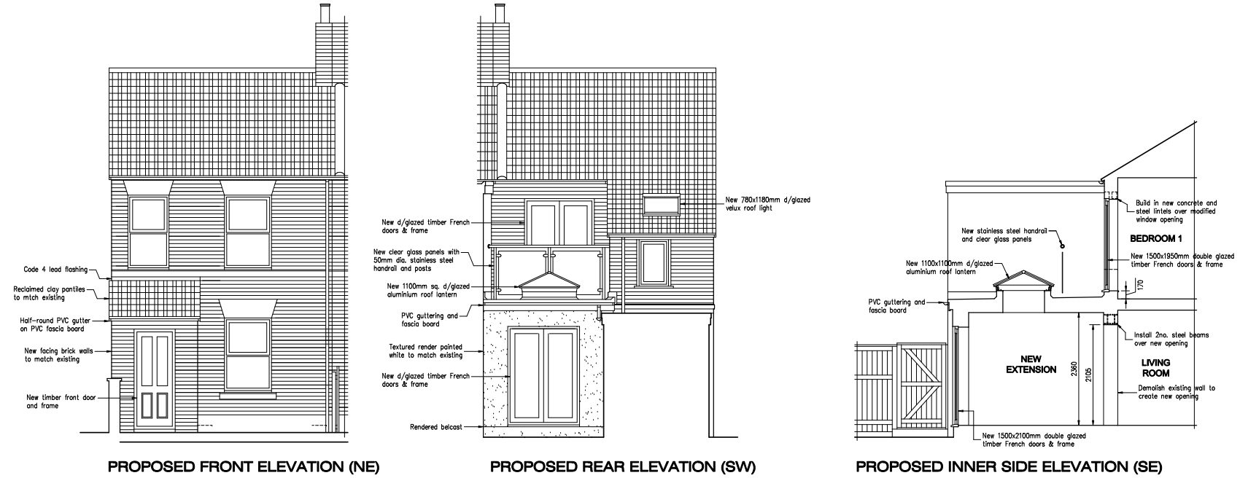
Proposed Elevations

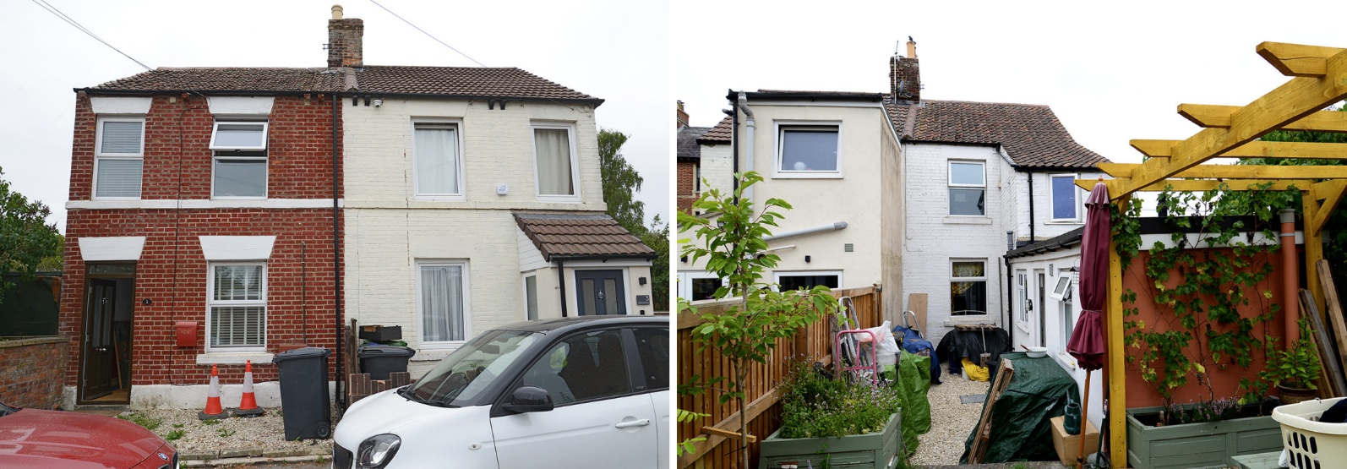
Front and Rear Elevations

Conservation and Heritage
Core Policy 58 outlines development consideration with regard to the historic environment. The policy states that heritage assets and their settings must be conserved and, where appropriate, enhanced through any proposed development.

Policy 99 of the emerging Wiltshire Local Plan outlines the need to conserve and protect heritage assets, and ensure that where proposals would affect historic environment, no harm would result.

The site lies within a designated Conservation Area. Owing to the limited visibility of the proposed works from the public realm, and the use of materials and detailing consistent with the existing building, the development would have a neutral effect on the character and appearance of the Conservation Area. The scale, position, and materials of the extensions are considered appropriate to their context and would not diminish the area's special interest.

The proposal is therefore considered acceptable with regard to heritage policy requirements.

Amenity
Point vii of Core Policy 57 Ensuring High Quality Design and Place Shaping of the Wiltshire Core Strategy seeks to ensure that developments do not adversely affect neighbouring properties.

The National Planning Policy Framework (NPPF), particularly Paragraph 135, stresses that planning decisions should ensure developments provide a high standard of amenity for existing and future users.

The proposed porch and ground-floor rear extension would have no significant effect on neighbouring privacy or outlook, given their modest scale and single-storey form. The first-floor balcony would be positioned between existing two-storey rear projections on the host and adjoining properties, which would effectively screen views to the north and south. While the balcony introduces a potential viewing platform to the west, the nearest dwelling is approximately 20 metres away, which is considered sufficient to prevent unacceptable harm to residential amenity. Moreover, an existing first-floor window already provides similar views, and the proposal would not materially increase overlooking.

The proposal is appropriately sited, designed, and oriented to ensure that it would not result in unacceptable impact upon/to the amenities or living conditions of neighbouring residential occupiers, particularly in terms of outlook, privacy, or access to natural light.

The proposal therefore accords with Core Policy 57 point vii in respect of safeguarding residential amenity and Appendix D of the Wiltshire Design Guide.

Transport and Highways
Core Policy 60 of the WCS states that Council will support and encourage safe and efficient movement of people and, where necessary, mitigate the impact of development on transport users and local communities. Core Policy 61 specifies that development should demonstrate that consideration has been given to a hierarchy of transport users and that proposals must, where relevant, serve as a safe access to the highway network. Paragraph 116 of the NPPF states that “Development should only be prevented or refused on highways grounds if there would be an unacceptable impact on highway safety, or the residual cumulative impacts on the road network, following mitigation, would be severe, taking into account all reasonable future scenarios”.

The proposal does not involve any alterations to access arrangements or parking provision and does not increase the number of bedrooms. The existing situation would remain unaffected, and no highway or parking concerns are identified.

Ecology
The WCS, through Core Policy 50, states that development proposals are expected to avoid and reduce disturbance of sensitive wildlife species and habitats. Biodiversity Net Gain (BNG) was established as a mandatory aspect of planning evaluation through Schedule 7A of the Town and Country Planning Act 1990 (as amended by the Environment Act 2021 Schedule 14). Householder planning applications are exempt from the requirement to deliver Biodiversity Net Gain under Schedule 7A, Section 4(2)(a) of the Town and Country Planning Act 1990, as inserted by the Environment Act 2021.

The works are confined to areas of existing built form and domestic garden with low ecological value. No demolition of roof spaces or other features likely to support protected species is proposed. As such, no ecological harm is anticipated.

Flooding and Drainage
Core Policy 67 of the WCS provides detail on the management of flooding in association with new development. Policy 95 of the emerging Wiltshire Local Plan directs new development to the requirement for a sequential test, as outlined by the NPPF. The policy states that new development will include measures to reduce rainwater run-off, and the incorporation of sustainable drainage systems. The NPPF sets out the application of a sequential, risk-based approach to the location of new development in paragraph 172.

The site lies within Flood Zone 1 and is not identified as being at risk from surface water or groundwater flooding. The minor scale of the works and the use of existing drainage arrangements indicate that the proposal would not give rise to increased flood risk. The development is therefore considered acceptable in drainage terms.

CONCLUSION

The proposal is considered to be acceptable and in accordance with the relevant policies and guidance outlined above.

RECOMMENDATION: That Planning Permission be GRANTED subject to the following conditions:

1.
The development hereby permitted shall be begun before the expiration of three years from the date of this permission.

REASON: To comply with the provisions of Section 91 of the Town and Country Planning Act 1990 as amended by the Planning and Compulsory Purchase Act 2004.

2.
The development hereby permitted shall be carried out in accordance with the following approved plans and documents:

Proposed Block Plan (9 December 2025)
Proposed Elevations (9 December 2025)
Proposed Section (9 December 2025)
Existing and Proposed Floor Plans (9 December 2025)
Design and Access Statement (9 December 2025)
Site Location Plan (9 December 2025)

REASON: For the avoidance of doubt and in the interests of proper planning.

