APPLICATION FOR PRIOR NOTIFICATION – PART 3
CASE OFFICER REPORT

APPLICATION REFERENCE: | PL/2025/09532
APPLICATION TYPE: | Prior approval Part 3 Class R: Agricultural buildings to a flexible commercial use
SITE ADDRESS: | PERTWOOD MANOR FARM, HIGHER PERTWOOD, HINDON, SALISBURY, SP3 6TA
DEVELOPMENT DESCRIPTION: | Change of Use of two agricultural buildings to a flexible commercial use falling within Class E (c) and E (g)of Schedule 2.
RECOMMENDATION: | That Prior Approval is required and GRANTED
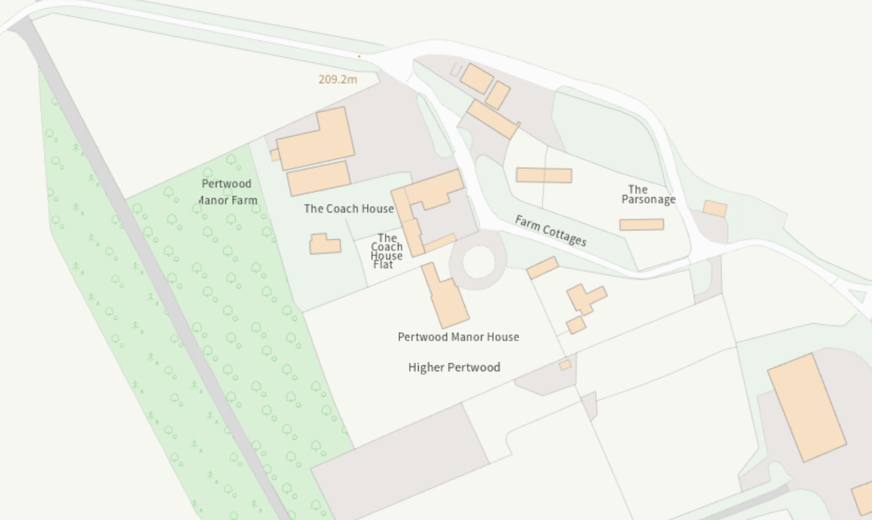
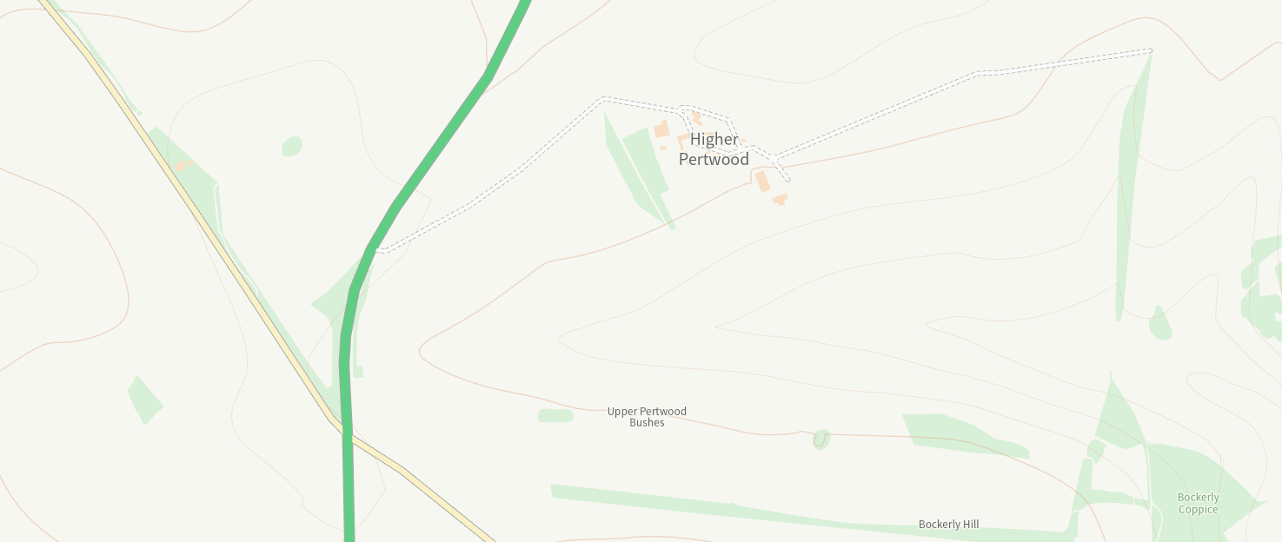
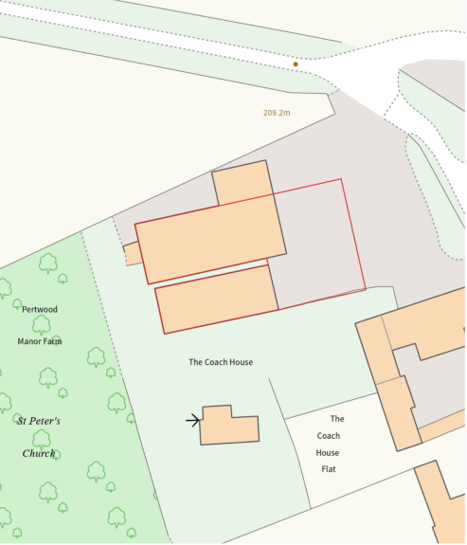

SITE DESCRIPTION/CONTEXT

The application site is an existing agricultural building located in the wider ownership of Pertwood Manor Farm. The site itself is located in the hamlet of Upper Pertwood, which is accessed via an unnamed track to the south of the A350 and located approximately 3.5 km northwest of Hindon. The hamlet is of a rural nature and surrounded by arable fields, pasture, and woodland. The site falls within the bounds of the Cranbourne Chase National Landscape/AONB. Upper Pertwood is a small, nucleated settlement set around a circular track, and consists of a few residential and agricultural buildings. This includes a Grade II listed mid-18th century, two-storey farmhouse located to the south of the existing agricultural buildings and Grade II listed St. Peter’s Church.

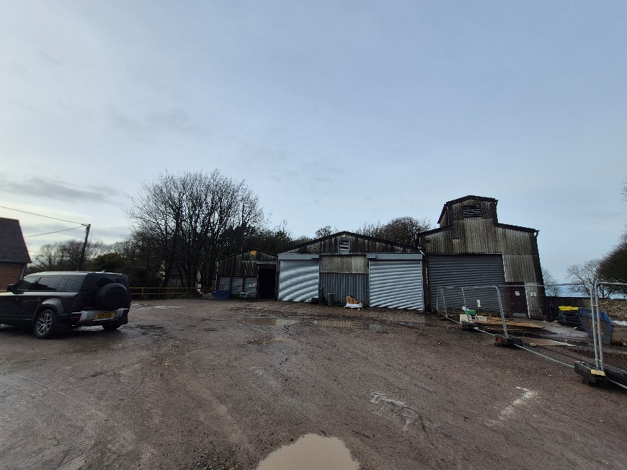
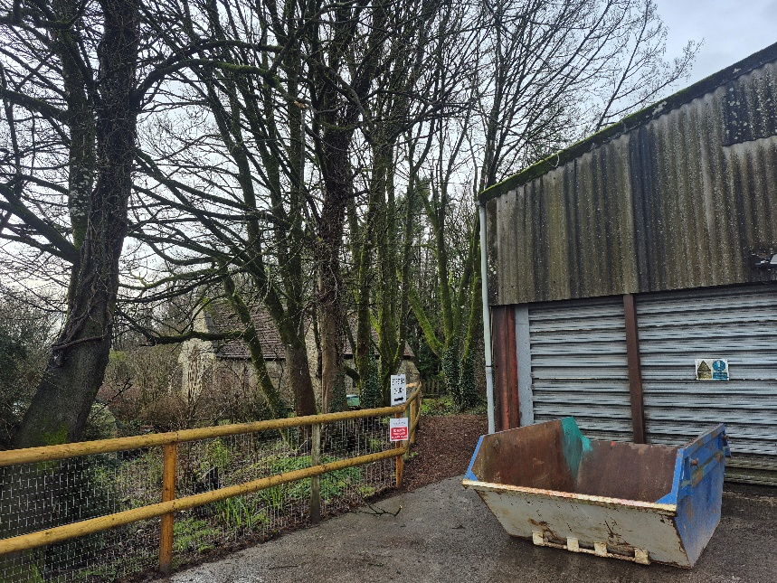
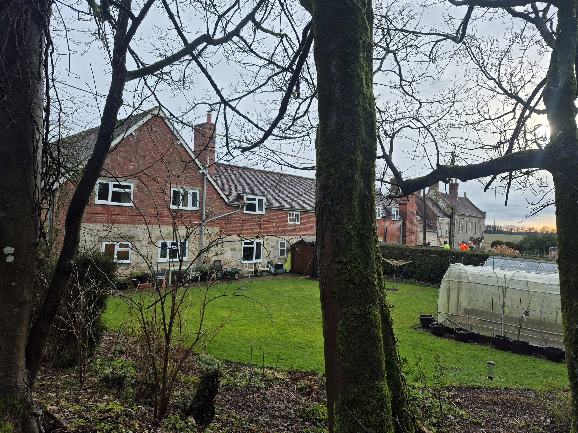
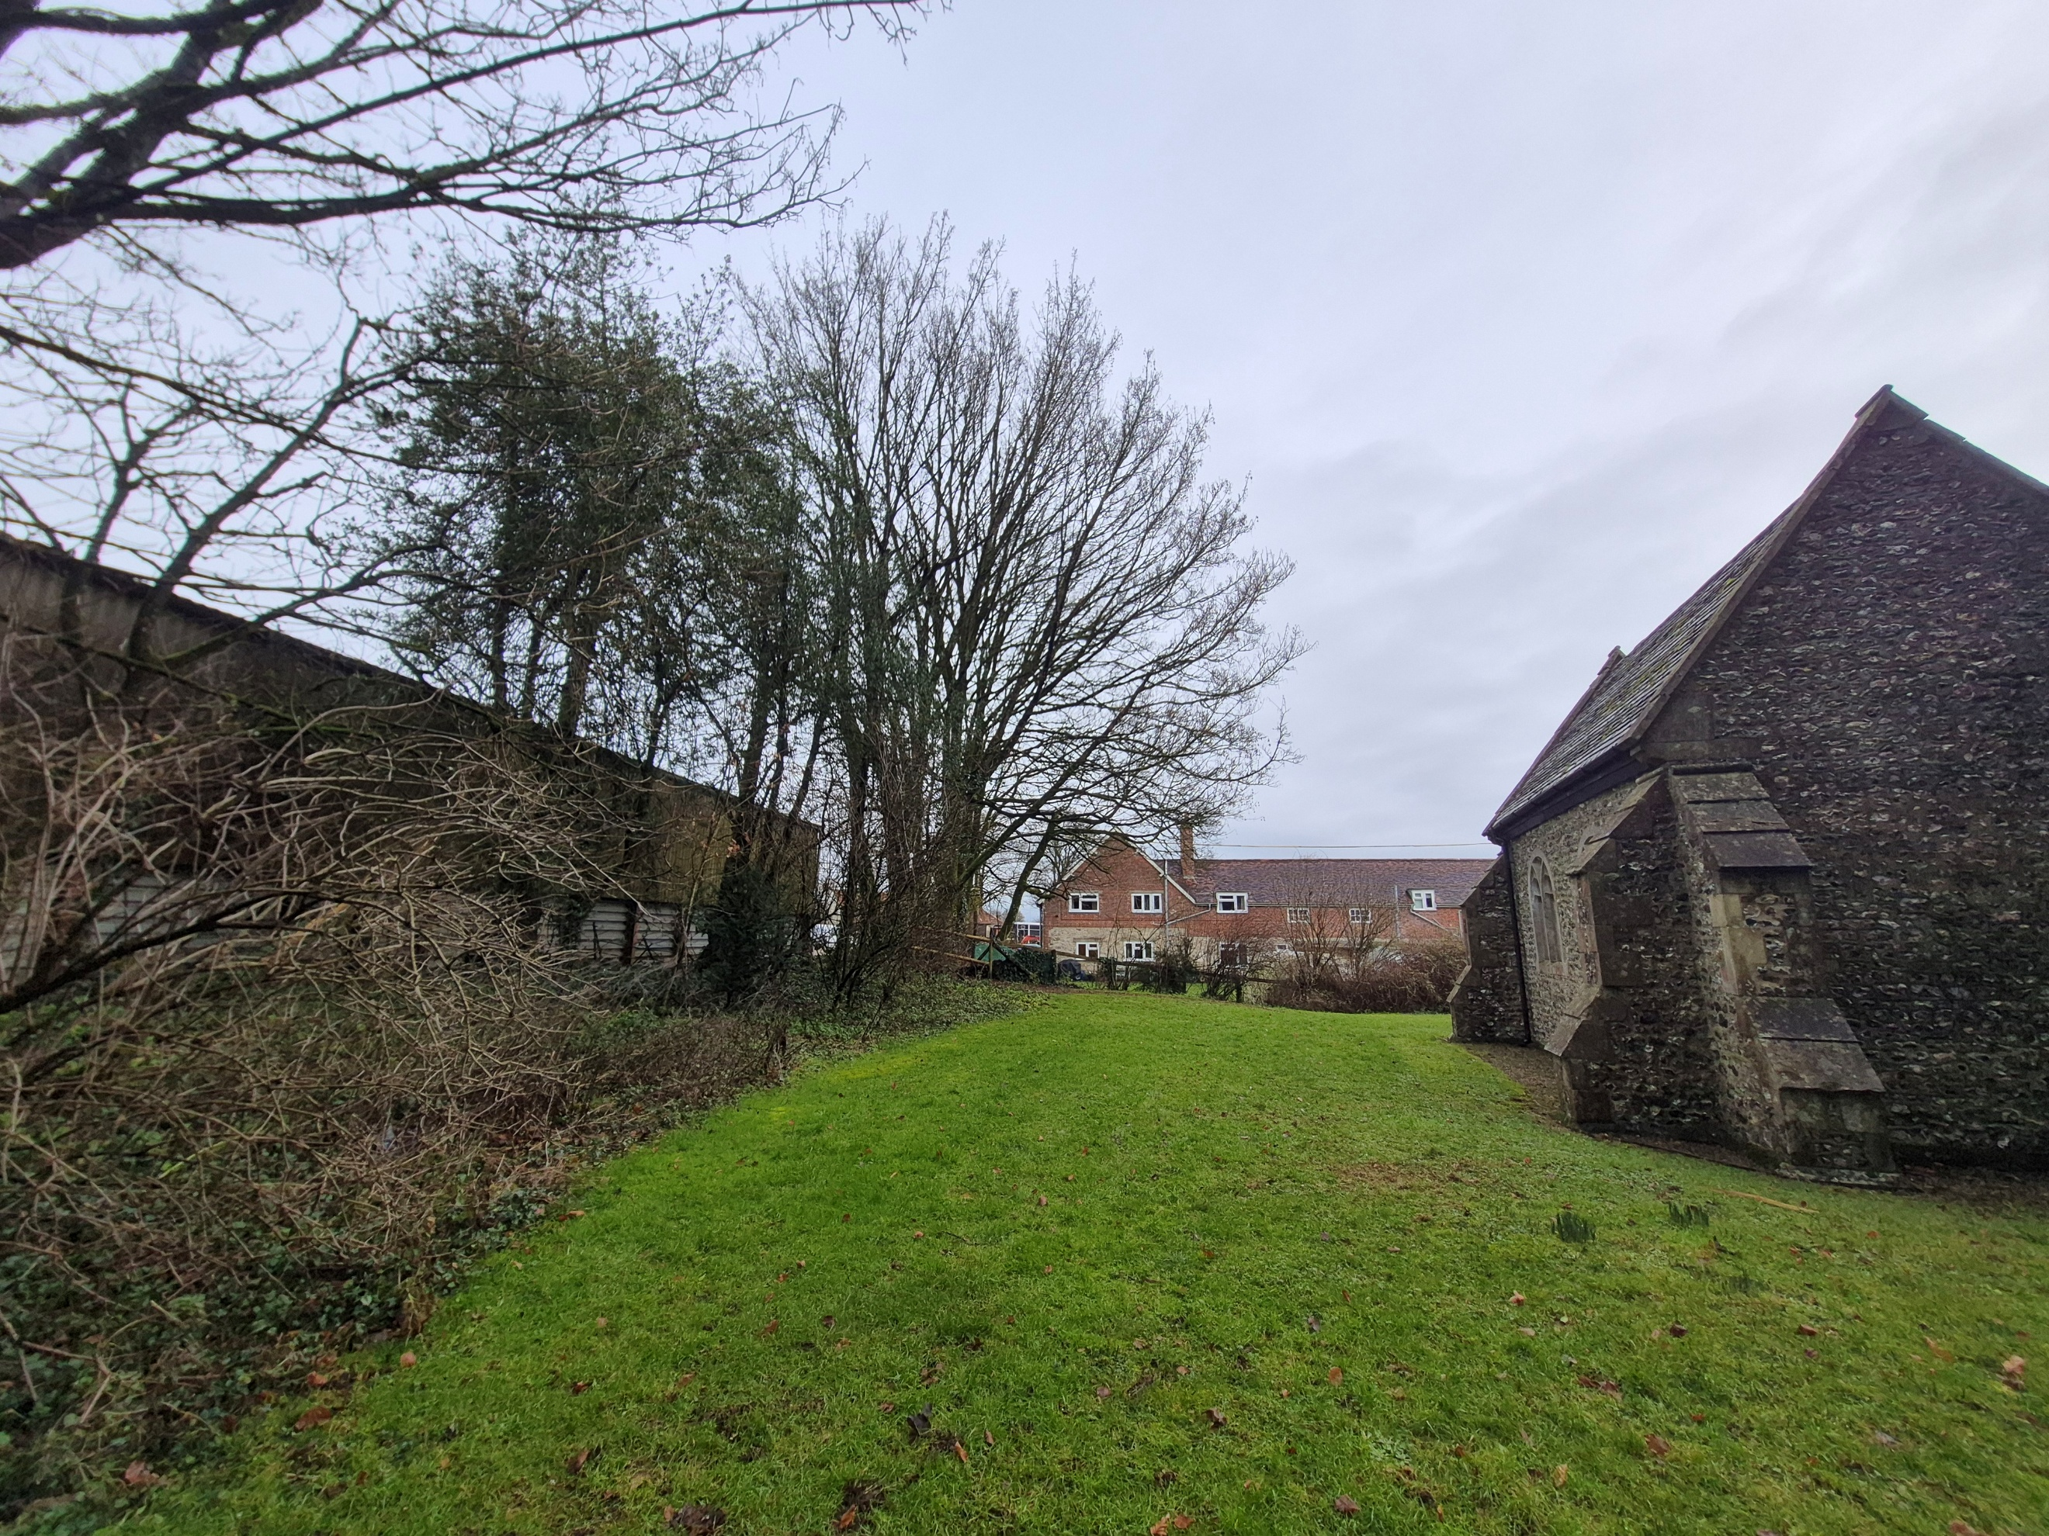

PROPOSAL

The proposal relates to a total floor space of 641.02 square metres to be changed from agriculture to a flexible commercial use Class E Under Schedule 2, Part 3, Class R of the Town and Country Planning (General Permitted Development) (England) Order 2015. Specifically, Class E ( c ) and (g)

- E(c) Provision of:
  - E(c)(i) Financial services,
  - E(c)(ii) Professional services (other than health or medical services), or
  - E(c)(iii) Other appropriate services in a commercial, business or service locality

- E(g) Uses which can be carried out in a residential area without detriment to its amenity:
  - E(g)(i) Offices to carry out any operational or administrative functions,
  - E(g)(ii) Research and development of products or processes
  - E(g)(iii) Industrial processes

Store 1 – 80ft x 30ft (24.38m x 9.14m) = 222.83m2
Store 2 – 100ft x 45ft (30.48m x 13.72m) = 418.19m2
In all 641.02m2

Curtilage area = approximately 500m2

The red line boundary is drawn around the two existing agricultural buildings measuring 641 square metres in total and an existing concrete farmyard to the front of the existing buildings measuring approximately 500 square metres. The existing access to the farmyard is from the main road and the building would benefit from this existing means of access via the farmyard which is all within the applicant’s ownership.

Works to provide or improve any access, parking and turning areas would normally form part of a planning application once the principle for change of use is permitted under the provisions of Class R.

Further information as to the proposed commercial use under Class E (c) and (g) was requested but the agent stated that a tenant had not yet been secured. No detailed plans or elevations have been provided. The agent has confirmed that no operation development is proposed in this application. Any physical alterations (e.g. windows, cladding) will require a separate planning application.

Curtilage and Part X

The curtilage and established agricultural unit are defined by Part X of the GPDO and states:

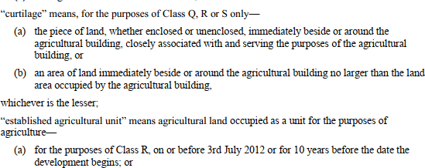
Appeal cases have recently shown that Inspectors do not expect the red line to enclose the means of access to buildings if this can be reasonably achieved.

There is an existing vehicle access to the farmyard where the building is sited. This is shown to be within the applicant’s ownership leading to the buildings.

The submitted plan shows the curtilage for the building located directly to the front of the existing buildings. The application is considered to satisfy part X as the application includes a curtilage defined as the area of land immediately beside or around the agricultural building no larger than the land occupied by the agricultural building.

RELEVANT LEGISLATION, POLICY AND GUIDANCE
This application is assessed under Article 3 of the Town and Country Planning (General Permitted Development) (England) Order 2015 (as amended), which grants planning permission for certain types of development described in Schedule 2 of the Order. The grant of permission is subject to the limitations, conditions, and provisions set out within the relevant Classes of permitted development.

Under Schedule 2, Part 3, Class R of the Town and Country Planning (General Permitted Development) (England) Order 2015 (as amended), certain changes of use and associated operations may be permitted subject to prior approval from the Local Planning Authority.

Conservation of Habitats and Species Regulations 2017 (as amended), which came into force on 30th November 2017, requires protection of hundreds of wildlife sites in England, covering the sites of greatest significance and international importance for nature. The application site sits outside Barbastelle 6km SAC Parcel Buffer Chilmark Quarries

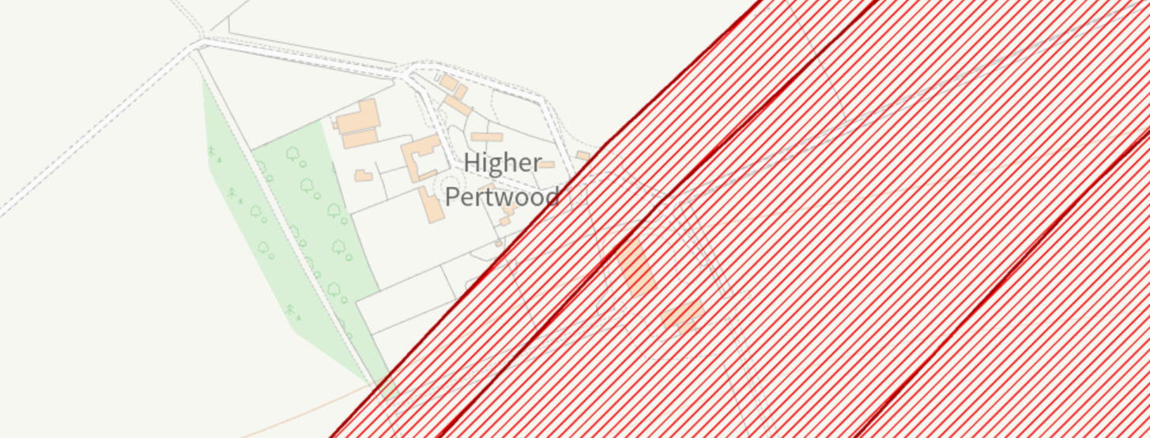

RELEVANT PLANNING HISTORY
The references below are associated with agricultural buildings elsewhere on the application site.
Reference | Proposal / Summary | Decision
S/1998/0381 | NEW AGRICULTURAL BUILDING | Full planning permission
PL/2025/07644 | Agricultural grain and machinery store | Prior Approval Not Required

CONSULTATIONS

Wiltshire Council Highways Officer: Comment: I can confirm that I would only accept E(c) and E(g) on that basis that these to not involve public/retail access.

I also note that the buildings are conversions as opposed to new build.

Wiltshire Council Public Protection Officer: Comment -

If you are minded to restrict the use of the site to class E, I agree that E(c) and E(g) would be most appropriate given the proximity of the noise-sensitive receptors.

However, I would still recommend that the following conditions are attached:

As requested, I have considered whether this application is likely to result in adverse noise impacts and/or contamination risks. Please find below my comments:

Noise:
The agricultural buildings are enclosed and have roller doors to the front. While the buildings are located within an agricultural complex, they are approximately 17 metres from the nearest residential dwelling and 18 metres from St Peter’s Church. Both the dwelling and the church are considered noise-sensitive receptors.

As we have not received a noise impact assessment with this application, I would recommend the following conditions:

1. The approved uses shall only take place between the hours of 08:00 and 18:00 on Mondays to Fridays and between 08:00 and 13:00 on Saturdays. The approved uses shall not take place at any time on Sundays and Bank or Public Holidays.

2. Approved uses must only take place inside the buildings.

Contaminated land:
My understanding is that no groundworks are to be undertaken as part of this application. I therefore have no comment to make on this matter.

ASSESSMENT
This application seeks prior approval under Class R, which allows for agricultural buildings to a flexible commercial use. This application is specifically restricted to Class E (c) and (g) Under Schedule 2, Part 3, Class R of the Town and Country Planning (General Permitted Development) (England) Order 2015.

- E(c) Provision of:
  - E(c)(i) Financial services,
  - E(c)(ii) Professional services (other than health or medical services), or
  - E(c)(iii) Other appropriate services in a commercial, business or service locality

- E(g) Uses which can be carried out in a residential area without detriment to its amenity:
  - E(g)(i) Offices to carry out any operational or administrative functions,
  - E(g)(ii) Research and development of products or processes
  - E(g)(iii) Industrial processes

Does the Proposal Qualify as Permitted Development?
Development under Class R is subject to a number of conditions and limitations. Development is not permitted by this class if any of the specified restrictions apply. These are set out at Appendix 1. Subject to compliance with these criteria and any limitations or conditions specified within the Order, the proposed development may be considered permitted development.

Having completed the detailed checklist at Appendix 1, it is concluded that the proposed development qualifies as permitted development under Schedule 2, Part 3, Class R of the Town and Country Planning (General Permitted Development) (England) Order 2015 (as amended), and the assessment may now proceed to consider whether prior approval is required by the LPA. The proposed use class in accordance with Class R is Use Class E (C) and (g).

Is Prior Approval Required?
Where a proposal complies with all the provisions limitations set out under Class R of Schedule 2, Part 3 of the Town and Country Planning (General Permitted Development) (England) Order 2015 (as amended), the developer must apply to the Local Planning Authority (LPA) for a determination as to whether prior approval is required for the specified impacts and, if so, whether it should be granted.

In respect of this proposal, the following considerations must be assessed as part of the prior approval process as set out R.3 (1)(b):

(b) where the cumulative floor space of the building or buildings which have changed use under Class R within an established agricultural unit exceeds 150 square metres, apply to the local planning authority for a determination as to whether the prior approval of the authority will be required as to—

(i) transport and highways impacts of the development;
(ii) noise impacts of the development;
(iii) contamination risks on the site; and
(iv) flooding risks on the site.

The proposal relates to two buildings:
Store 1 – 80ft x 30ft (24.38m x 9.14m) = 222.83m2
Store 2 – 100ft x 45ft (30.48m x 13.72m) = 418.19m2
In all 641.02m2

Curtilage area = approximately 500m2

The cumulative floor space of the building or buildings which have changed use under Class R exceeds 150m² and as such, the above prior approval matters must be assessed.

In addition, Paragraph W sets out a number of requirements for both the developer (in terms of the application submission) and the LPA (relating to consultations and advertisement of the application). Para. W(10) states that:

The local planning authority must, when determining an application—
(a) take into account any representations made to them as a result of any consultation under sub-paragraphs (5) or (6) and any notice given under sub-paragraph (8);

(b) have regard to the National Planning Policy Framework issued by the Ministry of Housing, Communities and Local Government in February 2019 July 2021, so far as relevant to the subject matter of the prior approval, as if the application were a planning application; and

(c) in relation to the contamination risks on the site—
(i) determine whether, as a result of the proposed change of use, taking into account any proposed mitigation, the site will be contaminated land as described in Part 2A of the Environmental Protection Act 1990, and in doing so have regard to the Contaminated Land Statutory Guidance issued by the Secretary of State for the Environment, Food and Rural Affairs in April 2012, and
(ii) if they determine that the site will be contaminated land, refuse to give prior approval

Para. W(13) allows LPAs to grant prior approval unconditionally or subject to conditions reasonably related to the subject matter of the prior approval.

Transport and highways impacts of the development
Policy Context
Paragraph 115 of the National Planning Policy Framework (NPPF) emphasises the importance of promoting sustainable transport modes, ensuring safe and suitable access for all users, and designing development in accordance with national guidance. It also requires that any significant impacts on the transport network—whether in terms of capacity, congestion, or highway safety—can be mitigated in a cost-effective manner.

Paragraph 116 of the NPPF further clarifies that development should only be refused on highways grounds where there would be an unacceptable impact on highway safety, or where the residual cumulative impacts on the road network, following mitigation, would be severe.

In terms of locational sustainability, the Local Planning Authority (LPA) is not able to assess whether the site’s location in open countryside is sustainable in relation to access to services, employment, or facilities. This is not a consideration under the relevant prior approval provisions. Accordingly, the key matter for assessment is the impact of the proposal on highway safety, particularly in relation to the site access and the surrounding local highway network.

Assessment
The Highways Officer has commented that: The site is served by an existing, historically established access, therefore, no highway objection is raised. The highways officer has noted: I can confirm that I would only accept E(c) and E(g) on that basis that these to not involve public/retail access.

Conclusion

Prior approval in relation to traffic matters is not required subject to the restriction of Class E (c) and (g).

Noise impacts
Policy Context
Paragraph 187(e) of the National Planning Policy Framework (NPPF) requires that planning decisions contribute to and enhance the natural and local environment by ensuring that new and existing development does not contribute to, or is not exposed to, unacceptable levels of noise pollution. This includes preventing development from being put at risk or adversely affected by such impacts.

Further to this, Paragraph 198(a) advises that new development should be appropriate for its location, taking into account the likely effects, including cumulative impacts, of pollution on health, living conditions, and the natural environment. It emphasises the need to mitigate potential adverse impacts arising from noise and to avoid noise that could result in significant harm to health or quality of life.

In the context of this proposal, the key consideration is whether the development would result in, or be exposed to, unacceptable levels of noise, and whether any such impacts can be appropriately mitigated to ensure a suitable living environment.

Assessment
Class R:

R. Development consisting of a change of use of a building and any land within its curtilage from a use as an agricultural building to a flexible use—

(a)falling within one of the following provisions of the Use Classes Order—
(i)Class B2 (general industrial) of Schedule 1;
(ii)Class B8 (storage or distribution) of Schedule1;
(iii)Class C1 (hotels) of Schedule 1;
(iv)Class E (commercial, business or service) of Schedule 2; or
(v)Class F.2(c) (outdoor sport or recreation) of Schedule 2; or

(b)for the provision of agricultural training.

The submitted letter states: Pertwood Manor Farm comprises of approximately 313.09ha (773.65 ac.) of predominantly arable land with some grassland. The buildings to which this application relates have been used as the principal storage for farm supplies including machinery, grain and fertiliser on the holding for many decades.

The public protection officer has noted: While the buildings are located within an agricultural complex, they are approximately 17 metres from the nearest residential dwelling and 18 metres from St Peter’s Church. Both the dwelling and the church are considered noise-sensitive receptors.

As we have not received a noise impact assessment with this application, I would recommend the following conditions:

- The approved uses shall only take place between the hours of 08:00 and 18:00 on Mondays to Fridays and between 08:00 and 13:00 on Saturdays. The approved uses shall not take place at any time on Sundays and Bank or Public Holidays.

- Approved uses must only take place inside the buildings.

Conclusion
The proposed use class order being applied for in this application is for Class E (c) and (g). The public protection officer has considered this use restriction is appropriate for this application site. The conditions noted by the public protection officer will be included in the recommendation.

Contamination risks
Policy Context
Paragraph 196 of the National Planning Policy Framework (NPPF) sets out the expectations for planning decisions in relation to land quality and safety. It states that:

- Sites must be suitable for their proposed use, taking into account ground conditions and any risks arising from land instability or contamination. This includes risks from natural hazards or former activities such as mining, and any proposed mitigation measures, including land remediation and its potential environmental impacts.
- Following any necessary remediation, land should not be capable of being determined as contaminated under Part IIA of the Environmental Protection Act 1990.
- Adequate site investigation information, prepared by a competent person, must be available to inform the assessment of these risks.

In the context of this proposal, the Local Planning Authority must be satisfied that the site is not subject to contamination or instability that would render it unsuitable for the proposed use, and that any necessary investigations or mitigation measures have been appropriately considered.

Assessment
Based on the site history and use for traditional arable farming, there is no known contamination on the site or known hazardous materials proposed. The public protection officer has noted: My understanding is that no groundworks are to be undertaken as part of this application. I therefore have no comment to make on this matter.

Conclusion
Prior approval in relation to contamination matters is not required.

Flooding risks
Policy Context
The NPPF makes clear that inappropriate development in areas at risk of flooding should be avoided by steering development towards areas with the lowest risk, whether that risk is current or future. Where development is necessary in areas at risk, it must be demonstrated that the development can be made safe for its lifetime without increasing flood risk elsewhere.

Assessment
The site lies within Flood Zone 1 and there are no known changes proposed that would affect surface water flow. On balance there are no flood risk concerns.

Conclusion
Prior approval in relation to flood risk matters is not required.

CONCLUSION

Class R of the GPDO permits development consisting of a change of use of a building and any land within its curtilage from a use as an agricultural building to a flexible use falling within one of the provisions under Class R. This application is specifically applying for Class E (c) and (g) and is within the specified provisions. Any associated operational development defined in R.3-4 above must be the subject of a subsequent S78 application for planning permission.

The LPA has no details of any future changes required to the building envelope. This provision does not enable the LPA to consider the merits or otherwise of the building’s structural suitability for conversion. Therefore, as the provision allows a change of use and no superfluous physical alterations are proposed in this instance, the LPA has no grounds to object in principle. The proposed use of Class E (c) and (g) falls within the permitted use categories under Class R.

The PPG has clarified that the sustainability of a site’s location is not a test that applies to this permitted development right. Therefore, concerns around the location and sustainability of the site, ecological impact and any associated NPPF paragraphs related to these topics are not material considerations for this application.

Nonetheless, under the Conservation of Habitat Regulations, it is an offence to harm or disturb bats or damage or destroy their roosts. Prior Approval or Permitted Development does not provide a defence against prosecution under this legislation. The applicant is advised that a Natural England licence may be required before any work is undertaken to implement this planning permission.

Prior Approval is Required
The proposed development has been assessed against the provisions, limitations, and conditions set out in Schedule 2, Part 3, Class R of the Town and Country Planning (General Permitted Development) (England) Order 2015 (as amended). Based on the submitted plans, supporting information, and the findings of this report, it is concluded that the proposal complies with the criteria for permitted development, and therefore falls within the scope of Class R.

Following assessment, it is determined that prior approval is not required in relation to highways, contamination, and flooding of the development but that prior approval is required in relation to noise.

Having considered the relevant matters that require prior approval, it is further concluded that:

Prior approval is granted, subject to the development being carried out in accordance with the submitted details and any conditions set out in this report.

RECOMMENDATION:

That Prior Approval be granted, subject to the following conditions:

1. The development hereby permitted shall be carried out in accordance with the following approved plans:

Proposed Block Plan Received: 20 January 2026
Covering Letter Received: 20 January 2026

REASON: For the avoidance of doubt and in the interests of proper planning.

2. Notwithstanding the provisions of the Town and Country Planning (General Permitted Development) (England) Order 2015 (or any Order revoking or reenacting or amending that Order with or without modification), the site shall be used solely for purposes within Class E (c) and (g) as set out in the Schedule of the Town and Country Planning (Use Classes) Order 1987 (as amended)(or in any provisions equivalent to that class in any statutory instrument revoking or reenacting that Order with or without modification).

REASON: The proposed use is acceptable, but the Local Planning Authority wish to consider any future proposal for a change of use, having regard to the circumstances of the case.

3. The approved Class E (c) and (g) use shall only take place between the hours of 08:00 and 18:00 on Mondays to Fridays and between 08:00 and 13:00 on Saturdays. The approved use shall not take place at any time on Sundays and Bank or Public Holidays.

Reason: In the interests of residential amenity.

4. Approved Class E (c) and (g) use must only take place inside the buildings.

Reason: In the interests of residential amenity.

INFORMATIVES:
Under the Conservation of Habitats and Species Regulations 2017 (as amended), it is an offence to harm or disturb bats or damage or destroy their roosts. Planning permission for development, Permitted Development, or Prior Approval does not provide a defence against prosecution under this legislation. The applicant is advised that a European Protected Species Licence could be required and should be obtained before any work is undertaken. Replacing the roof could also breach this legislation and advice should be obtained from a professional bat ecologist before proceeding with work of this nature.

External Lighting should be in accordance with the appropriate Environmental Zone standards set out by the Institution of Lighting Professionals (ILP) Guidance Notes on the Avoidance of Obtrusive Light (GN 01/2021) and Guidance note GN08/23 “Bats and artificial lighting at night”, issued by the Bat Conservation Trust and Institution of Lighting Professionals to avoid illumination of habitat used by bats.

A
APPENDIX 1 – PERMITTED DEVELOPMENT CHECKLIST CLASS R
Class R – agricultural buildings to a flexible commercial use
 |  | Yes / No
R. | Permitted Development  Note: If the answer is "Yes", proceed to assessment under R.1. If the answer is "No", the proposal does not qualify as permitted development under this class.
 | Does the development consist of a change of use of a building and any land within its curtilage from a use as an agricultural building to a flexible use—  (a) falling within one of the following provisions of the Use Classes Order—  (i)Class B2 (general industrial) of Schedule 1;  (ii)Class B8 (storage or distribution) of Schedule1;  (iii)Class C1 (hotels) of Schedule 1;  (iv)Class E (commercial, business or service) of Schedule 2; or  (v)Class F.2(c) (outdoor sport or recreation) of Schedule 2; or  (b) for the provision of agricultural training. | Yes, Class E (c) and (g)
R.1 | Development is not permitted by Class R if -  Note: If the answer to any of the questions below is "Yes", the proposed development would not constitute permitted development under this class
(a) | Was the building not used solely for an agricultural use as part of an established agricultural unit:  (i) on 3rd July 2012?  (ii) if not in use on that date, when it was last in use before that date?  (iii) if brought into use after 3rd July 2012, for a continuous period of at least 10 years before the date development under Class R begins? | The submitted letter states: The stores have been built for many decades and solely used for the storage of farm machinery and commodities during that time e.g. fertiliser, seed and grain. They continue to be in that use today.
(b) | Has the cumulative floor space of buildings that have changed use under Class R within the established agricultural unit exceeded 1,000 square metres? | The submitted letter states:  The proposal relates to two buildings:  Store 1 – 80ft x 30ft (24.38m x 9.14m) = 222.83m2  Store 2 – 100ft x 45ft (30.48m x 13.72m) = 418.19m2  In all 641.02m2  No other Class R applications have been made on the farm, and therefore the  application is within the permitted limit.
(c) | Is the site, or does it form part of, a military explosives storage area? | No.
(d) | Is the site, or does it form part of, a safety hazard area? | No.
(e) | Is the building a listed building or a scheduled monument? | No.

