APPLICATION FOR HOUSEHOLDER PLANNING PERMISSION
DELEGATED REPORT

APPLICATION REFERENCE: | PL/2025/09756
APPLICATION TYPE: | Householder planning permission
SITE ADDRESS: | 16 Middle Street, Harnham, Salisbury, SP2 8LL
DEVELOPMENT DESCRIPTION: | Proposed 2 storey infill extension and loft conversion with dormer window, associated internal works, and alterations to short front wall to widen and improve parking access.
RECOMMENDATION: | That Planning Permission be GRANTED

PROPOSAL

The proposal seeks planning permission for a proposed 2 storey infill extension and loft conversion with dormer window, associated internal works, and alterations to short front wall to widen and improve parking access.

SITE DESCRIPTION/CONTEXT

The site comprises a two-storey semi-detached dwelling located within the defined settlement boundary of the Principal Settlement of Salisbury, as defined by Wiltshire Core Strategy (WCS) policies CP1, CP2 and CP20. The application site lies just outside the Salisbury Conservation area; along the street there are a few listed buildings in the nearby vicinity.

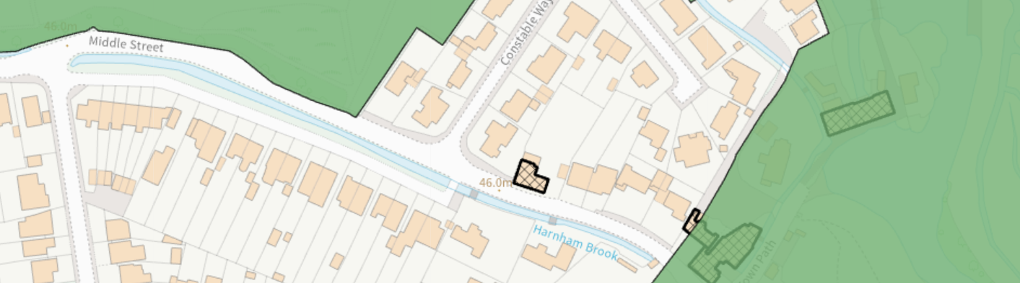

The application site also lies within the Hampshire River Avon Catchment and is within the 13.8- kilometre recreational buffer of the New Forest Special Protection Area (SPA) and RAMSAR site. However, due to the nature of the application, these designations do not have any bearing on the assessment of this application. The application site is bordered by residential dwellings to the north, east and west while the highway forms the southern boundary of the site.

PLANNING HISTORY
Reference | Proposal / Summary | Decision
S/2001/0354 | TWO STOREY SIDE EXTENSION AND SINGLE STOREY EXTENSION TO REAR | Approve with Conditions
18/03246/PNEX | Prior Notification (larger home extension scheme) - Single storey rear extension with rear projection of 4 metres with eaves height of 2.7metres and maximum height of 3.8 metres. | Prior Approval Not Required
RELEVANT POLICIES AND GUIDANCE

Wiltshire Core Strategy:

Core Policy 1: Settlement Strategy Core Policy 2: Delivery Strategy
Core Policy 20: Spatial Strategy: Salisbury Community Area
Core Policy 57: Ensuring High Quality Design and Place Shaping

Wiltshire Design Guide: Appendix D – Design Guidance for Householder extensions

The National Planning Policy Framework (NPPF)

The Planning Practice Guidance

National Design Guide

Salisbury Neighbourhood Development Plan 2020 to 2038

Wiltshire Local Transport Plan 2015-2026: Car Parking Strategy

CONSULTATION RESPONSES

Salisbury City Council: No Comment.
Highways Department: No Objection - Subject to Condition. (This will be discussed in the relevant section below.)

REPRESENTATIONS

1 comment received from the neighbouring dwelling was received. Their comments are as follows:

As our property shares the party wall we would like due consideration to be given to the potential transferable of noise into our loft bedroom that may be caused by a macerator toilet & shower room fan. As long as there is robust soundproofing & sensitive selection of the aforementioned items, we have no objections.

While the comment above is noted, only material planning considerations have been taken into account in the assessment of this application. The details of the potential noise impact of the proposed loft conversion could be dealt with through the building control process.

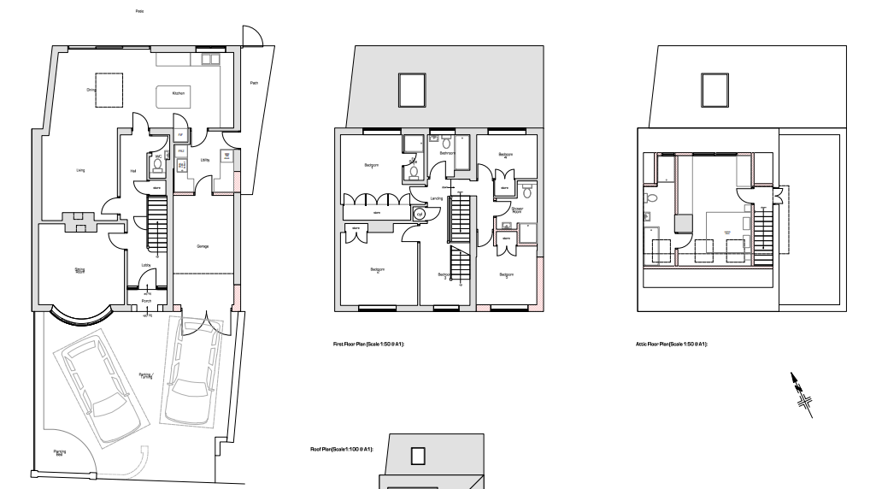
ASSESSMENT
Section 38(6) of the Planning and Compulsory Purchase Act 2004 states:

"If regard is to be had to the development plan for the purposes of any determination to be made under the planning Acts, the determination must be made in accordance with the plan unless material considerations indicate otherwise."

In accordance with this statutory requirement, this application has been assessed against the relevant policies of the Development Plan, including the adopted Wiltshire Core Strategy (2015) and, where applicable, any made Neighbourhood Plans.

Design and Impact upon the character and context of the area
Core Policy 57 - Ensuring High Quality Design and Place Shaping of the Wiltshire Core Strategy seeks to ensure that all new development is of high design quality, reflecting local context, character, and distinctiveness.

The dwelling consists of a two-storey semi-detached five- bedroom dwelling. The host dwelling has had a two-storey extension in 2001 and a rear extension in 2018 both of which have been constructed. This application now proposes a first-floor extension over the existing 1.5 storey integrated garage and the addition of a rear dormer. Additionally, the existing front wall is proposed to be amended.

The dwelling has an existing hipped principal roof with a lower half hipped roof over a single integrated garage with a pitched dormer. This application proposes to demolish the existing half hipped roof over the garage and construct a first-floor infill extension over this to allow for a full two storey extension within this area. The extensions are proposed to have a hipped roof which follows the ridge height of the principal roof. To the front elevation, a window is proposed in the extended area which matches the windows of the existing host dwelling. To the rear a flat roof dormer extension is proposed. The materials are proposed to be plain tile roof on the new hipped roof area to match the existing, grey membrane on the proposed dormer roof, and windows to match existing.

The proposed roof extension matches the height, scale, design and use of materials of the existing principal roof. The new window on the front elevation also matches the existing windows.

On the rear elevation, a flat roof dormer window is proposed to facilitate a loft conversion. The attached neighbouring dwelling has a similar dormer extension on the rear. While flat roof dormer extensions are not normally encouraged, this flat roof dormer extension is minimal in scale and not visible from the street scene. It would only be fleetingly visible from the side street similar to the neighbouring dwelling.
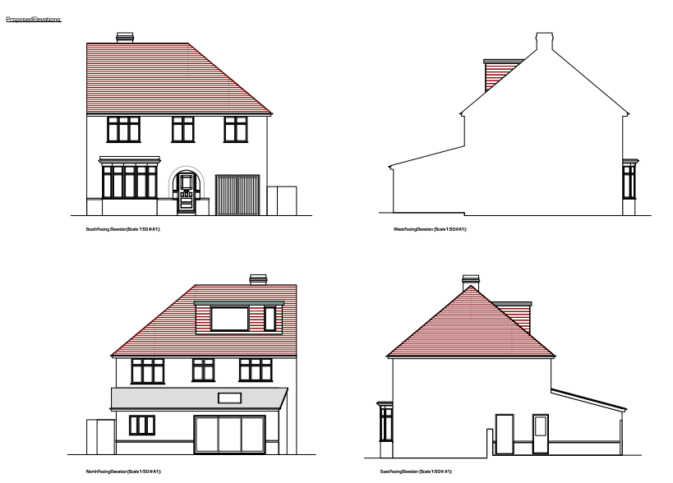
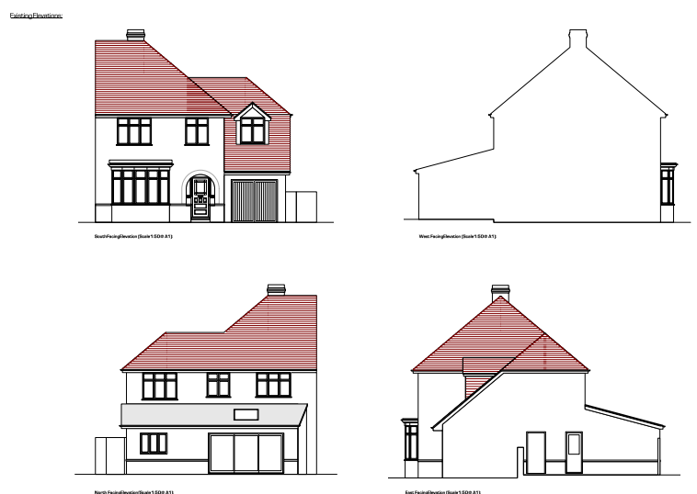
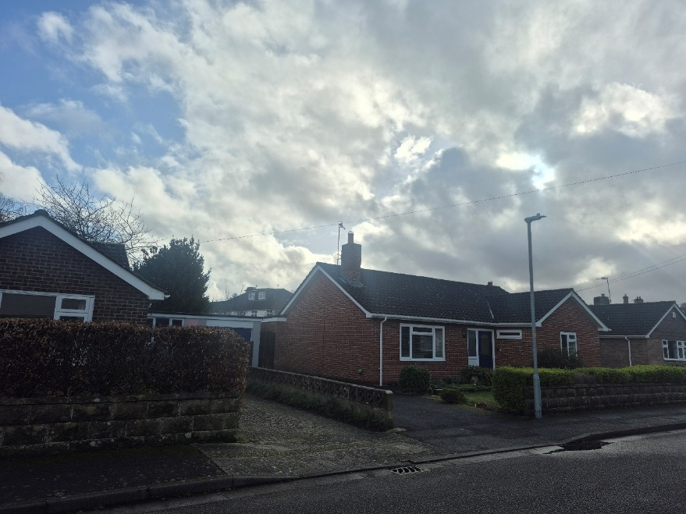
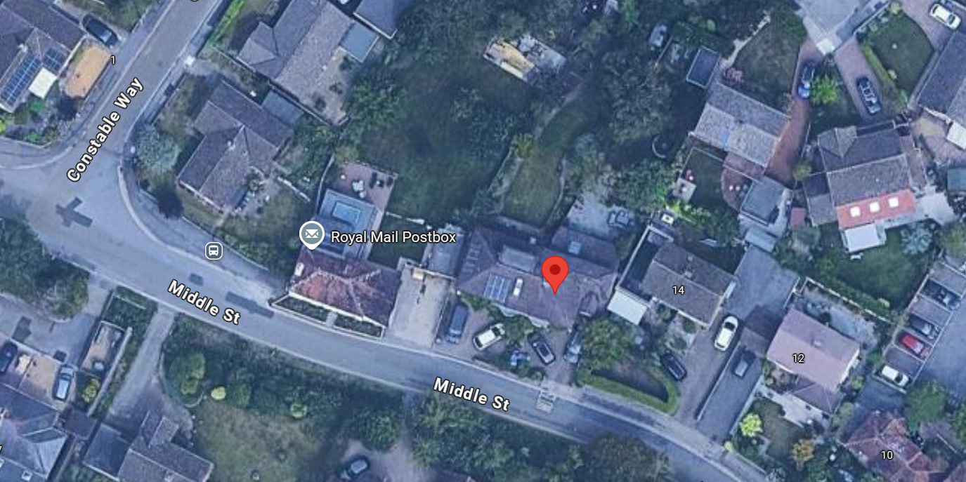
The proposed works are considered to be subservient in scale, utilises suitable materials, has been designed to complement the existing style of the dwelling, and would not be of harm to the visual amenity of the streetscape. The proposed alterations would not cause any significant impact on the wider area and are acceptable accordingly. Having regard to the above, the proposal complies with the design principles set out in Core Policy 57 of the Wiltshire Core Strategy and Appendix D of the Wiltshire Design Guide.

Amenity

Point vii of Core Policy 57 - Ensuring High Quality Design and Place Shaping of the Wiltshire Core Strategy seeks to ensure that developments do not adversely affect neighbouring properties.

The National Planning Policy Framework (NPPF), particularly Paragraph 135(f), stresses that planning decisions should ensure developments provide a high standard of amenity for existing and future users.

The proposed development has been assessed in terms of its potential impact on the residential amenity of neighbouring properties, with particular regard to loss of light, overshadowing, loss of privacy, and overbearing effects.

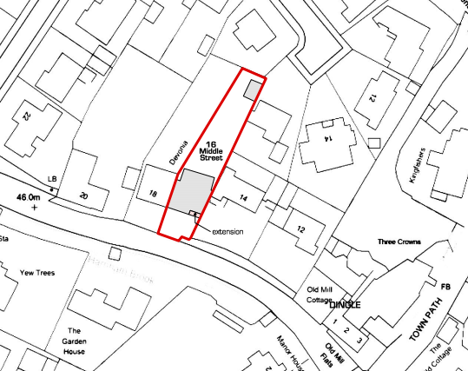
Loss of Light / Overshadowing
The proposed first floor side extension and proposed dormer extension are located on the eastern side of the application site. This lies adjacent to no.14 which has a single storey garage located adjacent to the application site albeit set back. With the additional height increase, there will be additional overshadowing onto the neighbouring dwelling. However, this is not substantial enough to warrant a refusal as there is already a 1.5 storey side extension in the same location.

Loss of Privacy
The application site proposes an additional window on the front elevation and a new dormer extension to the rear. The proposed front window does not create any additional overlooking as this replaces an existing window in a similar location and there are two existing windows on the same height and orientation as this new window. The proposed dormer extension to the rear is from a new proposed height (third storey) when compared to the existing rear windows of the host dwelling on the second storey. A degree of inter-relationship and overlooking is considered to be acceptable in an established tight knit residential area such as this. Nonetheless, a condition to obscure glaze the rear window proposed to serve the bathroom has been included in the recommendation. Additionally, a condition to remove permitted development rights to insert new side windows have been included in the recommendation. The proposal therefore accords with Core Policy 57 point vii in respect of safeguarding residential amenity and Appendix D of the Wiltshire Design Guide.

Highways Impact
Core Policy 57 (xiv) of the Wiltshire Core Strategy seeks to ensure that development must meet the requirements of Core Policy 61. This policy requires proposals to be capable of being served by safe access to the highway network. Core Policy 64 seeks to ensure compliance with parking standards set out in the Local Transport Plan.

The National Planning Policy Framework (NPPF), particularly Paragraph 115 and 116, requires that development proposals do not have an unacceptable impact on highway safety and that safe and suitable access to the site can be achieved for all users.

The application includes the removal of a section of the existing front boundary wall to facilitate better parking access. The LPA’s highways officer has no objections to the application and has noted: The proposal will increase the property from a 5 to a 6 bed dwelling. Three parking spaces are proposed to be maintained within the site with the front boundary wall being shortened to improve access.

The recommended condition and informative has been included in the recommendation, it can be concluded that the proposed development would not result in any adverse impact on highway safety. The proposal is therefore considered to comply with Core Policies 57 (xiv), 61 and 64 of the Wiltshire Core Strategy, the NPPF, and the Wiltshire Local Transport Plan.

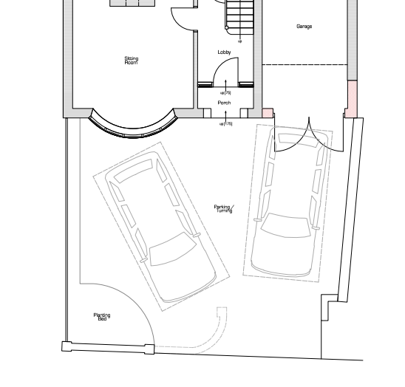
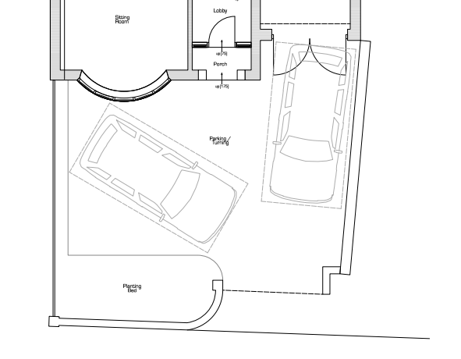
Drainage and Flood Risk
Core Policy 67 of the Wiltshire Core Strategy and paragraph 181 of the NPPF requires that all new development avoids increasing flood risk on-site or elsewhere and, where appropriate, incorporates sustainable drainage measures. Development must also comply with national policy on flood risk management and drainage design. Paragraph 176 (via footnote 62) of the NPPF states that householder development should not be subject to the sequential test, nor the exception test.

The site is in Flood Zone 3a and has a high risk of groundwater emergence. River Nadder and the Harnham Millstream is located approximately 100 metres north of the application site.
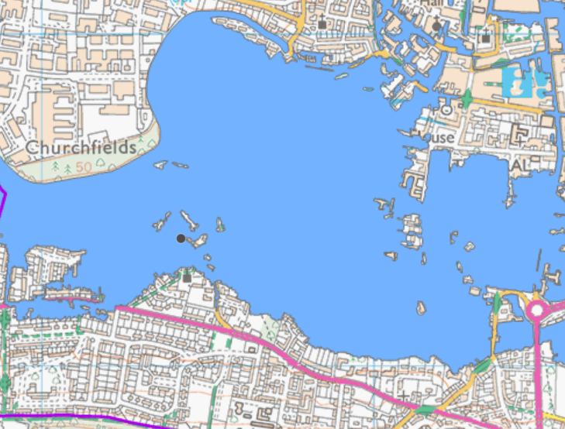

This application is for a first-floor extension and a dormer extension to an existing host dwelling. No site-specific flood risk assessment has been included as part of this application. However, as the application does not propose any additional footprint, it is not considered that the extensions increase flood risk and surface water drainage. The proposal therefore complies with Core Policy 67 of the Wiltshire Core Strategy and the policy in the NPPF.

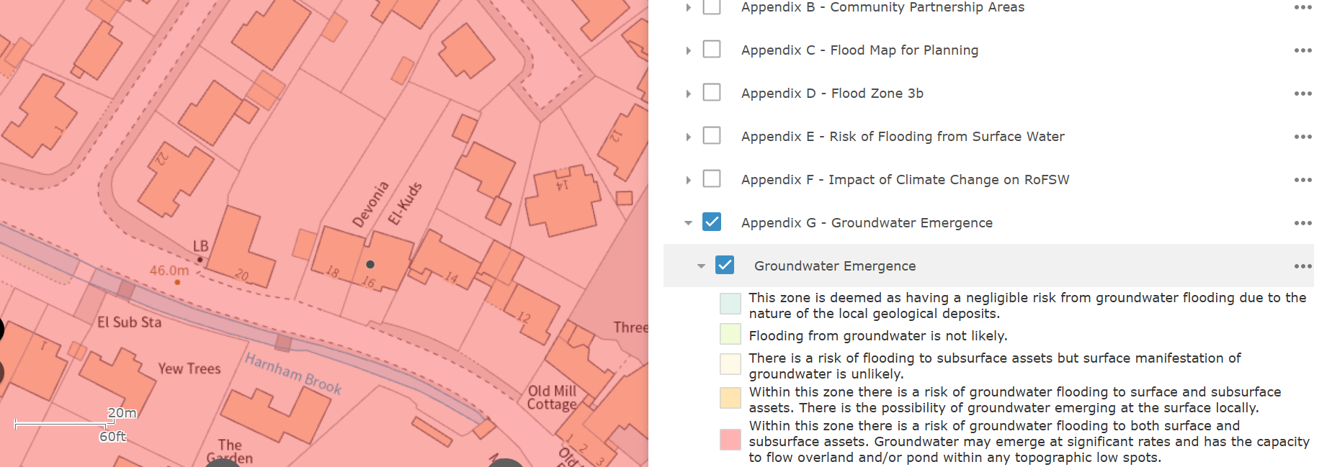

Biodiversity Net Gain

Householder planning applications are exempt from the requirement to deliver Biodiversity Net Gain under Schedule 7A, Section 4(2)(a) of the Town and Country Planning Act 1990, as inserted by the Environment Act 2021.

CONCLUSION

The proposed development is considered to be acceptable in terms of its design, scale, and relationship with the surrounding area. It would not result in any unacceptable harm to the character of the locality, the amenities of neighbouring occupiers, or the interests of highway safety, heritage, or ecology.

The proposal is therefore considered to comply with the relevant policies of the Wiltshire Core Strategy, the Wiltshire Local Plan, and the National Planning Policy Framework. As such, the application is recommended for approval, subject to the conditions set out below.

RECOMMENDATION: That Planning Permission be GRANTED subject to conditions.

1.The development hereby permitted shall be begun before the expiration of three
years from the date of this permission.

REASON: To comply with the provisions of Section 91 of the Town and Country
Planning Act 1990 as amended by the Planning and Compulsory Purchase Act
2004.

2.The development hereby permitted shall be carried out in accordance with the
following approved plans and documents:

Site Location Drawing No. 1131_01 Received: 15 December 2025
Proposed Plans Drawing No. 1131/04A Received: 15 December 2025
Proposed Elevations Drawing No.1131/ 05A Received: 15 December 2025

REASON: For the avoidance of doubt and in the interests of proper planning.

3. Materials to be used in the construction of the works hereby permitted shall be as stated on
the application form and in the submitted documents.

REASON: In the interests of visual amenity and the character and appearance of the area.

4.No part of the development hereby permitted shall be first brought into use until the access & parking spaces (3) have been completed in accordance with the details shown on the approved plans. The areas shall always be maintained for those purposes thereafter and maintained free from the storage of materials.

REASON: In the interests of highway safety.

4. Notwithstanding the provisions of the Town and Country Planning (General Permitted Development) (England) Order 2015 (or any Order revoking or re- enacting or amending that Order with or without modification), no windows shall be inserted in the first-floor east side elevation of the development hereby permitted.

REASON: In the interests of residential amenity and privacy.

5. Before the development permitted is first brought into use the proposed dormer window which serves the proposed bathroom in the rear (north) elevation shall be glazed with obscure glass only [to an obscurity level of no less than level 5] and the window shall be maintained with obscure glazing for the lifetime of the development.

REASON: In the interests of residential amenity and privacy.

Informative:
The application involves an extension to the existing vehicle access. The consent hereby granted shall not be construed as authority to carry out works on the highway. The applicant is advised that a licence will be required from Wiltshire’s Highway Authority before any works are carried out on any footway, footpath, carriageway, verge or other land forming part of the highway. Please contact our Vehicle Crossing Team on vehicleaccess@wiltshire.gov.uk and/or 01225 713352 or visit their website at http://wiltshire.gov.uk/highways-streets to make an application.

