Arboricultural Report

A tree survey of land adjacent to 5 Clift Avenue, Chippenham with advice on how to protect trees in the face of a proposed development

Prepared by: Paul Marshall

Marshall Tree Services
5 The Close
Gastard
Wiltshire
SN13 9PX

01249 701836

Prepared For: Mr ShaunAllen
30 Whitworth Road
Chippenham
SN15 3QS

Date 16thJanuary 2026

Contents

Page

3 Section 1 -Instruction, Section 2 -Limitations
4 Section 3 -Background and site details
5 Section 4 -Survey Methodology
6-9 Section 5 -Survey Data
10 Section 6 -Table of Root Protection Radii
11 Section 7 -Potential Arboricultural impacts of development
12-14 Section 8 -Measures to protect trees during construction

1.0 Instruction

1.1 I am instructed by Mr Allen to inspect the trees that might be affected by a proposed development on Land adjacent to 5 Clift Avenue, Chippenham, survey them to BS 5837:2012 and report on how they may be protected in the face of a proposed development.

1.2 I confirm that I am a qualified tree surgeon with 25years of experience in arboriculture. I hold the Arboricultural Association’s Tech. Cert. Arb. at distinction level. I attained the highest mark in the country in the 2006 examinations for this certificate.

2.0 Limitations

2.1 This report only covers evidence which could be seen by eye on the day of inspection. Many important components of a tree’s strength cannot be seen –underground roots for example.

2.2 Trees are dynamic living organisms. Their health and condition can change rapidly. Their health, condition and safety should be checked at least once a year and conclusions and recommendations are only valid for a period of one year. Any change in conditions near a tree may reduce this period. This is particularly true if ground works are carried out close to a tree.

2.3 No tree or part thereof should ever be considered as incapable of failure. Even a perfectly healthy tree may fail under extreme conditions (such as an exceptional storm).

2.4 I did not have permission to access land adjacent to the building plot and its driveway. The measurements of the trees on adjacent land have been estimated carefully based on known measurements taken close by on site.

3.0 Background and Site Details

3.1 This land lies behind Clift Avenue and is accessed via a lane that runs down the side of Number 5 Clift Avenue. The site has been used as car parking. A large part of the surface area of the site (on the Northern side) is hard standing -concrete slab. Throughout most of the site, this slab extends from close to the site’s northern boundary to between 6 and 7 metres of the site’s Southern boundary, which is a tall chain-link fence topped by lines of barbed wire.

3.2 The southernmost land (the land closest to the former Westinghouse site) has not been surfaced. This land is adjacent to a freely growing screening hedge of Leyland Cypress trees (with a self-seeded Sycamore at the western end), which grow on the Westinghouse site (tree trunk centres 1 metre from the boundary). I am informed that the owners of the Westinghouse site may eventually plan to remove this screen of Leyland Cypresses. However, they are currently behind protective fencing while the site is developed.

3.3 A number of self-seeded trees have grown up from the Clift Avenue site, through the high chain-link boundary fence itself into the hedge on the land of the Westinghouse site. None of these trees is in good health or of good form, having suffered competition with the strong Leyland Cypress hedge and having been harshly cut back from the Clift Avenue site in the past to 6 metres height. Some of these trees have considerable defects in their trunks as a result of damage from the fence wire.

3.4 The unsurfaced land to the south of the site was neglected following the topping of the boundary trees. Self-seeded trees and brambles began to grow in this area. Mr Allen purchased the site and cleared this scrub, which was not suitable for inclusion in a domestic garden. He also removed a young Sycamore tree growing next to a wall at the Eastern end of the Southern boundary because this tree had no more room for its trunk and root buttresses to grow without damaging the boundary wall.

4.0 Survey methodology

4.1 I have received a site plan drawn by John Thompson Architects.

4.2 I have visited site and marked the position of all trees on site on this plan.

4.3 I have assigned each tree a unique identifying number, added this to the plan and returned the plan to Stephen Kingshott MCABE for him to put the trees onto the site plan.

4.4 I have then surveyed each tree to BS 5837:2012. Where trees are multi-stemmed, I have recorded the diameters of all the stems and then worked out a nominal single stem diameter as per the formulae of BS 5837. Where I have not been able to access a tree on neighbouring land, I have estimated values based on measurements taken close by on site.

4.5 I have also surveyed hedges to BS 5837. Normal domestic hedges need only have their height recorded. If hedges are larger, I have also recorded the diameter of the largest tree in the hedge, so as to be able to make sure that the hedge has an adequate Root Protection Area. Where a large hedge contains an unusually large tree, I have recorded all the details of this tree as a separate individual tree, so that it is not necessary to give a needlessly large Root Protection Area to the rest of the hedge.

4.6 From my measurements I have produced a table of Root Protection Radii for each tree in accordance with the table in Annex D of BS 5837:2012. These can be seen below in section 6 of this report.

4.7 When the root protection Radii have been plotted onto the site plan, tree constraints can be assessed and appropriate tree protection can be specified for the site.

Tree Survey Schedule – Prepared by Marshall Tree Services to BS5837: 2012
Client: Mr Shaun Allen
Site: Land adjacent to 5 Clift Avenue Chippenham
Date of survey: 11th December 2025
Surveyor: Paul Marshall
Identification of trees: by number on plan

Explanation of Life Stage Classification: Y = Young, SM = Semi Mature, EM = Early Mature, M =Mature OM = Over mature, V = Veteran

Species are listed by common names. Scientific names are given in a list at the end of this schedule MS denotes a multi stemmed tree (each stem is measured and a combined nominal stem diameter calculated, which is given in bold in brackets)

Reference: Sheet number: 1

Tree  Reference  Number | Species | Height  (m) | Stem  diameter  (mm) | Branch  Spread  (m) | Height (m)  And direction of first branch | Height of canopy  (m) | Life  stage | General observations  (in particular: structural and/or physiological condition and/or preliminary management recommendations) | Estimated  remaining  contribution  (years) | Category  grading
T1 | Holly | 5.5 | 130 | N2  E2  S 2  W 3 | 1.5  N | 2 | Y | A very young tree | 40+ | C2
T2 | Holly | 3.5 | 75 | N1.5  E1.5  S1  W1.5 | 1.5  W | 1 | Y | A very young tree, barely making the threshold for inclusion in a survey | 40+ | C2
H1 | Beech | 1.5 |  | N  E  S  W |  |  |  | A small recently planted hedge composed of very small trees
H2 | Privet | 1.5 and 4.5 |  | N  E  S  W |  |  |  | This hedge spans two gardens. The hedge in one garden has been maintained recently, the other part of the hedge has grown tall. This multi-stemmed hedge is made up of thin stems, most being thinner than 25 millimetres
H3 | Leyland Cypress | 2.5 to 4.5 | Max 200 | N  E 2  S  W 1 |  |  |  | This hedge is borderline between being a domestic hedge and a larger hedge because it has not been maintained recently. I have given a maximum stem diameter for it.

Sheet number: 2

Tree  Reference  Number | Species | Height  (m) | Stem  diameter  (mm) | Branch  Spread  (m) | Height (m)  And direction of first branch | Height of canopy  (m) | Life  stage | General observations  (in particular: structural and/or physiological condition and/or preliminary management recommendations) | Estimated  remaining  contribution  (years) | Category  grading
T3 | Goat Willow | 14 | 380 | N2  E6  S 6  W 1 | 1.5  N | 6 | OM | Very poor Vigour, most of the tree is dead, growing into the Leyland Cypress Screen. Unsuitable for retention. Remove once the future of the fence into which it is growing has been decided and the fenced off area of the Westinghouse site is again open for access. | >10 | U
T4 | Sycamore | 14 | MS  140  150  120  240 | N 3  E4  S2  W3 | 1.5  N | 2 | SM | Previously topped at 6 metres, growing into the wire, large dead wood, a poor specimen | 10-20 | C2
T5 | Sycamore | 14 | 200 | N4  E4  S 0  W 3 | 2  E | 3 | EM | Growing through the wire, damaged by the wire, previously topped at 6 metres. A poor choice for long term retention | 10-20 | C2
T6 | Sycamore | 15 | 220 | N 0  E 2  S 6  W 3 | 2  S | 5 | EM | Growing through the wire, strong lean to the south, previously topped at 6 metres, now growing through the Leyland Cypress hedge behind. A very poor tree to retain in the long term | 10-20 | C2
T7 | Ash | 15 | MS  150  170  230 | N 3  E 2  S 2  W 2 | 0  N | 4 | SM | Previously topped at 6 metres, early Ash dieback, large dead wood poor choice for long term retention | 10-20 | C2
T8 | Sycamore | 12 | 150 | N4  E2  S2  W3 | 1  W | 3 | SM | Suppressed, poor form having grown seeking light | 10-20 | C2
T9 | Sycamore | 13 | 160 | N0  E2  S6  W2 | 2  S | 5 | SM | Very poor form, damaged by wire, growing out through the Leyland Cypress hedge with a strong lean. Remove once the future of the fence into which it is growing has been decided and the fenced off area of the Westinghouse site is again open for access. | >10 | U
T10 | Sycamore | 14 | 150 | N0  E1  S 6  W 4 | 2  S | 5 | SM | Growing through the chain-link. Damaged by the wire. Very strong lean to the South. Unsuitable for retention. Remove once the future of the fence into which it is growing has been decided and the fenced off area of the Westinghouse site is again open for access. | >10 | U

Sheet number: 3

Tree  Reference  Number | Species | Height  (m) | Stem  diameter  (mm) | Branch  Spread  (m) | Height (m)  And direction of first branch | Height of canopy  (m) | Life  stage | General observations  (in particular: structural and/or physiological condition and/or preliminary management recommendations) | Estimated  remaining  contribution  (years) | Category  grading
T11 | Ash | 7 | MS  200  250  320 | N0  E2  S 6  W 2 | 3  S | 4 | OM | Moribund. Ash dieback, previously topped at 6 metres, grows through wire. Remove once the future of the fence into which it is growing has been decided and the fenced off area of the Westinghouse site is again open for access. | >10 | U
H4  Except  T12 | Leyland Cypress  with some Sycamores | 17 | Up to 500 | N 3  E  S6  W |  |  |  | A Leyland Cypress hedge that has been allowed to grow freely. Such trees often begin to drop branches as they approach 20 metres height. This hedge is not ideal for long term retention as it is very hard to maintain, yet needs maintaining to prevent it becoming oversized and dropping branches or stems. I am told it is planned to remove it | 20-40 | B2
T12 | Leyland Cypress | 19 | MS  200  350  600  725 | N3  E5  S 6  W4 | 1.5  S | 2 | M | The most Eastern tree of H4, which has grown considerably larger than the rest of the hedge | 20-40 | B2

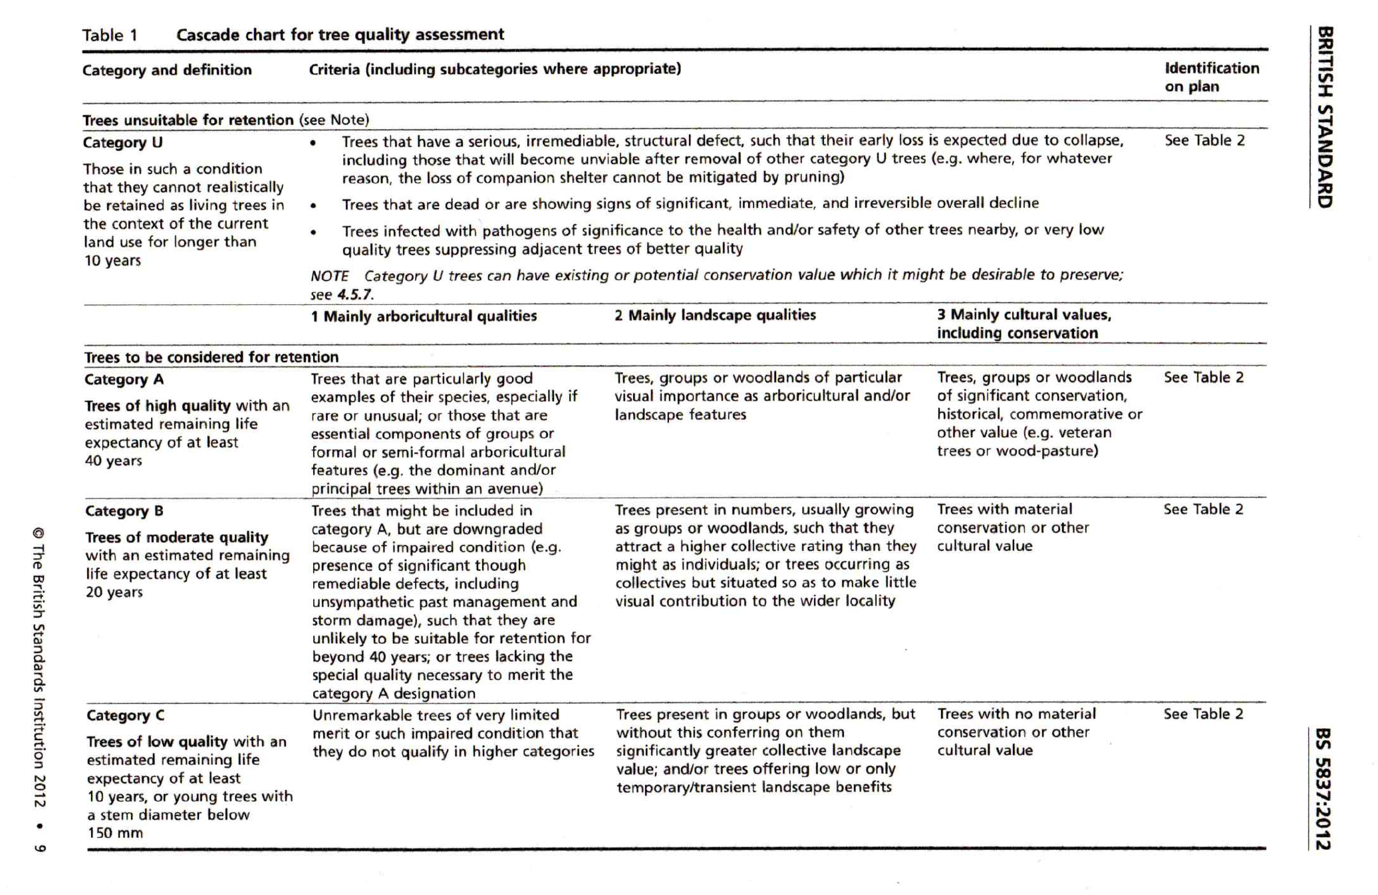

6.0 Table of Root Protection Area radii

6.1 I have calculated the root protection radii of the trees as per the table in appendix D of BS 5837:2012. Here below is a table of RPA radii (in anticlockwise order as one moves around site from the entrance gate).

Tree or hedge number | RPA radius in metres
T1 | 1.5
T2 | 0.9
H1 | To hedge canopy
H2 | 1.2
H3 | 2.4
T3 | 4.5
T4 | 3.0
T5 | 2.4
T6 | 2.7
T7 | 2.7
T8 | 1.8
T9 | 1.8
T10 | 1.8
T11 | 3.9
H4 Most western 8 metres | 3.6
H4 remainder except T12 | 6.0
T12 | 8.7

7.0 Potential Arboricultural Impacts of this development

7.1 All the major trees growing on this site are along the Southern boundary. There are some very small trees in neighbouring gardens and some smaller hedges along some of the boundaries. These smaller trees and hedges can be readily protected by a standard Construction Exclusion Zone. Tree 1 (a young Holly) has a slight incursion of its Root Protection Area into the site. However, this is a very young and small tree -130 mm diameter at 1.5 metres. This is a tree which is likely not to be permanently adversely harmed by development and it is also not of a size that would become dangerous if it were damaged.

7.2 There are no trees growing on site that would actually add value to a future development and most would detract from a future development. Unfortunately, the trees growing from the site are tangled with wire and growing far more over the Westinghouse site than the Clift Avenue site. They have also all been harshly topped at some point in the past. It is not practical to remove these trees until the Westinghouse Leyland Cypresses come out from behind protective fencing and the chain link fence is removed as almost all the wood in these trees is over the Westinghouse site and leaning at an angle.

7.3 It is very important to remember that the screening hedge of Leyland Cypresses on the land of the Westinghouse site to the South is tall and is weighted towards the South (away from this site but weighted towards what is currently a contractors’ car park). We also have no certainty that these trees will actually be removed until they are removed. It is very important that these trees are not de-stabilised by this development as they could fall onto the Westinghouse site.

7.4 There is plenty of space on site that is not under root protection areas but it is important to protect the trees to the South of the site during construction. Although I have been unable to access the Westinghouse site. I have been able to estimate the sizes of the diameters @ 1.5 metres height of the trees that stand on the Westinghouse site. I have calculated Construction Exclusion Zones which protect these trees. These Construction Exclusion Zones overlap with and cover the Construction Exclusion Zones of smaller trees that stand on the site boundary. Thus, by protecting the trees on the Westinghouse site, we can protect all trees to the South of the planned development.

7.5 Following development, particularly if the screening hedge is removed, there will not be any trees of arboricultural value on site. Some quality planting of smaller trees could add value to the site.

7.6 During development, there should be plenty of space on site for storage outside of Construction Exclusion Zones and the existing hard surface is very suitable for the mixing of cement but it will be important to be wise about the discharge of cement washings and make sure they do not travel into Construction Exclusion Zones.

8.0 Recommendations for tree protection

8.1 Services will need to be laid along the driveway of the site. There is no vegetation on either side of the driveway that would be damaged by trenching operations to lay services.

8.2 Due to the unusual circumstance of some small trees growing through the Southern barrier fence into a current Construction Exclusion Zone, it will not be practical to remove some small, poor quality, trees prior to construction beginning as would usually be done. These trees are relatively small and this work can be carried out later. None of the tees could threaten the future development.

8.3 Tree roots will need to be protected by standard Construction Exclusion Zones as per BS 5837.

8.4 A Tree Protection Plan is drawn up, showing the position of barriers to form a Construction Exclusion Zone to protect Root Protection Areas of trees and hedges that are not under hard standing.

8.5 The Construction Exclusion Zones, should be set up according to the Tree Protection Diagram and the specification below, which is should then beverified by an arboriculturist to be fit for purpose. These barriers should then remain in place for the entire duration of the construction project.

8.6 Concrete must be mixed close to any Root Protection Areas and cement washings should be discharged in a way that directs them away from root protection areas. Cement should be mixed on the existing hard standing. Cement washings can be very harmful to trees and it will be important that the tall screen of trees do not become destabilised by root damage as these trees could fall and strike a new house. The ground on this site is quite flat and it is likely that washings will not travel far but if washings prove to be travelling across the existing hard standing, then bunding will be needed, or a deep trench into which to drain washings, stopping their progress towards retained trees. An area for concrete mixing is marked onto the Tree Protection Plan.

8.7 When considering the trees on the Westinghouse site, the need for Construction Exclusion Zones can be broken down into 3 areas. Firstly, at the Eastern end of the hedge is a very large multi-stemmed Leyland Cypress (which has grown very much bigger than the other trees because it has had less competition from other trees). This tree should be considered on its own. It has been given an individual survey number and has been calculated an individual Root Protection Area.

8.8 To the West of this tree, there is no tree in the hedge that will have a stem diameter (or nominal stem diameter in the case of a multi-stemmed tree) larger than 500 millimetres. This section of hedge may be protected by creating a construction Exclusion Zone along the side of the hedge that treats all the trees as being of 500 millimetres diameter @ 1.5 metres height. Finally at the Western end of the screening hedge, there is no retained tree with a stem diameter above 300 millimetres, so a Construction Exclusion Zone, running along the side of the hedge, suitable for a tree of 300 millimetres diameter at 1.5 metres will be appropriate.

8.9 Some smaller, low quality, trees growing into the southern fence have their Root Protection areas entirely covered by the Root Protection Area of H4 and have canopies entirely incorporated into H4. Therefore, these trees are not shown as they are essentially part of H4 and are protected along with it.

8.10 If these Construction Exclusion Zones are set up with default standard protection to BS 5837 (as shown in the diagram below), trees should be successfully protected during construction.

8.11 Protective fencing specification

Prior to the commencement of any construction activity, protective fencing must be erected to protect the Root Protection Areas of retained trees. The fencing must be erected in the positions shown in the Tree Protection Plan diagram.

Fencing must be to the default specification of British Standard 5837:2012. Below is shown figure 2 from BS 5873:2012, showing the default construction of fencing specified by the British Standard.

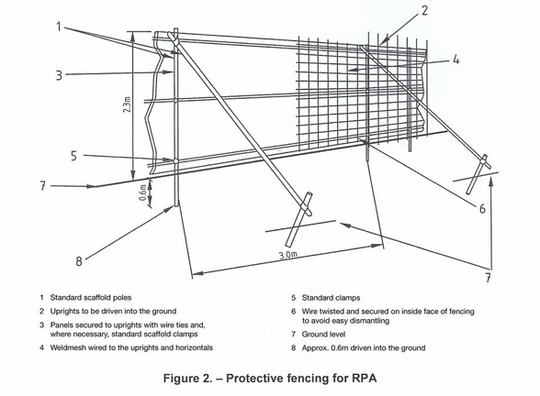

The Construction Exclusion Zone must be marked with waterproof signs reading “Construction Exclusion Zone –No Access” or words to this effect. The Construction Exclusion Zone is to remain sacrosanct throughout the construction process and must not be dismantled until all construction activity on this site has ceased. No one must access these areas for any reason unless it is first agreed with an Arboriculturist.

8.12 Arboricultural checks

Once fencing has been erected an arboriculturist should be called to site to verify that the fencing is fit for purpose. This check should be formally recorded (such as by the arboriculturist sending the project manager an email).

The fence should remain in place, untampered with for the duration of the entire project. At the end of the project an arboriculturist should again be called to verify that the fence is still in place in the correct position. This check should again be recorded.

Only after the final arboriculturist’s check, should the fence be dismantled and landscaping operations begin in the areas that were the Construction Exclusion Zone.

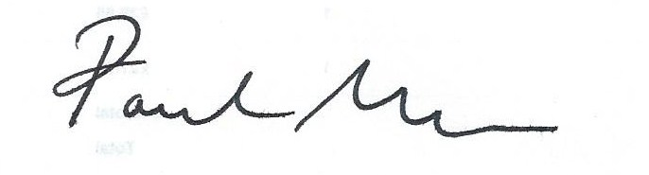
Paul Marshall BA Hons, Tech Cert Arbor A. 16th January 2026

