Ecological enhancements for new dwelling at 5 Clift Ave, Chippenham.

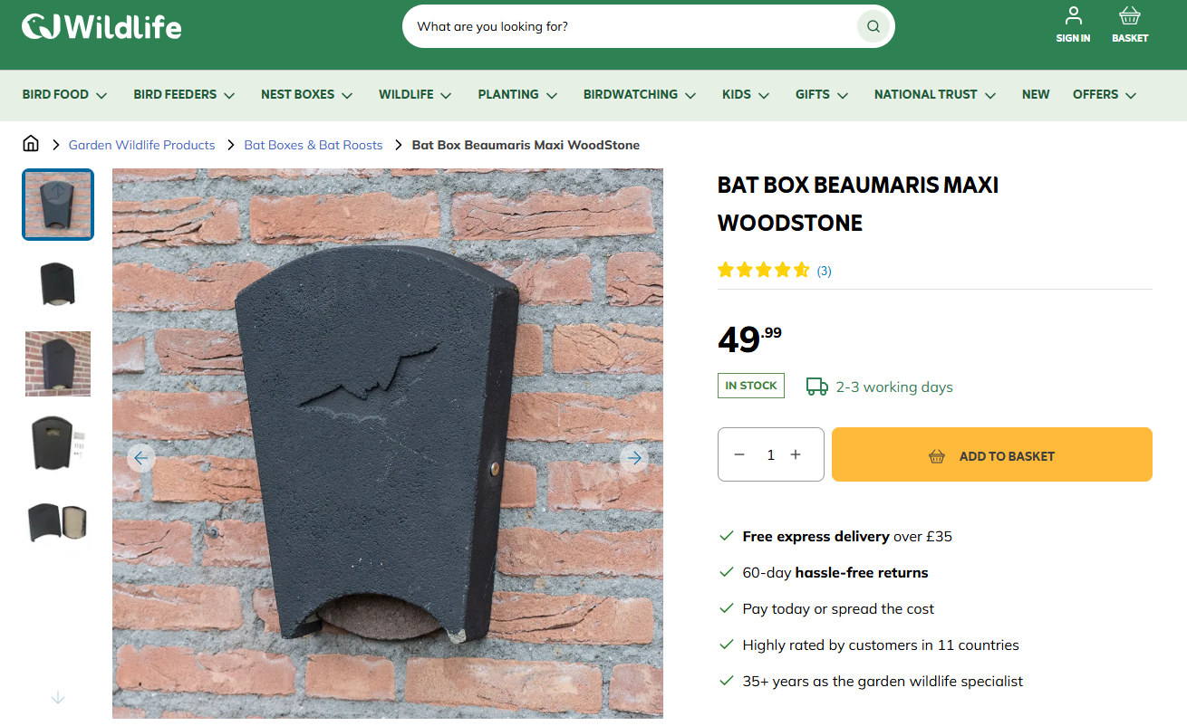
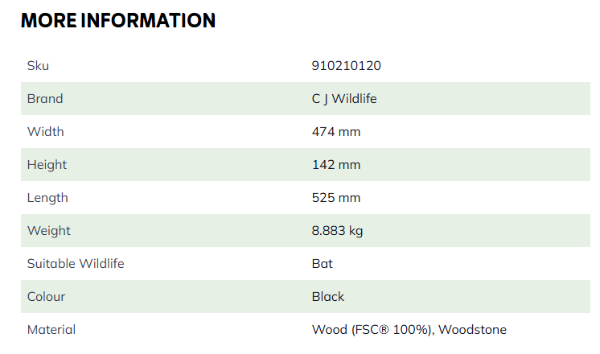

https://www.birdfood.co.uk/beaumaris-bat-box-large?utm_source=bing&utm_medium=cpc&utm_campaign=b-uk-en-viva-msc-pla-cvr-bofu-new&msclkid=4957b039fa9f1b34fc34d96791013a4e&utm_term=4574999189379029&utm_content=All%20Products
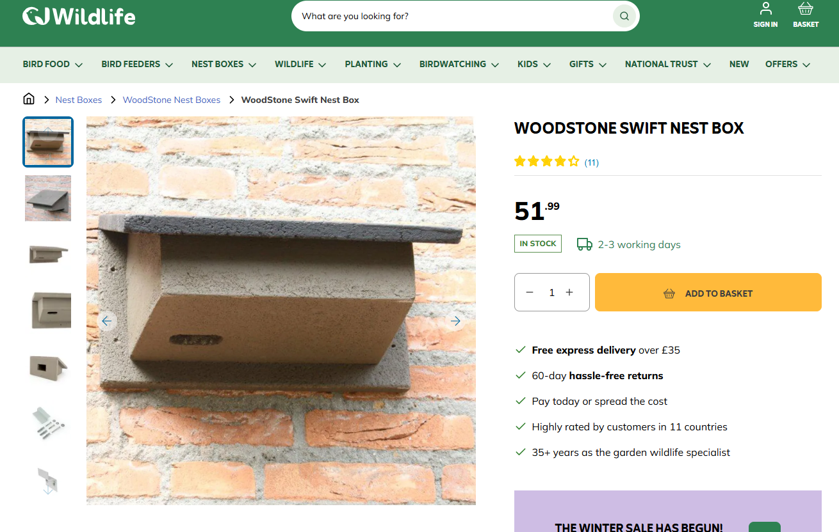

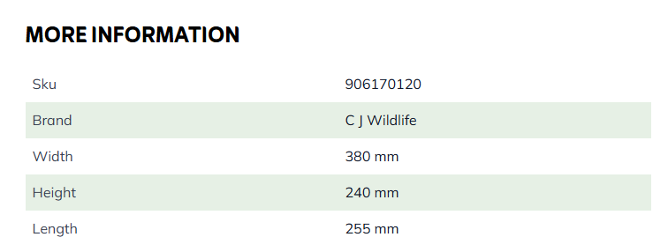

https://www.birdfood.co.uk/swift-nest-box-woodstoner

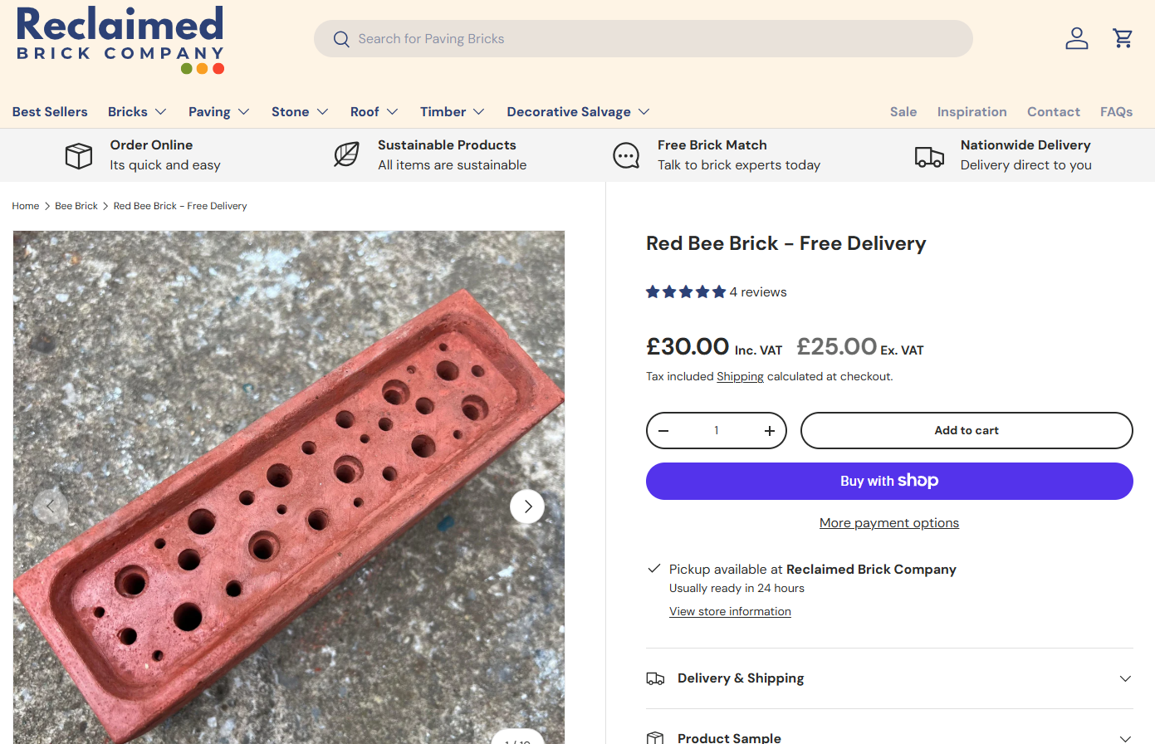
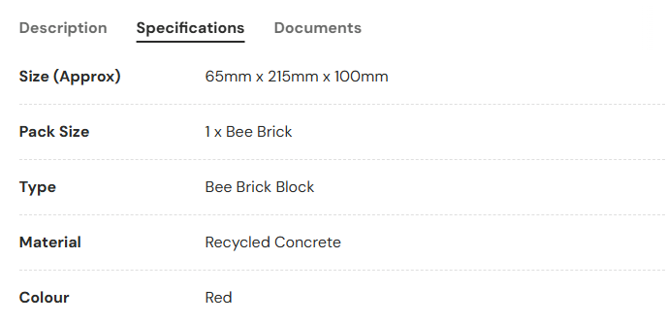

https://reclaimedbrickcompany.co.uk/collections/bee-brick/products/red-bee-brick-free-delivery

