EV Charging information/specification

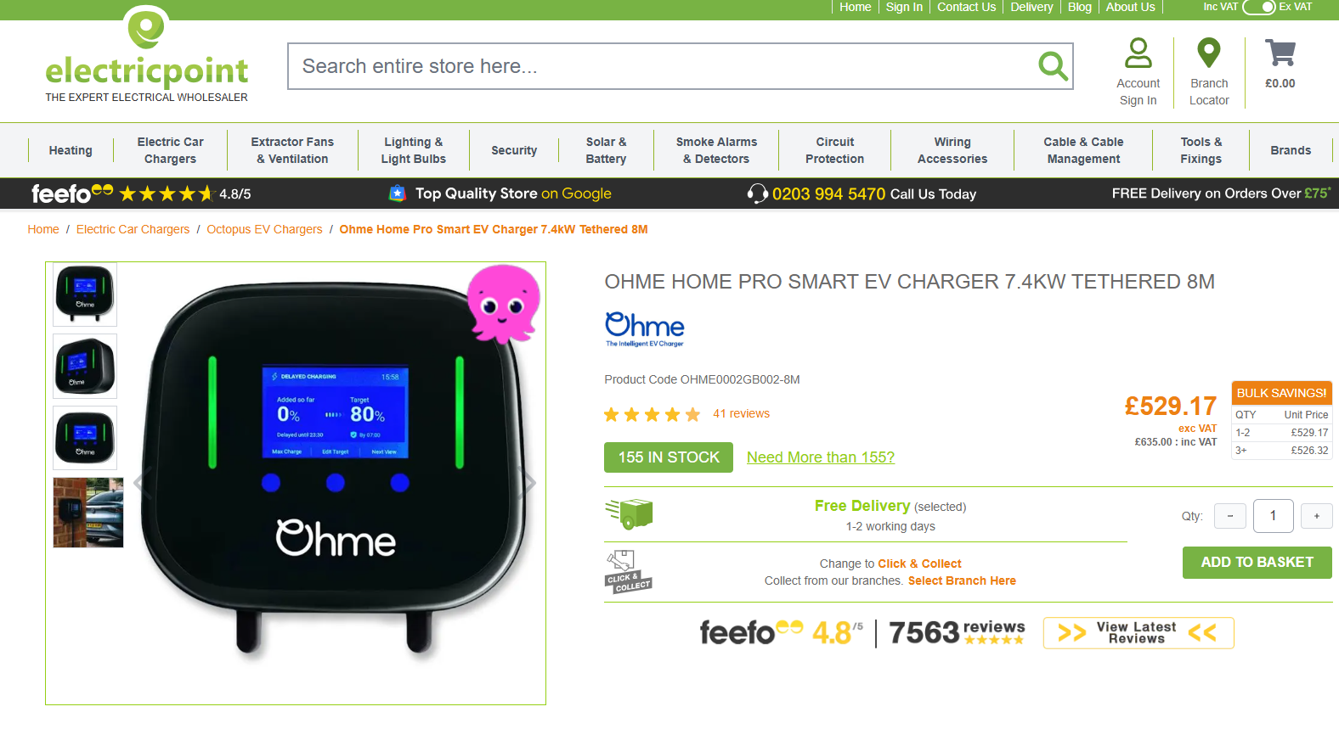

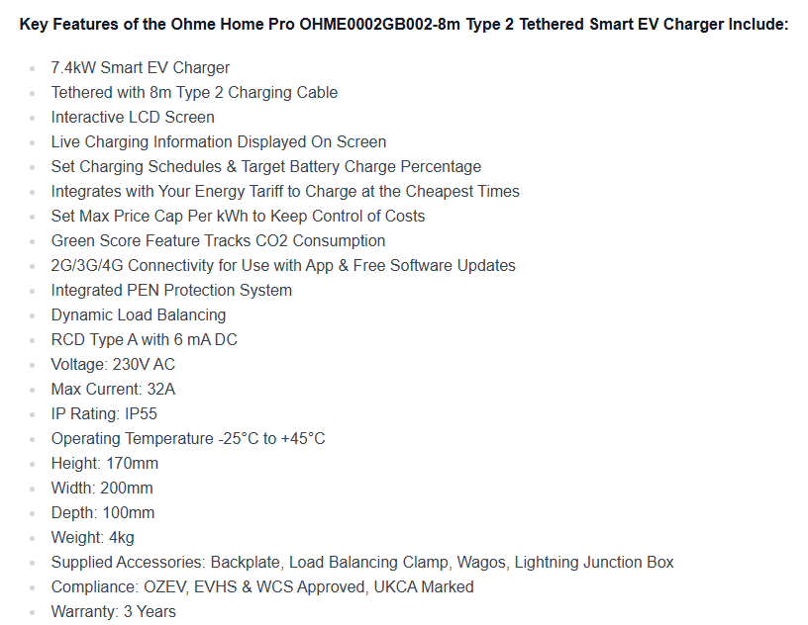
https://www.electricpoint.com/ohme-home-pro-7kw-tethered-8m-type-2-smart-ev-charger.html

