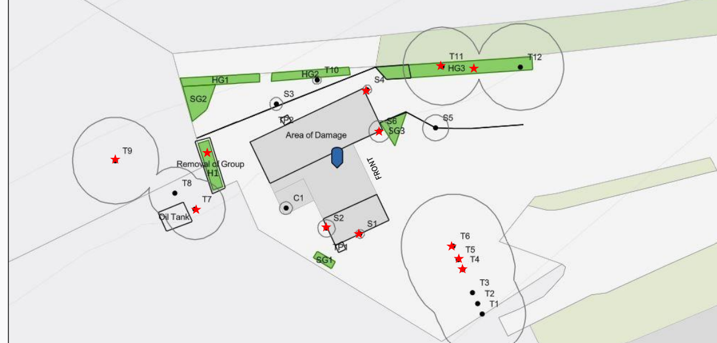
Coombe Farm, Coombe Lane, Bratton, Westbury, BA13 4SY

