Marlborough College

Construction Method Statement
In realation to

Planning App PL/2025/02151
Proposed Multi Use Games Area
to Barton Hill

Project Overview

As per planning application, proposed is the installation of a new Multi-Use Games Area (MUGA) at Barton Hill.

Site logistics
Site working hours will be Monday- Friday 8am -5pm (construction & deliveries)
Weekend and bank holiday working is not envisaged but if required hours will be 9am-4pm. No weekend deliveries.
All works are on private land away from any puplic highway or right of way, access is via collegfields on to privatly own college land.
Contractor parking and welfare will be situated in a compound just off of college fileds, again on privatly own college land.
Plant and materials will be delivered to a hardstanding set down area and moved to site by own means or mechanical handling. (see Fig 1 )
As mentioned the site is on private land so a full hoarding is not nessecary. Herras type fencing will be utilised to segregate the work site with access gates to enable emergency vehicle access if required (see Fig 1 )

Figure 1

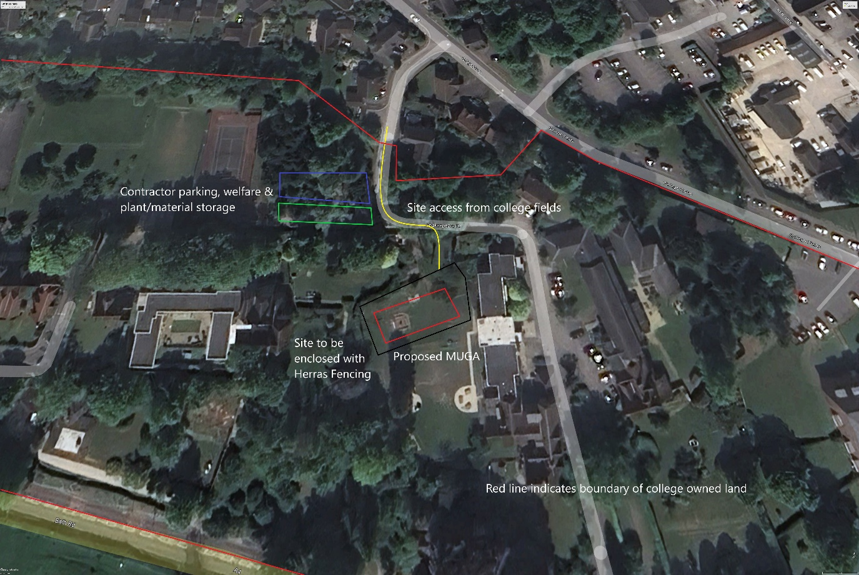

Environmental considerations
During the excavation phases dust suppression systems will be employed when required.
All excavation will be conducted from hardstanding; we do not envisage the requirement for a dedicated wheel wash for plant or delivery vehicles.
excavation and construction waste will be segregated and removed from site via licenced waste carriers.
To safeguard the natural environment during operations:
Site Containment: All works will be confined within designated site boundary fencing to prevent encroachment into surrounding areas.
Watercourse Assessment: The operational area has been surveyed and confirmed to contain no watercourses or open gullies, minimising risk of contamination or runoff.
Spill Response Preparedness: Spill kits will be readily available within the vicinity of the worksite to ensure rapid response in the event of any accidental discharge.
No species have been identified that would require a licensed ecologist to be present on site, aside from nesting birds. As the development is expected to be well underway by the nesting season (March–August), and no works are planned that would disturb nesting habitats, it has been advised that an ecologist will not be required. However, if considered necessary, an ecologist can be available on site to provide toolbox talks and guidance during the excavation period. All works will be conducted in accordance with the Wildlife and Countryside Act 1981.

