APPLICATION FOR HOUSEHOLDER PLANNING PERMISSION AND LISTED BUILDING CONSENT DELEGATED REPORT

APPLICATION REFERENCE: | PL/2025/08638 and PL/2025/08846
APPLICATION TYPE: | Householder planning permission and Listed Building Consent
SITE ADDRESS: | The Old Stables, 41A Main Street, Keevil, Trowbridge, BA14 6LX
DEVELOPMENT DESCRIPTION: | Replacement windows and doors, replacement concrete window cill.
RECOMMENDATION: | That Planning Permission/ Listed building consent be GRANTED

This is a joint report for PL/2025/08638 (HPP) and PL/2025/08846 (LBC).

As the garage/annexe structure is not considered curtilage-listed as it was built post-1948, LBC is only required for the elements relating to GII-listed Stable and Carriage House.

Planning Permission is required for the garage/annexe element as it is within the curtilage of a listed building.

SITE DESCRIPTION/CONTEXT

The subject property is a grade II listed dwelling, a residential conversion of a 19th century Stable and Carriage House, which was once part of the historic Longleaze Farm; the grade II listed 18th century Longleaze Farmhouse lying southeast of the site, and highly visible from the proposal site.

The site also benefits from a modern garage/annexe building approved in 1989 in parallel across a courtyard, with the first floor and part ground floor converted to ancillary residential use.

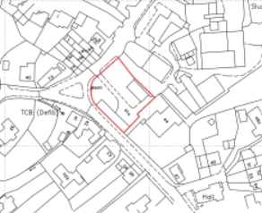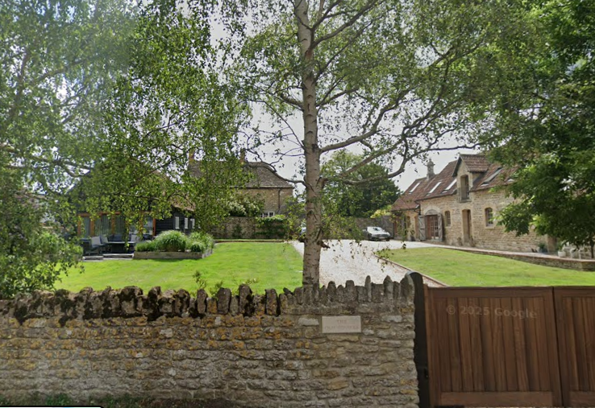

Location Plan and Google Earth Site Photo

The main dwelling (Coach House) is positioned in the junction of Martins Road to the west, and Main Street. Access is from Main Street into the historic farmyard as per the site photo above. Site Photos submitted with the application show that across the current access was once a barn of considerable size, which was destroyed by storms in 1987. This barn was late C18 and was individually listed and coeval to the farmhouse.

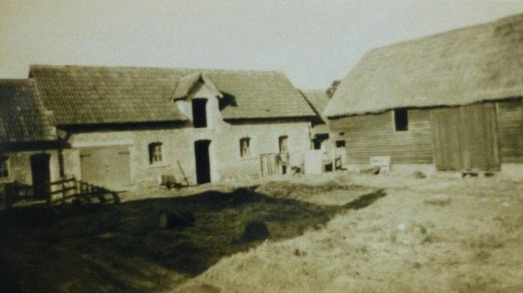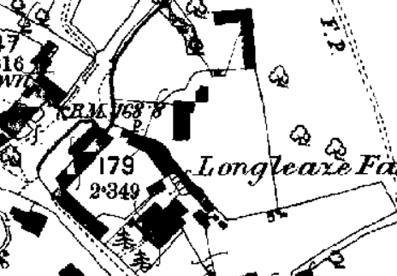

1968 photo of the subject property and lost barn.

First epoch mapping reveals the 1868-1899 courtyard arrangement of the agricultural buildings.

The Coach House reflects its C19 age and contrast to the earlier farmhouse, being part of a development of an older site of traditional farm buildings, by the introduction of these higher status stables. It was listed in its own right before its 1980s residential conversion. The building once included stabling, a carriage room, tack and feed room with gabled loft over. It has segmental openings with keystones, segmental-headed planked doors, an ashlar stack, and a loading bay.

Originally listed as ‘outbuildings to Longleaze Farm’ in 1968, the listing was updated in 1988 to refer to the buildings more specifically as ‘stables and carriage house’. In the 1980s the site appeared to be in the same ownership, but since the stable was converted to a separate dwelling, the site appears to have been divided into separate ownership, although the association of the farmhouse and its stable block remains close due to their physical relationship with each other. It is located in a fairly prominent location on the High Street of Keevil village, a rural village, the majority of which is protected by Conservation Area status.

The historic form and character of Keevil as a rural village remains legible, such that it is within Keevil’s Conservation Area, with the proposal site making an important and highly visible contribution to the rural character of the village.

PROPOSAL

The proposal seeks planning permission and listed building consent for replacement windows and doors. Timber elements are to be replaced with black coloured steel, all slim 18mm DG units. A concrete window cill to window 7 will also be replaced by stone, and the position of the windows within openings brought forward, as C19 examples. Existing windows have been shown to open outwards around a central pivot which is unusual, but this is the status quo.

Coach House and Stables:

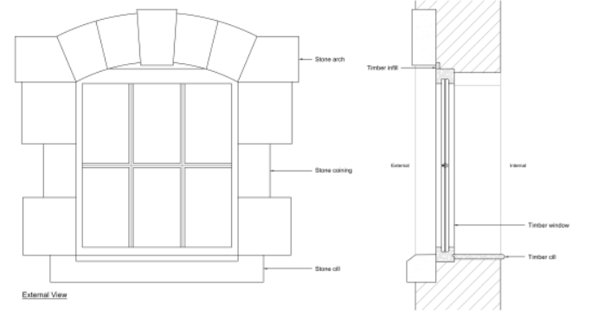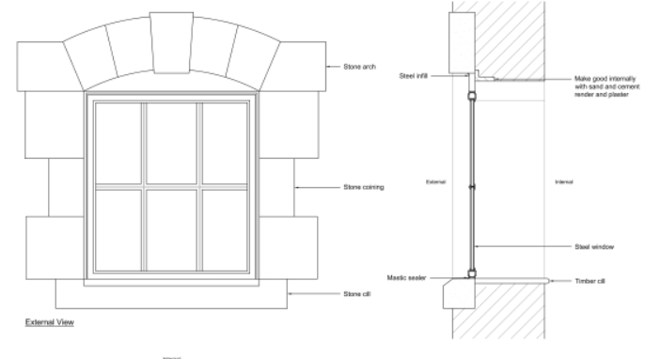

Existing and Proposed Window Details – concrete cill to be replaced with stone

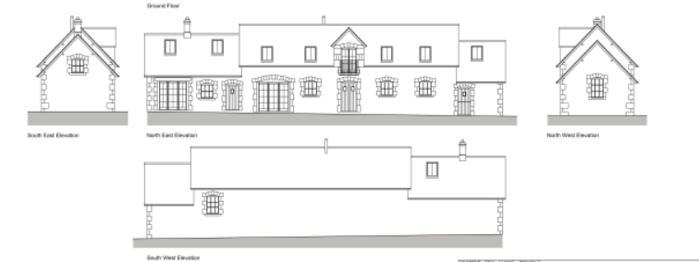

Existing Elevations

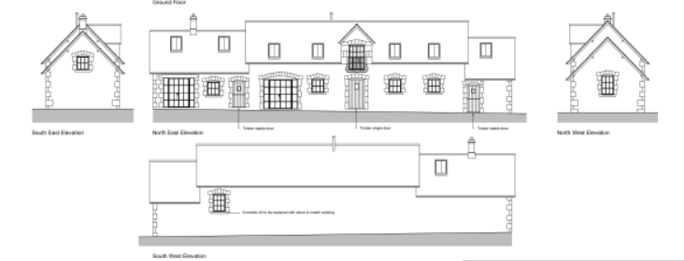

Proposed Elevations

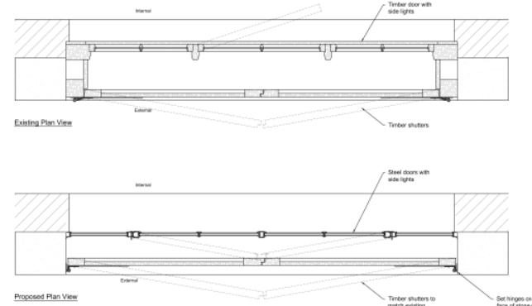

Existing and Proposed Door Details – timber door with sidelights replaced with steel doors with side lights, with timber shutters to match existing

Annexe:

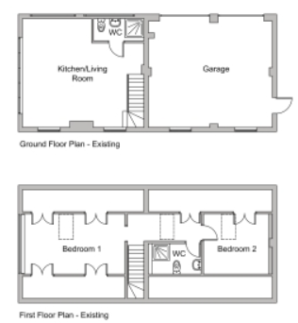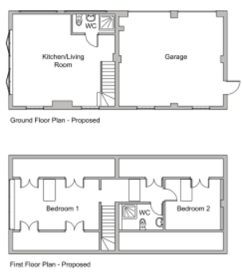

Existing and Proposed Ground Floor

Existing and Proposed First Floor Plans

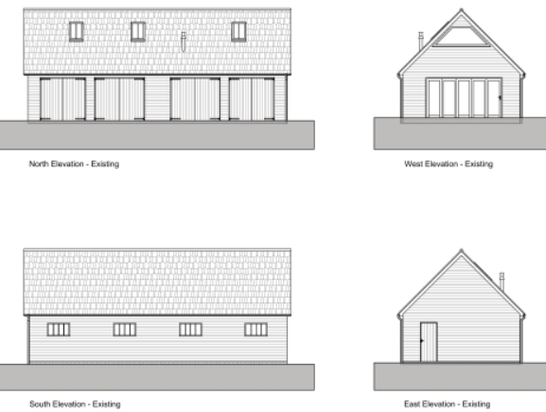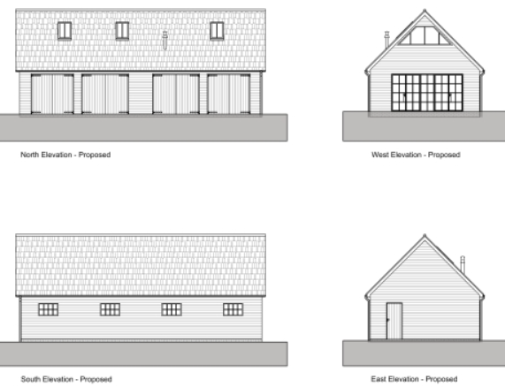

Existing Elevations Proposed Elevations

PLANNING HISTORY
W/82/00141/HIS - Historic apps 1974 to 1983 Decision - Approve with Conditions Date: 13/4/1982 – Change of use from stable to store
W/88/00406/LBC - Listed building consent Decision - Approve with Conditions Date: 19/7/1988 – Conversion of redundant stable block to residential use
W/88/00405/FUL - Full planning permission Decision - Approve with Conditions Date: 19/7/1988 – Change of use of redundant stables to residential use
W/88/00403/FUL - Full planning permission Decision - Approve with Conditions Date: 1/3/1989 – Conversion of redundant barn to residential use
W/88/00404/LBC - Listed building consent Decision - Approved Date: 1/3/1989 – Conversion and rebuilding of barn using matching new materials
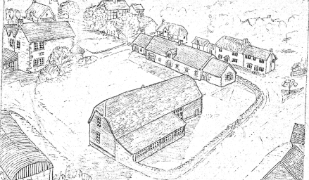
W/10/03401/LBC - Listed building consent Decision - Approve with Conditions Date: 13/12/2010 – Internal and external alterations to coach house and detached garage block, erection of stone walls, new gate and garden alterations
W/89/01253/FUL - Full planning permission Decision - Approve with Conditions Date: 22/8/1989 – Erection of four bay garage block for use of stable and barn conversion recently approved
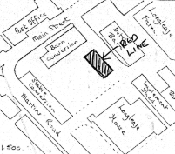
W/93/00504/FUL - Full planning permission Decision - Approve with Conditions Date: 15/6/1993 – Erection of single dwelling and 1.950 metre Cotswold stone wall
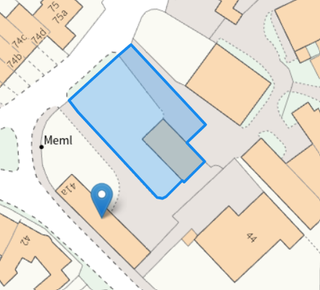
W/10/03402/FUL - Full planning permission Decision - Approve with Conditions Date: 13/12/2010 – Internal and external alterations to coach house and detached garage block, erection of stone walls, new gate and garden alterations
14/10777/FUL - Full planning permission Decision - Approve with Conditions Date: 20/1/2015 – Conversion of existing garage block to a residential annex involving the insertion of a new gable window, rooflights and internal works to the existing attic to provide two new bedrooms and a bathroom above the existing garden room and garage
PL/2025/08638 - Householder planning permission – Replacement windows and doors, replacement concrete window cill.
PL/2025/08846 - Listed building consent (Alt/Ext) – Replacement windows and doors, replacement concrete window cill.

RELEVANT POLICIES AND GUIDANCE
The National Planning Policy Framework (NPPF)
The Planning Practice Guidance
National Design Guide
Wiltshire Design Guide: Appendix D – Design Guidance for Householder extensions

The Planning (Listed Building and Conservation Area) Act 1990,
Sections 16 and 66: Listed Buildings
Section 72: Conservation Areas

Wiltshire Core Strategy:
- Core Policy 57 Ensuring High Quality Design and Place Shaping
- Core Policy 58: Ensuring the Conservation of the Historic Environment

Wiltshire Local Plan Pre-Submission Draft 2020-2038 (at Regulation 24 stage) – The Council’s draft Local Plan has reached Regulation 24 stage and is proceeding through examination. It is therefore a material consideration which will be given weight as appropriate at the time of any subsequent application. Emerging Policy –
Policy 89 – Biodiversity net gain
Policy 98 – Ensuring high quality design and place shaping
Policy 99 – Ensuring the conservation and enhancement of the historic environment

Keevil does not have a designated Neighbourhood Plan Area nor made plans.

Historic England’s Advice Note 2 – Making Changes to Heritage Assets is also relevant guidance for applying the policies within the NPPF.
Historic England’s “Conservation Principles” provides policy and guidance for the “sustainable management of the historic environment”. Additional guidance is also contained within their publications:
- Historic Environment Good Practice Planning Advice Note 2 – Managing Significance in Decision-Taking in the Historic Environment (2015)
- Advice Note 2 – Making Changes to Heritage Assets (2016) is also relevant guidance for applying the policies within the NPPF.
- Advice Note 18 – Adapting Historic Buildings for Energy and Carbon Efficiency (2024).
- Traditional Windows, their care, repair and upgrading (2015)
CONSULTATION RESPONSES

Keevil Parish Council: Support

Conservation Team: No objection

REPRESENTATIONS
No comments were received.

ASSESSMENT
Section 38(6) of the Planning and Compulsory Purchase Act 2004 states:

"If regard is to be had to the development plan for the purposes of any determination to be made under the planning Acts, the determination must be made in accordance with the plan unless material considerations indicate otherwise."

In accordance with this statutory requirement, this application has been assessed against the relevant policies of the Development Plan, including the adopted Wiltshire Core Strategy (2015) and, where applicable, any made Neighbourhood Plans.

Heritage, Design and Impact upon the character and context of the area:
From the point of view of the historic environment the main statutory tests are set out within the Planning (Listed Building and Conservation Areas) Act 1990.

Sections 16 and 66 requires that special regard be given to the desirability of preserving listed buildings, their settings or any features of special architectural or historic interest which they possess.

Section 72(1) of the Act requires the Council to pay special attention to the desirability of preserving or enhancing the character or appearance of designated Conservation Areas.

The Council’s Core Strategy Policy CP58 ‘Ensuring the conservation of the historic environment’ requires that designated and non-designated heritage assets and their settings will be conserved, and where appropriate enhanced, in a manner appropriate to their significance and encourages proposals which improve the condition of heritage assets at risk.

The Council’s Core Strategy CP 57: Ensuring high quality design requires a high quality of design in all new developments. The policy requires applicants to “demonstrate how the proposal will make a positive contribution to the character of Wiltshire through (amongst other things) responding to the value of the natural and historic environment and being sympathetic to and conserving historic buildings and landscapes. Development is required to respond positively to the existing in terms of building layouts, built form, height, mass, scale, building line, plot size, elevational design, materials, streetscape and rooflines to effectively integrate the building into its setting.

The NPPF outlines government policy for planning. Chapter 16 of the NPPF 'Conserving and enhancing the historic environment' sets out the Government's high-level policies concerning heritage and sustainable development. Paragraphs 213-215 of the NPPF require a balanced approach with any harm which would be caused being weighed against the potential public benefits which might be achieved. Paragraph 210 requires local planning authorities to take account of the desirability of sustaining and enhancing the significance of heritage assets and of new development making a positive contribution to local character and distinctiveness.

Section 14 of the NPPF addresses the challenge of climate change, flooding and coastal change. Paragraph 167 advises that “Local planning authorities should also give significant weight to the need to support energy efficiency and low carbon heating improvements to existing buildings, both domestic and non-domestic (including through installation of heat pumps and solar panels where these do not already benefit from permitted development rights).

Assessment must consider harm to historic fabric of the listed Stables and Carriage House, and potential harm to the setting of the listed subject property and Farmhouse outside the curtilage to the southeast.

The application is for the replacement of all the windows within the grade II listed building and matching windows for the annexe within the curtilage. The existing windows are modern, in a poor state of repair, are not thermally efficient and most cannot be opened and so there is clear justification for replacement.

The existing windows are single glazed, 6-pane, softwood casements. A further approval in 2010 included further replacements of 2-pane casements. The 2010 approved works were started meaning permission remains extant, but the windows were not replaced. Under this approval, the principle of replacement was established, and the windows could be replaced with 2-pane casements.

Despite this approval history, the current owner does not consider the approved change to be appropriate or sensitive to the listed building and the proposal is a welcome retention of the 6-pane design.

The Stable/Carriage House windows and doors are not considered original, as per the 1980s application. C19 Carriage Houses often had windows. These small functional windows were often small 6-pane casements, allowing in light and ventilation whilst keeping weather out.

There is, however, no standard way of opening of such windows, design being for external aesthetics and function-led: a typical window would be fixed, with top hung, inward opening light, hinged so the window opens at the top – this allowed the circulation of air without causing a draft. Submitted photos following the pre-app site visit, revealed that the windows pivot around a central point which is unusual. The proposal seeks to retain this design, due to internal limitations of the openings, which whilst not optimal, is acceptable.

The proposal is considered to be of a sensitive and appropriate design retaining the agricultural aesthetic of C19 improvements. Existing openings are unaltered, and stable and cart door designs are essential to the narrative of the building and retained. The use of Crittall rather than replacement timber, would retain the rural character, metal often being used in outbuildings, particularly workshops etc. and would not challenge the character. Metal allows a slimmer design. Although the application includes old photographs of the building pre-conversion, the window detail is hard to discern, and it is not clear whether these are historic or not.

The use of metal framed joinery within agricultural and equine-related buildings is typical for the building type, and in this instance, the slimmer profiling achieved by using metal will accommodate the slim double-glazed units without increasing the depth of timber (which would be required to take the extra weight of the glass).

Slim-line double-glazing is proposed. This would improve the energy efficiency of the building and could be achieved relatively easily without losing historic or significant joinery. The installation of metal casements in this instance, will not cause harm to historic features or overall appearance, and is therefore considered acceptable.

9-pane windows to the gable end and facing Martin’s Road is reasonable given their larger size. Replacing a concrete cill with stone is also acceptable, matching the other original cills.

The existing windows are set quite far back within the opening, with the proposal to bring them further forward. This would involve new timber cills, making good internally and steel infill. A lime-based render for infill is most appropriate but given that the modern residential conversion unfortunately used modern sand and cement simply making good the existing with the same material is reasonable.

The proposed double cart doors would attach to the stone detailing rather than further back within the reveal, which is a nominal change with no real impact considering they are replacing modern doors and would enable a consistent positioning and aesthetic across the site and limited harm to historic fabric.

The farmyard, although being visible from the streetscape, is sufficiently distanced from both the street and the listed Farmhouse such that details would not be dominant and so not impact the setting or special character. There is only one window on the Martin’s Road facing elevation but at first floor level and so again has limited visibility whilst replacing an opaque glazed window in a poor state of repair.

The proposed design enables both heritage and sustainability gains and are assessed to have a neutral impact on significance of the designated heritage asset.

The proposal, by virtue of its scale, design, and use of materials, is considered to preserve the historic fabric, character and appearance of the Conservation Area and setting of listed buildings. It would not result in harm to the significance of any heritage assets.

The development is therefore considered to comply with Core Policy 58 of the Wiltshire Core Strategy and Sections 16, 66 and 72 of the Planning (Listed Buildings and Conservation Areas) Act 1990, as well as the relevant provisions of the NPPF.

Impact on neighbour amenity
Core Policy 57 of the WCS requires a high standard of design in all new developments and that development has regard to the compatibility of adjoining buildings and uses, the impact on the amenities of existing occupants and ensuring that appropriate levels of amenity are achievable within the development.

Alterations proposed to the fenestration would have no additional impact on neighbour amenity in terms of overlooking/ loss of privacy.

Biodiversity Net Gain
Householder planning applications are exempt from the requirement to deliver Biodiversity Net Gain under Schedule 7A, Section 4(2)(a) of the Town and Country Planning Act 1990, as inserted by the Environment Act 2021.

CONCLUSION
The proposal has been assessed to have a neutral impact on the significance of the designated heritage asset and would not harm the setting of listed buildings nor the special character of the Conservation Area.

The proposed development is considered to be acceptable in terms of its design, scale, and relationship with the surrounding area. It would not result in any unacceptable harm to the character of the locality, the amenities of neighbouring occupiers, or the interests of highway safety, heritage, or ecology.

The proposal is therefore considered to comply with the relevant policies of the Wiltshire Core Strategy, the Wiltshire Local Plan, and the National Planning Policy Framework. As such, the application is recommended for approval, subject to the conditions set out below.

RECOMMENDATION: That Planning Permission/ Listed Building consent be GRANTED subject to conditions.

