APPLICATION FOR FULL-PLANNING PERMISSION
CASE OFFICER REPORT

APPLICATION REFERENCE: | PL/2025/09305
APPLICATION TYPE: | Full planning permission
SITE ADDRESS: | Unit 8, The Beacon Centre, Solar Way, Amesbury, Salisbury, SP4 7SZ
DEVELOPMENT DESCRIPTION: | Proposed change of use from Use Class B8 (Storage & Distribution) to Use Class E(d) (Indoor Sport, Recreation or Fitness)
RECOMMENDATION: | Planning permission be GRANTED subject to conditions

SITE DESCRIPTION/CONTEXT

This application relates to Unit 8, The Beacon Centre, a storage unit situated within the Solar Way business park, located south of the A303, on the north eastern fringe of the Market Town of Amesbury, as defined by Wiltshire Core Strategy (WCS) core policies 1 (Settlement Strategy), 2 (Delivery Strategy) and CP 4 (Spatial Strategy for the Amesbury Community Area).

The park is allocated by WCS policy CP35 (Existing Employment Sites) as a Principal Employment Area and it has been developed with a range of B1, B2 and B8 uses, a local centre and public open space within the parameters of the Solstice Park Master Plan (adopted as a Supplementary Planning Guidance (SPG) in 1999).

The unit is located in a block of three units on the northeast corner of the site. It has an internal floor area of 287.72m² across a ground floor and first floor mezzanine.

The previous use of the unit was for Class B8 (Storage and Distribution) used as a furniture warehouse for Goldcoins Estates Ltd. This use ceased over six months ago and the unit is currently vacant. The units either side appeared to be empty at the time of the Officer’s site visit. Public right of way AMES1 runs approximately 70m to the east of the site.

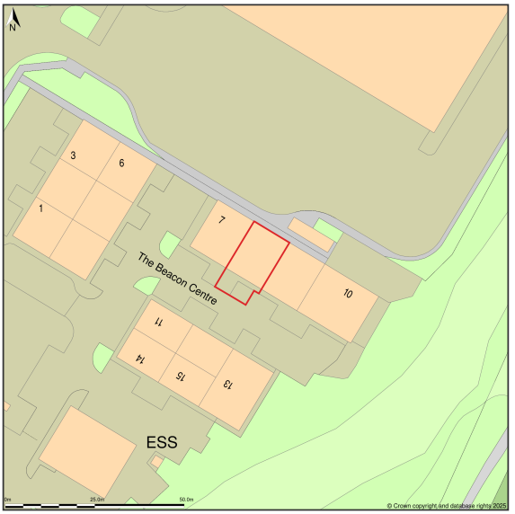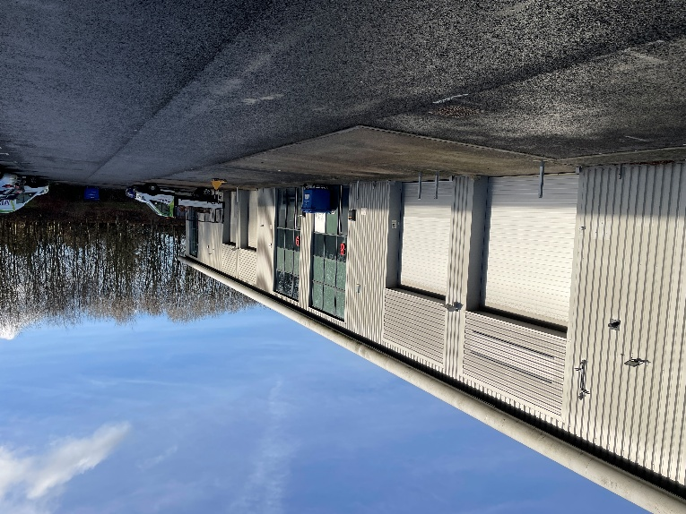

PROPOSAL
The proposal is for a change of use from Class B8 (Storage and Distribution) to Class E(d) indoor sport, recreation and fitness. The proposal is for the space to be used as a boxing and fitness facility for Relentless HQ Boxing & Fitness Ltd, formally Alive Amateur Boxing Club. No alterations are proposed to the external building fabric. The new use would employ 2 full time; and 4 part-time staff.

The site currently has 4 allocated parking spaces, this is not proposed to be changed.

Proposed floor plans

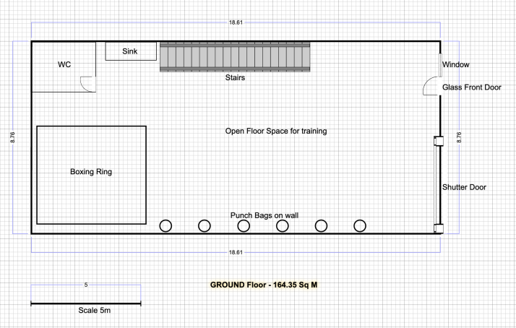

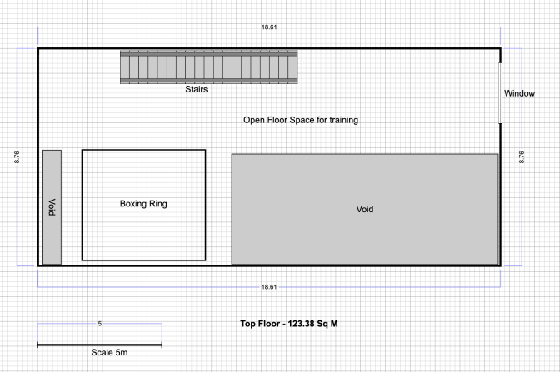

PLANNING HISTORY

Proposal / Summary
S/2003/0030 - Reserved Matters Decision - Approve with Conditions Date: 31/3/2003 – PROPOSED DEVELOPMENT OF B2 AND B8 AND ANCILLARY B1 USES TOGETHER WITH DETAILED DRAINAGE PROPOSALS AND ASSOCIATED PARKING LANDSCAPING AND ACCESS ROADS
S/2004/2203 - Reserved Matters Decision - Approve with Conditions Date: 13/1/2005 – PROPOSED DEVELOPMENT OF B2 AND B8 AND ANCILLARY B1 USES WITH DETAILED DRAINAGE, ASSOCIATED PARKING AND LANDSCAPING.
S/2006/1811 - Reserved Matters Decision - Approve with Conditions Date: 9/11/2006 – APPROVAL OF RESERVED MATTERS FOR B1, B1C, B2 AND B8 USE
S/1999/0721 - Outline Planning Decision - Approve with Conditions Date: 26/1/2000 – PRO. COMP. DEV. OF SITE FOR EMP’MENT/LEISURE PURPOSES W’IN USE CLASSES B1 B2 B8 & C1 TOG. WITH RDS, F'PATHS, C'WAYS, L'SCAPING, SEWERS, ALTS OF GROUND LEVELS & ASSOC. WKS GEN.IN ACCORD. WITH THE PRINCIPLES ILLUST.ON APP DEV.BRIEF MASTER PLAN L269-14/1/E
S/2002/1714 - Reserved Matters Decision - Approve with Conditions Date: 30/1/2003 – TO ADDRESS PLANNING CONDITIONS 7 & 8 ON CONSENT S/02/485 (STRUCTURAL LANDSCAPING)
S/2004/0755 - Reserved Matters Decision - Approve with Conditions Date: 28/5/2004 – PROPOSED DEVELOPMENT OF B2 AND B8 AND ANCILLARY B1 USES TOGETHER WITH DETAILED DRAINAGE PROPOSALS AND ASSOCIATED PARKING LANDSCAPING AND ACCESS ROADS
S/2002/0485 - Removal/variation of conditions Decision - Approve with Conditions Date: 30/7/2002 – SECTION 73 APPLICATION TO VARY CONDITION NO 3 4 14 AND 20 ON CONSENT NO S/1999/721 TO PROVIDE (1) SPECIFIED DATES FOR THE APPROVAL OF RESERVED MATTERS (2) TO PERMIT COMMENCEMENT OF ANY APPROVED EARTH WORKS AND LANDSCAPING SCHEME BEFORE WORKS HAVE COM

RELEVANT LEGISLATION, POLICIES AND GUIDANCE

National Planning Policy:
- National Planning Policy Framework (NPPF)
- Planning Practice Guidance (PPG)
- National Design Guide
Development Plan:
The development plan for Wiltshire comprises the Wiltshire Core Strategy (WCS) (adopted January 2015) and any made neighbourhood plans, which remains the principal statutory planning document guiding development across the county. In line with Section 38(6) of the Planning and Compulsory Purchase Act 2004, planning decisions must be made in accordance with the development plan unless material considerations indicate otherwise.

Though the development plan is considered as a whole, those parts deemed to be particularly relevant to this application are listed below:

The adopted Wiltshire Core Strategy (WCS), with particular regard to:

- Core Policy 1 Settlement Strategy;
- Core Policy 2 Delivery Strategy;
- Core Policy 3 Infrastructure Requirements;
- Core Policy 4 Spatial Strategy for the Amesbury Community Area
- Core Policy 34 Additional Employment Land
- Core Policy 35 Existing Employment Land
- Core Policy 50 Biodiversity and Geodiversity
- Core Policy 57 Ensuring High Quality Design and Place Shaping;
- Core Policy 60 Sustainable Transport;
- Core Policy 61 Transport & Development;

Salisbury District Local Plan policies (Saved by Wiltshire Core Strategy):
- S1 – Primary Shopping Areas
- S2 – Secondary Shopping Areas
- R1A – New/Improved Sport/Leisure Facilities on the edge of Settlements

Supplementary Planning Documents and other Guidance:
- Wiltshire Design Guide (adopted April 2024)
- Wiltshire Local Transport Plan 2011-2026, adopted 2015 - including the Car Parking Strategy and Cycling Strategy, adopted 2015

The main issues that need to be addressed in this case include:
- Principle of development
- Design and Impact on the Character and Appearance of the Area
- Amenity
- Highways Impacts and Parking
- Biodiversity Net Gain

CONSULTATION RESPONSES
Highways Officer – No objection with comments received stating:
I note the proposals seek to change the use of the existing vacant B8 building to a E(d) leisure use, for use by a boxing/fitness club.
I am aware that concerns were raised by this Highway Authority at pre-app stage and I understand that the building only has 4 allocated car parking spaces. Whilst this is sufficient for the extant B8 use, normally, a E(d) use would require additional car parking provision. I note the information submitted in support of the application, with the anticipate peak usage times of the facility being generally early mornings and evenings, thus outside the usual peak times for the other industrial uses across the wider estate. This view is generally supported and given the adopted highway does not front the unit, I feel that the likelihood of indiscriminate parking occurring on the adopted highway to be low.
Therefore, based on the information provided by the applicant, the number and use of the available parking spaces is unlikely to have any detrimental impact on highway safety. I therefore recommend that no highway objection be raised to this application.

Public Protection Officer – Comments received stating:
Thank you for forwarding the amended ‘Noise Impact Statement’ which outlines how the applicant will mitigate all noise sources associated with the intended use of the building, in order to reduce adverse impact on neighbouring businesses and distant dwellings.
I recommend upon any approval of this application, a condition is applied to ensure all mitigation measures as detailed at Section 5 of the document are implemented in full and maintained at all times thereafter.
You may also wish to condition the operation hours, detailed at Section 3 of the document.

Amesbury Town Council - Support

REPRESENTATIONS
In accordance with the requirements of the Town and Country Planning (Development Management Procedure) (England) Order 2015 (as amended), the application was publicised by way of:

- Neighbour notification letters sent to adjoining and nearby properties;
These methods were used to inform interested parties and provide a period of 21 days for comments to be submitted.

One representation of support was received.
Cllr Kevin Asplin: Support, comment stated below:
‘As the Divisional Councillor I very much support this planning request.’

ASSESSMENT
Section 38(6) of the Planning and Compulsory Purchase Act 2004 states:

"If regard is to be had to the development plan for the purposes of any determination to be made under the planning Acts, the determination must be made in accordance with the plan unless material considerations indicate otherwise."

In accordance with this statutory requirement, this application has been assessed against the relevant policies of the Development Plan, including the Wiltshire Core Strategy (2015) and, where applicable, any made Neighbourhood Plans. Consideration has also been given to the policies of the National Planning Policy Framework (NPPF) as a material consideration in the assessment.

Principle of Development
The application site is within the Market Town of Amesbury, as defined by Core Policy 1 (Settlement Strategy) of the WCS, it is also within the settlement boundary as defined by Core Policy 2 (Delivery Strategy). CP2 addresses the issue of development within settlement boundaries:

Within the limits of development, as defined on the policies map, there is a presumption in favour of sustainable development at the Principal Settlements, Market Towns, Local Service Centres and Large Villages.

The site is also identified, within the Core Strategy, as being a Principal Employment Area for Amesbury and therefore any proposals would be required to be in accordance with Core Policy 4 and 35 (Existing Employment Sites). CP35 seeks to retain these areas for employment purposes within use classes B1, B2 and B8 only. Redevelopment of buildings currently or last used for activities falling within use classes B1, B2 and B8 will be supported in Market Towns if they meet the following criteria:

- The proposed development will generate the same number, or more permanent jobs than could be expected from the existing, or any potential employment use.
- Where the proposal concerns loss of employment land of more than 0.25 ha in
the Principal Settlements, Market Towns or Local Service Centres it is replaced with employment land of similar size elsewhere at that settlement.
- It can be shown that the loss of a small proportion of employment floorspace would facilitate the redevelopment and continuation of employment uses on a greater part of the site, providing the same number or more permanent jobs than on the original whole site.
- The site is not appropriate for the continuation of its present or any employment use due to a significant detriment to the environment or amenity of the area.
- There is valid evidence that the site has no long term and strategic requirement
to remain in employment use; the ability of the site to meet modern business
needs must be considered, as well as its strategic value and contribution to the
local and wider economy both currently and in the long term. It must be shown
that the site is no longer viable for its present or any other employment use and
that, in addition, it has remained unsold or un-let for a substantial period of time
(at least 6 months), following genuine and sustained attempts to sell or let it on
reasonable terms for employment use, taking into account prevailing market
conditions.
- The change of use is to facilitate the relocation of an existing business from buildings that are no longer fit for purpose to more suitable premises elsewhere within a reasonable distance to facilitate the retention of employment.

The proposed use is for Class E(d) Indoor Sport, Recreation or Fitness, the supporting documentation and planning statement confirms how the proposals meet the criteria:

(i – iii) the new use will generate direct employment. It is confirmed that the size of the unit would on average generate approximately 1-2 employment opportunities if it were to be used as a B8 use, whereas this proposed use has identified that 2 full time and 4 part time staff will be employed by this particular use. This means that in terms of generating employment opportunities, the proposed use will provide the same if not more job opportunities than the lawful use of the building if it were to be occupied.

(iv - v) the existing unit has been empty for six months and the size of the unit means that it is not suitable for modern storage operations (no loading infrastructure, no storage yard).

(vi) there is no boxing facility within Amesbury, the proposed use will provide a community facility, particularly for youth members.

It should also be noted whilst no marketing information has been provided, the building is empty and currently generates no employment. On balance, it is therefore considered that this particular use is acceptable in principle.

Notwithstanding the principle acceptability; it is also necessary to consider the other relevant planning policies and the normal range of material considerations that have to be taken into account when determining a planning application. These matters are therefore addressed in more detail below.

Design and Impact on the Character and Appearance of the Area
Core Policy 57 - Ensuring High Quality Design and Place Shaping of the Wiltshire Core Strategy seeks to ensure that all new development is of high design quality, reflecting local context, character, and distinctiveness.

The proposals do not require any external alterations or modifications to the existing unit, and as the site is set within a business park, the proposed use is considered acceptable within this context. No proposals for signage or lighting have been included. Should signage or external lighting be required, it may be necessary to obtain consent from the LPA, and an informative related to this has been included on this consent. It is therefore concluded that the proposals will not have an impact on the character and appearance of the unit or the wider industrial estate.

Amenity
Core Policy 57 (Point vii) of the Wiltshire Core Strategy requires development to respect the amenity of existing occupants and ensure appropriate amenity levels for future residents.

The National Planning Policy Framework (NPPF), particularly Paragraph 135, reinforces the need for development to provide a high standard of amenity for both existing and future users.

Due to the sites location, within an industrial estate/business park, there are no concerns regarding loss of amenity for residential neighbours.

The proposed change of use to Class E(d) would be expected to generate additional noise beyond that generated by the current Class B8 use. A ‘Noise Impact Statement’ has been submitted in support of this application and a revised version received 14.01.2026 in response from the Council’s Public Protection Officer.

Noise mitigation measures are proposed to include; acoustic containment, equipment positioned away from party walls, impact-absorbing flooring, sound system control, class times scheduled to avoid early morning/late evenings, use of existing shared car park.

The Public Protection Officer has reviewed the submission and has recommended two planning conditions (implementation of noise mitigation measures and operational hours) to ensure that there would be no loss of amenity due to noise.

These conditions are considered necessary and reasonable in the interests of noise pollution. In line with these conditions it is considered that the proposal is acceptable in terms of its impacts upon amenity.

Highways Impacts and Parking
The submitted ‘Planning Statement’ and application form confirms that the proposals are to use the existing units allocated 4 parking units. The submission states that the proposed community use will have mostly off-peak use due to class scheduling with a high proportion of drop-off and pick-up movements, rather than users requiring parking due to the majority of members being juniors and youths.

The Highway Officer has reviewed the submission and no objection is raised, commenting that due to the anticipated peak use being outside of the usual peak times for the other industrial uses across the wider estate and that given the adopted highway does not front the unit, the likelihood of indiscriminate parking occurring on the adopted highway is low.

It is concluded that the change of use is unlikely to have any detrimental impact on highway safety and are acceptable in this regard.

Biodiversity Net Gain
As of 2 April 2024, the requirement for Biodiversity Net Gain (BNG) on all new sites came into force. Any small scale (non-major)/major scheme will need to demonstrate no net loss and a minimum of 10% net gain in biodiversity on the site, in line with the requirements of the NPPF, WCS policy CP50 (Biodiversity and Geodiversity) and the Environment Act.

However based on the information available the biodiversity gain planning condition is not considered to apply to this application as the development meets the following exemption criteria and is therefore below the de minimis threshold, meaning the development: − does not impact an onsite priority habitat (a habitat specified in a list published under section 41 of the Natural Environment and Rural Communities Act 2006); and − impacts less than 25 square metres of onsite habitat that has biodiversity value greater than zero and less than 5 metres in length of onsite linear habitat (as defined in the statutory metric).

CONCLUSION
The proposed change of use conforms to policy as outlined above and the proposal is considered acceptable in the context of its surroundings and in accordance with the general criteria set out in the aforementioned policies of the local development plan.

RECOMMENDATION:
That Planning Permission be GRANTED subject to the following conditions:

- The development hereby permitted shall be begun before the expiration of three years from the date of this permission.
REASON: To comply with the provisions of Section 91 of the Town and Country Planning Act 1990 as amended by the Planning and Compulsory Purchase Act 2004.

- The development hereby permitted shall be carried out in accordance with the following approved plans and documents:

DWG: Location Plan, received 05 December 2025
DWG: Proposed Floor Plans, received 05 December 2025
Noise Impact Statement, received 14 January 2026

REASON: For the avoidance of doubt and in the interests of proper planning.

- The development will be carried out in strict accordance with the noise mitigation measures outlined in Section 5 of the following document:
• Noise Impact Statement, received 14 January 2026

To include: acoustic containment, internal layout planning, flooring, sound system control, operational management and vehicle management, and maintained thereafter.

REASON: To ensure the creation/retention of an environment free from intrusive levels of noise and activity in the interests of the amenity of the area.

- The level of noise emitted from the site shall not exceed 60 dB LA at any time as measured on the boundaries of the site at locations of monitoring points.
REASON: To ensure the creation/retention of an environment free from intrusive levels of noise and activity in the interests of the amenity of the area.

- The use hereby permitted shall only take place between the hours of 06:00 in the morning and 22:00pm in the evening from Monday to Friday and between 08:00am in the morning and 18:00pm in the evening on Saturdays, Sundays and Bank or Public Holidays.
REASON: To ensure the creation/retention of an environment free from intrusive levels of noise and activity in the interests of the amenity of the area.

- Notwithstanding the provisions of the Town and Country Planning (General Permitted Development) (England) Order 2015 (or any Order revoking or reenacting or amending that Order with or without modification), the site shall be used solely for purposes within Class E(d) of the Schedule to the Town and Country Planning (Use Classes) Order 1987 (as amended)(or in any provisions equivalent to that class in any statutory instrument revoking or reenacting that Order with or without modification).

REASON: The proposed use is acceptable but the Local Planning Authority wish to consider any future proposal for a change of use, other than a use within the same class(es), having regard to the circumstances of the case.

Informatives:
1) Please note that any advertisement or signage for the use hereby approved may require advertisement consent and will need to be applied for separately, accordingly.

