APPLICATION FOR HOUSEHOLDER PLANNING PERMISSION
DELEGATED REPORT

APPLICATION REFERENCE: | PL/2025/09624
APPLICATION TYPE: | Householder planning permission
SITE ADDRESS: | 7 Oldbrick Fields, Trowbridge, BA14 0FB
DEVELOPMENT DESCRIPTION: | Single storey side extension
RECOMMENDATION: | That Planning Permission be GRANTED

PROPOSAL

The proposal seeks planning permission for a single storey side extension to the host dwelling to provide a ground floor bedroom with en-suite

SITE DESCRIPTION/CONTEXT

This application relates to an end terraced dwelling, 7 Oldbrick Fields, located within an established residential area in Trowbridge. The host dwelling benefits from an off-road parking area to the front elevation. The surrounding properties are all similar in style comprising of semi-detached pairs and terraced properties.

The application site sits within the Bath and Bradford on Avon Special Area of Conservation for bats and the Trowbridge and Westbury Bat Mitigation Strategy (TWBMS)

PLANNING HISTORY
N/A

RELEVANT POLICIES AND GUIDANCE

Wiltshire Core Strategy:
Core Policy 29 – Spatial Strategy for the Trowbridge Community Area
Core Policy 57 Ensuring High Quality Design and Place Shaping
Core Policy 50: Biodiversity and Geodiversity
Core Policy 57 - Ensuring High Quality Design and Place Shaping
Core Policy 60 – Sustainable Transport
Core Policy 61 – Transport and Development
Core Policy 64 – Demand Management

Wiltshire Local Transport Plan 2011 – 2026 (March 2015)

Wiltshire Design Guide: Appendix D – Design Guidance for Householder extensions

The National Planning Policy Framework (NPPF)

The Planning Practice Guidance

National Design Guide

CONSULTATION RESPONSES

Trowbridge Town Council: No objection

REPRESENTATIONS
No comments were received.

ASSESSMENT
Section 38(6) of the Planning and Compulsory Purchase Act 2004 states:

"If regard is to be had to the development plan for the purposes of any determination to be made under the planning Acts, the determination must be made in accordance with the plan unless material considerations indicate otherwise."

In accordance with this statutory requirement, this application has been assessed against the relevant policies of the Development Plan, including the adopted Wiltshire Core Strategy (2015) and, where applicable, any made Neighbourhood Plans.

Design and Impact upon the character and context of the area
Core Policy 57 - Ensuring High Quality Design and Place Shaping of the Wiltshire Core Strategy seeks to ensure that all new development is of high design quality, reflecting local context, character, and distinctiveness.

The two-storey side extension would be positioned on the south elevation and would project a width of 3m from the side elevation of the host dwelling at a depth of 6.6m. The monopitch roof would sit at a maximum height of 3.7m, and the rear elevation would align with the rear elevation of the host dwelling, the front elevation set back 2.5m from the principal elevation.

A window would be inserted on the front elevation and rear elevation., with access to the extension given from the existing living room.

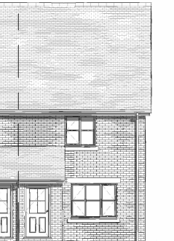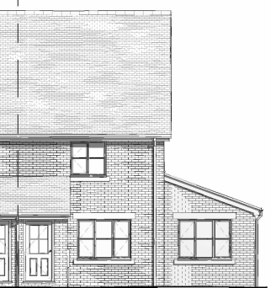
Existing (left) and proposed (right) front elevation

The use of matching materials (red brick under concrete roof tiles) with matching white UPVC fenestration would ensure the proposal would integrate into the surrounding setting and existing street scene. It is considered that the extension would by virtue of its height, scale and design constitute a complementary addition to the host dwelling that would appear commensurate to the size of the property and plot.

Having regard to the above, the proposal complies with the design principles set out in Core Policy 57 of the Wiltshire Core Strategy and Appendix D of the Wiltshire Design Guide.

Amenity
Point vii of Core Policy 57 - Ensuring High Quality Design and Place Shaping of the Wiltshire Core Strategy seeks to ensure that developments do not adversely affect neighbouring properties.

The National Planning Policy Framework (NPPF), particularly Paragraph 135(f), stresses that planning decisions should ensure developments provide a high standard of amenity for existing and future users.

The proposed development has been assessed in terms of its potential impact on the residential amenity of neighbouring properties, with particular regard to loss of light, overshadowing, loss of privacy, and overbearing effects.

The proposal relates to a single storey extension of limited scale with an extended separation distance to the nearest neighbour to the south, No.8 Oldbrick Fields. Therefore, officers raise no concerns in regard to any adverse overlooking, overbearing or overshadowing impacts.

The proposal therefore accords with Core Policy 57 point vii in respect of safeguarding residential amenity and Appendix D of the Wiltshire Design Guide.

Highways Impact
Core Policy 57 (xiv) of the Wiltshire Core Strategy seeks to ensure that development must meet the requirements of Core Policy 61. This policy requires proposals to be capable of being served by safe access to the highway network. Core Policy 64 seeks to ensure compliance with parking standards set out in the Local Transport Plan.

The National Planning Policy Framework (NPPF), particularly Paragraph 115 and 116, requires that development proposals do not have an unacceptable impact on highway safety and that safe and suitable access to the site can be achieved for all users.

Impact on parking provision – Core Policy 64 (Demand Management) seeks to manage the demand for vehicle parking and confirms that residential parking standards are to be based on minimum parking standards.
The development would introduce an additional bedroom at ground floor, bringing the number of bedrooms in the property to three. In order to comply with the Wiltshire Local Transport Plan 2011 – 2026: Car Parking Strategy (March 2015) two on-site car parking spaces would be required for a 3-bed dwelling (standard min. size 2.4m x 4.8m).
However, this criterion does not alter the number of required off road parking spaces that currently exists, as a two-bedroom property is also required to demonstrate off road parking for two vehicles. Therefore, the proposal would not alter the existing off road parking arrangement, and it is considered that sufficient off-street parking for two cars would be provided to the front elevation of the host dwelling, as illustrated by the plan insert below
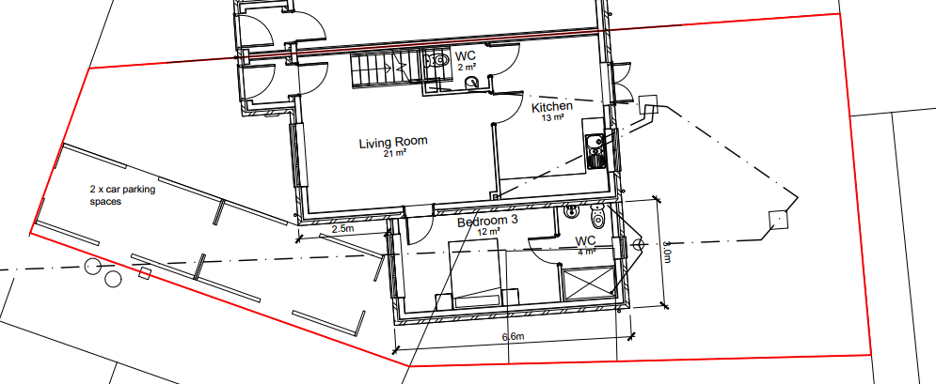

The proposed development would not result in any adverse impact on highway safety and adequate parking and turning provision is provided in accordance with Wiltshire’s adopted parking standards, and access arrangements are acceptable.

The proposal is therefore considered to comply with Core Policies 57 (xiv), 61 and 64 of the Wiltshire Core Strategy, the NPPF, and the Wiltshire Local Transport Plan.

Ecology Impact
Core Policy 50 of the Wiltshire Core Strategy seeks to protect and enhance biodiversity and geodiversity, including through ensuring that development avoids harm to protected species and habitats.

The National Planning Policy Framework (NPPF), in Paragraphs 193, requires that development minimises impacts on and provides net gains for biodiversity, including ensuring mitigation is secured where harm cannot be avoided.

The application site sits within the Bath and Bradford on Avon Special Area of Conservation for bats and the Trowbridge and Westbury Bat Mitigation Strategy (TWBMS). Therefore, due consideration has to be given to the potential disturbance of any bats because of proposed new residential development.

The proposed development comprises an extension of existing residential development consisting of limited built form close to the existing dwelling which does not involve works to the roof. Given the established high density urban residential nature of the location it is considered highly unlikely that any bats would be affected and significant effects relating to the disturbance to bats can be ruled out. As a precautionary measure an informative would be added to any decision that in event any evidence of bat activity is detected that the applicant should follow the advice of a professional ecologist or contact Natural England. The proposal does not result in a new residential unit and therefore does not require contribution to the mitigation strategy.

As such, the development complies with Core Policy 50 of the Wiltshire Core Strategy and the relevant provisions of the NPPF.

Biodiversity Net Gain
Householder planning applications are exempt from the requirement to deliver Biodiversity Net Gain under Schedule 7A, Section 4(2)(a) of the Town and Country Planning Act 1990, as inserted by the Environment Act 2021.

CONCLUSION
The proposed development is considered to be acceptable in terms of its design, scale, and relationship with the surrounding area. It would not result in any unacceptable harm to the character of the locality, the amenities of neighbouring occupiers, or the interests of highway safety or ecology.

The proposal is therefore considered to comply with the relevant policies of the Wiltshire Core Strategy, the Wiltshire Local Plan, and the National Planning Policy Framework. As such, the application is recommended for approval, subject to the conditions set out below.

RECOMMENDATION: That Planning Permission be GRANTED subject to conditions.

Conditions

1.The development hereby permitted shall be begun before the expiration of three years from the date of this permission.
REASON: To comply with the provisions of Section 91 of the Town and Country Planning Act 1990 as amended by the Planning and Compulsory Purchase Act 2004.

2. The development hereby permitted shall be carried out in accordance with the following approved plans and documents:
Location Plan DWG No 05640-00-A Sheet 1
Block Plan DWG No 05640-00-A Sheet 2
Existing Plans DWG No 05640-01 Sheet 1
Existing Elevations DWG No 05640-01 Sheet 2
Proposed Plans DWG No 05640-01 Sheet 3
Proposed Elevations DWG No 05640-01 Sheet 4
All Plans Received 08.12.2025

REASON: For the avoidance of doubt and in the interests of proper planning.

Informative
If bats or evidence of bats are found during the works, the applicant is advised to stop work and follow advice from an independent ecologist or to contact Natural England’s Bat Line through the internet.

