Design and Access Statement
35 Temple Corsley Warminster Wilts
BA12 7QN
Installation of 5 windows
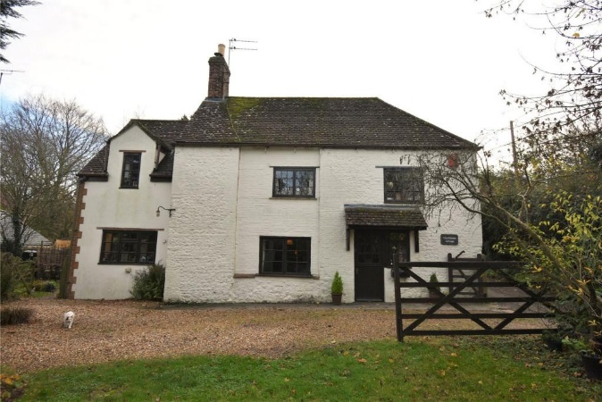

Location Plan
OS map at 1.1250 scale
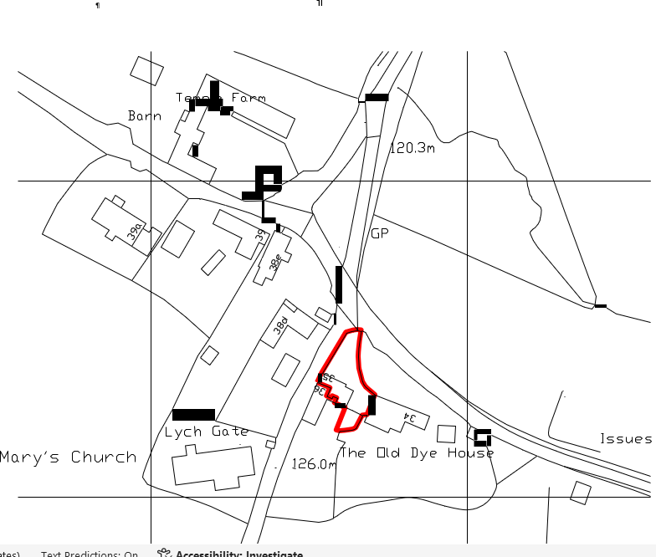
Part of the Cranbourne Chase and West Wiltshire downs

Five new Windows
The three windows on the South elevation and two on the West elevation are to be replaced. The windows will be replaced with timber windows to match the existing windows in style and colour. The glazing units will incorporate double glazed units as shown on drawing 203 DD 002 which will match the windows which were replaced in 2024 under application PL 2024o4661.

