Heritage Statement
35 Temple Corsley Warminster Wilts
BA12 7QN
Installation of 5 windows
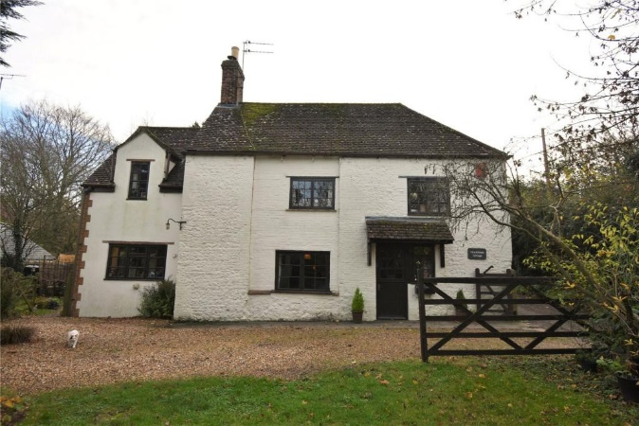

Location Plan
OS map at 1.1250 scale
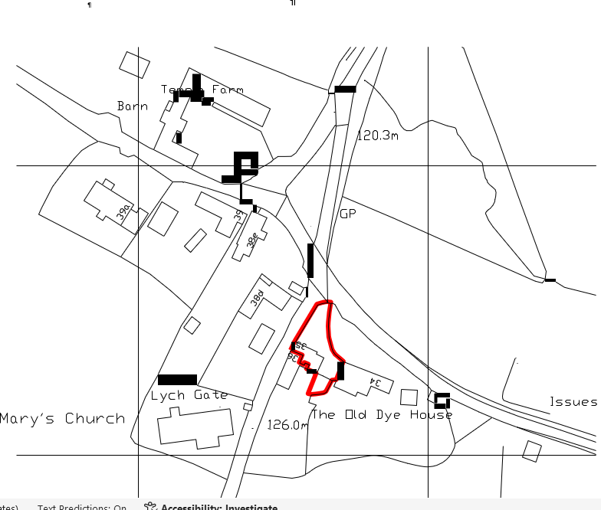
Part of the Cranbourne Chase and West Wiltshire downs

Five new Windows
The windows to be installed will match the existing windows which where installed under PL 2024 04661 in 2024. These are representative of windows in the Village and will improve the thermal performance of a listed building

