APPLICATION FOR HOUSEHOLDER PLANNING PERMISSION
DELEGATED REPORT

APPLICATION REFERENCE: | PL/2025/09140
APPLICATION TYPE: | Householder planning permission
SITE ADDRESS: | 73 Blair Road, Trowbridge, BA14 9JZ
DEVELOPMENT DESCRIPTION: | Two storey side extension to front and above existing single storey annex, with new front entrance canopy
RECOMMENDATION: | That Planning Permission be GRANTED

PROPOSAL

The proposal seeks planning permission for the construction of a two-storey side extension that would be sited atop the existing single storey flat roof garage. The existing single storey rear extension would be used as an ancillary annexe for a dependent elderly family relative.

SITE DESCRIPTION/CONTEXT

The site is 73 Blair Road, Trowbridge, which is a brick constructed semi-detached two storey building located within the Principal Settlement of Trowbridge. The site is not in a Conservation Area and is located within an established residential area of the town.

RELEVANT PLANNING HISTORY
N/A

RELEVANT POLICIES AND GUIDANCE
Wiltshire Core Strategy:

- Core Policy 29: Spatial Strategy for Trowbridge.
- Core Policy 50: Biodiversity and Geodiversity
- Core Policy 51: Landscape
- Core Policy 57 Ensuring High Quality Design and Place Shaping
- Core Policy 58: Ensuring the Conservation of the Historic Environment
- Core Policy 61: Transport and New Development
- Core Policy 64: Demand Management

Trowbridge emerging neighbourhood plan (Status: Designation of Trowbridge Neighbourhood Area).

Wiltshire Design Guide: Appendix D – Design Guidance for Householder extensions
The National Planning Policy Framework (NPPF)
The Planning Practice Guidance
National Design Guide

Emerging Wiltshire Local Plan:
The emerging Wiltshire Local Plan has reached Regulation 24 stage. The examination is programmed to have more hearing sessions through 2026 and as such, the weight to be attributed to the emerging local plan is very limited at this stage.

CONSULTATION RESPONSES
Trowbridge Town Council: No objections, subject to no adverse impact on neighbouring amenity.

Highways: No objections.

REPRESENTATIONS
One email of support received from the National Annexe Planning Consultancy (NAPC), supporting the principle of the use of the annexe.

ASSESSMENT
Section 38(6) of the Planning and Compulsory Purchase Act 2004 states:

"If regard is to be had to the development plan for the purposes of any determination to be made under the planning Acts, the determination must be made in accordance with the plan unless material considerations indicate otherwise."

In accordance with this statutory requirement, this application has been assessed against the relevant policies of the Development Plan, including the adopted Wiltshire Core Strategy (2015).

Design and Impact upon the upon the character and context of the area

Core Policy 57 - Ensuring High Quality Design and Place Shaping of the Wiltshire Core Strategy seeks to ensure that all new development is of high design quality, reflecting local context, character, and distinctiveness.

The proposals can be viewed within the following plan snippets taken from the submitted plans:

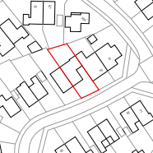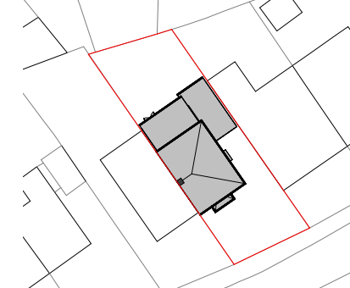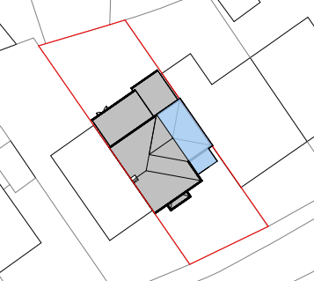
Location Plan Existing site plan Proposed Site Plan

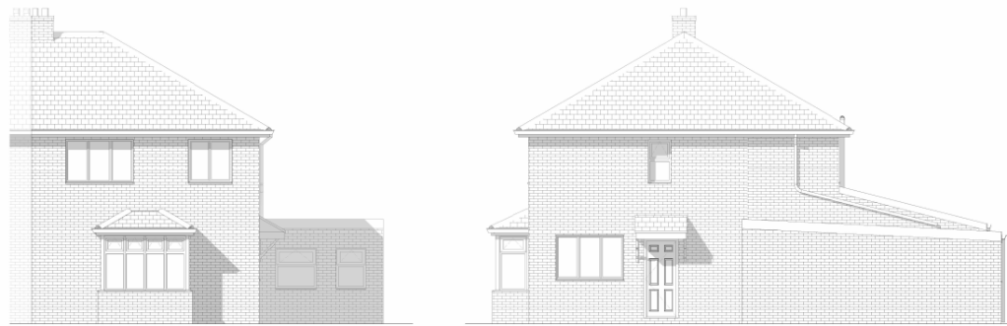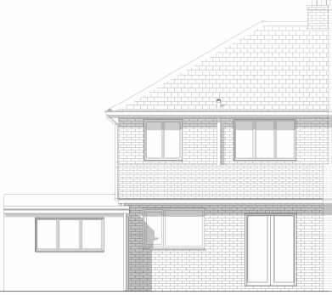
Existing front, rear & side elevations.

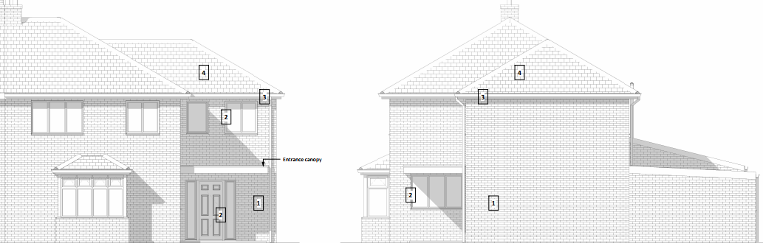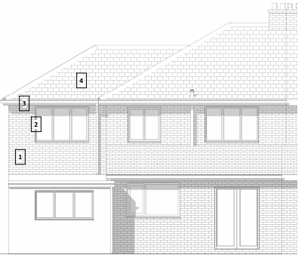
Proposed front, side and rear.

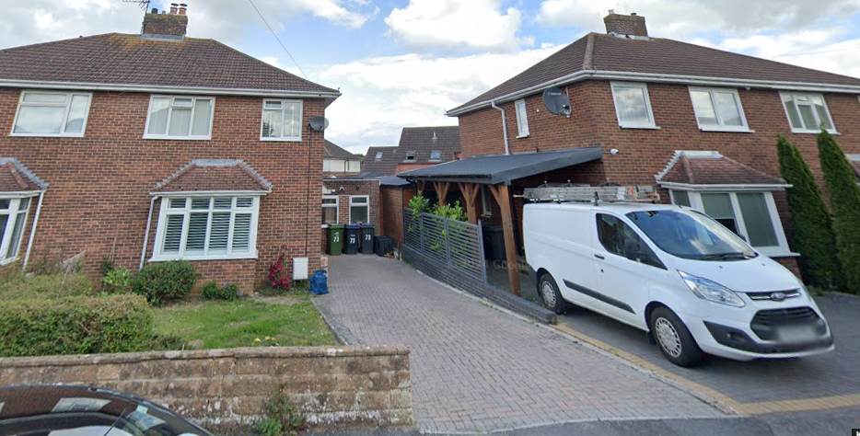
Street View Photograph.

The proposal would see the construction of the two-storey extension over the existing set back garage, the main front door access would be relocated from the side of the building to the new frontage. Both the dwelling and the newly created annexe would be accessed from this entrance. The newly created first floor room would serve as a fifth bedroom.

In terms of design the extension would have a lower roof ridge height than the existing roof and the front elevation of the proposal would be set back from the dwelling’s principal front elevation, these features ensure a subservient design to the principal host dwelling. Likewise, the proposal would have matching materials to the main dwelling.

Therefore, in summary, having regard to the above, the proposal complies with the design principles set out in Core Policy 57 of the Wiltshire Core Strategy and Appendix D of the Wiltshire Design Guide.

Amenity
Point vii of Core Policy 57 - Ensuring High Quality Design and Place Shaping of the Wiltshire Core Strategy seeks to ensure that developments do not adversely affect neighbouring properties. The National Planning Policy Framework (NPPF), particularly Paragraph 135(f), stresses that planning decisions should ensure developments provide a high standard of amenity for existing and future users.
The principle of high-level windows being sited within a developed urban area is firmly established at this location, so the newly created front first floor window would look over the site’s front garden and parking area and then onto the adjacent highway. Likewise, its matching rear window would look onto the property’s rear garden area, offering oblique views.
Due to the location and orientation of the proposal, there would not be any significant overshadowing or loss of light to the most immediate neighbour at No.75.

The proposal therefore accords with Core Policy 57 point vii in respect of safeguarding residential amenity and Appendix D of the Wiltshire Design Guide.

Annexe.
The site’s newly created annexe room at ground floor level would utilise what used to be a former bedroom and utility room. The proposal would see the provision of a combined open plan sleeping area with a living room and a shower room. The agent has confirmed that it would be used by an elderly family relative who would live with the household as a part of the family; this would include taking meals with the household.

The agent has also confirmed that the annexe would take its essential services, such as electricity, gas and drainage from the principal dwelling. The scheme does not show any delineation of garden land for the annexe’s sole use; these measures cumulatively serve to ensure that the use of the annexe is ancillary to the established residential use of the property and would not be an independent self-contained residential flat.

The use of the room as an annexe is appraised as being acceptable and it is necessary to apply the standard condition ensuring non-severance and from it becoming a separate independent self-contained Class C3 residential unit.

Highways.
In accordance with the council’s adopted car parking strategy, where there are four or more bedrooms within the house, there is a requirement to provide a minimum of three off road car parking spaces. As such, the highways officer initially requested a parking plan to show this arrangement which was supplied, consequently, the officer was satisfied and requested a condition and informative to be attached to the final decision notice. The officer commented:

“I raise no highway objection providing the following conditions are imposed:

No part of the development hereby permitted shall be first brought into use until the parking spaces [3] have been completed in accordance with the details shown on the approved plans. The areas shall always be maintained for those purposes thereafter and maintained free from the storage of materials.
REASON: In the interests of highway safety.

The application may involve an extension to the existing vehicle access/dropped kerb. The consent hereby granted shall not be construed as authority to carry out works on the highway. The applicant is advised that a licence will be required from Wiltshire’s Highway Authority before any works are carried out on any footway, footpath, carriageway, verge or other land forming part of the highway. Please contact our Vehicle Crossing Team on vehicleaccess@wiltshire.gov.uk and/or 01225 713352 or visit their website at http://wiltshire.gov.uk/highways-streets to make an application”.

Ecology Impact CP50 requires no net loss of biodiversity on site. The site is located within the Bath & Bradford on Avon Bat SAC and also within the grey hatched zone of the Trowbridge Bat Mitigation Strategy Area. The proposed development because of its minor nature and high-density urban location is considered unlikely to result in harm to bats or their habitat. There is no mechanism for significant effects from recreational pressure since it does not result in the creation of a new dwelling. Accordingly, the proposal is acceptable in this regard. As such, the development complies with Core Policy 50 of the Wiltshire Core Strategy and the relevant provisions of the NPPF.

Biodiversity Net Gain. This application is exempt from the requirement to deliver Biodiversity Net Gain under Schedule 7A, Section 4(2)(a) of the Town and Country Planning Act 1990, as inserted by the Environment Act 2021, because the proposal is a householder extension.

CONCLUSION
The proposed development is acceptable in terms of its design, scale, and relationship with the surrounding area. It would not result in any unacceptable harm to the character of the locality, the amenities of neighbouring occupiers, or the interests of highway safety, heritage, or ecology.

The proposal is therefore considered to comply with the relevant policies of the Wiltshire Core Strategy, the Wiltshire Local Plan, and the National Planning Policy Framework. As such, the application is recommended for approval, subject to the conditions set out below.

RECOMMENDATION: Planning Permission be GRANTED subject to conditions.

