APPLICATION FOR FULL - PLANNING PERMISSION
CASE OFFICER REPORT

APPLICATION REFERENCE: | PL/2025/08740
APPLICATION TYPE: | Full planning permission
SITE ADDRESS: | Land West of Cley Hill Roundabout Warminster
DEVELOPMENT DESCRIPTION: | Proposed Agricultural Machinery & Equipment Storage Building
RECOMMENDATION: | APPROVE

SITE DESCRIPTION/CONTEXT: The application site is located in open countryside to the east of Cley Hill and is served by an established vehicular access off the A362 road to the west of A36. There are already two existing agricultural buildings on the site, which have been previously approved under application references PL/2022/03014 and PL/2024/04303.

The site is located within the Cranborne Chase National Landscape and within the 6.4km buffer zone for the Salisbury Plain Special Protection Area (SPA), and is sited within the Hampshire River Avon Catchment. A public right of way, a footpath reference WARM2, runs along the southern boundary of the site.

The application site is shown on the Council’s Strategic Flood Risk Assessment mapping tool to be in an area of high risk of groundwater flooding, as shown in the extract below. The area washed over in the dark orange colouring depicts the areas susceptible to high groundwater flooding:

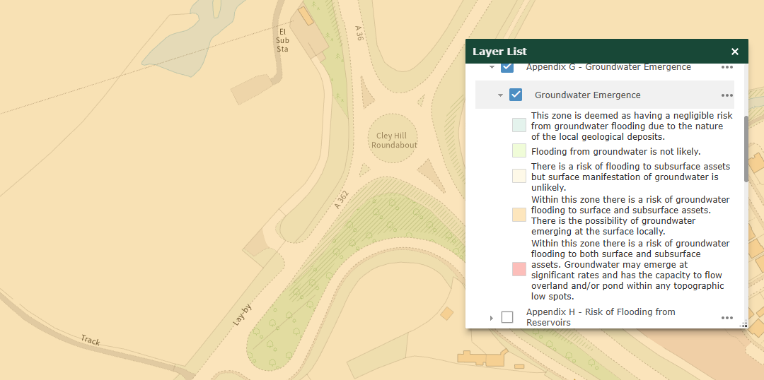

PROPOSAL: This application seeks planning permission for the construction of a new agricultural building for the storage of farm machinery and equipment, to be sited adjacent to two existing agricultural buildings.

The proposed building would be located on an underused part of the site and would occupy a shallow-pitched roof, be clad in dark green metal sheeting and be of a design and size to match the existing buildings already constructed on-site (shown as Unit 1 and Unit 2 in the below extract, taken from the submitted Proposed Block Plan and Landscape Plan):

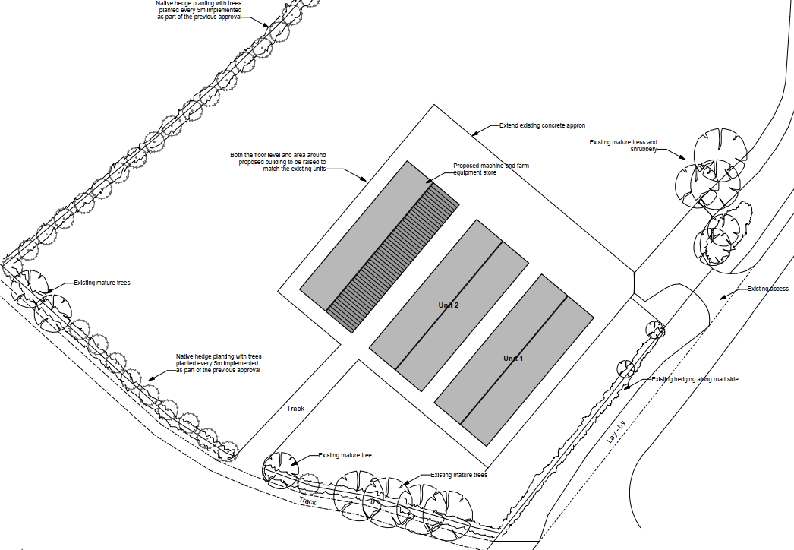

With reference to the submitted Design and Access Statement, the buildings relate to the relocation of an existing agricultural business (predominantly arable) from their former premises south of Victoria Road, which have since been demolished due to residential development (Bugley Barton).

RELEVANT PLANNING HISTORY

PL/2022/03014 – Full planning permission Decision – Approved with conditions Date: 02/11/2022 - Erection of a General Purpose Agricultural Building

PL/2024/04303 - Full planning permission: Decision - Approved with conditions Date: 20/6/2024 – Erection of a general purpose agricultural building

PL/2024/07144 - Prior notification: Road (agricultural/forestry): Decision - Prior Approval Not Required Date: 27/8/2024 – Proposed machinery track and concreting works

PL/2024/07162 - Approval of details reserved by a condition Decision - Approve Date: 11/9/2024 – Discharge of condition 5 of planning application PL/2024/04303 (Erection of a general purpose agricultural building at Land to the west of Cley Hill Roundabout, Warminster)

RELEVANT LEGISLATION, POLICIES AND GUIDANCE

National Planning Policy: National Planning Policy Framework (NPPF); Planning Practice Guidance (PPG)

Development Plan: The development plan for Wiltshire comprises the Wiltshire Core Strategy (WCS) (adopted January 2015) and any made neighbourhood plans, which remain the principal statutory planning document guiding development across the county. In line with Section 38(6) of the Planning and Compulsory Purchase Act 2004, planning decisions must be made in accordance with the development plan unless material considerations indicate otherwise.

Though the development plan is considered as a whole, those parts deemed to be particularly relevant to this application are listed below:

The adopted Wiltshire Core Strategy (WCS), with particular regard to:

- Core Policy 1 - Settlement Strategy;
- Core Policy 2 - Delivery Strategy;
- Core Policy 31 - Spatial Strategy for the Warminster Community Area
- Core Policy 50 - Biodiversity and Geodiversity;
- Core Policy 51 - Landscape
- Core Policy 52 - Green Infrastructure
- Core Policy 57 - Ensuring High Quality Design and Place Shaping;
- Core Policy 60 - Sustainable Transport;
- Core Policy 61 - Transport & Development;
- Core Policy 62 - Development Impacts on the Transport Network;
- Core Policy 64 - Demand Management
- Core Policy 67 - Flood Risk;
- Core Policy 68 - Water Resources

Saved policies from the West Wiltshire District Local Plan (1st Alteration) (WWDLP) including: U1a (Foul Drainage/sewerage treatment)

Neighbourhood Plan: Warminster Neighbourhood Plan, 2015-2026, as made in November 2016

Supplementary Planning Documents and other Guidance:
- Wiltshire Design Guide, adopted 2024
- Green & Blue Infrastructure Strategy for Wiltshire - Wiltshire’s Natural Environment Plan 2022-2030, adopted February 2022
- Wiltshire Council Local Transport Plan 2025-2038 (LTP4), endorsed at full council March 2025
- Wiltshire Local Transport Plan 2011-2026 (LTP3), adopted 2015 - including the Car Parking Strategy and Cycling Strategy
- Cranborne Chase National Landscape Partnership Plan 2025-2030

ISSUES: The main issues that need to be addressed in this case include: the principle of the development; landscape impacts; ecology; highways; drainage/flood risk

CONSULTATION RESPONSES

Wiltshire Council Highways: No highway objection is raised

Wiltshire Council Ecology: Provided a comment to say that there are no obvious ecology issues with the application, and therefore no consultation is required.

Warminster Town Council: No objections

REPRESENTATIONS
In accordance with the requirements of the Town and Country Planning (Development Management Procedure) (England) Order 2015 (as amended), the application was publicised by way of:

- Neighbour notification letters sent to adjoining and nearby properties;
- A site notice was issued to the applicant to display near the site

These methods were used to inform interested parties and provide a period of 21 days for comments to be submitted.

No third-party representations have been received.

ASSESSMENT
Section 38(6) of the Planning and Compulsory Purchase Act 2004 states:

"If regard is to be had to the development plan for the purposes of any determination to be made under the planning Acts, the determination must be made in accordance with the plan unless material considerations indicate otherwise."

In accordance with this statutory requirement, this application has been assessed against the relevant policies of the Development Plan, including the Wiltshire Core Strategy (2015) and, where applicable, any made Neighbourhood Plans. Consideration has also been given to the policies of the National Planning Policy Framework (NPPF) as a material consideration in the assessment.

Principle of Development: This application seeks planning permission for the construction of an agricultural building to be used in relation to the applicant's existing established agricultural business, which has relocated to this site from a different location within Warminster. As previously detailed, there are two existing agricultural buildings present on the site, and the building subject to this application would be of a design and size to complement these existing buildings.

Paragraph 88 of the NPPF states that planning policies and decisions should enable the sustainable growth and expansion of business in rural areas, including through well-designed new buildings (paragraph 88a), and the development and diversification of agricultural and other land-based rural businesses (paragraph 88b).

There is no in-principle objection to the proposal, which seeks to support agricultural use in the open countryside.

Landscape and Visual Impact: Policy CP51 of the adopted WCS requires development to:
- Protect, conserve, and enhance landscape character and quality.
- Respect local distinctiveness, key views, and visual receptors.
- Give particular weight to impacts on National Landscapes (formerly AONBs) and locally valued landscapes.

The Wiltshire Design Guide promotes a context-led approach, encouraging integration with natural features and settlement patterns while avoiding visual intrusion.

The Green and Blue Infrastructure Strategy (2022–2030) supports landscape protection through green infrastructure, habitat connectivity, and nature-based solutions.

The NPPF emphasises the need to protect and enhance valued landscapes, particularly those with scenic, historic, or ecological significance. Planning decisions should:

- Recognise the intrinsic character and beauty of the countryside.
- Safeguard key views, local distinctiveness, and landscape settings.
- Ensure development is well-integrated into its surroundings and avoids visual intrusion, especially in sensitive or designated areas.

Landscape impact must be considered alongside biodiversity, heritage, and green infrastructure objectives, with mitigation measures encouraged where harm cannot be avoided.

Furthermore, paragraph 189 of the NPPF requires that great weight should be given to conserving and enhancing landscape and scenic beauty in National Landscapes, which have the highest status of protection in relation to these issues.

Under Section 245 of the Levelling-up and Regeneration Act 2023, local planning authorities and other relevant authorities must now “seek to further” the statutory purposes of National Landscapes (formerly Areas of Outstanding Natural Beauty), replacing the previous duty to merely “have regard to” them.

This is an active duty, requiring authorities to take reasonable and proportionate steps to support the conservation and enhancement of the natural beauty, special qualities, and key characteristics of these designated areas when exercising any function that affects them.

The subject site is located adjacent to the well-trafficked A362 road and in proximity to the A36, and to the west of the Bugley Barton Farm development and West Warminster Urban Extension. The site is located within open countryside, to the west of Cley Hill (a prominent hill, managed by the National Trust) and within a National Landscape.

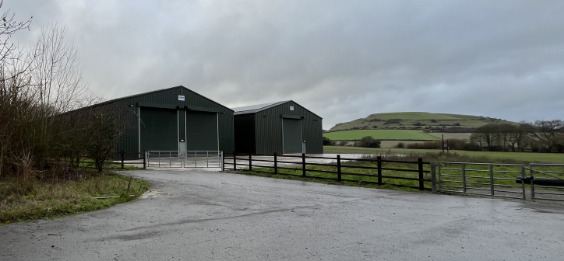
Officer site photo of existing buildings with Cley Hill visible to the right of the image
Whilst it is duly appreciated that the introduction of new development in such a setting would alter the character and appearance of the area, the proposed building would be sited close to two existing buildings and would be of a similar size and design to the buildings already present on-site.

The Cranborne Chase National Landscape Partnership Plan acknowledges that large-scale agricultural storage proposals are a key issue for the national landscape area and encourages proposals to be “in appropriate locations and of an appropriate form, scale, and materials” to ensure they integrate within the landscape (p.83 of the plan).

With due regard to the site’s environs, the position of the proposed building in relation to existing buildings, and the use of dark green cladding materials that would ensure the building assimilates within its rural setting, it is considered that the proposal would conserve the landscape and scenic beauty of the national landscape.

It is however considered necessary to impose a planning condition on any planning permission granted to request details of any external lighting, to preserve the International Dark Sky Reserve status of the Cranborne Chase National Landscape and to reduce light pollution.

The introduction of new landscaping adjacent to the public right of way footpath and along the north-west boundary of the development (as previously secured under the discharge of conditions application reference: PL/2024/03954) would also assist in screening the proposed development and conserving the landscape character of the area.

It is therefore considered that the proposals would comply with the aforementioned policies.

Design and Impact on the Character and Appearance of the Area: Policy CP57 of the adopted WCS makes it clear that a high standard of design is required in all new developments and for developments to respond positively to the existing townscape and landscape features including “building layouts, built form, height, mass, scale, building line, plot size, elevational design, materials, streetscape and rooflines to effectively integrate the building into its setting”.

Paragraph 135 of the NPPF also requires new developments to be well‑designed, high-quality, and long-lasting. Developments should also be visually attractive, have effective landscaping, respect local character and history, and create a strong sense of place.

The application site is located in open countryside, but with the proposed building being sited adjacent to existing agricultural buildings and being of a design, scale and size to complement these existing buildings, the proposed development is considered to satisfy the requirements of CP57.

Amenity: Policy CP57 (criterion vii) of the adopted WCS requires development to respect the amenity of existing occupants and ensure appropriate amenity levels for future residents.

Paragraph 135f of the NPPF reinforces the need for development to provide a high standard of amenity for both existing and future users.

The closest residential dwellings to the application site are located over 220m east at Folly Lane, the other side of the A362 road. On this basis, the proposed development would not have an adverse impact on the amenity of neighbouring properties, due to its location and design.

Highways Impacts and Parking: Planning proposals require developments to demonstrate:
- Safe and suitable access for all users, including pedestrians, cyclists, and those with mobility impairments.
- No severe residual impacts on the surrounding highway network.
- Promotion of sustainable travel, reducing reliance on private vehicles.
- Adequate parking and cycle provision, in line with adopted standards.
- Protection and enhancement of public rights of way and active travel routes.

The existing site benefits from an established access point from the A362, which currently serves the existing buildings. This application is not seeking to alter the existing access. The Council’s highways department has confirmed that the “site is served via an existing, established access. Therefore, no highway objection is raised” and therefore no highway-based concerns are raised with the proposal.

Ecology and Biodiversity: The ecological impact of development is a key planning consideration, especially for larger schemes. Proposals must assess and address potential effects on:
- Protected species
- Priority habitats
- Ecological networks
- Green and blue infrastructure

Policy CP50 of the adopted WCS requires development to:
- Avoid harm to ecological assets.
- Deliver measurable Biodiversity Net Gain (BNG), in line with the Environment Act 2021.
- Support habitat restoration and connectivity.
- Integrate biodiversity into site design.

The Green and Blue Infrastructure Strategy (2022–2030) promotes nature recovery, ecosystem services, and habitat connectivity through development.

Unless exempt, national policy requires a minimum of 10% Biodiversity Net Gain (BNG) for major developments, demonstrated via biodiversity metric calculations, and ecological assessments (e.g. PEAs, Phase 1 surveys, protected species surveys) where necessary.

In this instance, a submitted metric (dated May 2024) confirms that there would be a loss of 0.73 onsite habitats but a gain of 16.89% habitat units, based on the provision of the native hedge planting with trees that was previously secured within the previous planning applications on the site.

The Council’s ecology department was consulted on this application and has confirmed that a BNG small sites metric has been submitted and there are no other obvious ecology issues on this application.

With regards to the 6.4km buffer zone for the Salisbury Plain SPA, a strategic AA has been prepared pertaining to development within the 6.4km zone of influence that could result in a likely significant effect on the SPA as a result of an increase in recreational / visitor pressure. The AA reached a conclusion of no adverse effects on the integrity of the SPA or its qualifying features, provided that the Council’s mitigation strategy continues to be implemented. Annual stone curlew monitoring and protection measures continue to be secured by the Council. In July 2024 Natural England (NE) confirmed that the 2024 strategic AA for Salisbury Plain SPA continues to be supported by NE.

The application site is situated within the River Avon (Hampshire) SAC catchment area and therefore, regard must also be given to CP69, which seeks the avoidance and reduction of potential environmental effects on the River Avon SAC and for developments to incorporate measures “to avoid and prevent pollution and mitigate potential disturbance effects”.

In this instance, the proposed development is seeking planning permission for a new agricultural building, and therefore, there would be no increase in foul drainage. The completed application form confirms that there would be no new foul drainage disposal required as part of the development.

Flood Risk and Drainage: Policy CP67 of the adopted WCS and NPPF paragraphs 170–182 require:
- Avoidance of increased flood risk.
- Use of appropriate mitigation measures.
- Application of the sequential and exception tests for developments in Flood Zones 2 or 3.
- All new developments should include measures to reduce the rate of rainwater and improve rainwater infiltration to soil and ground.

As detailed above, the site is located in an area considered to be susceptible to a high risk of groundwater flooding with reference to the Council’s SFRA. The applicant was invited to submit a Flood Risk Assessment (FRA), which confirms that agricultural use is classified as less vulnerable development.

The proposed building would be partially located above some existing concrete disused hardcore and would be constructed to the same floor level as the existing two buildings, both of which have been constructed 1m above the existing ground level, with any electrical fittings to be set at a high level.

It is therefore considered that the proposed building would incorporate measures that would ensure it is floor resistant and resilient and would satisfy the above policies.

PLANNING BALANCE AND CONCLUSION: The proposal is broadly compliant with relevant local and national planning policies in respect of national landscape, design, scale, residential amenity, highway safety, flood risk, and ecology, subject to the recommended conditions.

The proposal seeks to provide the necessary facilities for an established farming business, and the design and scale of the proposed building would complement existing buildings on-site. The use of dark green cladding and the additional landscaping would also ensure the proposed development assimilates within its setting.

Accordingly, the proposal is considered acceptable in planning terms and in accordance with the Wiltshire Core Strategy, the National Planning Policy Framework, and all other relevant material considerations.

RECOMMENDATION: That planning permission be GRANTED, subject to conditions.

