APPLICATION FOR FULL-PLANNING PERMISSION
CASE OFFICER REPORT

APPLICATION REFERENCE: | PL/2025/09432
APPLICATION TYPE: | Full planning permission
SITE ADDRESS: | Brambles Pre School, Ablington, Figheldean, Salisbury, SP4 8JX
DEVELOPMENT DESCRIPTION: | Replacement and extended canopy, kitchen stainless vertical extractor flue
RECOMMENDATION: | Approve with Conditions

PROPOSAL

This is a full planning application for the replacement of and to extend the canopy of the existing building and to add a vertical extractor flue to the kitchen.

The extended covered play area would be on the southern side of the building where there is already a covered decking area. This proposal would extend that canopy across the whole of the southern elevation. The kitchen flue would also be on the southern elevation roof slope.

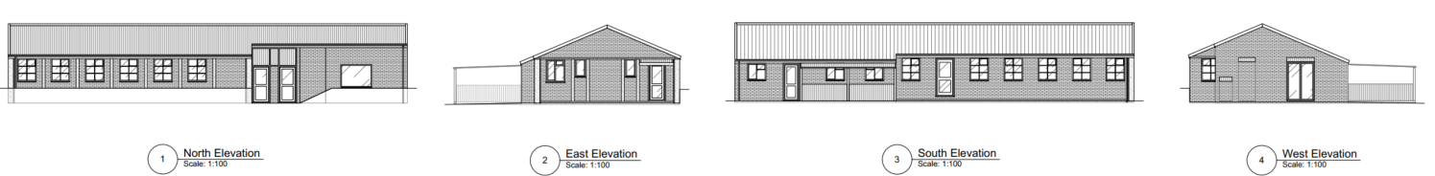

Existing Elevations

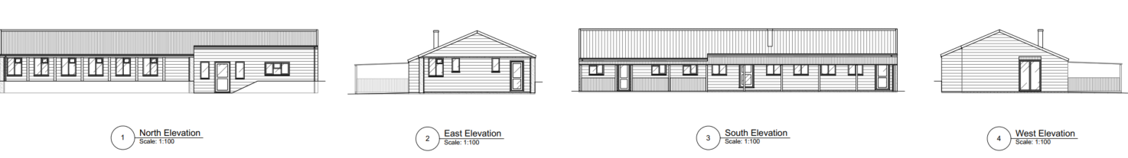
Proposed Elevations

The proposal would also include a small extension on the northern elevation at the main entrance which would create a larger reception area. The extension would only come out as far as the existing manager office wall.

Whilst no arboricultural survey has been submitted with the application, it is clear from Google Street view images and aerial photographs that the existing woodland in the southern part of the site is on a consistent line separated from the existing canopy and therefore would not be interfered with by the proposed canopy.
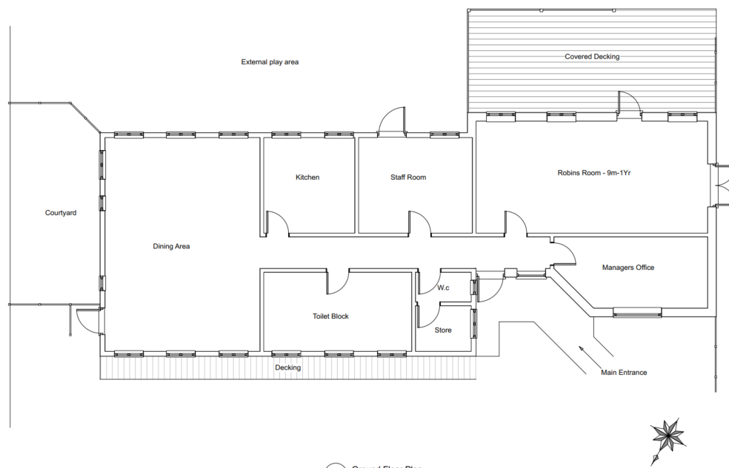

Existing Floor Plan (note that north faces down on this image)

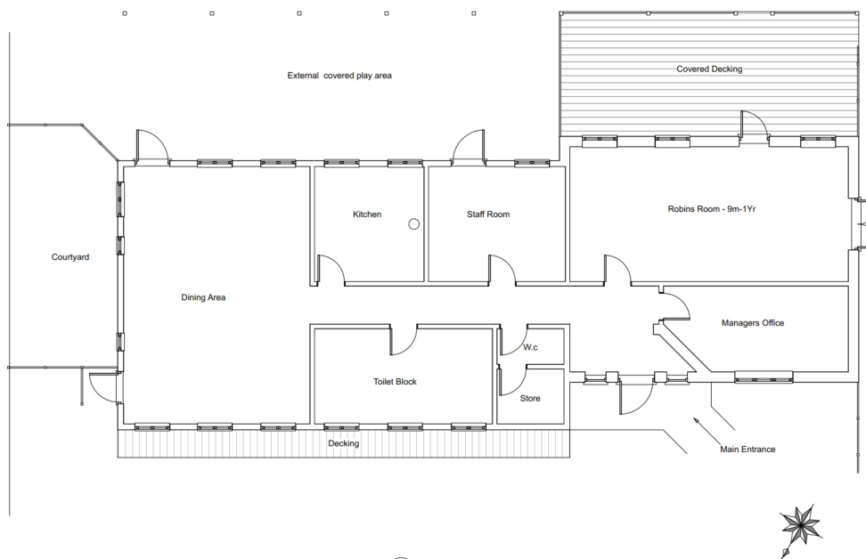
Proposed Floor Plan (note that north faces down on this image)

SITE DESCRIPTION/CONTEXT

The application relates to Brambles Pre School in Ablington, Figheldean. It is a children’s outdoor nursery which is accessed via the end of a cul-de-sac at the site’s north-eastern corner, also backing onto Ablington road at its southern boundary. To the west and North of the site lies a woodland and to the east lie residential properties. There is one main building within the site, with several other semi-permanent structures located sporadically throughout.

There are also a high number of mature trees throughout the site which largely disguise views of the main building and the other structures, although it clearly reads as an outdoor nursery when viewed from the street scene.

The site is located within the Figheldean and Ablington Conservation Area and is set within close proximity to several listed buildings, including 294 and 295 Ablington (List Entry Number: 1318511), 270 Ablington (List Entry Number: 1318510), and 277 and 279 Ablington (List Entry Number: 1183053).

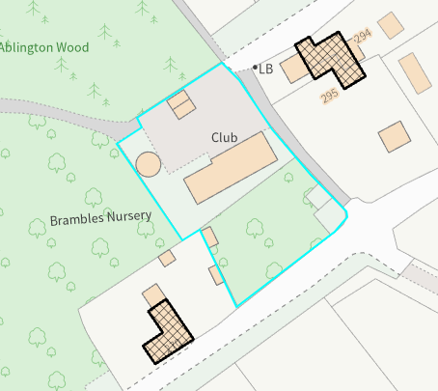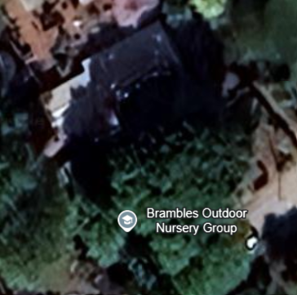

Mapping image showing the location of the two closest grade II listed buildings and 2025 aerial image of the site

Public right of way FIGH1 passes immediately alongside the east boundary of the application site.

The site is within flood zone 1 and is not subject to surface or ground water flood risk. The site is within the Sailsbury Plain SPA 6.4km buffer.

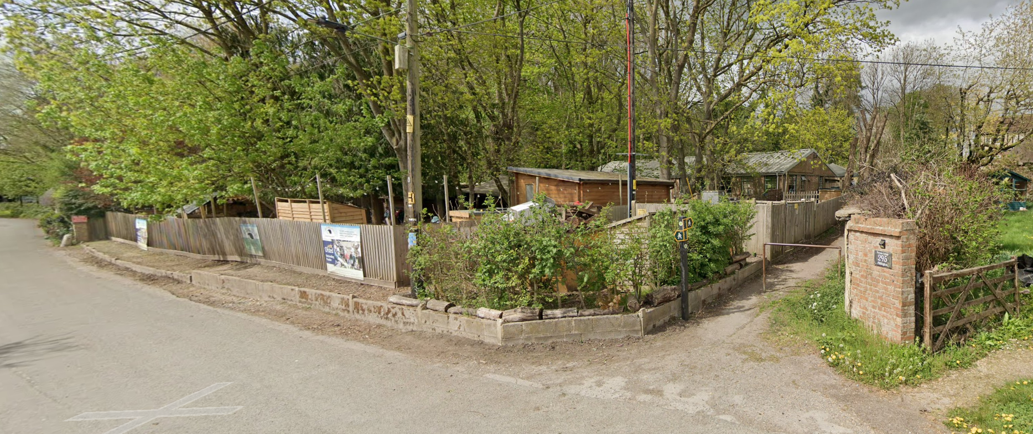

April 2025 Google Street View Image of the site from the Abingdon main road to the south

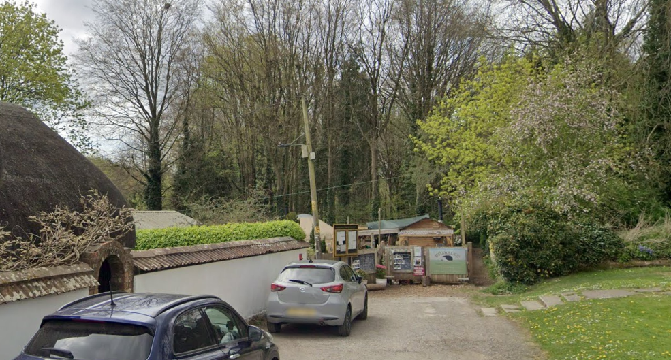

April 2025 Google Street View Image from ‘road to club figheldean’ – from the east

PLANNING HISTORY

18/08558/FUL - 1 no. proposed yurts to enable accommodation of increased pupils in the preschool. Approved with Conditions 17th May 2019.

PL/2023/07348 - Retrospective permission for the erection of a shed to be used as changing and toilet facilities. Approved with Conditions 21st August 2024.

PL/2025/04599 - Erection of Timber Office Outbuilding. Approved with conditions 29 August 2025

RELEVANT LEGISLATION, POLICIES AND GUIDANCE

Statutory Legislation:

From the point of view of the historic environment the main statutory tests are set out within the Planning (Listed Building and Conservation Areas) Act 1990.

Section 66 of the Act states that in considering whether to grant planning permission for development which affects a listed building or its setting, the local planning authority or, as the case may be, the Secretary of State shall have special regard to the desirability of preserving the building or its setting or any features of special architectural or historic interest which it possesses.

Section 72(1) of the Act requires the Council to pay special attention to the desirability of preserving or enhancing the character or appearance of designated Conservation Areas.

National Planning Policy:

- National Planning Policy Framework (NPPF)
- Planning Practice Guidance (PPG)
The NPPF outlines government policy for planning. Chapter 16 of the NPPF 'Conserving and enhancing the historic environment' sets out the Government's high-level policies concerning heritage and sustainable development. In particular:

Paragraph 208 requires LPAs should “avoid or minimise any conflict” between the heritage asset’s conservation (which includes achieving its optimum viable use) and any aspect of a proposal.

Paragraph 210 requires local planning authorities should take account of the desirability of sustaining and enhancing the significance of heritage assets and putting them to viable new uses and of new development making a positive contribution to local character and distinctiveness.

Paragraphs 212 requires “great weight” to be given to an asset’s conservation “irrespective of whether any potential harm amounts to substantial harm, total loss or less than substantial harm to its significance.”

Paragraph 213 advises that harm to the significance of a designated heritage asset should require “clear and convincing justification”.

Paragraphs 213-215(214-216) require a balanced approach with any harm which would be caused being weighed against the potential public benefits which might be achieved.

The Planning Practice Guidance provides guidance on interpreting the NPPF.

Development Plan:

The development plan for Wiltshire comprises the Wiltshire Core Strategy (WCS) (adopted January 2015) and any made neighbourhood plans, which remains the principal statutory planning document guiding development across the county. In line with Section 38(6) of the Planning and Compulsory Purchase Act 2004, planning decisions must be made in accordance with the development plan unless material considerations indicate otherwise.

Though the development plan is considered as a whole, those parts deemed to be particularly relevant to this application are listed below:

The adopted Wiltshire Core Strategy (WCS), with particular regard to:

- Core Policy 50: Biodiversity and Geodiversity
- Core Policy 57 Ensuring High Quality Design and Place Shaping;
- Core Policy 58 Ensuring the Conservation of the Historic Environment;

The Council’s Core Strategy CP 57: Ensuring high quality design requires a high quality of design in all new developments. The policy requires applicants to “demonstrate how the proposal will make a positive contribution to the character of Wiltshire through (amongst other things) responding to the value of the natural and historic environment and being sympathetic to and conserving historic buildings and landscapes. Development is required to respond positively to the existing in terms of building layouts, built form, height, mass, scale, building line, plot size, elevational design, materials, streetscape and rooflines to effectively integrate the building into its setting.”

The Council’s Core Strategy Policy CP58 ‘Ensuring the conservation of the historic environment’ requires that designated and non-designated heritage assets and their settings will be conserved, and where appropriate enhanced, in a manner appropriate to their significance and encourages proposals which improve the condition of heritage assets at risk.

Neighbourhood Plan:

Figheldean does not have a Neighbourhood Plan or area designation.

Supplementary Planning Documents and other Guidance:
- Wiltshire Design Guide (adopted April 2024)

ISSUES

The main issues that need to be addressed in this case include:

- Whether the scheme constitutes high quality design (CP 57)
- Whether the scheme would have an acceptable impact upon the reasonable living conditions of the adjoining occupants (CP 57)
- Whether the scheme would preserve or enhance the historic environment (CP 58)

CONSULTATION RESPONSES

WC Public Protection: No observations to make

WC Ecology: Verbal comments only – The proposal wouldn’t count as an increase in recreational pressure and would be screened out of appropriate assessment.

Figheldean Parish Council: No comments received

REPRESENTATIONS

In accordance with the requirements of the Town and Country Planning (Development Management Procedure) (England) Order 2015 (as amended), the application was publicised by way of:

- Neighbour notification letters sent to adjoining and nearby properties;
- A site notice displayed near the site;
- An advertisement placed in the local press

These methods were used to inform interested parties and provide a period of 21 days for comments to be submitted. For the avoidance of doubt the site notice was erected on 6 Jan 2026 and therefore this application was delayed until 27 January 2026 before the recommendation could be made.

No comments were received.

ASSESSMENT

Section 38(6) of the Planning and Compulsory Purchase Act 2004 states:

"If regard is to be had to the development plan for the purposes of any determination to be made under the planning Acts, the determination must be made in accordance with the plan unless material considerations indicate otherwise."

In accordance with this statutory requirement, this application has been assessed against the relevant policies of the Development Plan, including the Wiltshire Core Strategy (2015) and, where applicable, any made Neighbourhood Plans. Consideration has also been given to the policies of the National Planning Policy Framework (NPPF) as a material consideration in the assessment.

Principle of Development

This is an established pre-school and therefore the principle of development to improve the facilities are supported.

Design and Impact on the Character and Appearance of the Area

The proposed front extension would be a simple addition to the front (north elevation) and would be clad in matching materials. There would be no harm to the appearance of the host building nor its setting within the street scene.

The canopy on the rear (south) elevation would potentially be more visible on the street scene but would have the existing woodland screen and the other buildings (PL/2023/07348) helping to screen it from view. The canopy would only extend the existing canopy over the decking area and outside play area using the same pitch and depth and materials. Whilst there would be some harm to the host building and its setting in the street scene, it is considered that this would be minimal and would not warrant refusal of the application.

The proposed flue would not be a dominant feature and due to the existing screening surrounding the building, would largely be screened from view, as such this element of the scheme raises no concerns from a design perspective.

Having regard to the above, the proposal complies with the design principles set out in Core Policy 57 of the Wiltshire Core Strategy.

Impact on Heritage Assets

The site is located within the Figheldean and Ablington Conservation Area and is set within close proximity to several grade II listed buildings, including 294 and 295 Ablington (List Entry Number: 1318511), 270 Ablington (List Entry Number: 1318510), and 277 and 279 Ablington (List Entry Number: 1183053). The mature trees on site make a positive contribution to the conservation area and setting of the listed buildings, and the use as a nursery can be seen as a neutral visual impact, with the buildings largely consisting of natural materials which blend in with the woodland setting.

As discussed in the previous section, the proposal would not have a significant impact upon the appearance of the nursery upon the street scene due to the screening from existing buildings and mature trees on site, and it would generally appear in keeping with the existing land use, with the scale not appearing to be an overdevelopment of the site.

The main positive contribution made by the site towards the visual amenity of the street scene is the mature trees, and the proposals would not cause any harm to these features. The proposal would therefore not have a negative impact upon the visual amenity of the Conservation Area or the setting of the nearby listed buildings.

The development is therefore considered to comply with Core Policy 58 of the Wiltshire Core Strategy and Sections 66 and 72 of the Planning (Listed Buildings and Conservation Areas) Act 1990, as well as the relevant provisions of the NPPF.

Amenity

Core Policy 57 (Point vii) of the Wiltshire Core Strategy requires development to respect the amenity of existing occupants and ensure appropriate amenity levels for future residents.

The National Planning Policy Framework (NPPF), particularly Paragraph 135, reinforces the need for development to provide a high standard of amenity for both existing and future users.

The proposed extensions would cause no harm to neighbouring amenity as they would not be of a size or scale that would cause overshadowing or overbearing impacts.

The flue could cause some harm from smoke and fumes, but the Council’s Environmental Health Officer has no objection. The smell would only be from the kitchen when in use for preparing meals for the pre-school children and should therefore be limited to specific times of the day rather than comparted to, for example, a biomass boiler needed for heating. It is also considered that the kitchen is an existing facility at the site and the flue would likely improve the direction of fumes, therefore improving the current situation.

Therefore, the impact on neighbouring amenity would be acceptable.

Ecology and Biodiversity

Core Policy 50 of the Wiltshire Core Strategy seeks to protect and enhance biodiversity and geodiversity, including through ensuring that development avoids harm to protected species and habitats.

The National Planning Policy Framework (NPPF), in Paragraphs 193, requires that development minimises impacts on and provides net gains for biodiversity, including ensuring mitigation is secured where harm cannot be avoided.

The Council’s Ecology Officer has not been formally consulted on this application, but the application site is within the 6.4km zone of influence of the Salisbury Plain SPA and in light of the HRA for the Wiltshire Core Strategy and the HRA for the Wiltshire Housing Site Allocations Plan it is screened into Appropriate Assessment due to the potential impact of recreational pressure on stone curlew in combination with other plans and projects.

As the works would not result in the creation of any additional overnight accommodation, nor increase recreational pressure, there would be no additional recreational pressure on the SPA.

As such, the development complies with Core Policy 50 of the Wiltshire Core Strategy and the relevant provisions of the NPPF.

Biodiversity Net Gain (BNG)

The proposal would affect less than 25m2 of habitat and is therefore exempt from the 10% requirement. It is understood that the ‘play area’ would remain as existing meaning that there would be no loss of habitat.

CONCLUSION

The development is considered to be acceptable with no significant impact to neighbouring amenities or on the heritage assets, and it is therefore considered to be in accordance with the above listed Core Policies of the adopted Wiltshire Core Strategy, sections 66 and 72 of Planning (Listed Building and Conservation Areas) Act 1990 and the aims of the NPPF.

RECOMMENDATION:
That Planning Permission be GRANTED, subject to conditions

